[**Upload**](http://elmatrico.nvision.org.in)

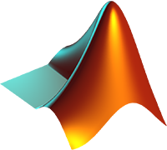

El Matrico

[](http://elmatrico.nvision.org.in)



Problems

**Submission Date** – 7th October, 2015 (Wednesday), 11:59 PM

**Problems Statement 2**

1. Given a row or a column matrix, write a function to plot a linear, quadratic, or cubic curve using least squares method. The user should be able to decide the degree of the curve. No inbuilt function for curve fitting should be used.
2. The Peaucellier–Lipkin linkage is the first planar linkage capable of transforming rotary motion into perfect straight-line motion, and vice versa. Using MATLAB create an animation of Peaucellier mechanism. Length of the link can be decided by the participant. OA should be the driver link.

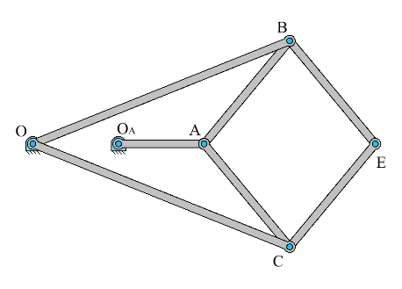

1. Given a picture with a blue ball. Write a program to find the centroid of it and mark it in the figure.
2. The **Scotch yoke** (also known as *slotted link mechanism*) is a reciprocating motion mechanism converting the linear motion of a slider into rotational motion, or vice versa. The piston or other reciprocating part is directly coupled to a sliding yoke with a slot that engages a pin on the rotating part. The location of the piston versus time is a sine wave of constant amplitude, and constant frequency given a constant rotational speed. Write a program to create the animation of it. Suitable link lengths can be assumed.
3. Write a function to extract YELLOW color from an image. The output should look like below.

 