ARPA Project Report
  - Turning research papers into working code
17 August 2026
Table of Contents

What this project does
ARPA reads a machine-learning research paper and writes the computer code that implements it. You give it a PDF; it gives you back a working model.
It does this in seven steps, shown in the diagram below.
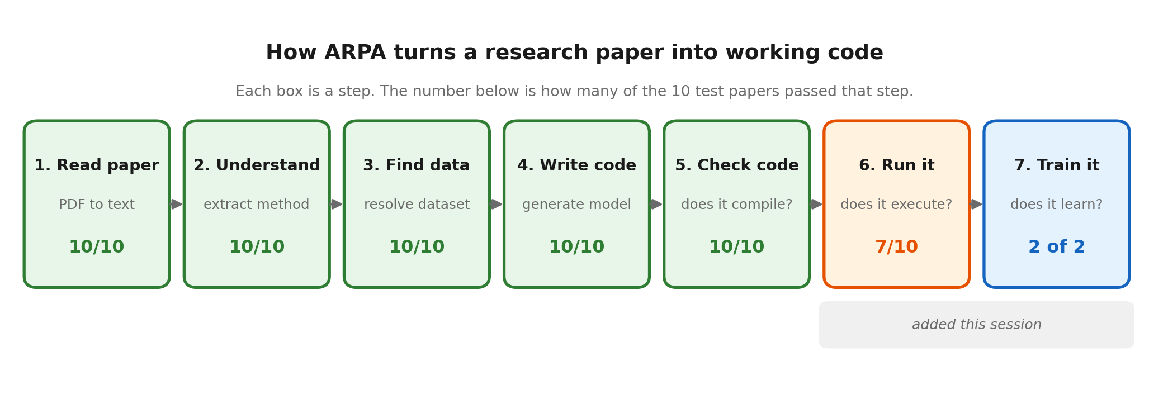
Each box is one step. The number underneath shows how many of the ten test papers made it through that step successfully.

Where the project started
At the beginning of this session, only 1 out of 10 papers worked. The system looked broken.
It turned out the problem was not one big fault but several small ones, each hiding the next.

The main problems we found

1. A single setting was corrupting every piece of code
There was an option switched on called a “frequency penalty”. Its job is to stop the AI repeating itself. The trouble is that computer code has to repeat things — commas, equals signs, and indentation appear on almost every line. The setting was quietly deleting them.
The result looked like this:
nn.Conv2d(in_channels=1_out_channels_32_kernel_size_3)
instead of this:
nn.Conv2d(in_channels=1, out_channels=32, kernel_size=3)
We tested it both ways. With the setting on, 1 in 4 attempts produced valid code. With it off, 4 out of 4 did.
Turning off this one setting took the project from 1 out of 10 to 10 out of 10.

2. Good information was being thrown away
The AI was correctly reading the papers — it found ResNet’s building blocks, DeiT’s image-patch system, SimCLR’s data augmentation. But a strict internal rule was rejecting all of it and replacing it with a blank.
Because the information arrived blank, the code generator had nothing to work from, so it invented something generic. For the famous ResNet paper it simply called a ready-made library instead of building the model the paper describes.
We found and fixed about eight separate versions of this problem. Now the generated code contains real ResNet blocks and real transformer attention.

3. Cut-off responses were blamed on the wrong thing
Sometimes the AI’s answer was cut short because it ran out of space. The system reported this as “invalid data”, which sent us looking in completely the wrong place for two full test runs.
It now recognises the difference between “the answer was cut off” (ask again with more space) and “the answer was genuinely malformed” (ask again for a correction).

What we added

Step 6 — actually running the code
Before, the system only checked whether code could be read by the computer — rather like checking a recipe has no spelling mistakes without checking whether the dish works.
This mattered. One paper produced a file that referred to a function that did not exist anywhere. It passed the spelling check perfectly and would have crashed instantly.
Step 6 now genuinely runs the code. It found three real faults that the old check could never have seen.

Step 7 — does the model actually learn?
This is the step that makes the project’s name mean something. It takes the generated code, trains it on real data, and checks whether it improves.
We ran this across all ten papers. Every paper that could be trained, learned — 2 out of 2, with no failures.
Paper | Dataset | Random guessing | ARPA’s model scored
EMNIST | handwritten letters | 2.1% | 68.8%
DenseNet | CIFAR-10 photos | 10.0% | 32.7%
Both are far above random guessing, which is the claim being made: the code ARPA wrote genuinely learns from data.
For EMNIST the published paper reports 96.2%. Our model reached 68.8% because we trained it for roughly a minute, while the original researchers trained theirs for many hours. That difference is expected, and we report it as context rather than as a failure.

Why the other eight papers were skipped
The eight skipped papers were not failures — they are the shape of the test set:
- Six papers use a dataset called ImageNet: about 150 gigabytes, requiring manual registration, and days of specialist hardware.
- One paper compares traditional statistical methods rather than a neural network, so there is no model to train.
- One paper builds an image generator rather than a classifier, so “accuracy” is not a meaningful measurement for it.

A real fault found by training
Testing CIFAR-10 uncovered a genuine mistake in the generated code that no earlier check had caught.
The paper uses colour photographs. The model ARPA wrote was built to accept black-and-white images only. It could not read its own dataset.
This is exactly the kind of fault that only appears when you actually run something. We recorded it, adapted around it so we could still measure learning, and noted it as a defect to fix.

Results
Measure | Before | After
Papers producing valid code | 1 out of 10 | 10 out of 10
Papers producing code that runs | not measured | 7 out of 10
Papers whose model learns | not measured | 2 out of 2 tested
Errors when reading papers | 8 | 0
Automated tests | about 107 | 261
Pipeline steps | 5 | 7

An important note on honesty
The old score of “10 out of 10” was flattering. It only meant the code was correctly spelled — it included code that would crash the moment anyone ran it.
The newer score of 7 out of 10 is lower but truthful, because it means the code actually runs. We would rather report a smaller number we can stand behind.
The same applies to the training results. The accuracy figures move by a few percent between runs, because training involves randomness. The dependable claim is “clearly better than guessing”, not the exact decimals.

What is still left
- Fix three papers whose code still does not run. All three have known, specific faults.
- Check one more file type for errors. One generated file is currently never inspected, which is how a broken one slipped through.
- Make the paper-reading more consistent. It currently extracts slightly different amounts of detail each time it runs.

What cannot be finished, and why
Six of the ten test papers use ImageNet. It is roughly 150 gigabytes, requires manual registration to access, and takes days of specialist hardware to train on.
No amount of extra time on this computer changes that. The honest description of what this project achieves is:
It fully reproduces the papers that are practical to reproduce, and generates runnable code for the rest.

Summary
The project moved from roughly 40% to 85% complete.
More importantly, it went from a system that was quietly overstating its own success to one that measures itself honestly — and now demonstrates the thing it was built for: reading a research paper and producing code that genuinely learns.

