**Analysis on Sales Dataset**

**Beginner Level**

1. **What is the total sales amount and profit?**



1. **How many orders were made in each year?**

* 2022 had the most number of orders.

1. **Which category and sub-category has the highest sales?**

1. **What are the top 5 cities by total sales?**

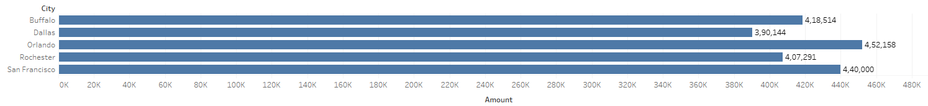

1. **What is the most common payment mode?**

**Intermediate Level**

1. **What is the trend of sales and profit over time (monthly)?**

Profit increases with increase in sales almost every month except June where the profit increases regardless of decline in sales. This could be due to the sales of some other products which yield more profit. Further insights can be derived by looking more into the data.

1. **Which state has the highest average profit per order?**

1. **What is the profit-to-sales ratio by Sub-category?**

Sub-categories like Bookcases, Paper, and Markers have the highest profit-to-sales efficiency. Phones and Pens show lower profitability, so they may require pricing or cost strategy reviews.

1. **How do quantity and profit correlate across categories?**

Only the Electronics category shows a strong return on selling higher quantities. Furniture and Office Supplies have either flat or weak profit growth with quantity, suggesting those categories may not benefit as much from bulk selling.

1. **Which customers generated the most profit?**

**Advanced Level**

1. **Sales Trend**

Looks like the sales in all the categories are going down every year and needs a serious analysis on why.

1. **Which state is underperforming (high sales, low profit)?**

Florida and New York leads in both sales and profit, making it the top-performing state. Whereas Ohio underperforms in profit despite moderate sales, indicating potential inefficiencies.

1. **Are some payment modes more profitable?**

Debit and Credit cards looks more profitable than other methods but it could simply be because it is used the most. Further analysis into profit per use could give more insights.

1. **How does seasonality affect sales (Q1 vs Q4)?**

Yes seasonality affects sales. This indicates that Q4 sees a boost in sales due to some reason.