给定建表语句，完成以下功能

#建学生信息表student

create table student

(

sno varchar(20) not null primary key,

sname varchar(20) not null,

ssex varchar(20) not null,

sbirthday datetime,

class varchar(20)

);

#建立教师表

create table teacher

(

tno varchar(20) not null primary key,

tname varchar(20) not null,

tsex varchar(20) not null,

tbirthday datetime,

prof varchar(20),

depart varchar(20) not null

);

#建立课程表course

create table course

(

cno varchar(20) not null primary key,

cname varchar(20) not null,

tno varchar(20) not null,

foreign key(tno) references teacher(tno)

);

#建立成绩表

CREATE TABLE score (

sno VARCHAR (20) NOT NULL ,

FOREIGN KEY (sno) REFERENCES student (sno),

cno VARCHAR (20) NOT NULL,

FOREIGN KEY (cno) REFERENCES course (cno),

degree DECIMAL

);

#添加学生信息

insert into student values('108','曾华','男','1977-09-01','95033');

insert into student values('105','匡明','男','1975-10-02','95031');

insert into student values('107','王丽','女','1976-01-23','95033');

insert into student values('101','李军','男','1976-02-20','95033');

insert into student values('109','王芳','女','1975-02-10','95031');

insert into student values('103','陆君','男','1974-06-03','95031');

#添加教师信息

insert into teacher values('804','李诚','男','1958-12-02','副教授','计算机系');

insert into teacher values('856','张旭','男','1969-03-12','讲师','电子工程系');

insert into teacher values('825','王萍','女','1972-05-05','助教','计算机系');

insert into teacher values('831','刘冰','女','1977-08-14','助教','电子工程系');

#添加课程信息

insert into course values('3-105','计算机导论','825');

insert into course values('3-245','操作系统','804');

insert into course values('6-166','数字电路','856');

insert into course values('9-888','高等数学','831');

#添加成绩信息

insert into score values('103','3-245','86');

insert into score values('105','3-245','75');

insert into score values('109','3-245','68');

insert into score values('103','3-105','92');

insert into score values('105','3-105','88');

insert into score values('109','3-105','76');

insert into score values('103','3-105','64');

insert into score values('105','3-105','91');

insert into score values('109','3-105','78');

insert into score values('103','6-166','85');

insert into score values('105','6-166','79');

insert into score values('109','6-166','81');

完成题目如下：

1. 查询student表中的所有记录的sname、ssex和class列。

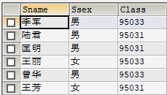、

select Sname,Ssex,Class from Student;

2、 查询教师所有的单位即不重复的depart列。

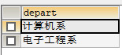

select distinct depart from teacher;

3、 查询student表的所有记录

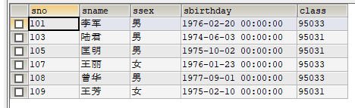

select \* from student;

4、 查询score表中成绩在60到80之间的所有记录。

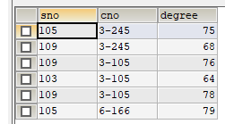

select \* from score where degree >= 60 && degree <= 80;

5、 查询score表中成绩为85，86或88的记录。

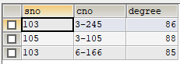

select \* from Score where degree in(85,86,88);

6、 查询存在有85分以上成绩的课程cno.



select distinct cno from score where degree >85;

7、查询“计算 机系”与“电子工程系“不同职称的教师的tname和prof。

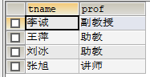

select `tname`,`prof` from teacher where depart in('计算机系','电子工程系')

8、 查询student表中“95031”班或性别为“女”的同学记录。

9、 以class降序查询student表的所有记录

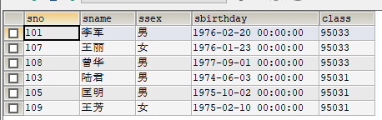

select \* from student order by class desc;

10、 以cno升序、degree降序查询score表的所有记录。

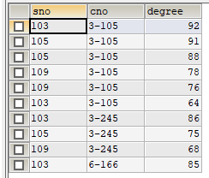

select\*from Score order by Cno asc, Degree desc

11、 查询“95031”班的学生人数。



select count(\*) from student where class='95031';

12、查询分数大于70，小于90的sno列。

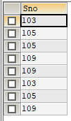

select Sno from Score where Degree>'70 'and Degree<'90'

13、查询score表中的最高分的学生学号和课程号。（如果还没有学过子查询,则用排序查）



select Sno,Cno from Score where Degree= ( select max(Degree) from Score )

14、查询每门课的平均成绩。

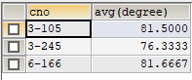

select cno,avg(degree) from score group by cno;

15、查询95033班和95031班全体学生的记录。

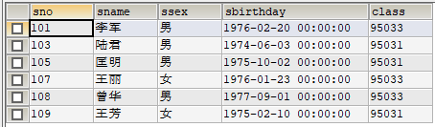

select \*from Student where class in ('95031','95033')

16、查询student表中不姓“王”的同学记录。

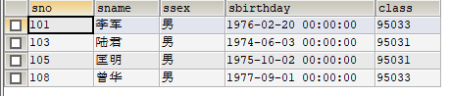

select \* from student where sname not like '王%';

17、查询student表中最大和最小的sbirthday日期值。



select max(Sbirthday),min(Sbirthday)from Student

18、以班号和年龄从大到小的顺序查询student表中的全部记录。

19、查询score表中至少有5个成绩记录的课程的平均分数。

20、查询所有学生的sname、cno和degree列(两表连接)。

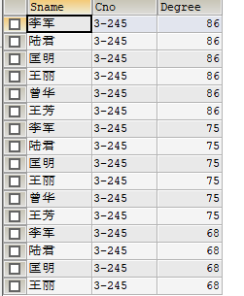

select Student.Sname,Score.Cno, Score.Degree from Student,Score

21、查询“男”教师及其所上的课程。



select\*from Teacher join Course on Teacher.Tno=Course.Tno where Teacher.tsex='男'

22、查询所有学生的sno、cname和degree列。

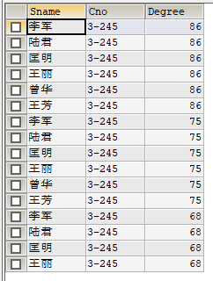

select Student.Sname,Score.Cno, Score.Degree from Student,Score

23、查询所有学生的sname、cname和degree列。

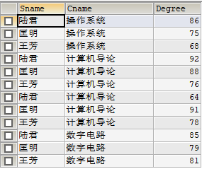

select Sname,Cname,Degree from Score join Student on Student.Sno = Score.Sno join Course on Score.Cno = Course.Cno

24、查询“95031”班学生的平均分。



select avg (Degree) from Score where Sno in (select Sno from Student where Class='95033')

25、查询最高分同学的sno、cno和degree列。



select\*from Score where Degree= (select max(Degree) from score)

26、查询和“李军”同性别的所有同学的sname.

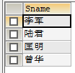

select Sname from Student where Ssex=(select Ssex from Student where sname='李军')

27、查询和“李军”同性别并同班的同学sname.

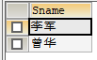

select Sname from Student where Ssex=(select Ssex from Student where sname='李军')and class=(select class from student where Sname='李军')

28、查询所有选修“计算机导论”课程的“男”同学的成绩表。

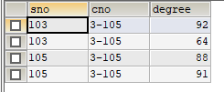

select \* from Score where Sno in (select Sno from Student where Ssex='男')and Cno in(select Cno from Course where Cname='计算机导论')

41、查询student表中每个学生的姓名和年龄。

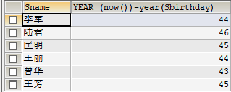

select Sname,year (now())-year(Sbirthday) from Student

30、查询选修“3-105”课程的成绩高于“109”号同学成绩的所有同学的记录。

31、查询成绩高于学号为“109”、课程号为“3-105”的成绩的所有记录

32、查询和学号为108、101的同学同年出生的所有学生的sno、sname和sbirthday列。



select student.Sno, student.Sname,Sbirthday from student where year(Sbirthday)= (select year(Sbirthday)from student where sno='108')

33、查询“张旭“教师任课的学生成绩。

34、查询某课程的成绩记录多于5个的教师姓名。



select Tname from Teacher where Tno in ( select Tno from course where Cno in( select Cno from Score group by Cno having count(\*)>5))

35、查询出“计算机系“教师所教课程的成绩表。

1. 查询选修编号为“3-105“课程且成绩至少高于选修编号为“3-245”的同学的cno、sno和degree,并按degree从高到低次序排序

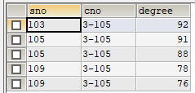

select\*from Score where Cno ='3-105'and Degree> any ( select Degree from score where Cno='3-245') order by Degree desc

37、查询选修编号为“3-105”且成绩高于选修编号为“3-245”课程的同学的cno、sno和degree.

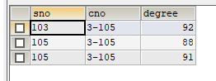

select\*from Score where Cno ='3-105'and Degree> all ( select Degree from score where Cno='3-245')

38、查询所有任课教师的tname和depart.

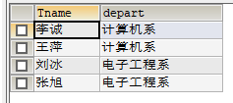

select Tname ,depart from Teacher where Tno in (select Tno from Course)

39、 查询所有未讲课的教师的tname和depart.



select Tname,depart from Teacher where Tno in(select Tno from Course where Cno not in(select Cno from Score))

40、查询至少有2名男生的班号。

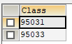

select Class from Student where Ssex='男' group by Class having count(\*)>1