Integrated Voice–Video Bullet Identification Pipeline – Executive Summary
We recommend using Python libraries with mature community support: for speech recognition, the SpeechRecognition package (v3.15.2, Mar 2026) can wrap engines like OpenAI Whisper or Vosk[1]. For text‐to‐speech (TTS), Coqui TTS provides pretrained neural voices in many languages[2]. Real-time audio I/O is handled via PyAudio or python-sounddevice (bindings to PortAudio)[3][4]. For vision, OpenCV 4.x (e.g. v4.13.0) captures camera frames[5], and deep models run on PyTorch 2.11[6] or TensorFlow 2.21[7]. A common choice is a YOLOv8-based detector (Ultralytics, PyTorch), which offers state-of-the-art accuracy/speed for object detection[8]【11†】. For bullet (cartridge) recognition, we would collect images of bullet types (e.g. calibers) and fine-tune a small object-detection or classification model. For example, one “Bullet” dataset contains ~3.4k labeled images[9]. Key design points include placing a noise-cancelling microphone close to the user[10], using a 1080p@60FPS camera[11], and targeting low latency (<100 ms for vision, ~1 s for ASR). A two-threaded architecture is proposed: Audio Pipeline (Mic → STT → intent logic → TTS → Speaker) and Vision Pipeline (Camera → frame capture → detector → class output). Integration is typically event-driven: e.g. the user says “what’s this bullet?”, triggering the vision analysis and spoken response. We outline below the recommended libraries, hardware, data strategy, models, architecture, implementation plan, and safety considerations, with citations from official sources and primary docs.

Python Libraries & Versions
- Speech Recognition: SpeechRecognition (v3.15.2, Mar 2026) requires Python≥3.9[1]. It interfaces with engines like Google/whisper/Vosk. For advanced ASR, consider faster-whisper, which reimplements OpenAI’s Whisper up to 4× faster[12]. Coqui STT is an alternative DL toolkit (“battle-tested in production and research”)[13].
- Text-to-Speech: Coqui TTS (latest dev v0.28) provides neural TTS with hundreds of pretrained voices[2]. (Other options: pyttsx3 for offline OS voices, or cloud APIs.) Coqui’s docs highlight “pretrained models in +1100 languages”[2].
- Audio I/O: PyAudio (bindings to PortAudio) “enables Python to play and record audio on a variety of platforms”[3]. Similarly, python-sounddevice wraps PortAudio for NumPy audio streams[4]. Both allow low-latency streaming from a mic to Python and back to speakers.
- Computer Vision: OpenCV Python (v4.x, e.g. 4.13.0) captures and preprocesses camera images[5]. For modeling, PyTorch (v2.11.0, Mar 2026)[6] and TensorFlow (v2.21.0, Mar 2026)[7] are current. We favor PyTorch for YOLO (Ultralytics) models; TensorFlow/TF Lite can be used if preferred.
- Model Serving: For production, TorchServe provides a “flexible and easy to use tool for serving PyTorch models in production”[14]. TensorFlow has TensorFlow Serving, “a flexible, high-performance serving system for ML models”[15]. For a prototype, a simple Flask or FastAPI service can host the model in-process (e.g. [49†L910-L919]).
Component | Library/Tool | Version / Notes | Source
Speech-to-Text (STT) | SpeechRecognition (pip package) | v3.15.2 (2026) wraps Whisper/Vosk/GCP; Python≥3.9 required[1] | SpeechRecognition PyPI
 | faster-whisper | pip package, faster CTranslate2-based Whisper[12] | GitHub Readme
 | Coqui STT | v1.4 (STT toolkit); high-quality pretrained models[13] | Coqui STT Docs
Text-to-Speech (TTS) | Coqui TTS | v0.28 dev; deep TTS with +1100 voices[2] | Coqui TTS Docs
 | pyttsx3 | Offline OS voice TTS (Windows/Mac/Linux) | (various)
Audio I/O | PyAudio (PortAudio binding) | v0.2.14 (Nov 2023); cross-platform audio capture/play[3] | PyPI
 | python-sounddevice | v0.5.x (Jan 2026); supports Numpy arrays I/O[4] | PyPI
Computer Vision | OpenCV (cv2) | v4.x (4.13.0 in 2026) for video capture/preprocessing[5] | PyPI
 | PyTorch | v2.11.0 (Mar 2026); tensor library & models[6] | PyPI
 | TensorFlow | v2.21.0 (Mar 2026); ML library[7] | PyPI
Vision Models | Ultralytics YOLOv8 | YOLOv8 (Jan 2023): SOTA real-time detector[8]; various sizes (nano/small/etc.) | Official Docs
 | TensorFlow Object Detection | e.g. SSD, EfficientDet; various pretrained models available | TensorFlow Model Zoo
Model Serving | TorchServe | PyTorch model server (“flexible, high-performance”[14]) | PyTorch Serve Docs
 | TensorFlow Serving | High-performance TF model server[15] | TensorFlow Serving
 | Flask / FastAPI | Python web frameworks for REST microservices (simple inference API) | (community)

Hardware Requirements
- Microphone: A high-quality USB condenser or headset mic is recommended. Place it close to the speaker’s mouth to minimize noise[10]. 16–48 kHz sampling is typical. (E.g. Blue Yeti, Shure SM58+USB interface, or professional lavalier.) Use a cardioid/unidirectional pattern to reject ambient sound[10].
- Camera: A color webcam at 1080p resolution and ≥30 FPS is a minimum; 60 FPS or higher reduces motion blur when hand is moving[11]. One example uses an Asus C3 at 1080p60[11]. A global-shutter or high FPS camera can further freeze motion. Ensure good focus and lighting on the hand region.
- CPU: A multi-core modern CPU (e.g. Intel i7 or i9, AMD Ryzen 7/9). For example, one study used a 4-core/8-thread Intel i7-1165G7[11]. More cores help parallel pipelines (audio + video).
- GPU: For real-time deep inference, a dedicated GPU is strongly recommended. Consumer cards like NVIDIA RTX 4090 (24 GB) are “the established standard” for AI workloads[16]. Even an RTX 3060/4060 (>8 GB) can accelerate YOLO-class models. For extreme low-latency, consider edge GPUs (Jetson Xavier/NX) or TensorRT optimizations. Table below compares options:
Component | Example | Specs | Use Case | Notes
CPU | Intel i7-1165G7[11] | 4 cores / 8 threads | Basic prototyping | Laptops/Labs; multithreading
 | AMD Ryzen 9 | 8–16 cores, high clock | Heavy compute | Faster training or multiple threads
GPU | NVIDIA RTX 4090[16] | 24 GB VRAM, CUDA 8.1 | High-speed inference/training | Top-tier consumer GPU
 | NVIDIA RTX 3060/4060 | 8–16 GB VRAM | Mid-range deep learning | Sufficient for small/medium models
 | NVIDIA Jetson NX | 384 CUDA cores, 8 GB RAM | Edge/portable | On-board for robotics; slower than desktop GPU
Camera | Logitech C920 | 1080p @ 30 FPS | General webcam | Good quality, autofocus
 | High-Speed Cam | 720p @ 120+ FPS | Fast motion capture | If needed to freeze bullet movement
Microphone | USB Condenser (e.g., Blue Yeti) | 16-bit, 44.1/48 kHz | USB convenience | Near-field voice; easy setup
 | Headset/XLR Mic | dynamic/condenser, ~44/48 kHz | Low latency, noise reduction | Headset holds mic near mouth[10]
Latency targets should be set: e.g. ASR end-to-end ~500–1000 ms, TTS ~200 ms, vision inference ~50–100 ms/frame. Overall response (voice question → answer) should ideally be <2 s for good UX.

Bullet Recognition Data & Labeling
We assume a finite set of bullet (cartridge) classes (e.g. calibers, manufacturers). Data must be collected or found. Public datasets are scarce, but some exist (e.g. Roboflow’s “Bullet” detection dataset: ~3.36k images[9]). Otherwise, one must build it by photographing bullets in various orientations, lighting, and backgrounds. Each image should be labeled by class. For detection tasks, labels include bounding boxes + class; for classification (framed bullet), labels are just the class. We recommend at least several hundred images per class, more for deep models. Augmentation is crucial: apply rotations, scaling, flips, brightness/contrast changes to simulate variation. For example, YOLOX-based bullet studies used extensive augmentation[17]. Ensure varied hands, backgrounds, and lighting to avoid overfitting. Privacy concerns are minimal for inanimate bullets, but compliance with any firearms imagery regulations should be checked.
Labeling strategy example: If using YOLO/COCO format, label as e.g. “9mm_pistol: x_center y_center width height”. Tools like LabelImg or Roboflow can assist. If classifying whole-frame (only bullet visible), simply assign class ID to each image.

Model Options and Tradeoffs
Detection vs. Classification: A detection model (e.g. YOLOv8) will find and classify bullets in the scene (bounding box + label). This is robust if the hand or background is cluttered. A classification model (e.g. ResNet/EfficientNet) assumes the bullet is centered/isolated in the frame; it only outputs a class. Detection is more flexible but heavier. Given “bullet in hand” context, detection is practical (camera may see hand+background).
Pretrained vs Custom: Starting from a pretrained model (e.g. YOLOv8 pretrained on COCO) yields faster development. Fine-tune on bullet data to adapt features. Alternatively, train a small CNN from scratch on bullet images (needs more data, likely less accurate). Pretrained backbones (ResNet, MobileNet) can be used for a classification head if classification chosen.
Specific Models: Ultralytics YOLOv8 (PyTorch) is recommended: it “offers cutting-edge performance in terms of accuracy and speed” and is “ideal for various object detection tasks”[8]. YOLOv8 comes in sizes: nano/small/medium/large. For an MVP, a smaller variant (nano/small) is faster for real-time on CPU/GPU, at some accuracy cost. For example, one study found a YOLOv8-nano (3.2M params) much faster though less accurate than larger models[18]. Other options: YOLOv5/YOLOX/SSD/EfficientDet, but YOLOv8’s active development and integration makes it appealing.
Tradeoffs: - Speed: Smaller models (YOLO-nano/FAST-serve) or quantized/pruned versions run faster (e.g. YOLO Tiny or TensorRT).
- Accuracy: Larger models (YOLO-Large) give higher mAP but need GPU.
- Real-time: Aim for >10 FPS on the target hardware. YOLOv8-nano on GPU can exceed this easily[8].
- Implementation: Ultralytics’ repo provides easy Python APIs (detect in one line). TensorFlow models (e.g. SSD MobileNet) are easier on mobile (TFLite) but we assume Python usage.
Approach | Advantage | Disadvantage | Example/Citation
YOLOv8 Detection | Fast, one-step detect+class[8] | Larger model size (vs simple classifier) | Ultralytics YOLOv8 (PyTorch)[8]
SSD/EfficientDet | Good accuracy (with TensorFlow) | Less optimized for multiple scales | TF Model Zoo SSD
CNN Classification | Simpler pipeline (only class) | Requires framing/cropping bullet in view | ResNet/EfficientNet fine-tuning
Pretrained Feature Extract | Leverage large datasets | Needs less custom training | Use PyTorch Hub models
Figure: YOLOv8 architecture (backbone+head).
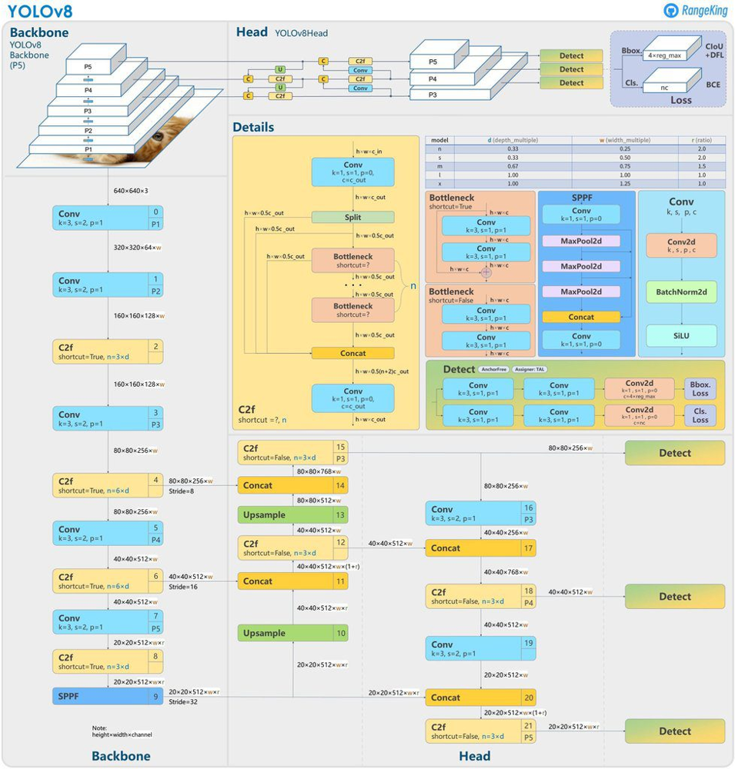
Figure: YOLOv8 object detection architecture (backbone extracts multi-scale features; head predicts bounding boxes and classes)[19][8].

System Architecture & Interfaces
We propose an integrated multithreaded pipeline (see mermaid flowchart below).
- Audio Pipeline: Continuously capture from microphone. Use an ASR engine (e.g. Whisper or SpeechRecognition) to convert speech to text. Process the text to detect commands (e.g. “identify bullet”). Then output text prompts (results or follow-up questions). Finally, send text to TTS (Coqui) and play on speakers.
- Vision Pipeline: Continuously capture frames from the camera via OpenCV. Optionally run the detector on each frame or on-demand. When triggered (by a voice command or button), pass the current frame to the bullet identification model. The model returns the bullet class. Send this result to the audio pipeline (for speech output).
Integration: These pipelines should communicate via thread-safe queues or async events. For example, one thread listens and performs STT; when a recognized command arrives (“what is this bullet?”), it puts a message on a queue. Another thread grabs that message and invokes the vision module. After classification, the result is queued back to the audio thread for TTS. IPC/REST: For a modular design, one could run the model as a REST API (Flask)[20] or use Python threads with shared queues (simpler for prototype). Data exchange can use JSON (e.g. {"command":"identify_bullet"} or {"bullet":"9mm_parabellum"}).
flowchart LR
subgraph Audio Pipeline
MIC[Microphone] --> ASR[Speech-to-Text (ASR)]
ASR --> CommandLogic{Parse Command}
CommandLogic -->|e.g. "identify"| TriggerVision
CommandLogic -->|other| ActionHandler
ActionHandler --> TTS[Text-to-Speech]
TTS --> Speaker[Speaker Output]
end
subgraph Vision Pipeline
CAM[Camera] --> FrameGrab[Frame Capture]
FrameGrab --> VisionModel[Bullet Detection/Classification]
VisionModel --> VisionResult[Bullet ID]
end
TriggerVision --> FrameGrab
VisionResult --> CommandLogic
Figure: System block diagram (Audio and Vision pipelines). The audio thread handles ASR and TTS; the vision thread processes camera frames when triggered. Threads communicate via events (arrows).
Each module’s interface: e.g. the ASR module takes raw audio and outputs text (string). The vision model takes an image (NumPy array) and outputs a label (string/class). These can be simple Python function calls. For packaging, one could expose HTTP endpoints (e.g. /recognize-speech, /detect-bullet) but internal calls are faster.

Implementation Plan (Milestones)
- Audio I/O & STT: Install and test microphone capture (PyAudio/sounddevice) and speech recognition. Use a demo code (e.g. SpeechRecognition’s sample) to transcribe spoken phrases. Verify in quiet and noisy environments. Time: ~1 week.
- TTS Engine: Install Coqui TTS, select a voice, and generate speech from text (e.g. “Hello world”). Test audio quality and latency. Time: ~2 days.
- Bullet Dataset Collection: Gather ~500+ images per bullet class under varied conditions. Use synthetic augmentation. Time: ~2–3 weeks (data collection & labeling).
- Vision Model Development: Choose architecture (e.g. YOLOv8-nano). Train or fine-tune on bullet dataset. Use transfer learning from a pretrained model. Evaluate accuracy. Time: ~3–4 weeks (iterative).
- Integration Prototype: Write main application: start audio thread (continuously listens), and camera thread (continuous or on-demand capture). Implement the command logic: when ASR output indicates identification request, freeze a frame and run model. Then feed result to TTS and speak it. Time: ~1–2 weeks.
- Optimization & Testing: Measure end-to-end latency. Optimize (e.g. reduce model size, use half-precision, enable GPU). Test accuracy with new data, refine models. Time: ~2 weeks.
A Minimal Viable Prototype (MVP) timeline (approx 10–12 weeks) might be: audio pipeline working (2 weeks), vision model trained (4 weeks), integration (2 weeks), testing/iteration (2–4 weeks). Resources: 1–2 developers; GPU for training/inference (e.g. RTX 30xx).

Code Structure (Outline & Snippets)
A clean codebase might include modules like: audio.py (handles STT/TTS), vision.py (runs camera and model), and main.py (coordinates threads). Example snippets:
Speech Recognition (STT) using SpeechRecognition:
import speech_recognition as sr
r = sr.Recognizer()
with sr.Microphone(sample_rate=16000) as source:
print("Say something:")
audio = r.listen(source, timeout=5) # capture audio
try:
text = r.recognize_google(audio) # or r.recognize_whisper()
print(f"Recognized: {text}")
except sr.UnknownValueError:
print("Could not understand audio")
Text-to-Speech (TTS) with Coqui:
from TTS.api import TTS
tts = TTS(model_name="tts_models/en/ljspeech/tacotron2-DDC") # example voice
tts.tts_to_file(text="This is a bullet.", speaker_wav=None, language="en", file_path="out.wav")
# Play the WAV file via PyAudio or OS
Vision Model (YOLOv8 via Ultralytics):
import torch
model = torch.hub.load('ultralytics/yolov8', 'yolov8n', pretrained=True) # nano model
# Process a frame (OpenCV BGR to RGB)
frame_rgb = frame[:,:,::-1]
results = model(frame_rgb) # run inference
df = results.pandas().xyxy[0] # Pandas DataFrame of detections
if not df.empty:
label = df['name'][0] # top prediction name
conf = df['confidence'][0] # confidence score
Threading and Queues (simplified):
import threading, queue
cmd_queue = queue.Queue()
res_queue = queue.Queue()
def audio_thread():
while True:
text = recognize_speech()
if "bullet" in text.lower():
cmd_queue.put("identify")
response = res_queue.get() # wait for result from vision
speak_text(response)
def vision_thread():
while True:
cmd = cmd_queue.get()
if cmd == "identify":
frame = capture_frame()
bullet_type = detect_bullet(frame)
res_queue.put(f"You have a {bullet_type}")
This high-level structure shows how modules interface (via shared queues). In practice, use proper synchronization and exception handling.

Testing and Evaluation
- Speech Recognition: Evaluate Word Error Rate (WER) on sample commands. Ensure high accuracy on expected phrases.
- Bullet Identification: Measure classification accuracy or detection mAP on a test set. Confusion matrices for bullet classes help identify errors.
- Latency: Record audio-command to audio-response time. E.g. measure ASR time + model inference + TTS time. Aim for <1.5 s total.
- Real-time Throughput: Ensure the vision loop runs sufficiently fast (e.g. ≥15 FPS) using a lightweight model. Measure frame processing time on target hardware.
- User Testing: Have users speak commands and hold bullets; check correctness and usability. Iterate on voice command vocabulary (e.g. “what is this?” triggers bullet ID).
Official metrics like precision/recall/F1 are standard. For detection models, use mAP (mean Average Precision) at IoU thresholds. As one study did, compute precision/recall on held-out images[21]. For TTS quality, a Mean Opinion Score (MOS) can be gathered subjectively.

Deployment Options
- Local (On-Premise): Run entirely on a PC or embedded device. This maximizes privacy (no data leaves device). Use a GPU-equipped machine for best performance. A Docker container can package dependencies for portability.
- Edge Devices: Deploy on hardware like NVIDIA Jetson (TX2, Xavier) with TensorRT-optimized model. Useful for mobile or standalone lab setups. Limited by memory—choose small models.
- Cloud/Server: Offload heavy inference to cloud (AWS, GCP) using services or VMs. Use TorchServe or TensorFlow Serving for scalable endpoints[14][15]. Send audio/video streams over network (raising latency and privacy concerns). Not ideal if low latency or offline use is required.
- Hybrid: Run ASR locally but vision inference in cloud, or vice versa. Provide fallback on spotty networks.

Security, Safety, and Ethics
- Privacy: Voice recordings are personal data in many jurisdictions. Under GDPR/CCPA, a person’s voice is treated as personal (and even biometric) data[22][23]. Therefore, one must secure audio data: encrypt it at rest, do not log it unnecessarily, and inform users. If storing or transmitting audio/text, ensure compliance (e.g. obtain consent). For camera, do not record bystanders; focus only on the object (bullet) to avoid privacy issues. The cited autonomous-driving study notes that “addressing privacy concerns through anonymization is crucial” when streaming camera data[20].
- Safety: Handling bullets can be dangerous. The system must be used only with inert dummy rounds or under strict safety protocols. The software should avoid any automated “fire” commands. Also, ensure network ports (if any) are secured and software dependencies are up-to-date to avoid exploits.
- Ethical Use: The tool could be used in law enforcement or military contexts. Be clear about its accuracy limits and intended use. Avoid false identification claims (calibrate confidence thresholds). Be aware of biases: if training data lacks certain bullet types, the model may mislabel them.
- Legal: Check any export controls or restrictions on cryptographic TTS or ASR libraries. Ensure bullet imagery is not copyrighted (likely public domain).

Assumptions
- The bullet classes of interest (e.g. 9mm, .45ACP, 5.56mm, etc.) will be defined by the developers.
- Operating environment is a lab or workshop (indoor lighting, no heavy rain/steam on camera).
- The system runs on Windows/Linux with Python 3.9+ (per library requirements[1][6][7]).
- No requirement for end-user authentication (any user can talk to the system).
- Real-time means under ~2 seconds round-trip for voice queries.

Minimal Viable Prototype (MVP) Plan
Key components: SpeechRecognition (ASR) + PyAudio; Coqui TTS; OpenCV video capture; YOLOv8-nano model.
Rough timeline:
- Week 1–2: Set up audio capture & ASR; test microphone quality (coarse).
- Week 3: Implement TTS module; link it to ASR (echo back transcribed text).
- Week 4–6: Collect bullet images and annotate; prepare dataset.
- Week 7–8: Train or fine-tune YOLOv8-nano on bullet data.
- Week 9: Integrate vision; when ASR outputs “identify,” run vision and get class.
- Week 10–11: Optimize (model size, threading), add error handling.
- Week 12: Test end-to-end with users, refine.
Resources: 1 full-stack AI engineer, GPU machine (e.g. desktop with RTX 30xx).

References
- SpeechRecognition (Python) – PyPI (v3.15.2)[1]; coqui-tts docs[2]; PyAudio & sounddevice docs[3][4].
- Faster-Whisper (GitHub)[12]; Coqui STT docs[13].
- OpenCV (v4.13) PyPI[5]; PyTorch (2.11) PyPI[6]; TensorFlow (2.21) PyPI[7].
- Ultralytics YOLOv8 documentation[8]; YOLOv8 architecture figure[19].
- Bullet detection research (improved YOLOX)[17].
- Bullet image datasets (Roboflow “Bullet” 3.36k images)[9].
- Hardware examples (camera 1080p60, CPU i7)[11]; GPU guide (RTX 4090)[16].
- Microphone placement guidelines[10].
- TorchServe (PyTorch) doc[14]; TensorFlow Serving[15].
- Privacy/ethics: voice as personal/biometric data[22][23]; privacy in vision pipeline[20].

[1] SpeechRecognition · PyPI
https://pypi.org/project/SpeechRecognition/
[2] coqui-tts 0.28.0.dev0 documentation
https://coqui-tts.readthedocs.io/en/latest/
[3] PyAudio · PyPI
https://pypi.org/project/PyAudio/
[4] sounddevice · PyPI
https://pypi.org/project/sounddevice/
[5] opencv-python · PyPI
https://pypi.org/project/opencv-python/
[6] torch · PyPI
https://pypi.org/project/torch/
[7] tensorflow · PyPI
https://pypi.org/project/tensorflow/
[8] Explore Ultralytics YOLOv8 - Ultralytics YOLO Docs
https://docs.ultralytics.com/models/yolov8/
[9] Top Bullet Datasets and Models | Roboflow Universe
https://universe.roboflow.com/search?q=class%3Abullet
[10] How to Choose the Right Microphone - Voice Recognition Rates Can Change with the Microphone! - AmiVoice Techblog
https://acp.amivoice.com/en/blog/2024-4-25/
[11] [18] [20] [21] Object Detection and Classification Framework for Analysis of Video Data Acquired from Indian Roads - PMC
https://pmc.ncbi.nlm.nih.gov/articles/PMC11479008/
[12] GitHub - SYSTRAN/faster-whisper: Faster Whisper transcription with CTranslate2 · GitHub
https://github.com/SYSTRAN/faster-whisper
[13] Home - Coqui STT 1.4.0 documentation
https://stt.readthedocs.io/en/latest/
[14] TorchServe — PyTorch/Serve master documentation
https://docs.pytorch.org/serve/
[15] Serving Models | TFX | TensorFlow
https://www.tensorflow.org/tfx/guide/serving
[16] 9 Best GPU for Deep Learning in 2026: Guide for Serious AI Training - Fluence
https://www.fluence.network/blog/best-gpu-for-deep-learning/
[17] Frontiers | A bullet recognition algorithm based on improved YOLOX
https://www.frontiersin.org/journals/physics/articles/10.3389/fphy.2023.1213489/full
[19] YOLOv8 Object Tracking and Counting
https://learnopencv.com/yolov8-object-tracking-and-counting-with-opencv/
[22] [23] Rise of Text-to-Speech AI Models Part 2: Data Protection Issues – Tech & Sourcing @ Morgan Lewis
https://www.morganlewis.com/blogs/sourcingatmorganlewis/2024/07/rise-of-text-to-speech-ai-models-part-2-data-protection-issues

