

**NINE SOFTECH LLP**

​​#504, Brick Meadows, Madhapur, Hyderabad – 500081

​admin@ninesoftech.com

**​​**​+91 6363617779 **​**

**Business Requirement Document**

**For**

**e-Market place**

**Introduction**

This application **e-Marketplace** platform is an advanced solution for Wholesale/Retail markets. This application helps vendors manage products, orders, and inventory efficiently and allows customers to place orders (small/bulk) seamlessly.

**Business Objectives**

* In this application we Equip vendors to manage products, orders, and inventory efficiently. This includes features for adding, editing, and removing products, as well as tracking orders and category inventories.
* Provide customers with a smooth and intuitive shopping experience, from browsing products to placing bulk orders and tracking deliveries on the custom/subdomain provided to the vendor.
* Rather than Supporting multiple payment gateways in this application we offer customers to pay the amount at the time of delivery(COD) also provides payment online if applicable.
* **Insights:** It enables vendors to make decisions based on real-time insights from the application and tools that track sales performance, customer Engagement, and inventory levels.
* **Marketing and Promotions:** Managing marketing campaigns and promotions with discounts, and special offers to boost customer sales through Email and SMS Notifications.
* This application allows businesses to manage multiple store locations from a single platform, with features to customize settings and track performance for each location.

**Scope**

* Developing a user-friendly and responsive web environment to handle the online sales of small scale merchants to wholesale operatives on their own custom sub-domains on our platform. Provide a range of themes and customizable layouts for landing pages, allowing vendors to create attractive and personalized online stores.
* Multi-Store Management Support centralized management of inventory, sales, and promotions for businesses with multiple locations.
* Order Scheduling: Allow customers to schedule orders with preferred delivery or pick-up dates.
* Payment Mode: Providing cash on delivery or online payments for bulk orders or regular orders based on the customer/Vendor requirement.
* Marketing Tools used to Develop features for creating and managing marketing campaigns, such as discounts, coupons, email, and SMS campaigns.

1. **Your Own Website (Vendor)**

Web app for your store: Our e-commerce platform allows vendors to build a

loyal customer base by providing a more personalized and convenient shopping

and bulk ordering Experience.

**Key benefits include:**

* **Online store :** Customers can easily browse and buy products directly from

the app on the custom url/subdomain provided to the vendor.

* **Enhanced User Engagement:** Push notifications can keep customers informed about new arrivals, promotions, and special offers.

**2. Customizable Landing Pages**

Customizable landing pages allow vendors to create attractive and unique

storefronts. Key features include:

* **Themes and Layouts:** Choose from various themes and customize the layout to reflect the brand’s identity.
* **Banners and Promotions:** Add banners to highlight special offers, new products, or seasonal promotions.
* **User Experience:** Improve user experience by tailoring the landing page to meet customer expectations.

**3.Multi-Store Support**

Multi-store support allows vendors with multiple locations to manage all their stores from a single platform. Key features include:

* **Centralized Management:** Oversee inventory, sales, and promotions across all locations.
* **Location-specific Settings:** Customize settings for each store, including pricing, inventory, and promotions.

**Reporting:** Generate reports for individual stores or the entire business.

**4.Order Scheduling**

Order scheduling gives customers the flexibility to plan their purchases.

Key benefits include:

* **Convenience:** Customers can place orders and choose a preferred delivery
* **Time Management:** Helps vendors manage their order fulfillment processes more efficiently.

**5. Pre-Loaded Catalog**

A pre-loaded catalog simplifies the setup process for vendors by providing:

* **Ready-to-useData:**Pre-populated product information, images, and descriptions.
* **Time-saving:** Reduces the time and effort needed to manually enter product data.
* **Consistency:** Ensures consistent and accurate product information across the platform.

**6. Delivery Integration (optional)**

Delivery integration stream lines the delivery process, making it easier for vendors to manage.

* **Settings Configuration:** Set delivery ranges, available delivery days, time slots, and delivery charges.
* **Order Management:** Manage and track delivery orders from a central hub.
* **Customer Communication:** Provide customers with real-time updates on their delivery status.

**7. Instant Reports**

Instant reports provide vendors with real-time data to make informed business

decisions.

Key features include:

* **Sales Analytics:** Track sales performance over different periods (daily, monthly, all-time).
* **Product Performance:** Identify best-selling products and under performers.

**8. Marketing Tools**

Marketing tools help vendors attract and retain customers through various promotional strategies.

* **Deals and Promotions:** Create and manage discounts, coupon codes, and special offers.
* **Campaigns:** Run email and SMS marketing campaigns to reach a broader audience.
* **Analytics:** Measure the effectiveness of marketing campaigns and adjust strategies accordingly.

**9. Manage Promotions**

This feature, though similarly named, focuses on managing customer

engagement through promotions within the mobile app:

* **App-specific Deals:** Offer exclusive deals to app users to encourage app downloads and purchases.
* **Push Notifications:** Alert customers about ongoing promotions, flash sales, or special events directly on their mobile devices.

**10. WhatsApp Chat Support**

Integrating WhatsApp chat support enhances customer service by providing:

* **Instant Communication:** Resolve customer queries quickly through a familiar and widely used messaging platform.
* **Personalized Support:** Offer personalized assistance to enhance customer satisfaction.
* **24/7 Availability:** Automate responses for common queries to provide round-the-clock support.

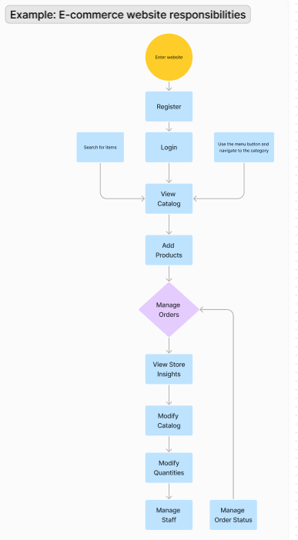

**Functionalities of Website:-**

In this Application we have two types of plans mainly to users they are

1. Free Plan
2. Enterprise Plan

**Free Plan**

The Free Plan is ideal for businesses that are exploring and testing mobile ordering apps and eCommerce systems. It provides essential features to get started with online sales and mobile ordering. Here’s a detailed explanation of the features included in the Free Plan:

**Website**

A fully functional eCommerce website where vendors can list their products, and customers can browse and purchase items.

**Store Admin App (Web and Mobile)**

A web and mobile application for store administrators to manage their store, including adding products, managing orders, and viewing sales data.

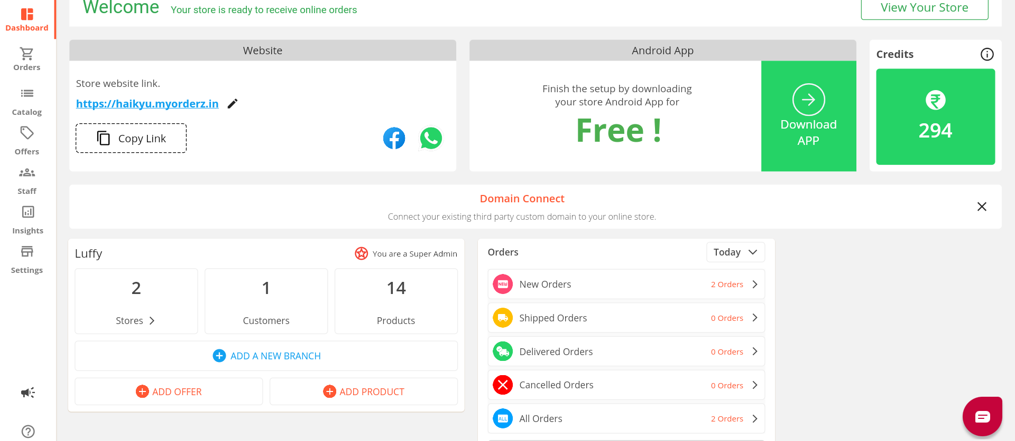

**Themes and Customisation for Website and Mobile App**

Options to customize the appearance of the website and mobile app to match the brand's identity, including themes, colors, and layouts.

**Link Existing/Custom Domain**

Ability to link an existing domain name or a custom domain to the eCommerce website for a professional web address.

**Order Management & Delivery Features**

Tools to manage customer orders, including tracking, processing, and updating order statuses, as well as handling delivery logistics.

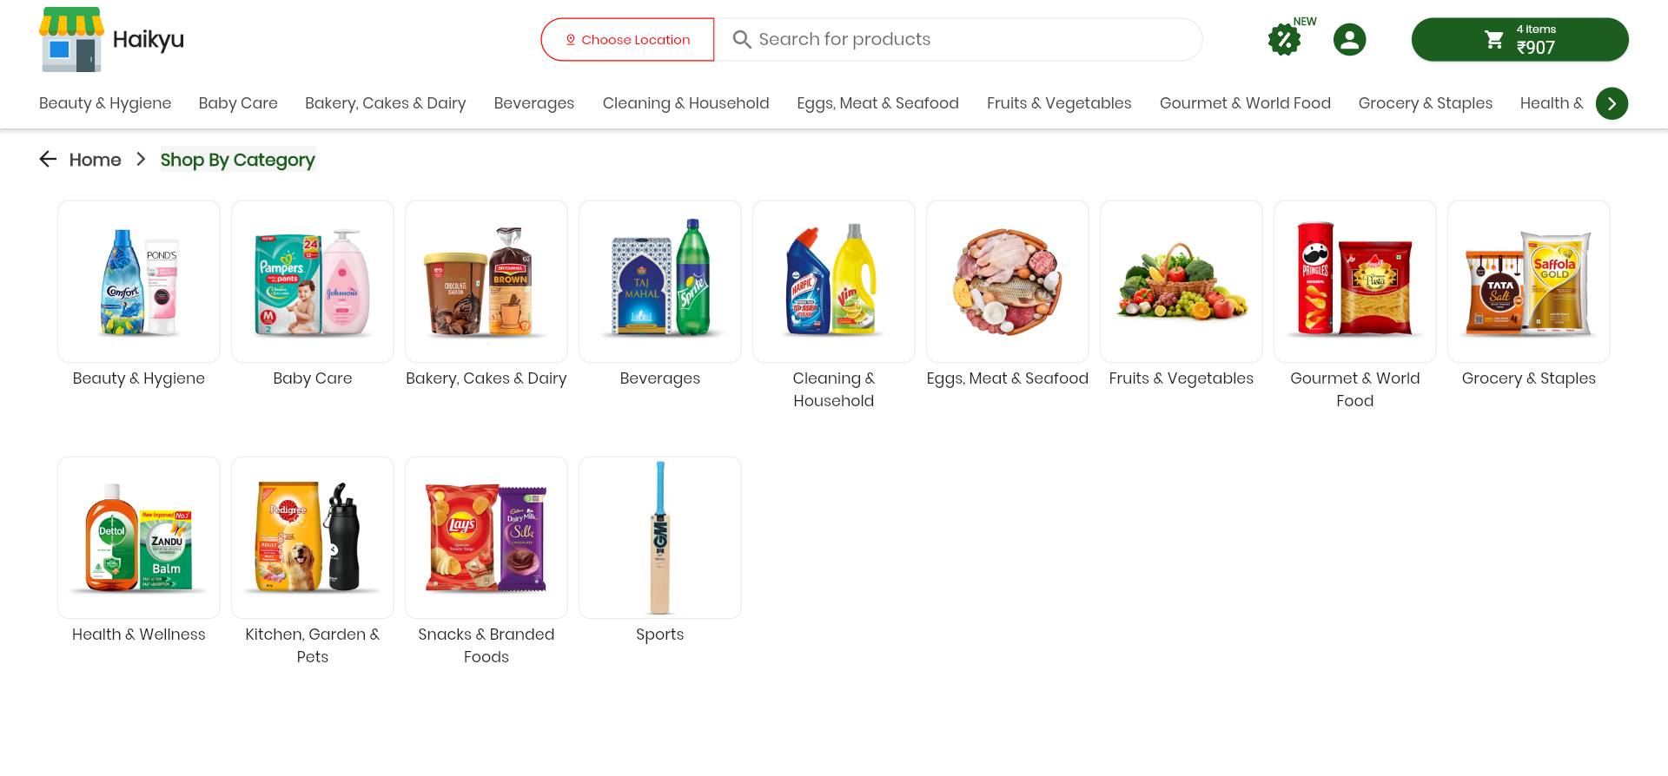

**Readymade Catalog**

A pre-loaded catalog of products that vendors can use to quickly populate their store without manual data entry.

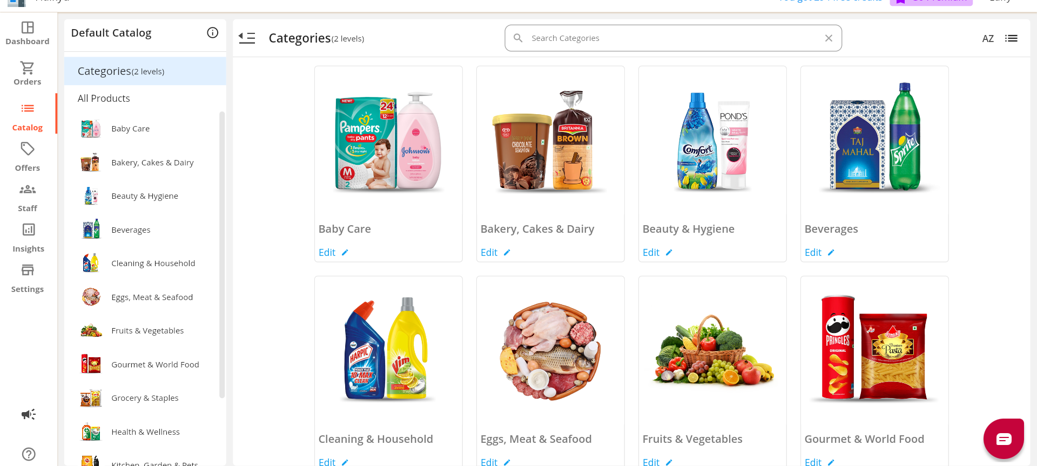

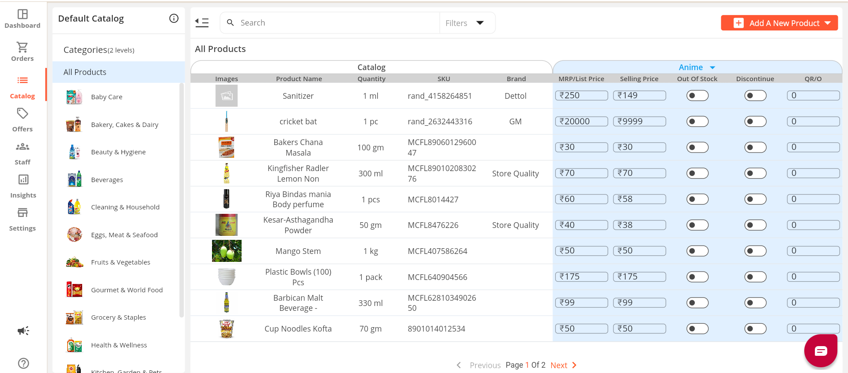

**Bulk Update Products with Excel**

Feature to upload and update product information in bulk using Excel spreadsheets, saving time and reducing manual effort.

**Marketing and Offer Creation**

Tools to create and manage marketing campaigns, discounts, and special offers to attract and retain customers.

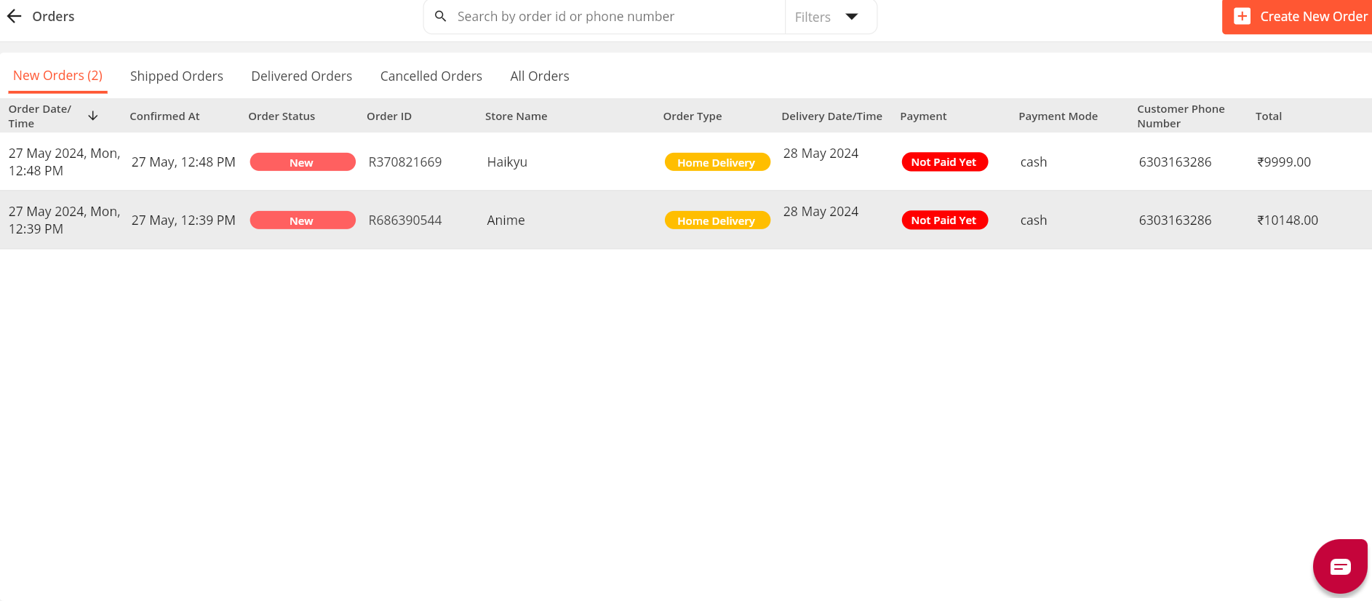

**Analytics**

Basic analytics tools to track website and app performance, including sales data, customer behavior, and product popularity.

**Example for free trial**

**Vendor login**

**https://haikyu.myorderz.in/**

**Enterprise Plan**

The Enterprise Plan offers advanced features suitable for established businesses looking to expand their reach and improve operational efficiency. Here’s a detailed explanation of the features included in the Enterprise Plan:

**Dedicated Onboarding Support**

Personalized support to help businesses set up and configure their online store, mobile app, and other features, ensuring a smooth onboarding process.

**Delivery Service Integration - (optional)**

Integration with popular delivery services like Dunzo, Shadowfax, and Porter to streamline the logistics and delivery process, ensuring fast and reliable delivery options for customers.

**POS Integration**

Integration with Point of Sale (POS) systems to synchronize online and offline sales, manage inventory, and track cash flow seamlessly.

**Online Payments (If Applicable)**

Integration with a popular payment gateway, to enable secure and efficient online payment processing for customers.

**Google Analytics​ Integration**

Integration with Google Analytics to provide comprehensive insights into website and app performance, user behavior, and marketing effectiveness.

**Visit Website:**

Go to E-Commerce Website

In the homepage click on the Register to begin the registration process.

Complete the profile details to create the store

**Login:**

Based on the registration details login to the website

**Home Page**

After Redirecting to the home page

We will be having 6 different sections

They are:

* Orders
* Catalog
* Offers
* Staff
* Insights
* Settings

**Selecting the items from catalog**

View products according to category

Switch between the stores to check their Inventory product accordingly

**Offers**

Product promotion

Incentives on Purchase

**Vendor Inventories:**

**Adding a product:**

* Product Name
* Brand
* Images
* Quantity
* Unit
* MRP price
* Selling Price
* Product category
* Description About product

**Staff**

**Choose one from below roles**

* Branch Staff
* HQ Staff
* Inventory Manager
* Catalog Manager
* Delivery Executive
* Orders ManagerStaff Name
* Staff Mob.No

**Order**

* Order Id
* Order Type
* Pay type -> payment status->paid date->payment made & balance pay
* Product Id
* Quantity
* Order Date
* Delivery Date

**Customer Inventories:**

**Shop by category**

* Beauty And Hygiene
* Baby Care
* Bakes And Diary
* Beverages
* Cleaning And Household
* Meat And Seafood
* Fruits And Vegetables
* Groceries
* Health And Wellness
* KItchen And Pets
* Snacks And Foods
* Sports

**Product Fields**

* Product Name
* Brand
* Images
* Quantity
* Unit
* MRP price
* Selling Price
* Product category
* Offers
* Description About product

**Delivery Inventories**

* Apply coupon
* Order Id
* Order Type
* Pay type -> payment status->payment mode & balance pay
* Product Id
* Quantity
* Order Date
* Delivery Date

In this application it is mandatory to complete the registration process in order to login into the application.

Here are some details about registration page :

**User Interface (UI)**

**Registration Forms**

* Vendor Registration Form: It collects vendor-specific information such as business name, email, password, business address, and phone number.

**Fields in registration form:**

* FirstName (Required)
* LastName (Required)
* Mobile Number (Optional)
* Email ( Required)
* Password (Required)
* Confirm Password (Required)
* Address (Optional

**Login and Authentication Pages**

* Login Page: Allows existing users to log in using their email or mobile number and password.
* Forgot Password Page: Provides functionality for users to reset their password by entering their registered email.

**Fields in login form:**

* *Registration Id-(email/Mobile Number)
* *Password

**Fields In forget Password:**

Fields should be filled with an e-mail/mobile number which is used at the time of registration and login.

* E-mail/Mobile Number:
* OTP

**Verification and Confirmation Pages**

* Email Verification Page: Displays a message prompting the user to check their email for a verification link.
* Account Confirmation Page: Confirms that the user’s email has been successfully verified.

**Functional Requirements**

**User Registration and Authentication:**

Users (vendors and customers) must be able to register and log in.

Password recovery and reset functionality must be available.

**Vendor Management:**

Vendors must be able to create and manage their store profiles.

Vendors should be able to add, edit, and delete products.

Vendors should be able to customize their store’s appearance (themes, layouts).

**Product Management:**

Vendors must be able to upload products individually or in bulk using Excel.

Vendors should have access to a pre-loaded catalog for quick product addition.

Product details must include descriptions, prices, images, and categories.

**Order Management:**

Customers must be able to place orders for multiple products.

Vendors must be able to manage orders, update order statuses, and process returns.

Order tracking functionality must be available for both vendors and customers.

**Payment Processing:**

Integration with multiple payment gateways (e.g., Razorpay) for secure transactions.

Support for various payment methods, including credit/debit cards and digital wallets.

**Marketing and Promotions:**

Vendors should be able to create and manage marketing campaigns, discounts, and promotions.

Integration with Google Analytics for advanced marketing insights (Enterprise Plan).

**Non-Functional Requirements**

**Performance**:

The platform must handle a large number of concurrent users without performance degradation.

Page load times should be minimal to ensure a smooth user experience.

**Scalability**:

The system must be scalable to accommodate an increasing number of vendors, products, and customers.

The architecture should support adding new features and integrations easily.

**Security**:

Secure user authentication and authorization mechanisms must be in place.

Data encryption must be used for sensitive information (e.g., payment details).

Compliance with industry standards (e.g., PCI DSS for payment processing).

**Reliability:**

The platform must have high availability with minimal downtime.

Regular backups must be performed to prevent data loss.

**Usability:**

The interface must be intuitive and user-friendly for both vendors and customers.

The mobile app should offer a seamless experience across different devices and screen sizes.

**Maintainability:**

The codebase must be well-documented to facilitate maintenance and future development.

**Architecture:**

In this Application we use  **MVP (Minimum Viable Product)** architecture focused on delivering the core functionalities of the application with minimal complexity, allowing for quick development and release. For the e-Market Place application, the MVP architecture should include the essential features necessary for vendors and customers to start using the platform effectively. Below is an outline of the MVP architecture for the e-Market Place application, followed by detailed explanations of each component.

**Benefits of Using MVP in the E-Commerce Application**

* **Separation of Concerns:** Clear separation between data handling (Model), UI (View), and business logic (Presenter) enhances maintainability.
* **Testability:** Each component can be independently tested. For instance, Presenters can be unit tested without relying on Android framework classes.
* **Flexibility:** Easier to update or replace components without affecting other parts of the application. For example, changing the data source in the Model layer won’t impact the View.
* **Reusability:** Common logic can be reused across different Views by sharing the same Presenter.

**Mobile and Web Applications:**

Browsing and Purchasing Customers can browse products, view detailed descriptions and images, and add items to their cart for bulk purchasing. The interface will be intuitive and easy to navigate.

Push Notifications Send push notifications to customers for updates on new arrivals, special offers, order status, and other important information.

**Sales Analytics:** Provide vendors with real-time sales data, including total sales, sales by product, and sales by category.

**Product Performance:** Track the performance of individual products, highlighting best-sellers and underperforming items.

**Customizable Reports:** Allow vendors to generate and customize reports based on various parameters such as date range, product category, and sales channel.

**Customizable Landing Pages:**

**Themes and Layouts:** Offer a variety of themes and customizable layouts for landing pages to help vendors create a unique brand identity.

Discounts and Coupons: Allow vendors to create and manage discounts, coupon codes, and special offers to attract and retain customers.

**App-Specific Deals:** Encourage app downloads and purchases by offering exclusive deals and promotions available only through the mobile app.

Promotional Notifications: Use push notifications to alert customers about ongoing promotions, flash sales, and special offers.

WhatsApp Chat Support:

**Instant Communication:** Offer customers the option to communicate instantly with vendors through WhatsApp for personalized support.

Automated Responses: Implement automated responses for frequently asked questions and 24/7 support availability.

**Inventory Management:** Automatically update inventory levels across all channels, reducing the risk of stockouts or overselling.

.

**Order Management:** Centralize the management and tracking of delivery orders, ensuring timely and accurate order fulfillment.

Multi-Store Support:

**Central Management:** Enable vendors to manage multiple store locations from a single platform, with centralized inventory, sales, and promotion management.

**Store-Specific Settings:** Allow vendors to customize settings for each store location, including pricing, inventory levels, and promotional offers.

**Detailed Reporting:** Provide reports that track performance at both the individual store level and across the entire business.

**Pre-Loaded Catalog:**

**Product Information:** Provide vendors with a pre-loaded catalog of product information, images, and descriptions to quickly set up their stores.

**Domain Linking:** Enable vendors to link existing or custom domains to their online stores.

**Dedicated Support:** Provide dedicated onboarding support to help vendors set up and optimize their stores.

**Advanced Analytics:** Integrate Google Analytics for comprehensive insights into website and app performance.

**User Roles and Permissions**

**Vendor:**

**Product Management:** Add, edit, and delete products.

**Sales Analytics:** Access detailed sales analytics and reports.

Store Administrator:

**Operations Management:** Oversee all store operations.

**Staff Management:** Manage staff and assign roles and permissions.

Customer Service: Handle customer service inquiries and support issues.

**Order Management**: Manage delivery orders and update their status.

Customer:

**Shopping:** Browse products, add items to the cart, and make purchases.

Order Scheduling: Schedule orders and choose preferred delivery or pick-up dates.

**Tracking:** Track the status of their orders and deliveries.

**Reporting and Analytics**

**Sales Reports:**

**Sales Data:** Provide detailed sales data on a daily, monthly, and all-time basis.

**Customer Behavior:**

Engagement Tracking: Track customer engagement, including browsing history, purchase patterns, and interaction with promotions.