Capstone Project-5: Multi-Agent Research Analyst
Agent: LLM in a loop. LLM with Hands. LLM + Tool + System Prompt. Given a goal. It can reason & plan. Uses Tools observe results and loop until the given goal is achieved.
Tools: Tools is a function or method which takes defined inputs/arguments and returns a result or performs an action. Tools Acts as a hand which perform some actions (get data, extract data, hitting API requests) in external apps or systems.
Graph: Connected Nodes with edges.
Nodes: A node is a unit of work in an agent graph. Programmatically, it is typically a function that receives the current graph state, performs an operation such as calling an LLM, tool, API, database, or Python logic, and returns updates to the state.

My New Perspectives from building this project.
- Think about usage costs per each execution.
- Latency how fast can agent give response < 10ms.
- Security for agent’s guardrail the input prompts and response.
- Evaluation of the agent for all agent trajectory.
Project Report:
Objective: To move from a single-loop AI Agent to an Agentic AI system by orchestrating multiple specialized sub-agents using LangGraph, demonstrating parallel execution, shared state management, and self-correcting feedback loops.
Tech Stack: Python, LangGraph, Groq (Llama 3.3 70B), Tavily (Web Search), Streamlit (Frontend Deployment).
1. System Architecture:
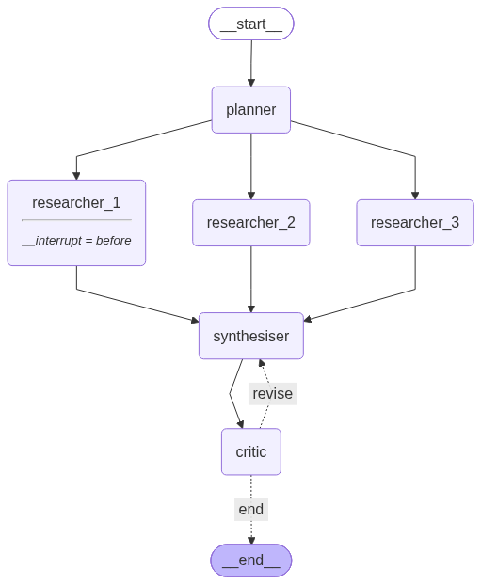

2. Multi-Agent Pattern Mapping
The system explicitly realizes the three foundational Agentic AI patterns taught in the course:
Course Pattern | Implementation in Code | How it was realized
Planner–Executor | planner_node → Researchers | The Planner LLM decomposes the complex question into 3–5 discrete sub-tasks. It does not execute the research; it only creates the execution plan for the workers.
Orchestrator–Workers | graph.py Fan-out/Fan-in | The graph draws 3 edges from the Planner to researcher_1,2,3. LangGraph executes these in parallel threads. They safely merge their findings using the orchestrator's reducer on the findings state key before feeding into the Synthesizer.
Evaluator–Optimizer | critic_node → synthesizer_node | A conditional edge routes the Critic's output. If the draft is APPROVED, it goes to END. If NEEDS_REVISION, it loops back to the Synthesizer. An iteration cap (MAX_ITERATIONS = 3) prevents infinite loops.

3. Evaluation & Baseline Comparison
To prove the value of orchestration, the system was benchmarked against a Part-1 "Single-Agent Baseline" (a single ReAct loop with web search). An LLM-as-Judge scored both outputs 1-5 on Coverage, Faithfulness, Citation Quality, and Coherence.
LLM-as-Judge Results:
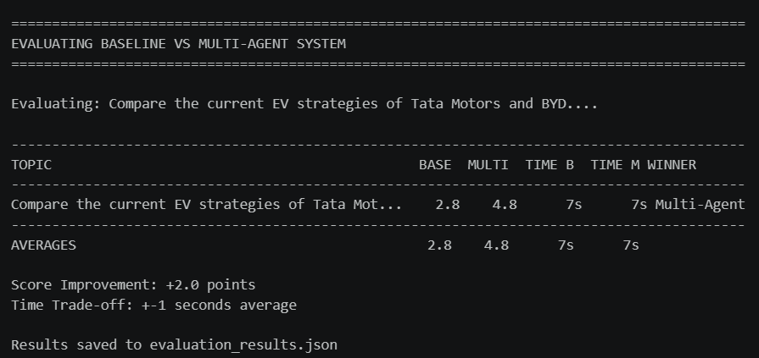

[
{
"topic": "Compare the current EV strategies of Tata Mot...",
"baseline_score": 2.75,
"multiagent_score": 4.75,
"baseline_time": 7.37,
"multiagent_time": 6.61,
"winner": "Multi-Agent"
}
]

Cost & Latency Trade-off
Agentic AI trades higher cost and latency for higher reliability. While the single-agent baseline is fast and cheap, it frequently produces shallow answers or hallucinates citations. The multi-agent system consumes significantly more Groq tokens (due to multiple planner/researcher/critic calls) and takes longer, but yields structured, multi-perspective briefs with verified citations.

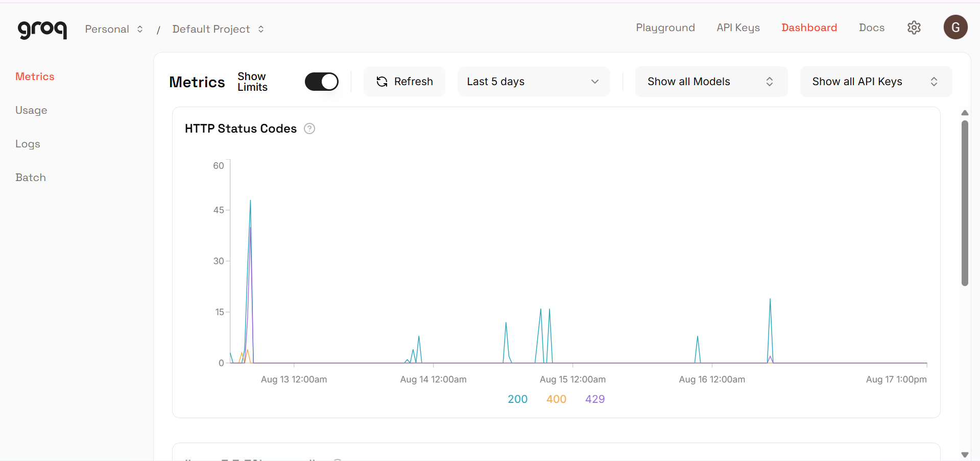

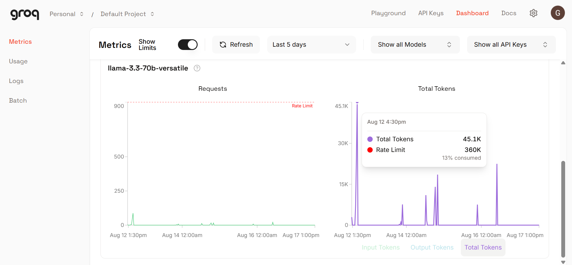

Note: The multi-agent system also experienced rate-limiting (HTTP 429) on the Groq free tier during parallel researcher execution, highlighting the infrastructural requirements of Agentic systems.

