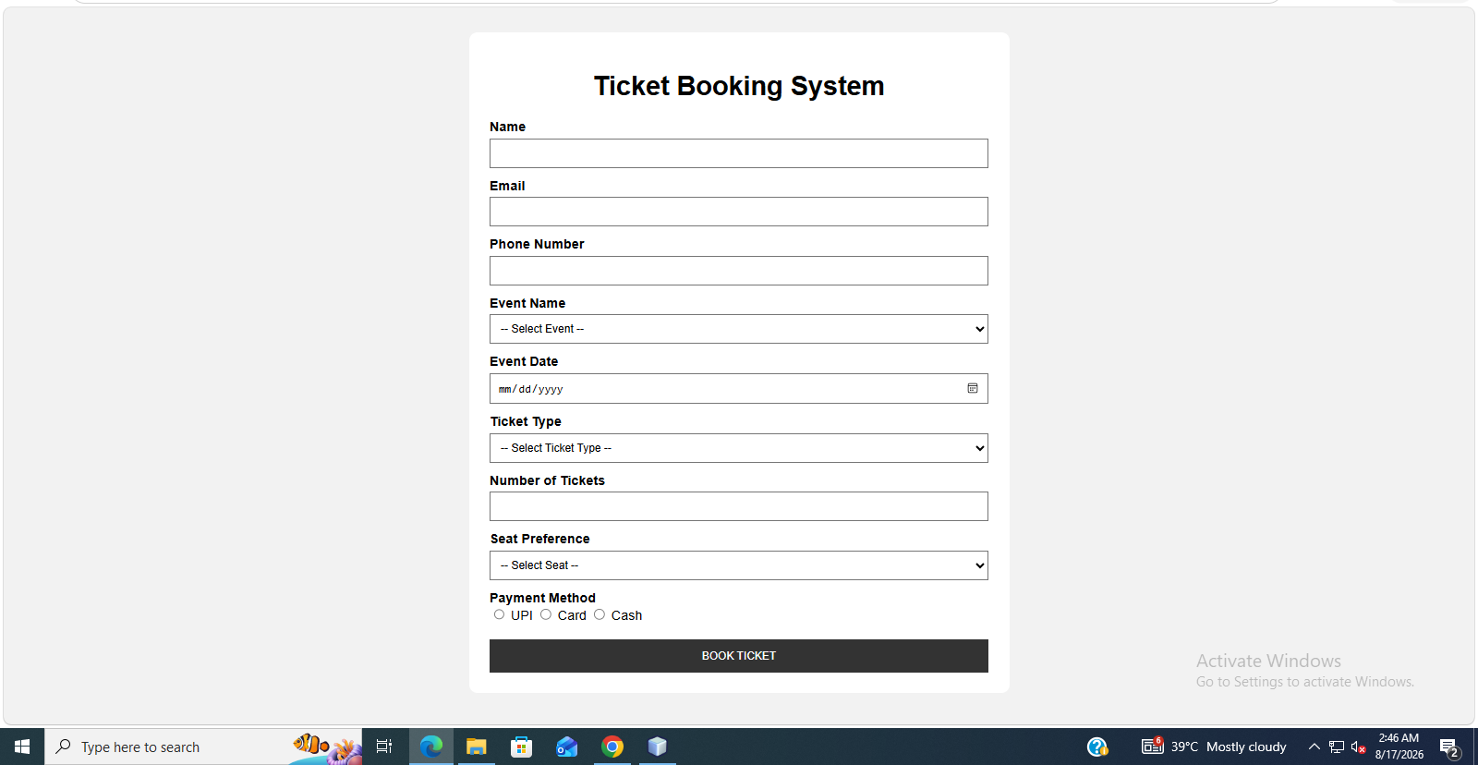
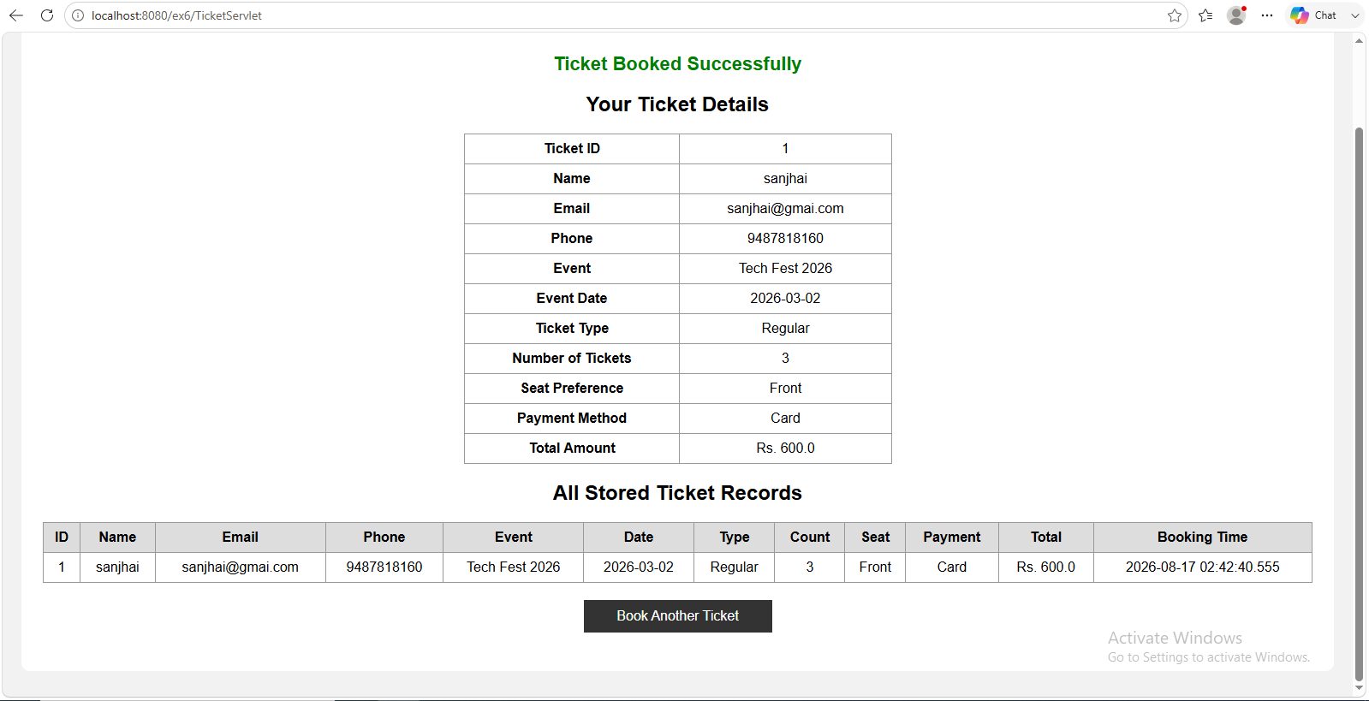

DATABASE :

CREATE TABLE TICKETS (
TICKET_ID INT GENERATED ALWAYS AS IDENTITY
(START WITH 1, INCREMENT BY 1)
PRIMARY KEY,
USERNAME VARCHAR(100),
EMAIL VARCHAR(100),
PHONE VARCHAR(20),
EVENT_NAME VARCHAR(100),
EVENT_DATE DATE,
TICKET_TYPE VARCHAR(30),
NUM_TICKETS INT,
SEAT_PREFERENCE VARCHAR(30),
PAYMENT_METHOD VARCHAR(30),
TOTAL_AMOUNT DOUBLE,
BOOKING_TIME TIMESTAMP
);

Index.html

<!DOCTYPE html>
<html>
<head>
<title>Ticket Booking System</title>
<meta charset="UTF-8">
<meta name="viewport" content="width=device-width, initial-scale=1.0">
<style>
body {
font-family: Arial, sans-serif;
background-color: #f2f2f2;
}
.container {
width: 600px;
margin: 30px auto;
background: white;
padding: 25px;
border-radius: 10px;
}
h1 {
text-align: center;
}
label {
display: block;
margin-top: 12px;
font-weight: bold;
}
input, select {
width: 100%;
padding: 9px;
margin-top: 5px;
box-sizing: border-box;
}
.radio {
width: auto;
}
.button {
margin-top: 20px;
width: 100%;
padding: 12px;
background-color: #333;
color: white;
border: none;
cursor: pointer;
}
.button:hover {
background-color: #555;
}
</style>
</head>
<body>
<div class="container">
<h1>Ticket Booking System</h1>
<form action="TicketServlet" method="post">
<label>Name</label>
<input type="text" name="userName" required>
<label>Email</label>
<input type="email" name="email" required>
<label>Phone Number</label>
<input type="tel" name="phone"
pattern="[0-9]{10}"
required>
<label>Event Name</label>
<select name="eventName" required>
<option value="">-- Select Event --</option>
<option value="Tech Fest 2026">Tech Fest 2026</option>
<option value="Music Fest 2026">Music Fest 2026</option>
<option value="Cultural Fest 2026">Cultural Fest 2026</option>
<option value="Sports Meet 2026">Sports Meet 2026</option>
</select>
<label>Event Date</label>
<input type="date" name="eventDate" required>
<label>Ticket Type</label>
<select name="ticketType" required>
<option value="">-- Select Ticket Type --</option>
<option value="Regular">Regular - ₹200</option>
<option value="Student">Student - ₹250</option>
<option value="VIP">VIP - ₹500</option>
</select>
<label>Number of Tickets</label>
<input type="number"
name="numTickets"
min="1"
max="10"
required>
<label>Seat Preference</label>
<select name="seatPreference" required>
<option value="">-- Select Seat --</option>
<option value="Front">Front</option>
<option value="Middle">Middle</option>
<option value="Back">Back</option>
</select>
<label>Payment Method</label>
<input class="radio"
type="radio"
name="paymentMethod"
value="UPI"
required> UPI
<input class="radio"
type="radio"
name="paymentMethod"
value="Card"> Card
<input class="radio"
type="radio"
name="paymentMethod"
value="Cash"> Cash
<button class="button" type="submit">
BOOK TICKET
</button>
</form>
</div>
</body>
</html>

TicketServlet.java

import java.io.IOException;
import java.io.PrintWriter;
import java.sql.Connection;
import java.sql.Date;
import java.sql.DriverManager;
import java.sql.PreparedStatement;
import java.sql.ResultSet;
import java.sql.Timestamp;
import javax.servlet.ServletException;
import javax.servlet.annotation.WebServlet;
import javax.servlet.http.HttpServlet;
import javax.servlet.http.HttpServletRequest;
import javax.servlet.http.HttpServletResponse;
@WebServlet("/TicketServlet")
public class TicketServlet extends HttpServlet {

private static final String DB_URL =
"jdbc:derby://localhost:1527/TicketDB";
private static final String DB_USER = "app";
private static final String DB_PASSWORD = "app";
@Override
protected void doPost(HttpServletRequest request,
HttpServletResponse response)
throws ServletException, IOException {
response.setContentType("text/html;charset=UTF-8");
PrintWriter out = response.getWriter();
try {
String userName = request.getParameter("userName");
String email = request.getParameter("email");
String phone = request.getParameter("phone");
String eventName = request.getParameter("eventName");
Date eventDate =
Date.valueOf(request.getParameter("eventDate"));
String ticketType =
request.getParameter("ticketType");
int numTickets =
Integer.parseInt(request.getParameter("numTickets"));
String seatPreference =
request.getParameter("seatPreference");
String paymentMethod =
request.getParameter("paymentMethod");
double ticketPrice;
switch (ticketType) {
case "Regular":
ticketPrice = 200;
break;
case "Student":
ticketPrice = 250;
break;
case "VIP":
ticketPrice = 500;
break;
default:
ticketPrice = 0;
break;
}
double totalAmount =
ticketPrice * numTickets;
Class.forName(
"org.apache.derby.jdbc.ClientDriver"
);
Connection con =
DriverManager.getConnection(
DB_URL,
DB_USER,
DB_PASSWORD
);
String insertSQL =
"INSERT INTO TICKETS "
+ "(USERNAME, EMAIL, PHONE, EVENT_NAME, "
+ "EVENT_DATE, TICKET_TYPE, NUM_TICKETS, "
+ "SEAT_PREFERENCE, PAYMENT_METHOD, "
+ "TOTAL_AMOUNT, BOOKING_TIME) "
+ "VALUES (?, ?, ?, ?, ?, ?, ?, ?, ?, ?, ?)";
PreparedStatement ps =
con.prepareStatement(
insertSQL,
java.sql.Statement.RETURN_GENERATED_KEYS
);
ps.setString(1, userName);
ps.setString(2, email);
ps.setString(3, phone);
ps.setString(4, eventName);
ps.setDate(5, eventDate);
ps.setString(6, ticketType);
ps.setInt(7, numTickets);
ps.setString(8, seatPreference);
ps.setString(9, paymentMethod);
ps.setDouble(10, totalAmount);
Timestamp bookingTime =
new Timestamp(System.currentTimeMillis());
ps.setTimestamp(11, bookingTime);
ps.executeUpdate();
int ticketId = 0;
ResultSet generatedKeys =
ps.getGeneratedKeys();
if (generatedKeys.next()) {
ticketId =
generatedKeys.getInt(1);
}
generatedKeys.close();
ps.close();
out.println("<!DOCTYPE html>");
out.println("<html>");
out.println("<head>");
out.println("<meta charset='UTF-8'>");
out.println("<title>Ticket Booking System</title>");
out.println("<style>");
out.println(
"body{" +
"font-family:Arial,sans-serif;" +
"background-color:#f2f2f2;" +
"}"
);
out.println(
".container{" +
"width:95%;" +
"margin:30px auto;" +
"background:white;" +
"padding:25px;" +
"border-radius:10px;" +
"}"
);
out.println(
"h1,h2{" +
"text-align:center;" +
"}"
);
out.println(
".success{" +
"text-align:center;" +
"font-size:22px;" +
"color:green;" +
"font-weight:bold;" +
"}"
);
out.println(
".details{" +
"width:500px;" +
"margin:20px auto;" +
"border-collapse:collapse;" +
"}"
);
out.println(
".details td{" +
"border:1px solid #999;" +
"padding:8px;" +
"text-align:center;" +
"}"
);
out.println(
"table{" +
"width:100%;" +
"border-collapse:collapse;" +
"margin-top:20px;" +
"}"
);
out.println(
"th,td{" +
"border:1px solid #999;" +
"padding:8px;" +
"text-align:center;" +
"}"
);
out.println(
"th{" +
"background:#ddd;" +
"}"
);
out.println(
".button{" +
"display:block;" +
"width:200px;" +
"margin:20px auto;" +
"padding:10px;" +
"text-align:center;" +
"background:#333;" +
"color:white;" +
"text-decoration:none;" +
"}"
);
out.println(
".button:hover{" +
"background:#555;" +
"}"
);
out.println("</style>");
out.println("</head>");
out.println("<body>");
out.println("<div class='container'>");
out.println(
"<div class='success'>" +
"Ticket Booked Successfully" +
"</div>"
);
out.println(
"<h2>Your Ticket Details</h2>"
);
out.println(
"<table class='details'>"
);
out.println(
"<tr>" +
"<td><b>Ticket ID</b></td>" +
"<td>" + ticketId + "</td>" +
"</tr>"
);
out.println(
"<tr>" +
"<td><b>Name</b></td>" +
"<td>" + userName + "</td>" +
"</tr>"
);
out.println(
"<tr>" +
"<td><b>Email</b></td>" +
"<td>" + email + "</td>" +
"</tr>"
);
out.println(
"<tr>" +
"<td><b>Phone</b></td>" +
"<td>" + phone + "</td>" +
"</tr>"
);
out.println(
"<tr>" +
"<td><b>Event</b></td>" +
"<td>" + eventName + "</td>" +
"</tr>"
);
out.println(
"<tr>" +
"<td><b>Event Date</b></td>" +
"<td>" + eventDate + "</td>" +
"</tr>"
);
out.println(
"<tr>" +
"<td><b>Ticket Type</b></td>" +
"<td>" + ticketType + "</td>" +
"</tr>"
);
out.println(
"<tr>" +
"<td><b>Number of Tickets</b></td>" +
"<td>" + numTickets + "</td>" +
"</tr>"
);
out.println(
"<tr>" +
"<td><b>Seat Preference</b></td>" +
"<td>" + seatPreference + "</td>" +
"</tr>"
);
out.println(
"<tr>" +
"<td><b>Payment Method</b></td>" +
"<td>" + paymentMethod + "</td>" +
"</tr>"
);
out.println(
"<tr>" +
"<td><b>Total Amount</b></td>" +
"<td>Rs. " +
totalAmount +
"</td>" +
"</tr>"
);

out.println("</table>");
out.println(
"<h2>All Stored Ticket Records</h2>"
);
out.println("<table>");
out.println(
"<tr>" +
"<th>ID</th>" +
"<th>Name</th>" +
"<th>Email</th>" +
"<th>Phone</th>" +
"<th>Event</th>" +
"<th>Date</th>" +
"<th>Type</th>" +
"<th>Count</th>" +
"<th>Seat</th>" +
"<th>Payment</th>" +
"<th>Total</th>" +
"<th>Booking Time</th>" +
"</tr>"
);
String selectSQL =
"SELECT * FROM TICKETS " +
"ORDER BY TICKET_ID DESC";
PreparedStatement selectPS =
con.prepareStatement(selectSQL);
ResultSet rs =
selectPS.executeQuery();
while (rs.next()) {
int id =
rs.getInt("TICKET_ID");
String name =
rs.getString("USERNAME");
String dbEmail =
rs.getString("EMAIL");
String dbPhone =
rs.getString("PHONE");
String dbEvent =
rs.getString("EVENT_NAME");
Date dbDate =
rs.getDate("EVENT_DATE");
String dbType =
rs.getString("TICKET_TYPE");
int count =
rs.getInt("NUM_TICKETS");
String dbSeat =
rs.getString("SEAT_PREFERENCE");
String dbPayment =
rs.getString("PAYMENT_METHOD");
double dbTotal =
rs.getDouble("TOTAL_AMOUNT");
Timestamp dbBookingTime =
rs.getTimestamp("BOOKING_TIME");
out.println("<tr>");
out.println(
"<td>" + id + "</td>"
);
out.println(
"<td>" + name + "</td>"
);
out.println(
"<td>" + dbEmail + "</td>"
);
out.println(
"<td>" + dbPhone + "</td>"
);
out.println(
"<td>" + dbEvent + "</td>"
);
out.println(
"<td>" + dbDate + "</td>"
);
out.println(
"<td>" + dbType + "</td>"
);
out.println(
"<td>" + count + "</td>"
);
out.println(
"<td>" + dbSeat + "</td>"
);
out.println(
"<td>" + dbPayment + "</td>"
);
out.println(
"<td>Rs. " + dbTotal + "</td>"
);
out.println(
"<td>" + dbBookingTime + "</td>"
);
out.println("</tr>");
}
rs.close();
selectPS.close();
con.close();
out.println(
"</table>"
);
out.println(
"<a class='button' " +
"href='index.html'>" +
"Book Another Ticket" +
"</a>"
);
out.println("</div>");
out.println("</body>");
out.println("</html>");
} catch (Exception e) {
out.println(
"<h2>Error Occurred</h2>"
);
out.println(
"<pre>"
);
e.printStackTrace(out);
out.println(
"</pre>"
);
}
}
}

GITHUB: https://github.com/Govardhanan-1108

