EX:7a | CREATE DASHBOARD USING TABLEAU

Aim:
To develop an interactive Heart Disease Analytics Dashboard using Tableau by analyzing heart disease patient data through KPI cards, charts, tables, and interactive filters, in order to understand patient demographics, heart disease prevalence, age-group distribution, gender-wise analysis, risk factors, and overall disease patterns for effective data-driven healthcare insights.

Algorithm:
- Open Tableau Desktop.
- Connect the Heart Disease Dataset.
- Create KPI cards for:
- Total Patients
- Heart Disease Cases
- Heart Disease Percentage
- Average Age
- Create a Column Chart for Heart Disease by Age Group.
- Create a Donut Chart for Heart Disease by Gender.
- Create a Bar Chart for Heart Disease by Chest Pain Type.
- Create a Scatter Plot for Cholesterol vs Maximum Heart Rate.
- Create a Table showing patient details and disease status.
- Add filters for Age Group, Gender, and Heart Disease Status.
- Create a new Dashboard and add all visualizations.
- Arrange KPI cards at the top and charts below.
- Test the filters and verify interactive analysis.

Output:

Diagram 1: Total Followers KPI

Procedure
- Create a new worksheet in Tableau.
- Select the Patient ID field (or any unique patient identifier) from the Data pane.
- Drag Patient ID to the Text option in the Marks card.
- Change the aggregation to COUNT to calculate the total number of patients.
- Format the displayed number to make it clearly visible.
- Rename the worksheet as Total Patients.

Output
The Total Followers KPI displays:
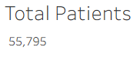

Diagram 2: Heart Disease Cases KPI Procedure
- Create a new worksheet.
- Select the Target field from the Data pane.
- Drag Target to the Text option in the Marks card.
- Tableau calculates the SUM(Target), representing the total number of heart disease cases.
- Format the number for better visibility.
- Rename the worksheet as Heart Disease Cases.

Output
The KPI displays the total aggregated engagement rate:

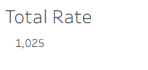
Diagram 3:
Heart Disease by Age Group Procedure

- Create a new worksheet.
- Drag Age Group to the Columns shelf.
- Drag Target to the Rows shelf.
- Ensure the aggregation is SUM(Target).
- Select Bar Chart from Show Me if required.
- Tableau generates a chart showing heart disease cases across different age groups.
- Format the chart and provide a suitable title.
- Rename the worksheet as Heart Disease Cases by Age Group.

Output
A bar chart is generated showing the distribution of heart disease cases among different age groups.

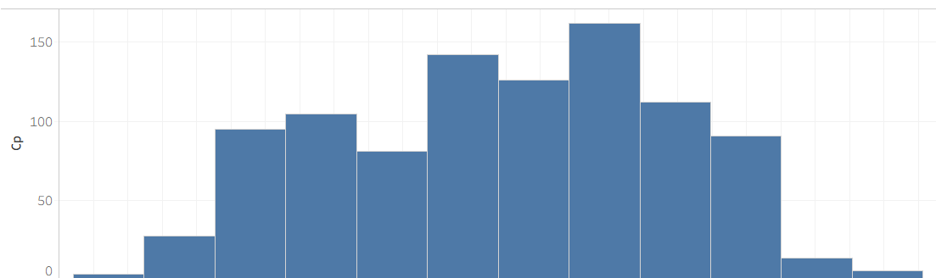
Diagram 4: Heart Disease by Chest Pain Type
Procedure
- Create a new worksheet.
- Drag Chest Pain Type (cp) to the Columns shelf.
- Drag Heart Disease Cases (SUM(Target)) to the Rows shelf.
- Select the Bar/Column Chart from Show Me.
- Tableau generates a separate bar for each chest pain type.
- Add the title heart disease by Chest Pain Type.
- Format the chart for easy comparison.

Output:
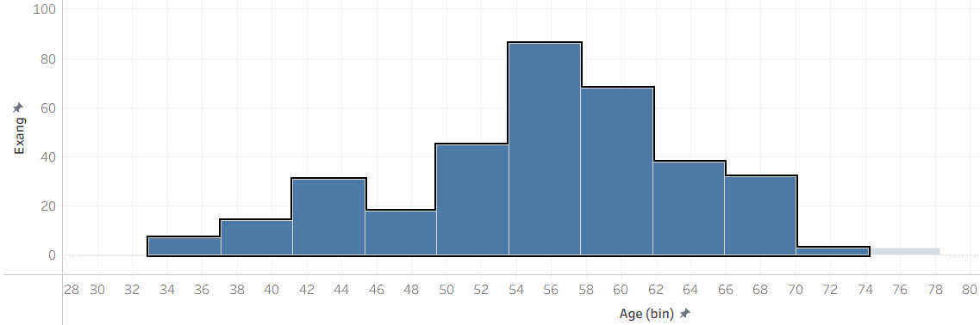

Diagram 5: Heart Disease by Gender Procedure
- Create a new worksheet.
- Select Pie Chart from Show Me.
- Drag Gender (Sex) to Color in the Marks card.
- Drag Heart Disease Cases (SUM(Target)) to Angle.
- Tableau divides the pie into sections according to gender.
- Add the title heart disease by Gender.
- Format the visualization appropriately.

Output:

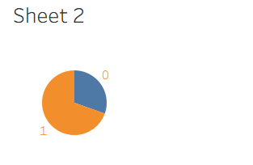

Diagram 6: Age Group Filter
Procedure
- Add Age Group to the Filters shelf.
- Select All Age Groups.
- Click OK.
- Select Show Filter.
- The age groups are displayed as an interactive filter.
- Select any age group to analyse that group separately.

Output:

Procedure
- Select Dashboard → New Dashboard.
- Tableau displays the available worksheets on the left side.
- Drag the required worksheets onto the dashboard.
- Add the following visualizations:
○ Total Patients
○ Heart Disease Cases
○ Heart Disease Cases by Age Group
○ Heart Disease by Gender
○ Heart Disease by Chest Pain Type
○ Top Patients Table
- Arrange the KPI cards at the top.
- Place the charts below the KPI cards.
- Place the patient details table at the bottom.
- Add Age Group, Gender, and Heart Disease Status filters.
- Add the title:
- HEART DISEASE ANALYTICS DASHBOARD
- Resize and align the visualizations.
- Test the filters by selecting different age groups, genders, and disease statuses.
- Verify that the dashboard updates according to the selected filters.

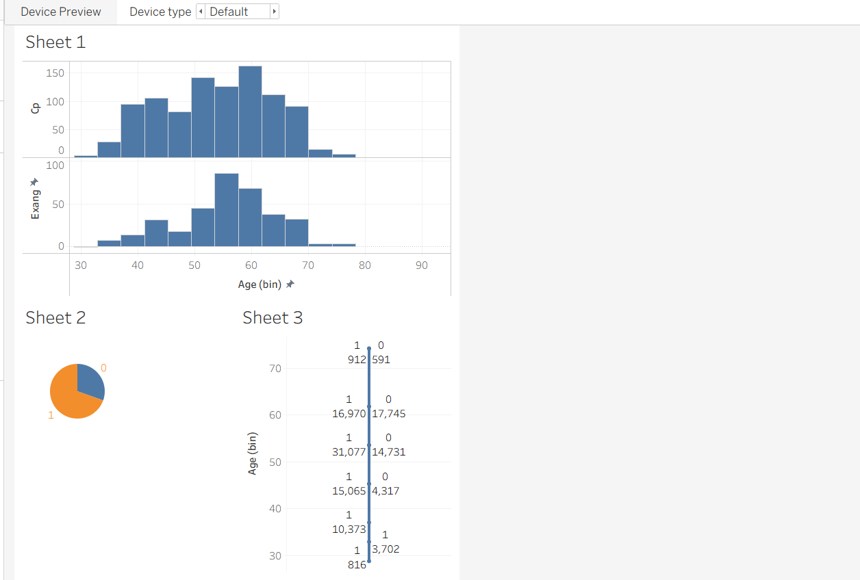

RESULT:
Thus, the Heart Disease Analytics Dashboard was successfully created using Tableau. The dashboard provides an interactive analysis of heart disease data through KPI cards, charts, tables, and filters, helping users understand disease prevalence, patient demographics, and key health indicators.

