EX:1a | SETTING UP PYTHON ENVIRONMENT AND LIBRARIES – JUPYTER NOTEBOOK

Aim:
To install Python, configure Jupyter Notebook, understand the notebook environment, execute Python programs, create Markdown cells, and use basic Jupyter Notebook features for Data Analytics applications.

Algorithm:
- Start the program.
- Import the required libraries (if needed).
- Declare and initialize the required variables or data.
- Perform the required operations or processing.
- Display the output/results.
- Stop the program.

Code:
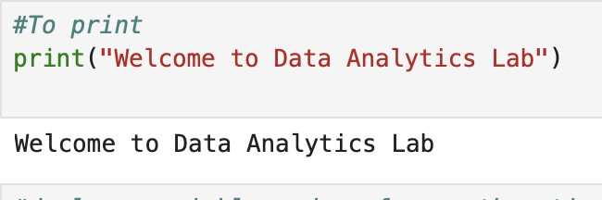

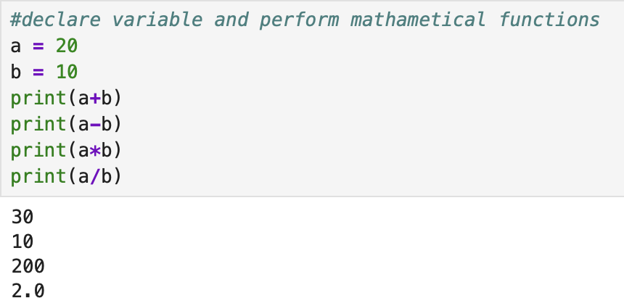
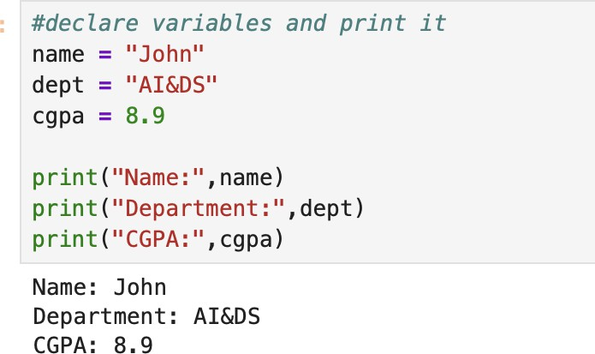

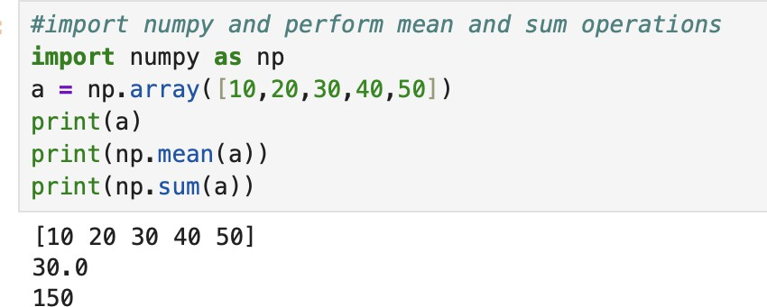

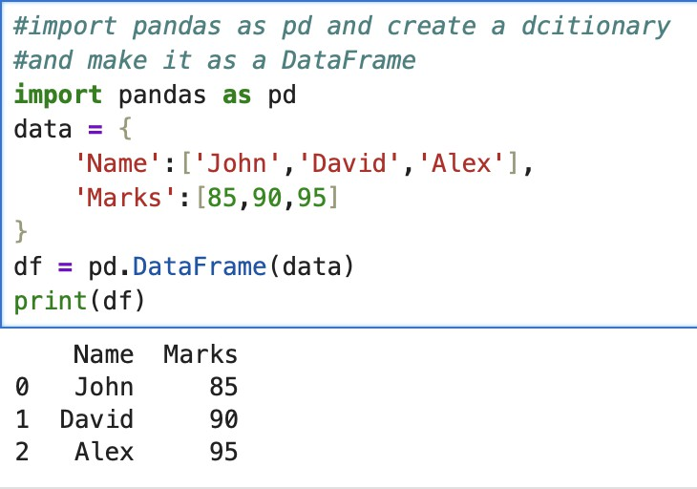

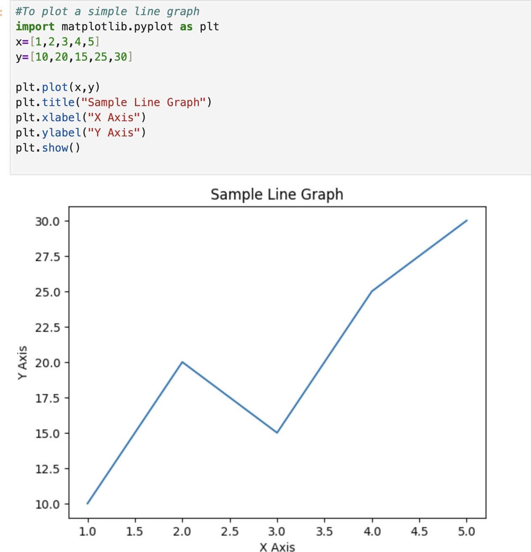

Result:

Thus, Exploratory Data Analysis and data cleaning were performed successfully on the shark attack dataset. Missing values and duplicate records were identified and handled, relevant data types were processed, and important features such as Age, Year, Country, Type, Activity, and Fatal (Y/N) were analyzed for further data analysis.

