EX:2 | EDA-DATA IMPORT AND EXPORT

Aim:
To inspect the features of heart disease dataset, detect null values, and export the data into CSV, Excel, and SQLite database formats.

Algorithm:
- Start the program.
- Import the required libraries (if needed).
- Declare and initialize the required variables or data.
- Perform the required operations or processing.
- Display the output/results.
- Stop the program.

Code:

import pandas as pd
from sklearn.preprocessing import StandardScaler

# Load dataset
df = pd.read_csv("heart.csv")

# Display dataset
print(df)

# Top 2 rows
print("\nTop 2 Rows:")
print(df.head(2))

# Bottom 2 rows
print("\nBottom 2 Rows:")
print(df.tail(2))

# Shape
print("\nShape:")
print(df.shape)

# Info
print("\nInfo:")
df.info()

# Description
print("\nDescription:")
print(df.describe())

# Column names
print("\nColumns:")
print(df.columns)

# Data types
print("\nData Types:")
print(df.dtypes)

# First 5 rows
print("\nFirst 5 Rows:")
print(df.head())

# Missing values
print("\nMissing Values:")
print(df.isnull().sum())

# Fill missing values in cp column (if any)
if "cp" in df.columns:
df["cp"] = df["cp"].fillna(df["cp"].mean())

# Duplicate rows
print("\nDuplicate Rows:", df.duplicated().sum())

# Remove duplicates
df = df.drop_duplicates()

# Summary statistics
print("\nSummary Statistics:")
print(df.describe())

# Outlier detection using IQR
Q1 = df.quantile(0.25, numeric_only=True)
Q3 = df.quantile(0.75, numeric_only=True)
IQR = Q3 - Q1

outliers = ((df[Q1.index] < (Q1 - 1.5 * IQR)) |
(df[Q1.index] > (Q3 + 1.5 * IQR)))

print("\nOutliers Count:")
print(outliers.sum())

# Feature scaling
numerical_columns = ["age", "trestbps", "chol", "thalach", "oldpeak"]

scaler = StandardScaler()
df[numerical_columns] = scaler.fit_transform(df[numerical_columns])

print("\nScaled Data:")
print(df[numerical_columns].head())

# Target distribution
print("\nTarget Distribution:")
print(df["target"].value_counts())

Output:
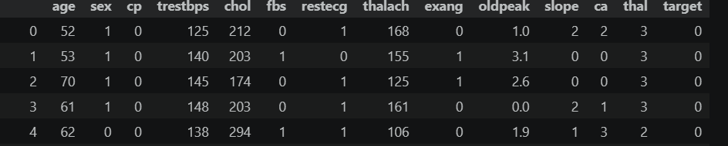
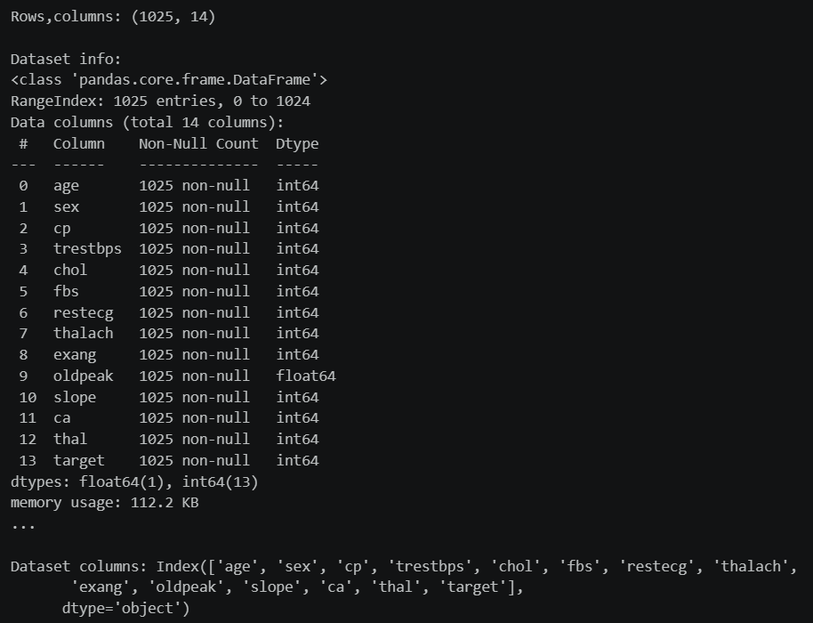
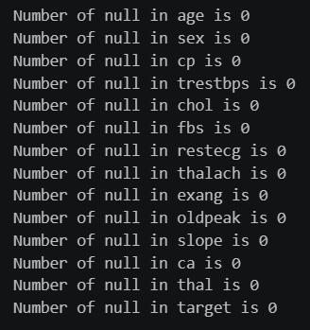
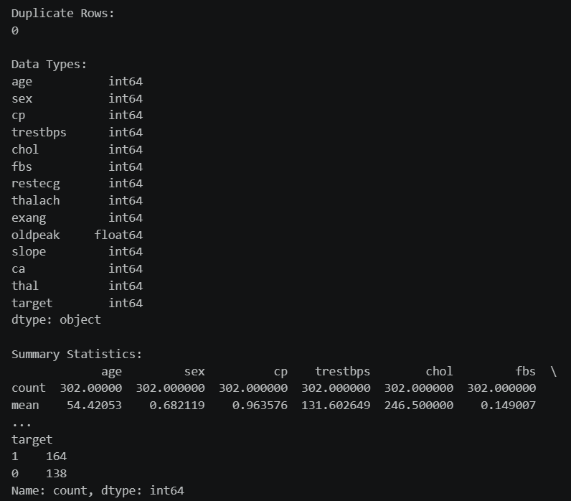

Result:
Thus, the inspection of features of the customer shopping behavior dataset, detect null values, and export the data into CS V, Excel, and SQLite database formats is done successfully.

