EX:3 | DATA CLEANING

Aim:
To perform data cleaning using the Pandas library by identifying and handling missing values, duplicate records, and inconsistent data. To prepare a clean and reliable dataset for accurate data analysis and machine learning tasks

Algorithm:
- Import the Pandas library.
- Load the dataset into a Pandas Data Frame.
- Inspect the dataset for missing values, duplicate records, and incorrect data types.
- Handle missing values by removing or filling them with appropriate values.
- Remove duplicate records from the dataset.
- Correct inconsistent or invalid data entries and convert data types if required.
- Verify the cleaned dataset and save it for further analysis.

Code:

import pandas as pd
import numpy as np

# Create DataFrame
df = pd.DataFrame({
"Name": ["Alice", "Bob", "Alice", "David", "Nyang", "Frank"],
"Age": [25.0, np.nan, 25.0, 17.0, 30.9, 999.0],
"Salary": [50000.0, 60000.0, 50000.0, 45000.0, np.nan, 70000.0],
"Place": ["Chennai", "Delhi", "Chennai", np.nan, "Mumbai", "Delhi"],
"Joined": ["2021", "2026", "2021", "2019", "2022", "2023"]
})

print("Original DataFrame:")
print(df)

# Drop rows with any null values
print("\nDrop rows with any null values:")
print(df.dropna())

# Drop rows where all values are null
print("\nDrop rows where all values are null:")
print(df.dropna(how="all"))

# Keep rows with at least 4 non-null values
print("\nRows with at least 4 non-null values:")
print(df.dropna(thresh=4))

# Drop rows where Name or Salary is null
print("\nDrop rows with null in Name or Salary:")
print(df.dropna(subset=["Name", "Salary"]))

# Check duplicates
print("\nDuplicate rows:")
print(df.duplicated())

print("\nNumber of duplicate rows:")
print(df.duplicated().sum())

# Display duplicate rows
print("\nAll duplicate rows:")
print(df[df.duplicated(keep=False)])

# Remove duplicates
df_clean = df.drop_duplicates()

print("\nDataFrame after removing duplicates:")
print(df_clean)

print("\nShape after removing duplicates:")
print(df_clean.shape)

# Remove duplicates based on Name and Age
df.drop_duplicates(
subset=["Name", "Age"],
keep="last",
inplace=True
)

print("\nAfter removing duplicates based on Name and Age:")
print(df)

# Data types
print("\nData Types:")
print(df.dtypes)

# Fill missing Age values and convert to int
df["Age"] = df["Age"].fillna(0).astype(int)

print("\nAge column after filling nulls:")
print(df["Age"])

print("\nData Types:")
print(df.dtypes)

# Convert Joined to datetime
df["Joined"] = pd.to_datetime(df["Joined"], format="%Y")

print("\nJoined column:")
print(df["Joined"])

print("\nJoined Data Type:")
print(df["Joined"].dtype)

# Convert Age to numeric
df["Age"] = pd.to_numeric(df["Age"], errors="coerce")

print("\nAge column after numeric conversion:")
print(df["Age"])

print("\nData Types:")
print(df.dtypes)

# Rename Name column
df.rename(
columns={
"Name": "Full_Name"
},
inplace=True
)

print("\nAfter renaming Name:")
print(df)

# Rename remaining columns
df.rename(
columns={
"Age": "Years",
"Salary": "Income",
"Place": "City",
"Joined": "Joining_Date"
},
inplace=True
)

print("\nAfter renaming all columns:")
print(df)

# Remove leading/trailing spaces from City
df["City"] = df["City"].str.strip()

print("\nCity values:")
print(df["City"].tolist())

Output:
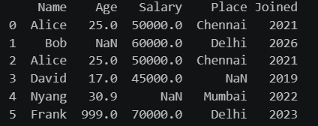
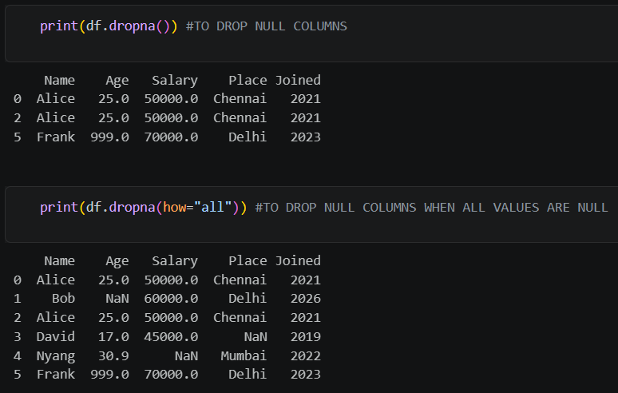
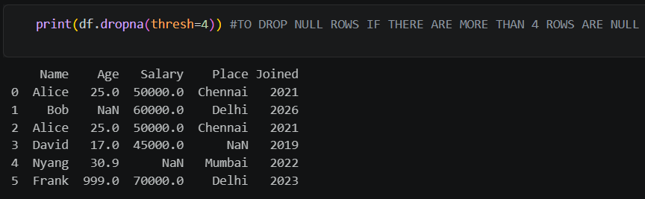
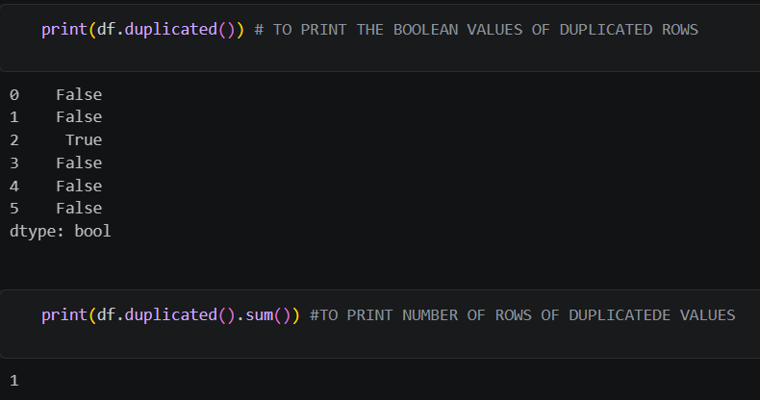
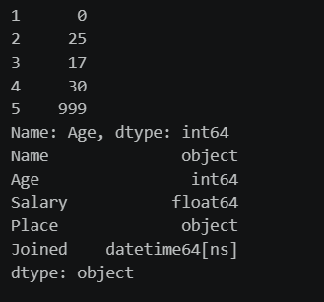
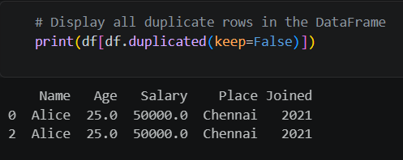
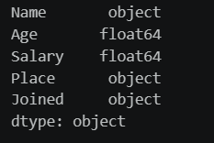
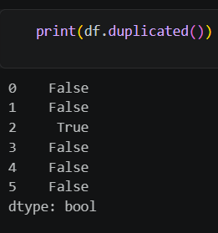
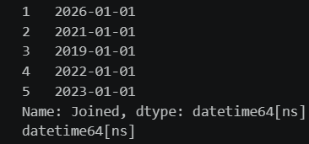
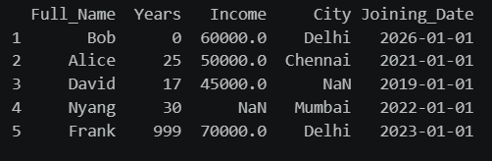

Result:
Thus, the heart disease dataset was successfully cleaned by identifying missing values and applying multiple data-cleaning techniques. The cleaned data is suitable for further analysis.

