EX:6a | DATA VISUALIZATION USING POWER BI

Aim:
To load the heart disease dataset into Power BI, transform the data, and visualize patient health indicators to gain insights into heart disease prediction.

Algorithm:

Step 1: Input Data Loading
- Read the dataset from heart.xlsx.
- Dataset contains the following attributes:
  - age
  - sex
  - cp (chest pain type)
  - trestbps (resting blood pressure)
  - chol (cholesterol)
  - fbs (fasting blood sugar)
  - restecg
  - thalach (maximum heart rate)
  - exang
  - oldpeak
  - slope
  - ca
  - thal
  - target (heart disease: 1 = Yes, 0 = No)
Step 2: Data Cleaning and Transformation
- Check for missing values.
- Verify data types of all attributes.
- Remove duplicate records if present.
- Create calculated columns if required.
Step 3: KPI Calculation
- Calculate Total Patients.
- Calculate Patients with Heart Disease (target = 1).
- Calculate Patients without Heart Disease (target = 0).
- Compute Heart Disease Percentage.
Step 4: Age Group Analysis
- Group patients by age ranges:
  - 30–40
  - 41–50
  - 51–60
  - 61–70
  - Above 70
- Count patients in each age group.
- Display using a bar chart.
Step 5: Gender-wise Analysis
- Group data by sex.
- Calculate:
  - Male Patients
  - Female Patients
  - Heart Disease cases by gender
- Display using a pie/donut chart.
Step 6: Cholesterol and Blood Pressure Analysis
- Calculate average cholesterol level.
- Calculate average resting blood pressure.
- Compare values between patients with and without heart disease.
- Display using clustered column charts.
Step 7: Dashboard Render
- Display KPI Cards:
  - Total Patients
  - Heart Disease Patients
  - Healthy Patients
  - Disease Percentage
- Display:
  - Age Group Bar Chart
  - Gender Distribution Donut Chart
  - Cholesterol Analysis Chart
  - Blood Pressure Analysis Chart
- Add slicers for:
  - Age
  - Gender
  - Heart Disease Status
Step 8: Interactive Filtering
- When a slicer selection changes:
  - Filter the dataset.
  - Recalculate all KPIs and visualizations.
Update dashboard dynamically.

Output:
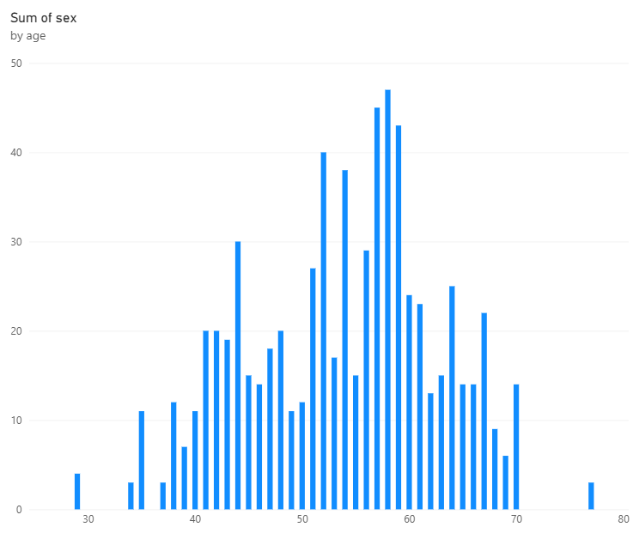

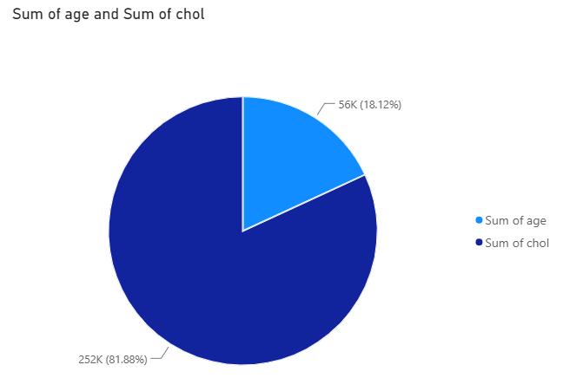

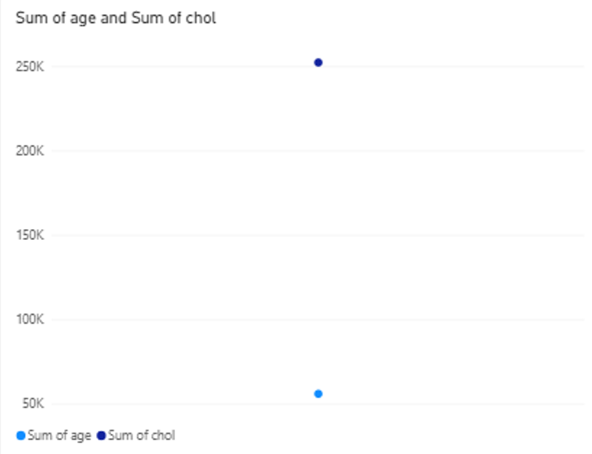

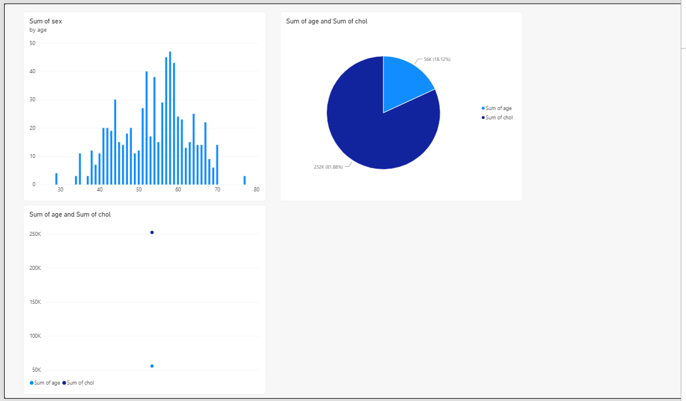

Result:

Thus, the data was successfully loaded, transformed, and visualized using Power BI. The dashboard with KPI cards, bar charts, donut charts, and slicers was created successfully to analyze the data and obtain useful insights.

