EX:6a | DATA VISUALIZATION USING POWER BI  (ADVANCED SALES ANALYTICS)

Aim:
To Load the data (Retail_sales) into Power BI and transform the data and visualize it to get insights

Algorithm:

- Input Data Loading
- Open Power BI Desktop.
- Import the Retail Sales dataset using Get Data → Excel/CSV.
- Load and verify the imported data.
- Open Power Query Editor using Transform Data.
- Clean the dataset by removing duplicates and handling missing values.
- Rename columns and format data where necessary.
- Parse and standardize the Order Date column.
- Handle invalid or negative quantity values.
- Apply changes and load the cleaned dataset.
- Create a new calculated column Revenue using Quantity, Unit Price, and Discount.
- Build visualizations:
  - Line Chart for Revenue by Date
  - Bar/Column Chart for Revenue or Quantity by Region
  - Donut Chart for Product-wise Quantity Distribution
- Add slicers for Region and Date filtering.
- Arrange visuals to create an interactive dashboard.
- Save the Power BI report (.pbix).
- Analyse the dashboard to derive sales insights and trends.

Output:
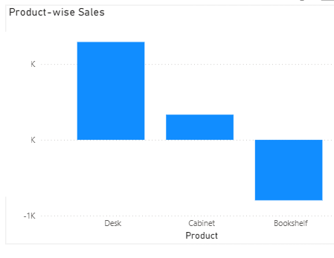
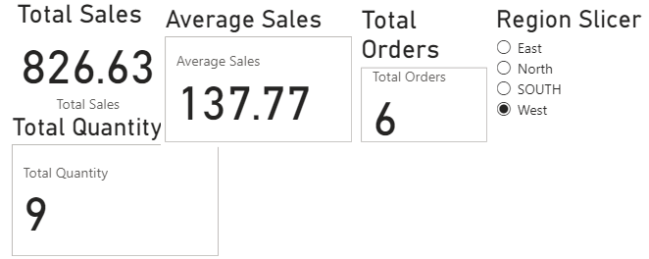
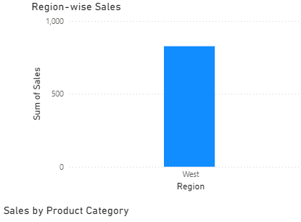
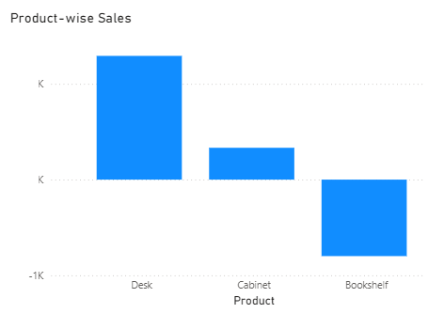
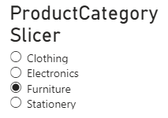
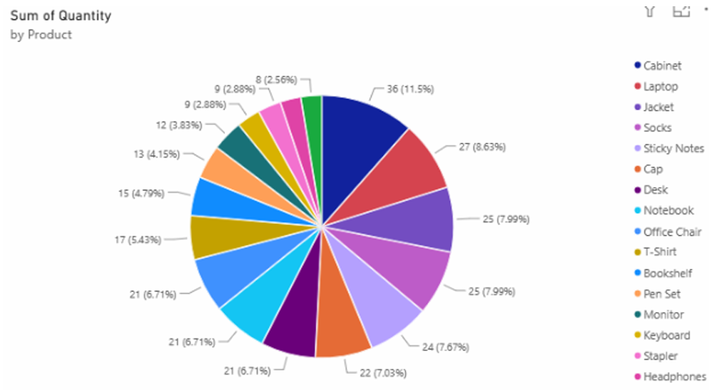
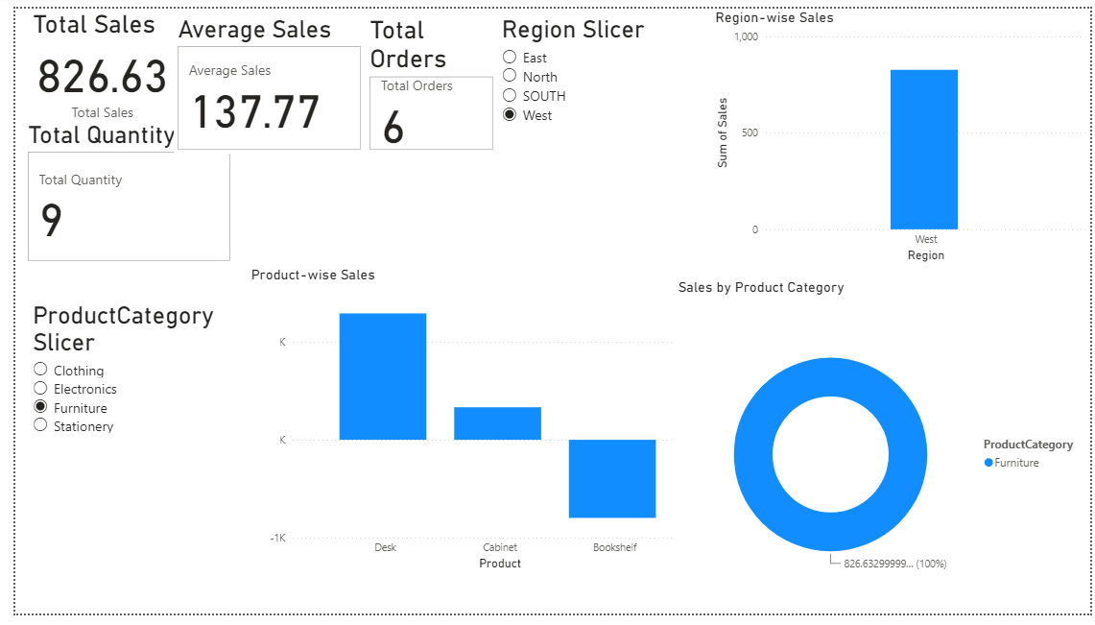

Result:

Thus, the dataset was successfully imported, cleaned, transformed, and visualized using Power BI. Advanced data transformations, calculated columns, charts, and interactive slicers were created successfully to analyze the dataset and obtain meaningful insights.

