EX:6c | CREATE A DABSHBOARD IN POWER BI

Aim:
To develop an interactive Heart Disease Dashboard using Microsoft Power BI

Algorithm:
- Open Microsoft Power BI Desktop.
- Import the heart.xlsx dataset into Power BI.
- Examine the available fields such as age, sex, cp, trestbps, chol, fbs, restecg, thalach, exang, oldpeak, slope, ca, thal, and target.
- Select suitable visualizations based on the analysis requirements.
- Create a KPI Card to display the Total Patients.
- Create another KPI Card to display the Heart Disease Cases (target = 1).
- Create a Donut Chart to analyze the distribution of patients with and without heart disease using target.
- Create a Column Chart to compare heart disease cases across different age groups.
- Create a Bar Chart to analyze heart disease occurrence by gender (sex).
- Create a Scatter Chart to study the relationship between cholesterol (chol) and maximum heart rate (thalach).
- Create a Line Chart to analyze average cholesterol levels across age groups.
- Create a Table displaying age, sex, cholesterol, maximum heart rate, and target.
- Create a Slicer for sex.
- Create another Slicer for target (Heart Disease Status).
- Arrange and format all visualizations on a single dashboard.
- Test the slicers and verify that the visualizations respond interactively.
- Analyze the completed dashboard and derive meaningful insights regarding heart disease risk factors

Output:

Diagram 1: KPI Card – Age
Procedure:
Open the Power BI report.
- Select the Card visual from the Visualizations pane.
- Drag the age field from the Data pane.
- Drop it into the Value field of the Card.
- Power BI automatically performs the aggregation, such as Sum of age.
- Rename the card title as Total Followers.
- Format the card for better visibility.

Output:
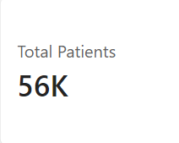

Diagram 2: KPI Card – Age
Procedure
- Select a new Card visual.
- Locate the age field in the Data pane.
- Drag age into the Value field.
- Verify that Power BI calculates the required aggregation.
- Rename the card as age.
- Format the card appropriately.

Output
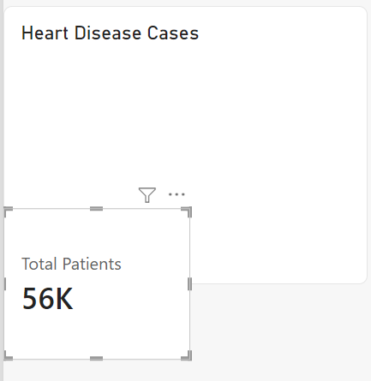

Diagram 3: Line Chart – Age Group
Procedure
- Select the Line Chart visualization.
- Drag Age Group into the X-axis.
- Drag chol (Cholesterol) into the Y-axis.
- Change the aggregation of chol to Average.
- Power BI plots the average cholesterol levels across different age groups.
- Add a suitable title such as Average Cholesterol by Age Group.
- Format the chart for clear visualization by adjusting labels, title, and axis settings.

Output
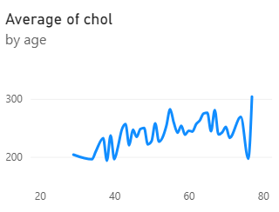

Diagram 4: Column Chart – Heart Disease Cases by Age Group Procedure
- Select the Clustered Column Chart visualization.
- Drag Age Group into the X-axis.
- Drag target into the Y-axis.
- Change the aggregation of target to Sum.
- Power BI calculates the number of heart disease cases for each age group.
- Add the title Heart Disease Cases by Age Group.
- Format the chart for better readability by adjusting colors, labels, and axis titles.

Output
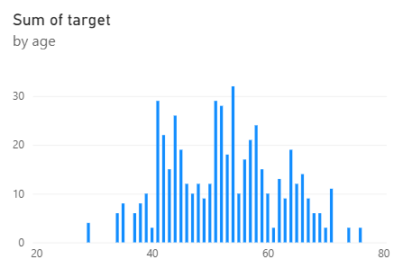

Diagram 5: Donut/Pie Chart – Heart Disease Distribution
Procedure
- Select the Donut Chart visual.
- Drag target into the Legend field.
- Drag target into the Values field.
- Change the aggregation to Count if required.
- Power BI creates separate sections for patients with heart disease (1) and without heart disease (0).
- Add the title Heart Disease Distribution.
- Format the chart and enable Data Labels to display counts or percentages.
Output
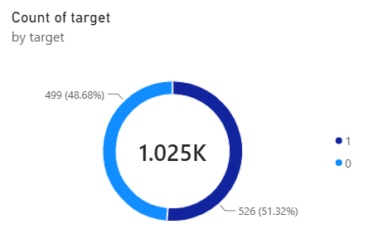

Diagram 6: Table – Top Posts by Engagement Procedure
- Select the Table visualization.
- Drag age into the table.
- Drag sex into the table.
- Drag chol (Cholesterol) into the table.
- Drag thalach (Maximum Heart Rate) into the table.
- Drag target into the table.
- Sort the chol column in descending order (or sort target to view heart disease cases first).
- The patient records with higher cholesterol levels or heart disease status appear at the top.

Output
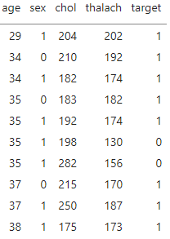

Diagram 7: Gender Slicer Procedure Procedure :
- Select the Slicer visual.
- Choose List Slicer.
- Drag sex into the Field area.
- The available gender categories are displayed as a list.
- Select a gender to filter the dashboard visuals accordingly.
- Clear the selection to return to the complete dataset.

Output
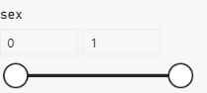

FINAL DASHBOARD

Procedure
- Arrange the Total Patients and Heart Disease Cases KPI cards at the top of the dashboard.
- Place the Heart Disease Cases by Age Group column chart in the main analysis area.
- Place the Average Cholesterol by Age Group line chart beside or below it.
- Place the Heart Disease Distribution donut chart in the dashboard.
- Add the Patient Details table.
- Place the Gender and Heart Disease Status slicers in an easily accessible area.
- Add the dashboard title:

HEART DISEASE ANALYSIS DASHBOARD

- Resize and align all visualizations properly.
- Apply appropriate formatting, colors, and titles to improve readability.
- Test the slicers to verify that the dashboard responds dynamically and filters all visuals accordingly.

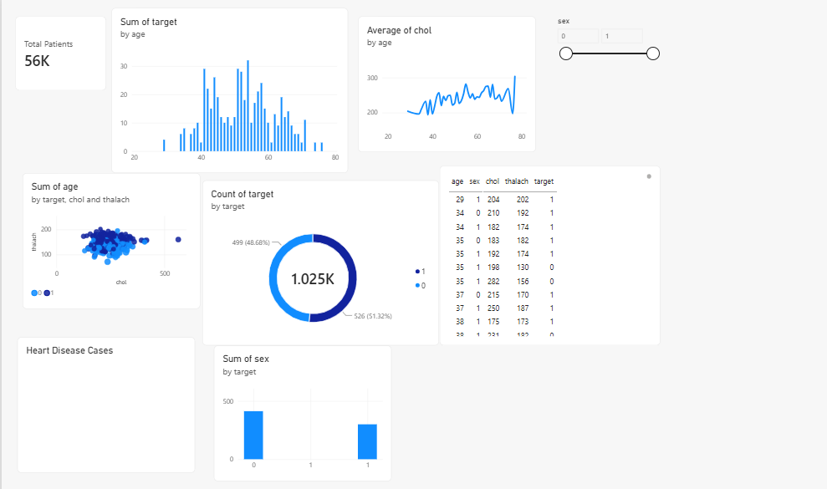

Result:
Thus, an interactive Heart Disease Dataset was successfully created using Microsoft Power BI.

