EX:7a | CREATE DASHBOARD USING TABLEAU WITH STUDENT MARKSHEET DATASET

Aim:
To create an interactive Tableau dashboard to visualize and analyze students' marks across different departments using bar charts, line charts, a pie chart, and filters.

Algorithm:
- Import the student marks dataset into Tableau.
- Create individual worksheets for different visualizations.
- Create a bar chart to compare marks by department.
- Create line charts to display marks for each student.
- Create a table showing department, student, and marks.
- Create a pie chart to represent marks by department.
- Add department and mark filters to the dashboard.
- Arrange all worksheets into a single dashboard.
- Apply suitable titles, labels, and formatting.
- Verify the dashboard and its interactive filters.

Output:

- Open Tableau and connect to the student marks dataset.
- Drag the required fields such as Department, Student, and Marks into the respective shelves.

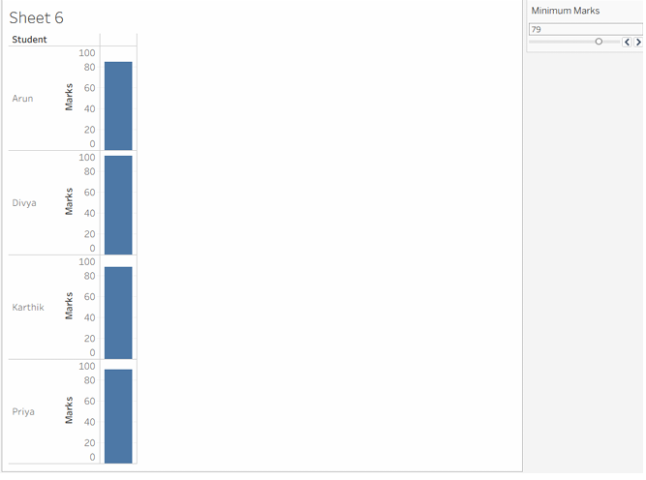
- Create the department-wise bar chart using Department and Marks.

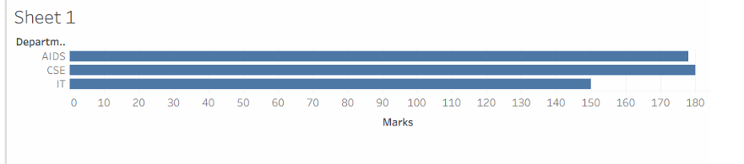

- Create line charts using Student and Marks, and enable mark labels.

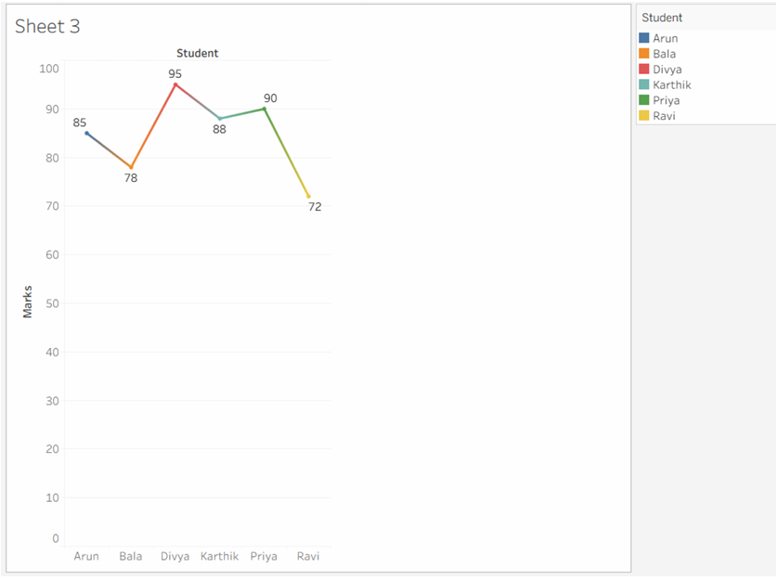
- Create a table containing Department, Student, and Marks.

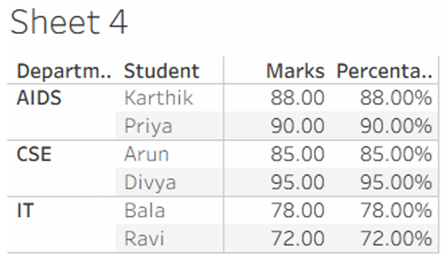
- Select the Pie Chart option from Show Me and use Department and Marks.

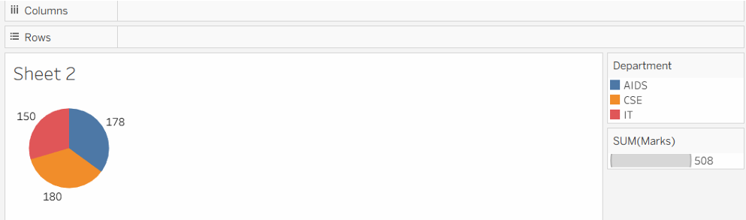

- Create a new Dashboard and drag the created worksheets into it.

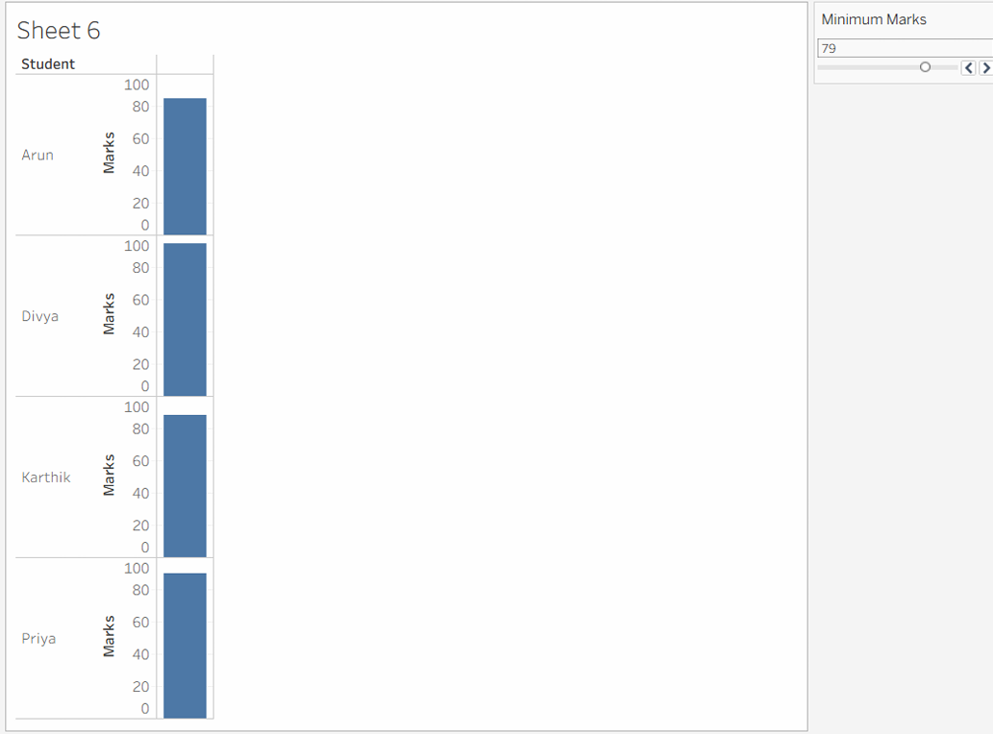

Result:
The Tableau dashboard was successfully created to analyze student performance. It displays department-wise marks, student-wise performance, tabular details, and department-wise distribution using multiple visualizations. Interactive filters allow the user to view the required departments and students based on minimum marks.

