EXPERIMENT 1B
PERFORMING CRISP-DM AND SEMMA

Aim:

Toapply the CRISP-DM (Cross-Industry Standard Process for Data Mining) and SEMMA (Sample, Explore, Modify, Model, Assess) methodologies for systematically understanding, preparing, analyzing, modeling, and evaluating data to extract meaningful insights and support effective decision-making.
Algorithm :

- Apply the CRISP-DM framework by understanding the problem, collecting and preparing the data, building the model, evaluating the results, and presenting the findings.
- Apply the SEMMA framework by sampling the data, exploring its characteristics, modifying and preprocessing it, building the model, and assessing its performance.
- Compare and interpret the outcomes obtained using both CRISP-DM and SEMMA methodologies.
- Draw conclusions based on the analysis and communicate the results for informed decision-making.
Code - CRISP-DM:

- TO LOAD THE DATASET
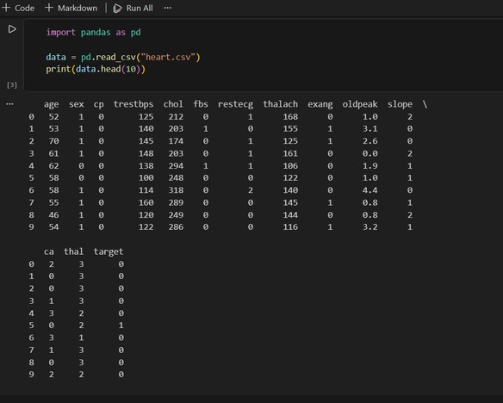

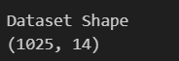
- TO PRINT TAIL AND ANALYSE SHAPE

- TO PRINT COLUMN TO LIST
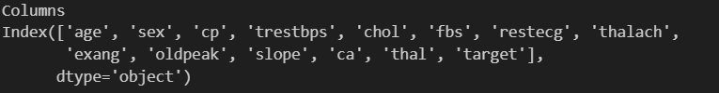

- PRINT SAMPLE
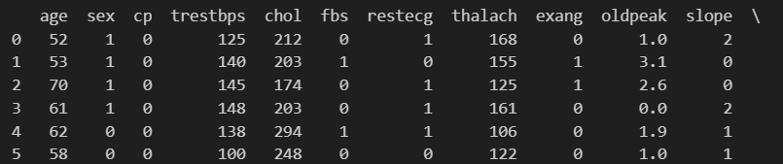

- TO DESCRIBE THE DATASET
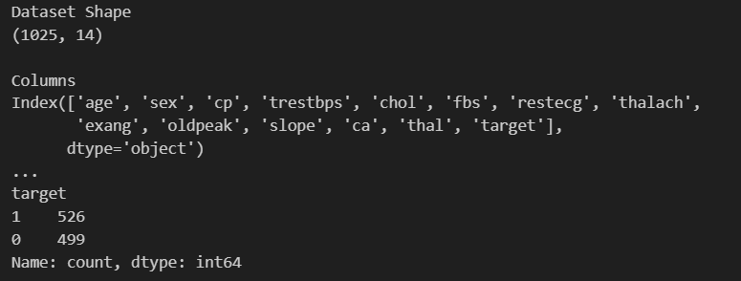
- TO ANALYSE THE MISSING VALUES
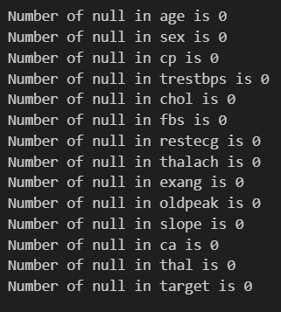

- TO PRINT DUPLICATE ROWS

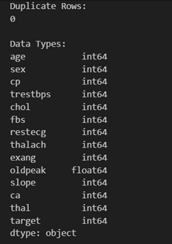

- TO VISUALISE CORRELATION MATRIX

