EXPERIMENT 3 DATA CLEANING

Aim:
To perform data cleaning using the Pandas library by identifying and handling missing values, duplicate records, and inconsistent data. To prepare a clean and reliable dataset for accurate data analysis and machine learning tasks.

Algorithm:
- Import the Pandas library.
- Load the dataset into a Pandas Data Frame.
- Inspect the dataset for missing values, duplicate records, and incorrect data types.
- Handle missing values by removing or filling them with appropriate values.
- Remove duplicate records from the dataset.
- Correct inconsistent or invalid data entries and convert data types if required.
- Verify the cleaned dataset and save it for further analysis.
Code - CRISP-DM:
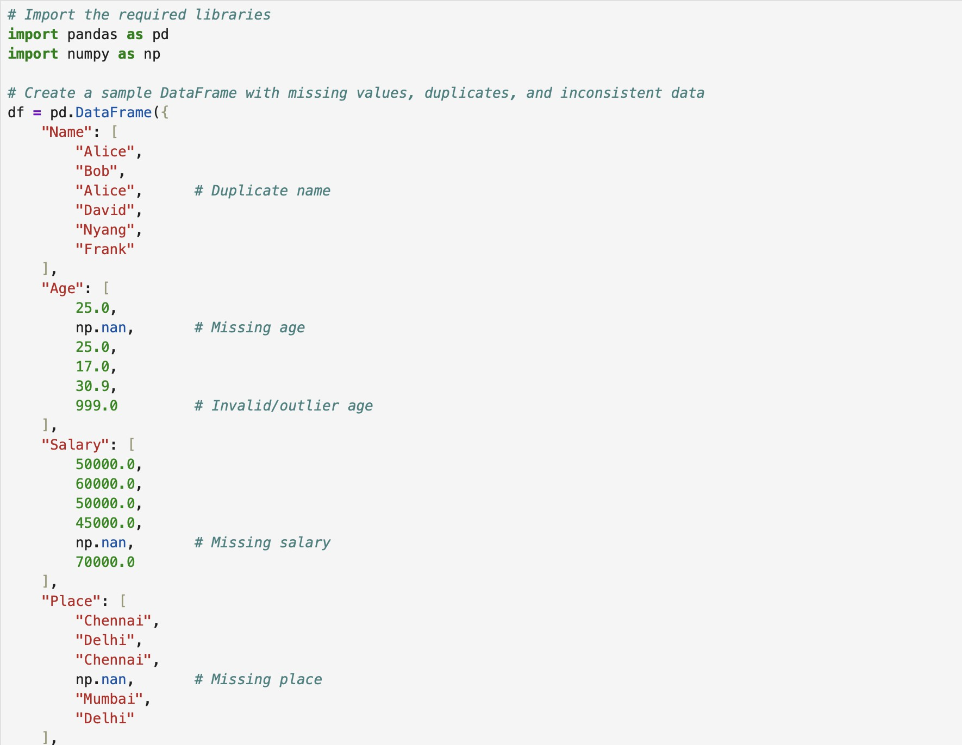

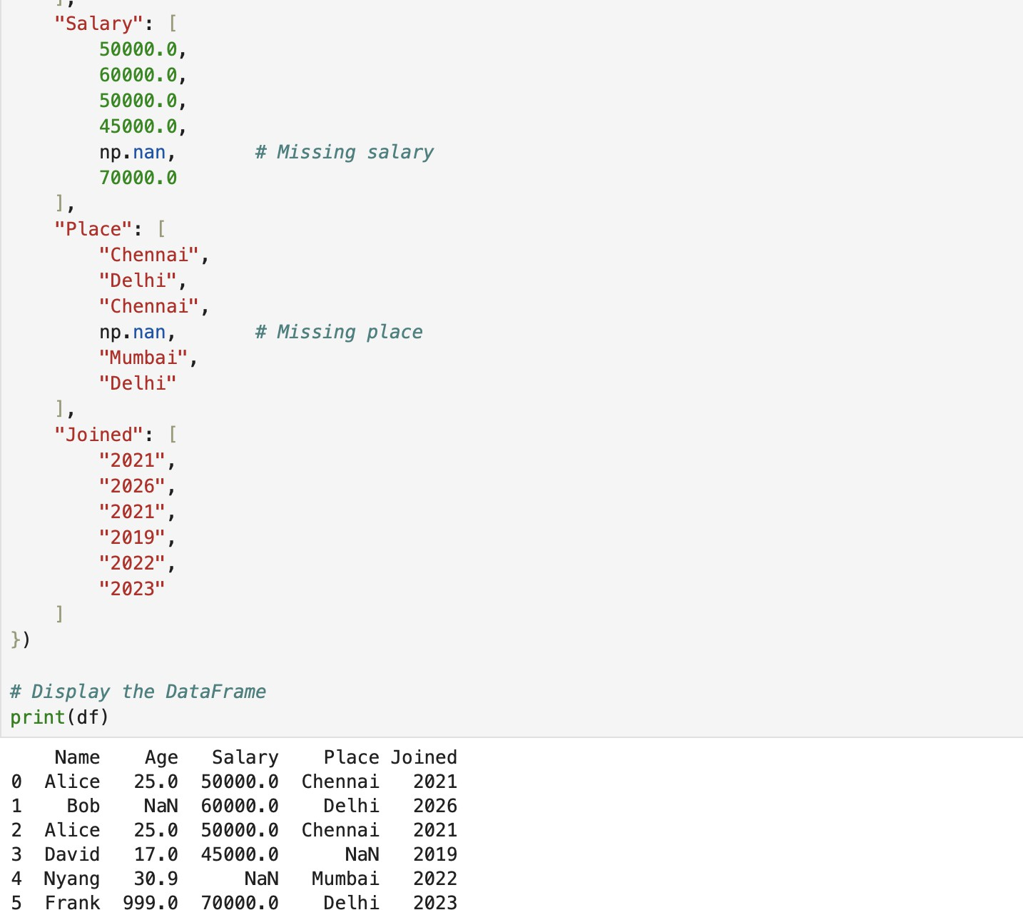

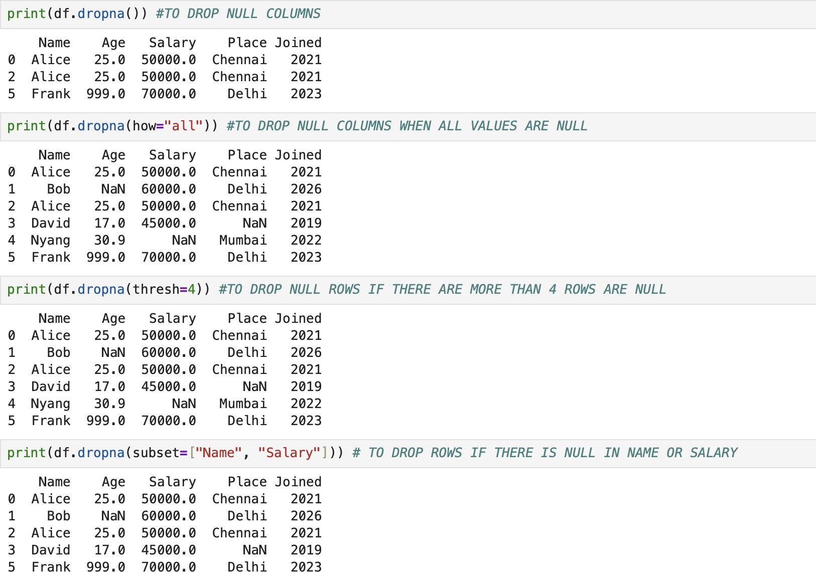

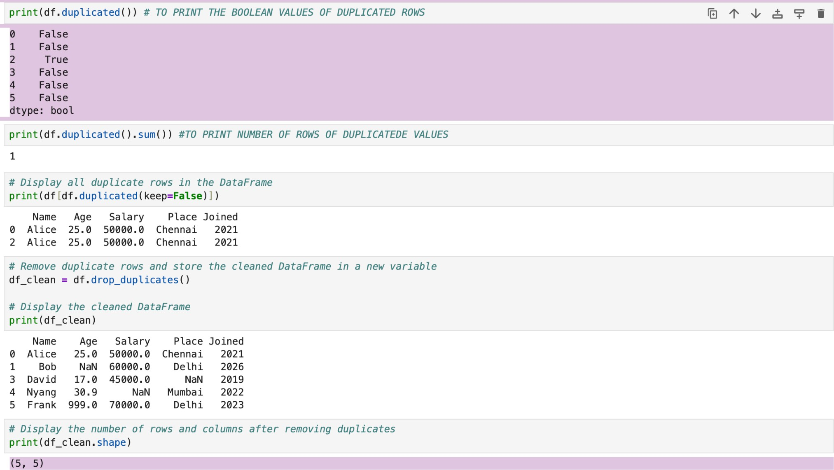
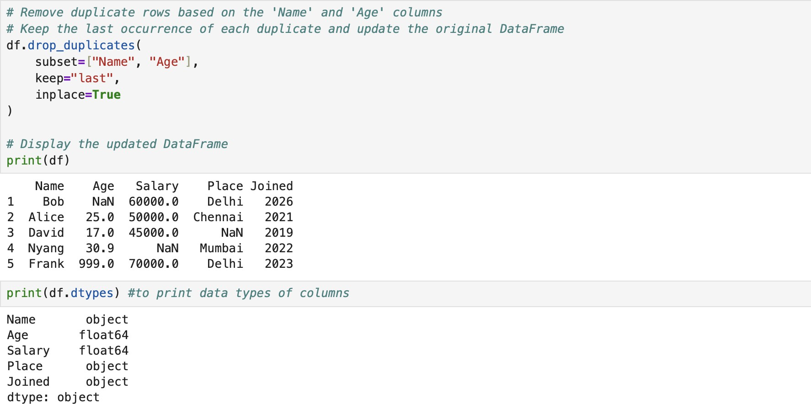

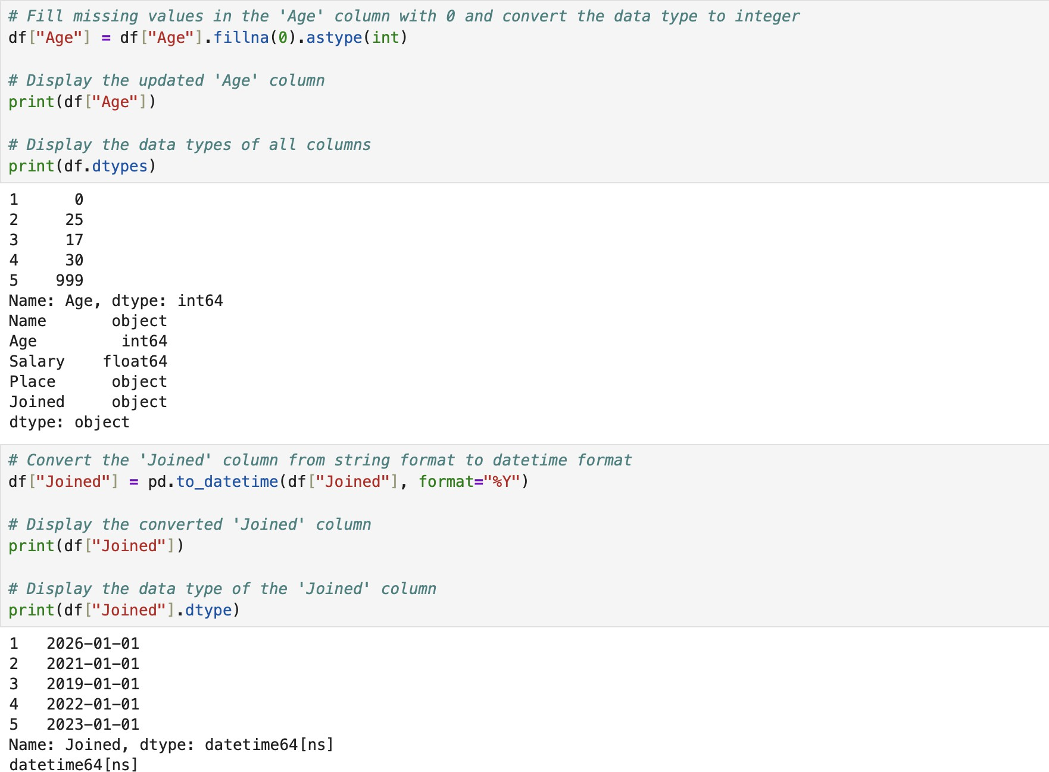

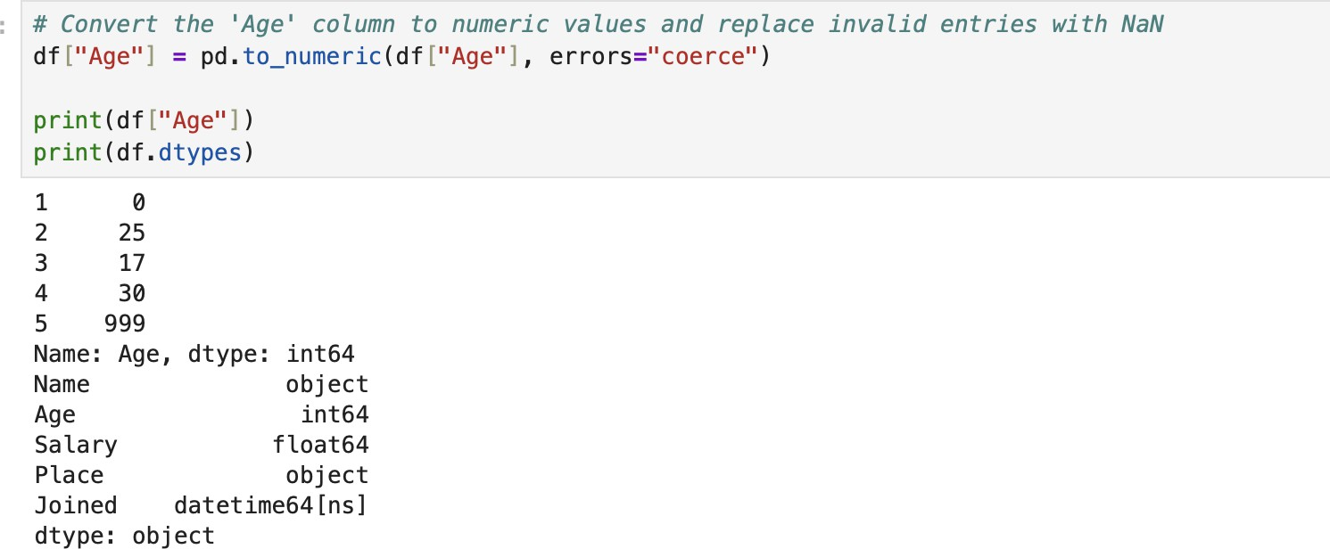

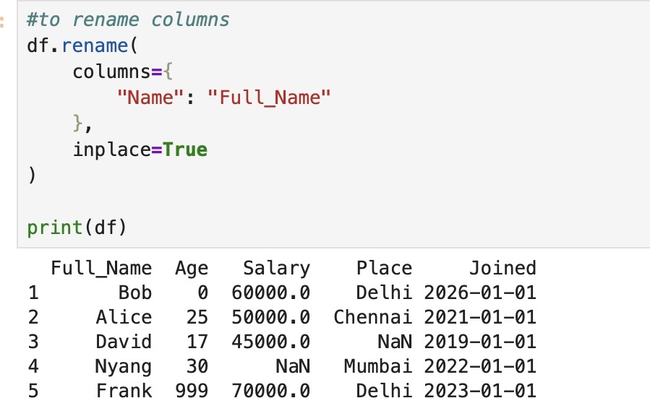

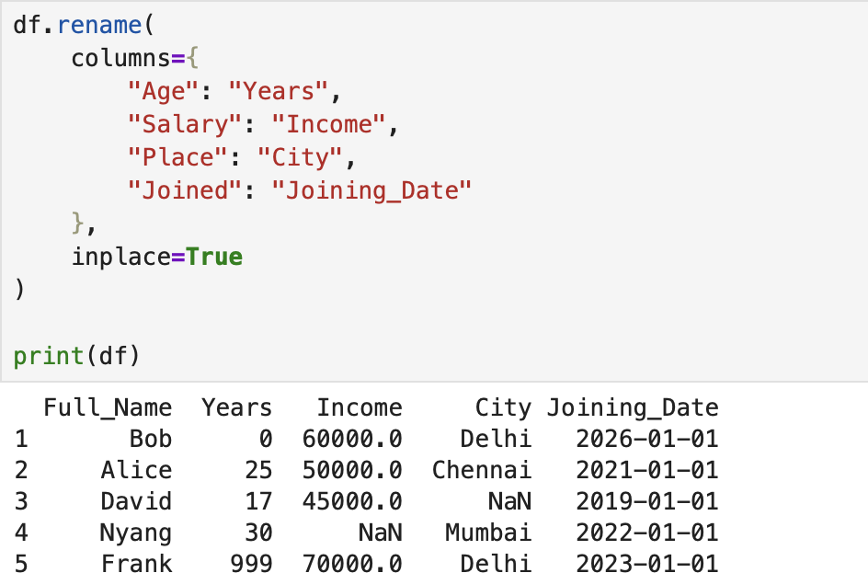

Result:
The program to perform data cleaning in a sample dataset

