PROG6212
POE PART 3

HASHMIRA GOVENDER
ST10437073

Table of Contents
1. GitHub Link
2. Introduction & Context
3. Project Planning
4. System Design Choices
5. Database Design
6. Graphical User Interface (Prototype)
7. Assumptions and Constraints
8. Conclusion
9. Part 1 and 2 Feedback
Reference List

1. GitHub link

In my github repo which is public I have a readme that links to all these documents in my github repo

- GitHub link (https://github.com/GovenderHashmira/CMCS_POE)
- Youtube video (https://youtu.be/Y5z648RvBCg)
- POE project files
- POE Documentation
- POE PowerPoint
- DataScript.sql
- SchemaScript.sql

2. Introduction & Context

The Contract Monthly Claim System (CMCS) is a .NET Core MVC prototype designed to streamline the monthly claim submission, verification and approval process for lecturers. The protypes purpose is to replace manual claim handling with a digital workflow. Lecturers submit claims and supporting documents, programme coordinators verify entries, and academic managers approve or reject claims. By centralising claim data, CMCS reduces administrative overhead, improves accuracy in rate/hour calculations, and provides transparent status tracking for all stakeholders.

CMCS models a real-world administrative process commonly found in higher-education institutions and training providers. Typical users include lecturers (claim submitters), programme coordinators and academic managers (final approvers) and now in part 3 HR user (super users). The prototype focuses on core interactions (create claim, attach documents, view status, and review queue) so assessors can evaluate system design and usability before functional persistence is added in later parts.

In industry terms, CMCS demonstrates sound separation of concerns (MVC), use of structured data models for auditability, and UI affordances to reduce input error (validation stubs, calculated totals, file upload placeholders). This prototype delivers a non-functional, visual that form the foundation for subsequent functional implementation and testing.

3. Project Planning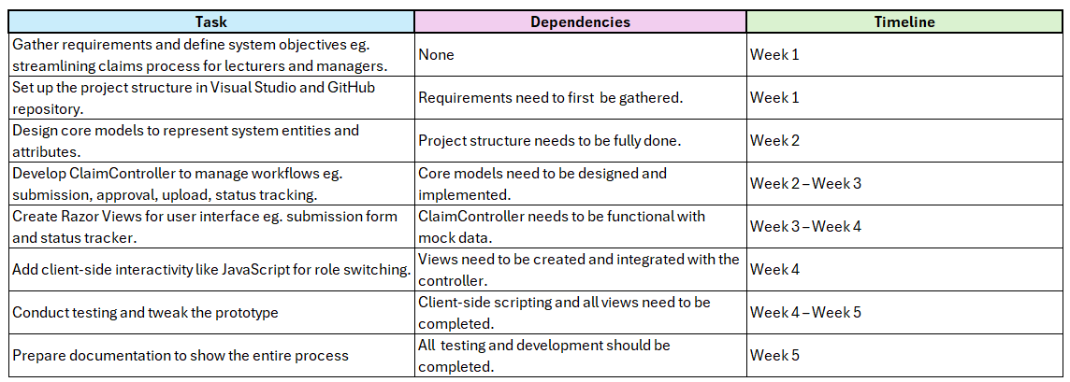
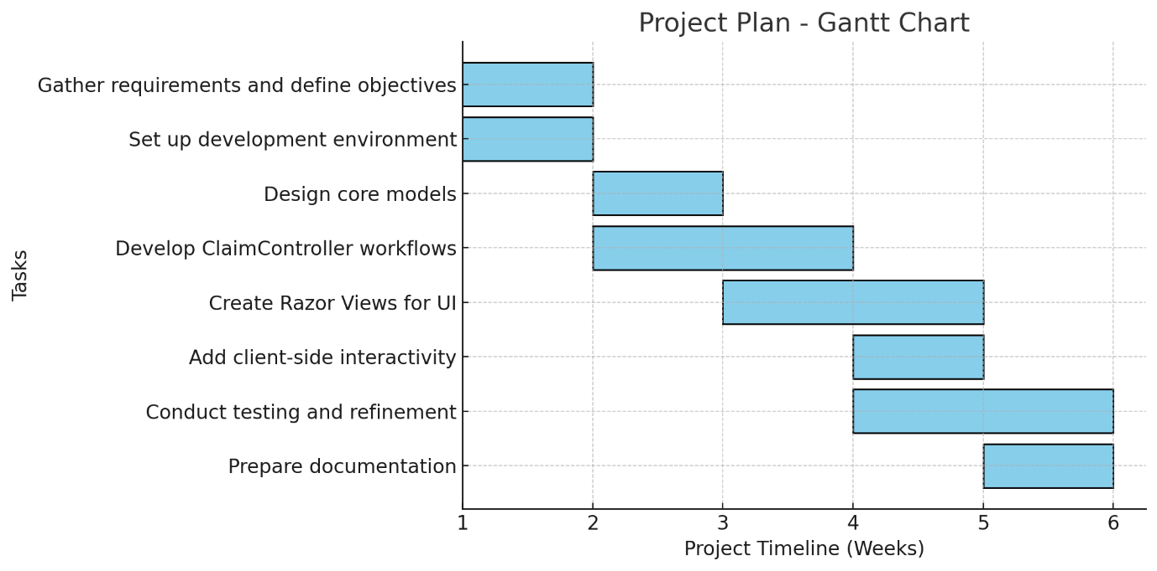

The methodology used was an iterative, Agile-inspired approach, which enabled the development and testing of functionality incrementally. The prototype was built using several key resources and technologies, including .NET Core MVC (C#) for the web application structure, GitHub for version control, Mermaid (mermaid.live) for UML design diagrams, and Visual Studio as the integrated development environment.

4. System Design Choices
The design of the Contract Monthly Claim System (CMCS) was driven by the need for simplicity, scalability, and role-based clarity. The system was built using the MVC architecture in .NET Core, which separates the interface, logic, and data layers, ensuring maintainability and supporting future enhancements. A prototype-first approach was adopted, focusing on creating the front-end mock-up before adding full backend functionality. This allowed usability and workflows to be validated early, reducing risks and aligning the system with real-world academic processes.
The database structure follows a relational model to maintain data integrity and enable efficient querying. Key entities include Lecturers, Claims, ClaimLines, Documents, and Approvals. Lecturers store staff details, while Claims record the overall submission linked to a lecturer and supporting files. ClaimLines provide itemised records of hours worked and rates, ensuring detailed tracking. Documents are tied to claims for proof of work, and Approvals record the actions of programme coordinators and managers.
This design directly supports the claim lifecycle. Lecturers submit claims by entering hours and attaching supporting documents, after which claims are tracked with statuses such as Draft or Submitted. Programme Coordinators and Academic Managers approve or reject claims. Approved claims are locked for integrity, ensuring reliable payroll processing. By structuring the process in this way, the design guarantees accountability, transparency, and traceability across all stages of the claim workflow.

5. Database Design
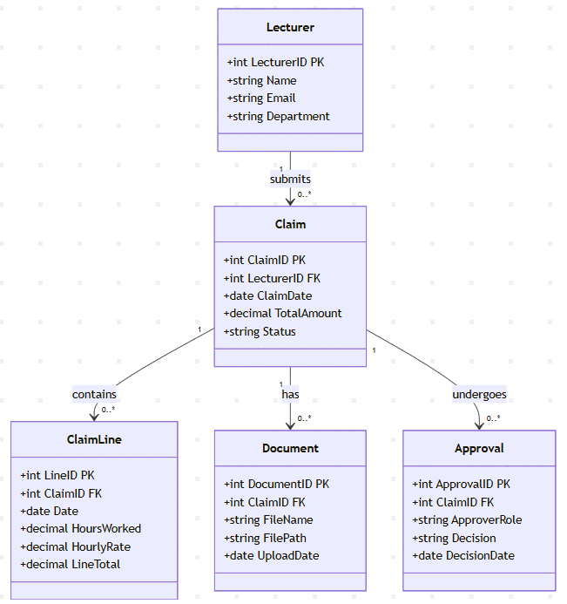
The relational model was chosen because it supports clear entity relationships, enforces integrity, and is widely used in enterprise applications. Each lecturer can submit multiple claims, and each claim may contain multiple claim lines for itemised hours. Supporting documents are attached to claims for verification, while approvals track actions by coordinators and managers. This structure enforces accountability by linking every action to a claim and lecturer, ensures scalability as more roles or workflows are added, and supports transparency with a full audit trail of documents and approvals.

6. Graphical User Interface (Prototype)
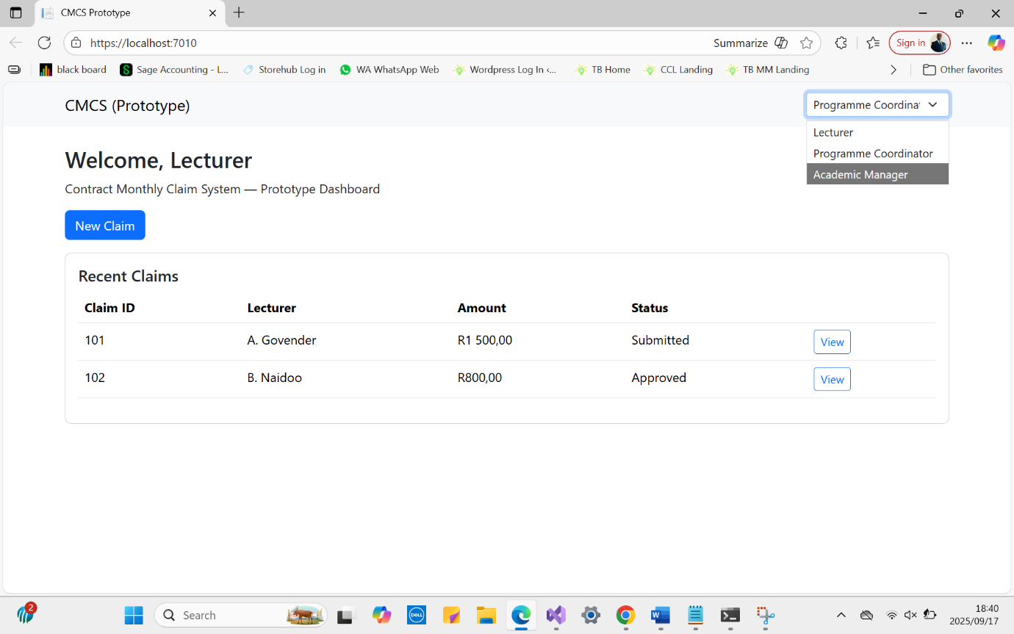
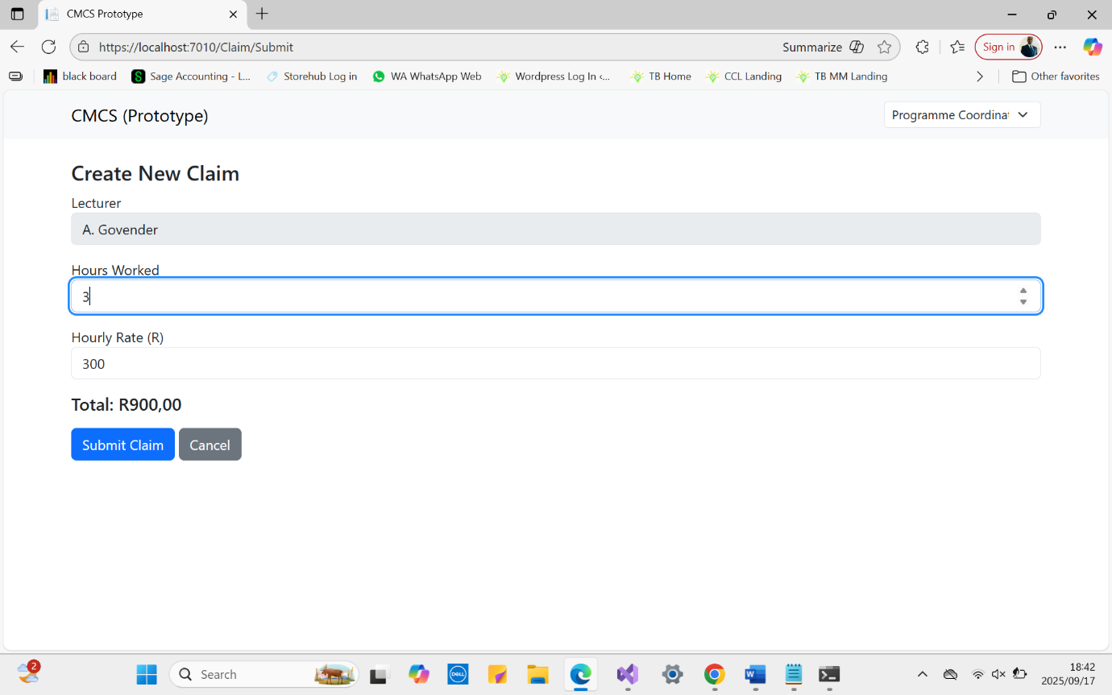
Part 1

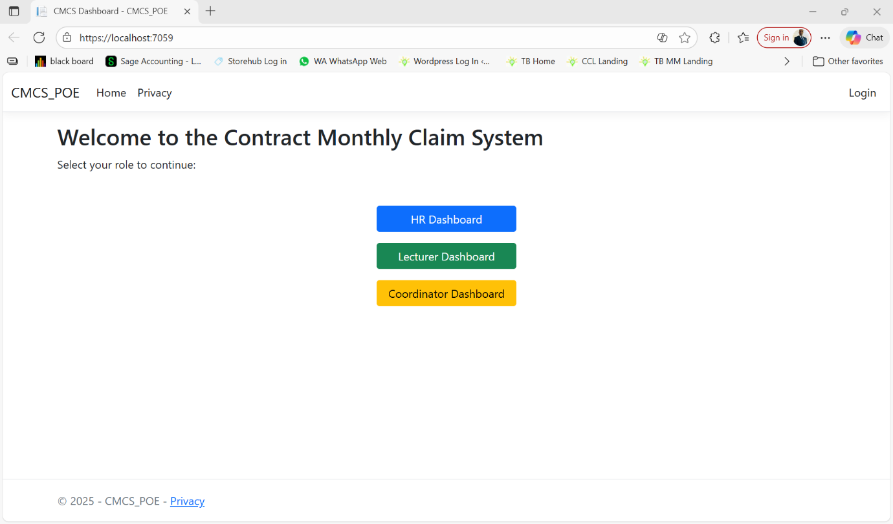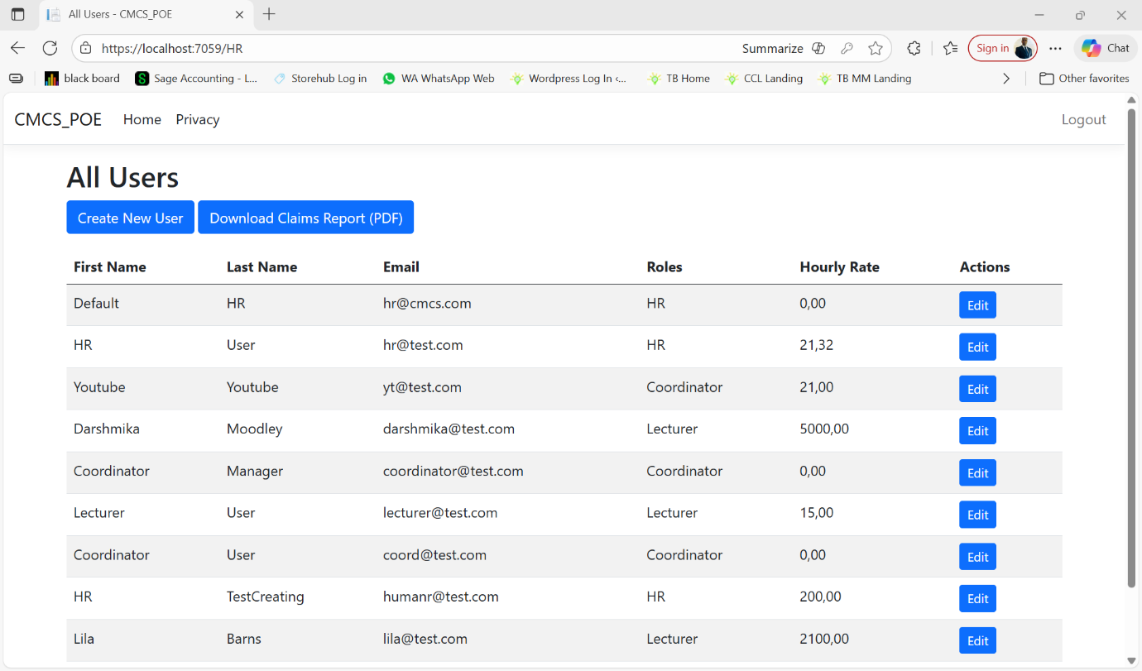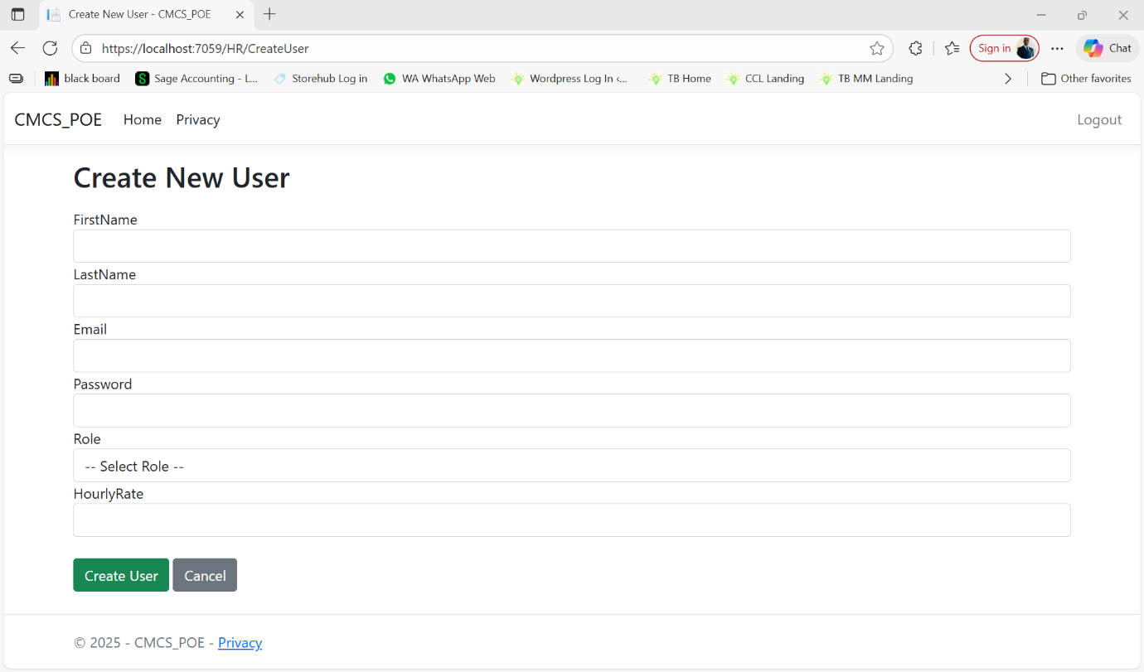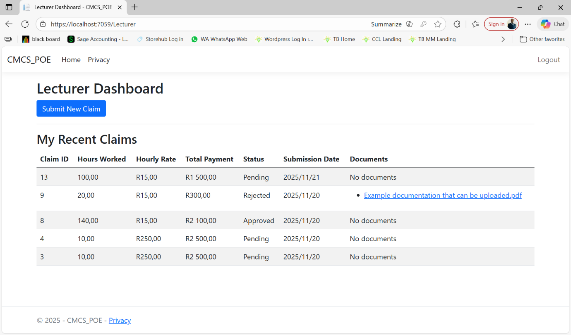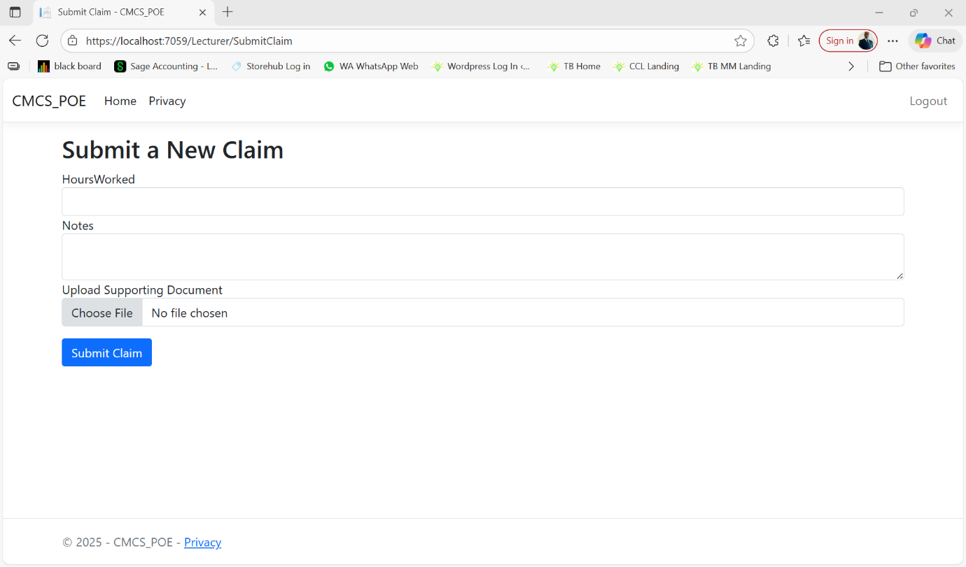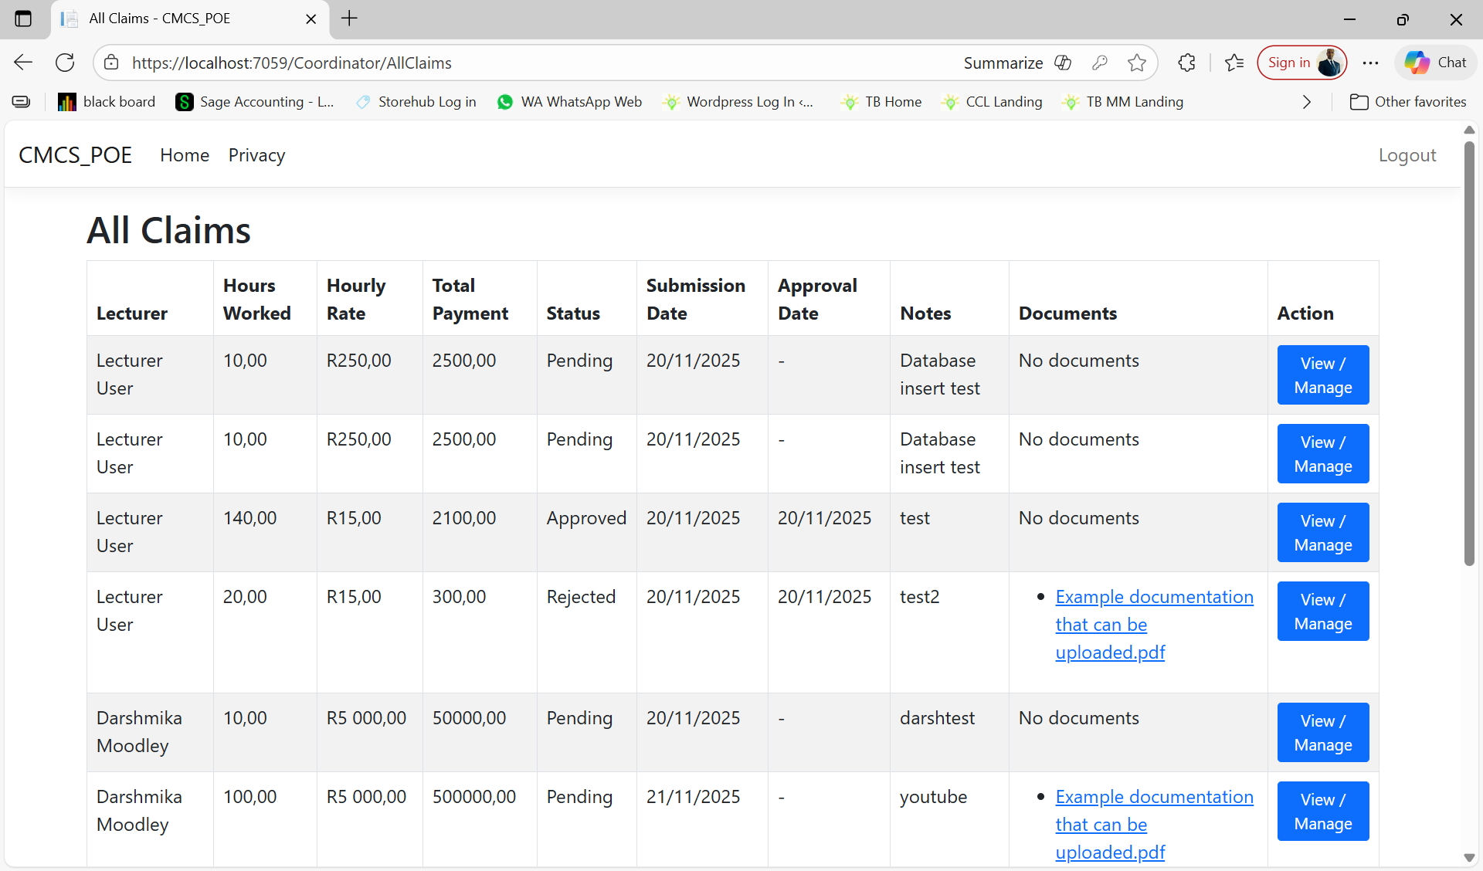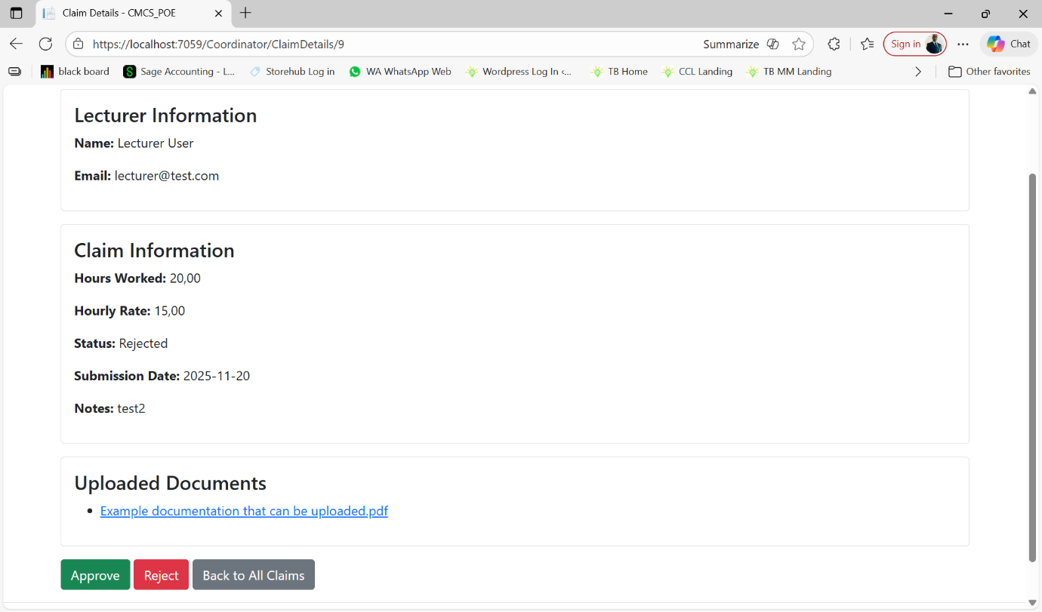
Part 3

The Graphical User Interface (GUI) for the Contract Monthly Claim System (CMCS) was designed with a focus on usability, consistency, and accessibility to ensure a smooth and effective user experience. Usability principles were applied by keeping the layout intuitive and uncluttered, with clearly labelled input fields, buttons, and messages that guide the user through claim submission, document upload, and approval workflows without requiring extensive training. Consistency was maintained across all screens through uniform colour schemes, typography, and button placements, which reduces cognitive load and enables users to quickly understand the interface. Accessibility considerations were integrated by ensuring adequate text-to-background contrast, using legible font sizes, and following logical tab orders for keyboard navigation. Additionally, descriptive labels and error messages were provided to support users with varying levels of digital literacy. Together, these principles ensure that the GUI is user-friendly, reliable, and inclusive, allowing lecturers and administrators to interact with the system efficiently and effectively.

7. Assumptions and Constraints
There were several assumptions and constraints identified in this prototype. The system assumes that lecturers submit a single claim covering all their modules, as there is currently no feature to specify the claim for individual modules beyond attaching supporting documentation, which is not yet functional. It is also assumed that programme coordinators and academic managers follow the standard verification and approval workflow, reviewing claims and attached documents in sequence. These assumptions and constraints highlight the design limitations of This prototype, while providing a clear foundation for the functional implementation in later phases.

8. Conclusion
In conclusion, This prototype of the CMCS project delivered a visual prototype, including core system workflows, wireframes, and database design diagrams. While the system is non-functional at this stage, it clearly models the roles, claim processes, and document handling that will underpin the final application. These deliverables provide a solid foundation for future development by defining the structure, user interactions, and data relationships, ensuring that subsequent functional implementation can proceed efficiently and align with real-world academic claim processes.

Part 1 and 2 Feedback
Part 1:
Sadly for part 1 my word file corrupted in ARC. My lecturer could not view half of my project so it was marked based off what was not corrupted. I cannot provide any improvements to my original documentation because I lacked feedback due to this error in ARC.

Part 2:
From my feedback from part 2 I completely reworked the project. I had not given the lecturers any way to view old claims only a submit claim page as their dashboard. Additionally I had not managed to get the document upload feature to work but now for part 3 I fixed that.
For the Managers the All Claims table was only showing the columns not rows. Now the All Claims table has rows and more columns than before.
For the HR user I never had them previously but now it improves from part 2 because the lecturer does not have to enter their hourly rate its saved in their user in the database and is used from there to calculate total payments.

Reference List

Troelsen, A. and Japikse, P. 2021. Pro C# 9 with .NET 5: Foundational Principles and Practices in Programming. 10th ed. Apress.

Farrell, J. 2017. Visual C# 2017: An Introduction to Object-Oriented Programming. 7th Edition. Cengage Publishing.

Whitaker, R.B. 2016. The C# Player's Guide.

