Liberación SISTRA: plugin Custodia plug-in

Code: SISTRA-PLUGINCUSTODIA

DOCUMENT CONTROL SHEET

 |  | DOCUMENT / FILE
Title: Liberación SISTRA: plugin Custodia |  |  |  |  |  |  |  |  |  | File Name / s:0000.doc
Code: SISTRA-PLUGINCUSTODIA |  |  |  |  |  |  |  |  |  | Software: Word
Date: 30/03/2010
Version1
 |  |  |  | RECORD OF CHANGES
 | Version |  |  | Pages |  |  | Reason for change
 | 1 |  |  | 6 |  |  | Document Creation
 | 2 |  |  | 7 |  |  | Added function to obtain query url of a document in custody
 |  |  |  |  |  | DISTRIBUTION OF DOCUMENT
 |  |  | Name |  |  |  |  | Staff
 |  |  |  | DOCUMENT CONTROL
PREPARATION |  |  |  |  | REVISED / APPROVED |  |  |  |  |  |  |  | ACCEPTED |  | ACCEPTED
Rafael Sanz |  |  |  |  | José Vicente Juan Pérez |  |  |  |  |  |  |  | Jerome Navarrete |  | Bernat Alberti
Complete with the name, signature and date |  |  |  |  |  |  |  |  |  |  |  |  |  |  |  | Customers only

INDEX
1. Goal 4
2. Subclass 5
3. Plug-in interface 6

Goal
The purpose of this document is to define actions to perform for allowing REDOSE integration with a signed document custody system..

Subclass
The scheme works as follows:

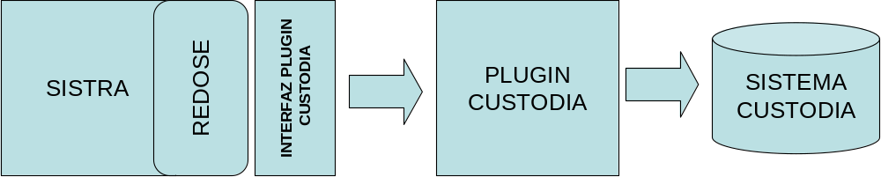

REDOSE module will synchronize through a custody plug-in to store signed documents in custody system (for models configured to be in custody). In this way, after inserting, modifying or deleting a signed document in REDOSE, this update will be propagated to the custody system.

Plug-in interface
Communication interface between SISTRA and custody plug-in is next:
Method | Description | Parameters | Result
custodiarDocumento | It inserts a document in custody system | DocumentoRDS: RDS document with document content and associated signatures | In custody document identifier
eliminarDocumento | It removes a document from custody system. If a document that does not exist is deleted, it will generate a warning (no exception). | codigoDocumentoCustodia: In custody document identifier | EstadoEnvio: shipment and a description status
obtenerUrlDocumento | It gets query url of document in custody. | codigoDocumentoCustodia: In custody document identifier | Query url (null if not allowed)

For more information consult javadoc.

REDOSE will call custodiarDocumento each time the document or its signatures are modified.
In case of non-transactional integrations, this function should return a different identifier each time. In this way, different custody versions will be stored in REDOSE and then remove process will delete old versions. It assures transactional logic because a roolback in REDOSE transaction would maintain equivalent document in custody.

