Liberación SISTRA: plugin Gestor Documental

Code: SISTRA-PLUGINGESTDOC

DOCUMENT CONTROL SHEET

 |  | DOCUMENT / FILE
Title: Liberación SISTRA: plugin Gestor Documental |  |  |  |  |  |  |  |  |  | File Name / s:0000.doc
Code: SISTRA-PLUGINGESTDOC |  |  |  |  |  |  |  |  |  | Software: Word
Date: September 2010
Version1
 |  |  |  | RECORD OF CHANGES
 | Version |  |  | Pages |  |  | Reason for change
 | 1 |  |  | 6 |  |  | Document Creation
 | 2 |  |  | 8 |  |  | Document associated with pre-registration can have 3 uses
 |  |  |  |  |  | DISTRIBUTION OF DOCUMENT
 |  |  | Name |  |  |  |  | Staff
 |  |  |  | DOCUMENT CONTROL
PREPARATION |  |  |  |  | REVISED / APPROVED |  |  |  |  |  |  |  | ACCEPTED |  | ACCEPTED
Rafael Sanz |  |  |  |  | José Vicente Juan Pérez |  |  |  |  |  |  |  | Jerome Navarrete |  | Bernat Alberti
Complete with the name, signature and date |  |  |  |  |  |  |  |  |  |  |  |  |  |  |  | Customers only

INDEX
1. Object 4
2. Subclass 5
3. Interface plugin 6

Goal
The purpose of this document is to define actions to integrate REDOSE with a document manager.

Subclass
The scheme works as follows:

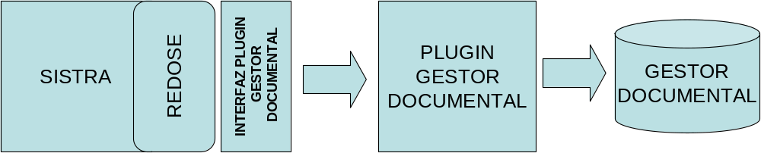

REDOSE module consolidates documents stored in REDOSE associated to processes, notifications and record events in the document manager through its plug-in.
Document consolidation will be performed in background once:
- processes have been registered or they were confirmed for preregister processes (for documents associated to processes)
- notifications have been registered (for documents associated to notifications)
- record events were stored (for documents associated to record events)
Therefore, documents in persistence processes (still under development by the citizen) will not be consolidated in document manager until the process is recorded.

Identifier provided by the document manager for the document will be informed as a property in the input warning to the back-office managing the process.
It is necessary to emphasize that a process warning won’t be performed until its documents are consolidated in the document manager. So, the back-office can receive document identifiers in the document manager when it receives process warning.

Plug-in interface
Communication interface between SISTRA and Custody plug-in is as follows:
Method | Description | Parameters | Result
consolidarDocumento | Insert document in the document manager. | DocumentoRDS: RDS document with document content and its associated signatures  Usos del document: It indicates where the document is being used (input registry, telematic box, output registry, etc.) | Document identifier in document manager
For more information consult javadoc.

This plug-in will consolidate documents associated to: processes, notifications and event records.
At process level, documents will be consolidated once process is registered or it is confirmed for processes with preregistration.
Usos del documento will indicate where the document is being used (input registry, telematic box, output registry, etc). Each use will contain the reference associated to use type (fi for an input registry use type it will exist iput registry number as reference).
Theses uses can be used to organize documents by process, notification, etc. in the document manager.

Possible cases are:
 | Shipment type SISTRA process | Contain 2 uses:  - Telematic shipment  - Input telematic box
 | Preregistration type SISTRA process | Contain 3 uses:  - Preregistry  - Input registry (only if it was confirmed correctly in registry)  - Input telematic box
 | Process no SISTRA * | Contain 1 use:  - Input telematic box
Documents associated with records and notifications | Document belonging to a record event | Contain 1 use:  - Record event
Documents associated with records and notifications | Document belonging to a notification | Contain 1 use:  - Output telematic registry
* Process no SISTRA: as Sistra implements telematic registry interface there is the possibility that third party applications (other than Sistra) exist implementing telematic processes. For these processes, telematic input registry will be done and third party application will be responsible of its processing (that is, no entry will be generated in Sistra telematic box for these processes)

Depending on use type, an identifier associated to the use will be obtained:
Type Use | Use Code | Identifier associated with the use
Telematic input registry | ConstantesRDS.TIPOUSO_REGISTROENTRADA | Registration number
Telematic shipment | ConstantesRDS.TIPOUSO_ENVIO | Shipment number
Preregistration | ConstantesRDS.TIPOUSO_PREREGISTRO | Preregistration number
Entry in telematics box | ConstantesRDS.TIPOUSO_BANDEJA | Input number
Record event | ConstantesRDS.TIPOUSO_EXPEDIENTE | Code of record event composed by:  Record Number – Event date  Event date in format: yyyymmddHHMMSS
Telematic output registry | ConstantesRDS.TIPOUSO_REGISTROSALIDA | Output registry Number

Next document organization is set in a directory of a file system according to uses while implementing a test plug-in document manager:

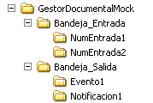

Where NumEntrada1, Event1, Notificacion1 would be associated identifiers to each use (input number, event code output registry number) and documents associated to each entry, event or notification would go inside each folder.

