Integración BackOffice integration

Code: SISTRA-INTBOF

DOCUMENT CONTROL SHEET

 |  | DOCUMENT / FILE
Title: Integración BackOffice |  |  |  |  |  |  |  |  |  | File Name / s:0000.doc
Code: SISTRA-INTBOF |  |  |  |  |  |  |  |  |  | Software: Word
Date: January 2014
Version11
 |  |  |  | RECORD OF CHANGES
 | Version |  |  | Pages |  |  | Reason for change
 | 1 |  |  | 33 |  |  | Document Creation
 | 2 |  |  | 23 |  |  | Add webservice interface
 | 3 |  |  | 24 |  |  | Webservice telematic registry simplification
 | 4 |  |  | 30 |  |  | Integration orientation to api webservices. EJBs api remain as legacy.  Version 2 of webservices api is detailed
 | 5 |  |  | 30 |  |  | Registry api is modified to set persistence while preparing input registry
 | 6 |  |  | 30 |  |  | Shipment verification functionality of Mobtratel.
 | 7 |  |  | 31 |  |  | Citizen personal area activation
 | 8 |  |  | 31 |  |  | Process refocusing to procedure
 | 9 |  |  | 32 |  |  | Warning simplification  Explanation notification consent
 | 10 |  |  | 32 |  |  | Notifications and events with access by key
 | 11 |  |  | 33 |  |  | Obtain process payment status in zonaper
 |  |  |  |  |  | DISTRIBUTION OF DOCUMENT
 |  |  | Name |  |  |  |  | Staff
 |  |  |  | DOCUMENT CONTROL
PREPARATION |  |  |  |  | REVISED / APPROVED |  |  |  |  |  |  |  | ACCEPTED |  | ACCEPTED
Rafael Sanz |  |  |  |  | José Vicente Juan Pérez |  |  |  |  |  |  |  | Jerome Navarrete |  | Bernat Alberti
Complete with the name, signature and date |  |  |  |  |  |  |  |  |  |  |  |  |  |  |  | Customers only

INDEX
1. Introduction 4
2. Processing assistant (SISTRA and FORMS) 5
2.1. Domains 5
2.2. Query type processes 7
3. Secure Document Repository (REDOSE) 9
4. Telematic box (BANTEL) 13
5. Personal Zone (ZONAPER) 18
6. Telematic Registry (REGTEL) 24
7. Mobility (MOBTRATEL) 31

Introduction
The purpose of this document is to define BackOffices integration with Telematic Processing Platform.
This integration concerns following points:
- integration with Processing System (Domains and Consultation resolution)
- integration with Telematic Box (Input Processing)
- integration with Personal Zone (My records)
- Integration with Secure Document Repository (RDS)
- integration with Telematic Registry (Notification and Input records)
- integration with Mobility module (Email and SMS message shipment)

BackOffice access to platform (and vice versa) is performed through Web Service access. EJB access is also maintained for compatibility with previous versions but this access is considered as legacy mode and it won’t be detailed in this document.
A WSDL will be defined for each module that will include:
- offered services by module
- invoked services by module
The platform supports web services versioning to enable specification change management in the interface, defining a WSDL for each interface version. In this way, a new Sistra version can add a new interface version so that previous integrations can continue working with old interface.

Web services url will be:
http (s)://host:port/{module}ws/services/{version}/BackofficeFacade
where:
{module} is the involved module: sistra, zonaper, redose, bantel, mobtratel or regtel
{version} is: v1, v2, etc. according to Web Service versioning

Currently latest webservices api version is 2 which is detailed in this document.

Processing assistant (SISTRA and FORMS)

Domains
A Domain is a value which ​​normally comes from a DB query. There are cases (in telematic processing procedure to complete a form or perform a validation) where it is necessary to access to domains to be resolved by BackOffice application because BackOffice can access this data.

Processing System can invoke domains located in BackOffice in a remote way. This invocation can be done in two ways:
- JDBC direct access: it requires direct connectivity between Processing System and destination DB.
- access via Web Service: BackOffice must implement a Web Service to be invoked by the Processing System to resolve the domain

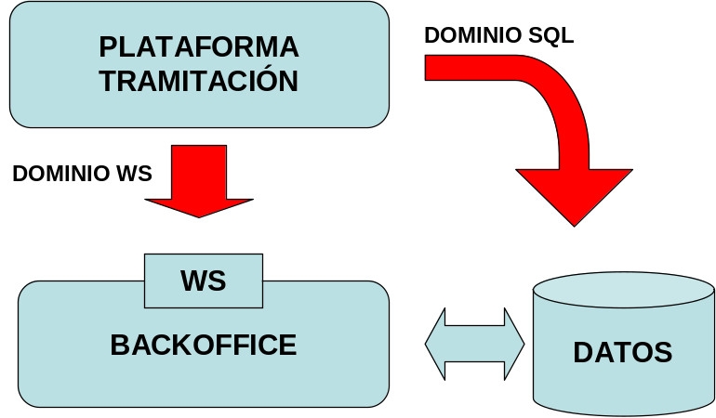

An identifier will be assigned to identify a domain (maximum 10 characters). The assignment of these identifiers should follow naming schema defined in identifier definition annex.

Access to a domain can be:
- JDBC direct access
In this type of access, it is necessary to indicate JNDI path of a Datasource accessible from application server where Processing System is installed.
Furthermore SQL query should be noted too. This SQL can contain parameters (these parameters will be of string type).
In this type of access, BackOffice should not implement any item.
Example: SQL for the towns of a province.
LOC_CODIGO SELECT CODE, LOC_DESC LOCATION FROM LOCATIONS WHERE LOC_PROV =?

- Access via Web Service
BackOffice shall implement Web Service specified in WSDL from project folder:
/moduls/modul-sistra/moduls/webservicesClient/wsdl/v2/SistraFacade.wsdl.

Operation to resolve domains is next:

SERVICE | obtenerDominio
DESCRIPTION | It allows to look up a back office domain
PARAMETERS | - id: domain identifier  - parametros: Domain parameters. Parameters list of string type. They will be identified according to list position when resolving the domain.
RETURN | - ValoresDominio:  - error: it indicates whether there has been an error in backoffice during domain look up (true / false)  - descripcionError: it indicates error description on failure  - rows: if there is no error, row list for the domain will be returned. A row is composed by a list of columns, which in turn contain:  - codigo: column code  - valor: column value in that row

Query type processes
It exists a kind of process whose purpose is to obtain information from BackOffice and display it on the screen (Ex.: note result, certificate queries, etc.).
These processes consist in one or more forms that collect data to perform the query and then this query is executed against BackOffice. As a result, one or more documents are obtained as response.
These processes don’t register nor leave information in Telematic Box.

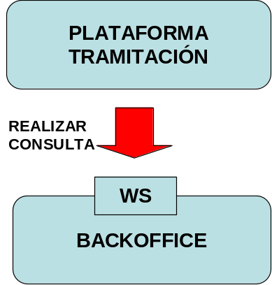

BackOffice shall implement Web Service specified in WSDL from project folder:
/moduls/modul-sistra/moduls/webservicesClient/wsdl/v2/SistraFacade.wsdl.

The operation to perform the query is:

SERVICE | realizarConsulta
DESCRIPTION | It allows to query a back office by passing a form list and obtaining documents as result.
PARAMETERS | - identificadorTramite: Process identifier  - forms: Form list. A form contains fields:  - identificador: form identifier within the process  - numeroInstancia: form instance (always will be 1)  - xml: XML with form data
RETURN | - DocumentosConsulta: document list as query result. It has next fields:  - tipoDocumento: it indicates document type. Other fields should be informed depending on document type. Permitted types are:  - Binario (B): document content will be indicated directly  - Rds (R) an existing RDS document is referenced  - Url (U): an URL to an http link is specified.  - Xml (X): an xml is indicated with option to be formatted by the RDS.  - nombreDocumento: document descriptive name appearing to citizen  - codigoRDS / claveRDS [OPTIONAL]: if type is Rds, RDS code and key will be indicated  - xml / model / version / template [OPTIONAL]: if type is xml, xml will be informed with data, model, version and template (optional, if not default template will be used) to format xml.  - contenidoFichero / filename [OPTIONAL]: if type is binario, file content will be pointed out in bytes and file name with extension  - accessURL / nuevaVentana [OPTIONAL]: if type is URL, url will be indicated and if you want the link to be opened in a new window.

.

Secure Document Repository (REDOSE)
Secure Document Repository is a document container in electronic format that manages:
- Document model and version registry: it’s necessary to point out document model/version to insert a document in RDS.
- Integrity: it allows to control document integrity by means of hash functions
- Access control to them: it’s necessary to have a password for accessing a document. Moreover operations on documents are audited.
- Digital signature: a document can be digitally signed. A digital signature can be associated to a document (verifying that signature is valid).
- PDF rendering of xml documents: it defines that a particular document model is structured (xml) and PDF display templates for these documents.

A BackOffice application could directly use RDS in next cases:
- Telematic Input/Output record generation: insert annexed documents referenced in registry note.
- Record warning generation Personal Zone: a warning may have associated documents.
- Telematic input box processing: it allows saving document RDS reference to be accessed later when inputs in telematic box are processed.

In previously described cases, BackOffice application can insert a document in RDS and it will get a ReferenciaRDS composed by a code and a password to access it.
A document in RDS has associated Uses indicating that this document is being used (filling process, box input, document associated to a record event, etc.). A document without uses will be interpreted as not existing in the platform and it will be deleted by an automatic process. These uses are automatically generated by the platform when operations are performed on the document.

The platform offers a webservice allowing insertion and query of documents.
BackOffice shall implement a client for this Web service specified in WSDL from project folder:
\Moduls\modul-redose\moduls\webservices\wsdl\redose\v2\BackofficeFacade.wsdl

Available operations are next:

SERVICE | consultarDocumento
DESCRIPTION | It allows query a document
PARAMETERS | - Referencia: document reference (code / key)
RETURN | - DocumentoRDS (properties are specified at the end of operation listing)

SERVICE | consultarDocumentoFormateado
DESCRIPTION | It allows to query a structured document (XML) formatted by RDS as a PDF.
PARAMETERS | - referencia: document reference (code / key)  - tipoPlantilla [OPTIONAL]: a template can be specified for formatting. If not specified, template configured by document will be used.  - idioma [OPTIONAL]: a language can be pointed out for formatting. If not specified, language configured by document will be used.
RETURN | - DocumentoRDS: formatted RDS document. It will have the same properties as original document except content and file name which will refer to PDF one.

SERVICE | insertarDocumento
DESCRIPTION | It inserts a document in RDS
PARAMETERS | - documento: RDS document with filled fields
RETURN | - ReferenciaRDS: RDS reference to inserted document
COMMENTS | It won’t have any use when inserting document. After performing an operation referencing this document (output registry, adding record event, etc.), the platform will automatically create an associated use.  Documents without uses will be removed by an automated process.

SERVICE | insertarDocumentoConTransformacion
DESCRIPTION | It inserts a document in RDS applying certain transformations
PARAMETERS | - documento: RDS document with filled fields  - transformación: transformation over the document. Available transformations are:  - convertToPDF: converts the document to PDF  - barcodePDF: inserts a barcode for document verification
RETURN | - ReferenciaRDS: RDS reference to inserted document
COMMENTS | It won’t have any use when inserting document. After performing an operation referencing this document (output registry, adding record event, etc.), the platform will automatically create an associated use.  Documents without uses will be removed by an automated process.

DocumentoRDS is used as data structure to pass a document and it contains following fields:

Field | Description | Comments
modelo | Document model | Mandatory in document insertion.
version | Document version | Mandatory in document insertion
titulo | Document title | Mandatory in document insertion.
nif | At descriptive level, it indicates person nif to whom document belongs in RDS
usuarioSeycon | At descriptive level, it indicates person user name to whom document belongs in RDS
unidadAdministrativa | Administrative unit responsible of the document | Mandatory in document insertion.
nombreFichero | Physical file name associated with the document (fi documento1.doc) | Mandatory in document insertion.
extensionFichero | File extension associated with the document. Maximum 4 characters. (Fi doc) | Mandatory in document insertion..
datosFichero | File data associated with the document | Mandatory in document insertion.
fechaRDS | Adding date into the RDS. | Data calculated by the RDS.
estructurado | Indicates whether the document is structured (XML). | Data calculated by RDS depending on document model.
hashFichero | File hash (SHA-512). | Data calculated by the RDS
plantilla | Template code used to display structured document. If not specified, default template specified in model version is used.
urlVerificacion | It points out verification url if document was formatted and it has verification barcode. | This data is calculated by the RDS.
idioma | Document creation language | Mandatory in document insertion.
firmas | Document signatures | For signature serialization, Web Service serializes it in bytes through signature plug-in (parseFirmaToWS and parseFirmaFromWS methods) and signature format and its content in bytes are specified.  This implies that signatures waited or to be send should be in compliance with adopted format by signature plug-in.
referenciaGestorDocumental | If a document manager plug-in is used and document was consolidated in that system, it points out document reference in custody system. | Data calculated by RDS.
codigoDocumentoCustodia | If signed document custody plug-in is used and document is in custody, it indicates document reference in custody system. | Data calculated by RDS

.

Telematic box (BANTEL)
As result of Telematic Processing, forms and documents provided by citizen are left in Input Telematic Box. BackOffice must access to Input Telematic Box to collect new entries to be processed.

Then we see different calls between BackOffice and Telematic Box:
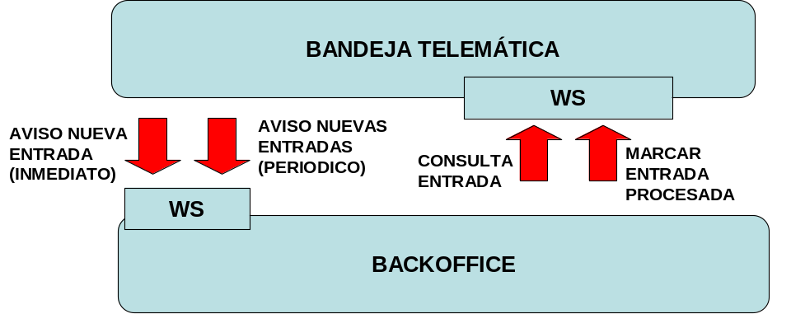

- Aviso nueva entrada (New entry warning): it can be configured (by process) that Telematic Box warns BackOffice about new entries (marked as non processed). There are two types of warnings:
  - Immediate: BackOffice is warned about new entry just after it is being added pointing out its number.
  - Periodic: BackOffice is warned about new entries every certain period of time.
EJB or Webservice must be implemented in the BackOffice to collect these warnings.
- Consulta entrada (entry query): once warning is received, BackOffice can query input data through an EJB or Webservice found in Telematic Box. This data contain forms and documents sent by citizen.
- Marcar entrada procesada (mark processed input): once input is processed by BackOffice, input should marked as processed in Telematic Box because next time the system warns about new inputs it would include this input. If Backoffice cannot process input due to an internal error (fi error inserting information into BackOffice tables, etc.), it should mark this entry as processed with error in order to avoid to be reprocessed. It’s a BackOffice task to control this kind of errors and inform users about. Information in Telematic Box can be accessed through its viewer if it’s wanted to process it manually.

An important issue to consider is that an entry can be included in a warning message several times, because while it is pending to be processed BackOffice will continue to be notified. To avoid problems it is desirable that BackOffice implements a control that prevents an input to be processed twice. This control can be to set entry number (in table where processed entry data is stored) as alternative key.

For interaction with telematic box we see that there are:
- services invoked from Sistra to BackOffice (input warning)
- services invoked from BackOffice to Sistra (query and status mark of input processing)

For input warning, BackOffice should implement Web Service specified in WSDL from project folder:
/moduls/modul-bantel/moduls/webservicesClient/wsdl/v2/BantelFacade.wsdl.

Operation for input warning is:

SERVICE | avisoEntradas
DESCRIPTION | It warns a BackOffice that it has inputs to be processed
PARAMETERS | - numeroEntradas: references to pending inputs to be processed. A reference comprises:  - numeroEntrada: entry number  - claveAcceso: password for entry
RETURN | This method returns nothing
COMMENTS | An important issue to consider is that an entry can be included in a warning message several times, because while it is pending to be processed BackOffice will continue to be notified. To avoid problems it is desirable that BackOffice implements a control that prevents an input to be processed twice. This control can be to set entry number (in table where processed entry data is stored) as alternative key.

Once warned inputs to BackOffice, it should collect data from inputs, process them and mark processing status. The platform offers a webservice that will allow access to these functions in telematic box specified in WSDL from project folder:
\Moduls\modul-Bantel\moduls\webservices\wsdl\Bantel\v2\BackofficeFacade.wsdl

Available operations are:

SERVICE | obtenerEntrada
DESCRIPTION | It allows a BackOffice to collect data from an input
PARAMETERS | - numeroEntrada: reference to input (input number / password)
RETURN | - TramiteBTE: it returns input data. Fields contained are:  - numeroEntrada: input number  - unidadAdministrativa: organizational unit  - fecha: date of entry in telematics box  - Tipo: input type: Input record (E) / Shipment (B) / Preregistry (P) / Pre-Shipment (N)  - firmadaDigitalmente: it indicates whether input was digitally signed (true/false)  - procesada: it points out whether it has been processed by BackOffice: Processed (S) / Not processed (N) / Processed with error (X)  - identificadorTramite: process identifier  - versionTramite: process version  - nivelAutenticacion: authentication level used during telematic processing  - usuarioSeycon: Seycon user during telematic processing  - descripcionTramite: process description  - codigoReferenciaRDSAsiento / claveReferenciaRDSAsiento: RDS reference of registry note  - referenciaGestorDocumentalAsiento: in case of existing document manager plug-in, it indicates the reference in this manager.  - codigoDocumentoCustodiaAsiento: in case of existing signature custody plug-in, it indicates the reference in this system.  - codigoReferenciaRDSJustificante / claveReferenciaRDSJustificante: RDS reference registry /shipment proof  - referenciaGestorDocumentalJustificante: in case of existing document manager plug-in, it indicates the reference in this manager  - codigoDocumentoCustodiaJustificante: in case of existing signature custody plug-in, it indicates the reference in this system.  - numeroRegistro: registry/shipment number  - fechaRegistro: registry/shipment date  - numeroPreregistro: pre-registry/pre-shipment number  - fechaPreregistro: pre-registry/pre-shipment number  - usuarioNif: user (or representative) nif who has developed telematic processing  - usuarioNombre: user (or representative) name who developed telematic processing  - representadoNif: representative nif (in case of representation)  - representadoNombre: representative name (in case of representation)  - delegadoNif: delegated person nif who delivers the process (If there is delegation). Delegated entity data will appear in usuarioSeycon, usuarioNif and usuarioNombre fields.  - delegadoNombre: delegated person name (If there is delegation)  - idioma: processing language.  - tipoConfirmacionPreregistro: in case of pre-registry, it points out how pre-registry was confirmed:In person registry point (R) / Confirmed by manager in bantelfront (G) / Confirmed automatically (A) / Automatically confirmed and in registry point later (X)  - habilitarAvisos: it indicates whether processing warnings are enabled  - avisoSMS: it indicates mobile for warnings  - avisoEmail: email for warnings  - habilitarNotificacionTelematica: it points out if telematic notification is enabled (in case process allows it). If not permitted by the procees, it will have null value.  - tramiteSubsanacion: it indicates associated record for a correcting process:  - expedienteCodigo: record code  - expedienteUnidadAdministrativa: administrative unit  - documentos: documents associated with input. Each document has the following fields:  - nombre: descriptive name of the document  - identificador: document identifier  - numeroInstancia:document instance number  - presentacionTelematica: in case of telematic presentation next information should be provided:  - codigoReferenciaRDS / claveReferenciaRDS: Document RDS Reference  - nombre: file name  - extension: file extension  - content: file content in bytes  - firmas: file signatures serialized in bytes through signature plugin (parseFirmaToWS method).  - estructurado: it indicates whether the document is structured (XML)  - referenciaGestorDocumental: in case document manager plug-in exists, it indicates the reference in this manager.  - codigoDocumentoCustodia: Ifcustody signature plug-in exists, it indicates reference to this system.  - presentacionPresencial: if it was delivered in person it’s necessary to inform:  - tipoDocumento: Proof (J) / Form (F) / Form proof (G) / Annex (A) / Payment (P)  - compulsarDocumento Indicates whether to certify a copy.  - fotocopia: Indicates whether a photocopy should be delivered.  - firma: Indicates whether to sign.

SERVICE | establecerResultadoProceso
DESCRIPTION | BackOffice sets input process status
PARAMETERS | - numeroEntrada: input reference (inputNumber / password)  - resultado:it indicates processing status: Processed (S) / Not processed (N) / Processed with error (X)  - resultadoProcesamiento: BackOffice indicates descriptive text of error when it occurs
RETURN | This method returns nothing
COMMENTS | IMPORTANT: It is important to note that input process status only indicates that BackOffice has correctly received input data. This result doesn’t mean that BackOffice treated this input internally with its logic. Therefore if BackOffice receives data correctly it should mark input as processed even it may not treat it in its logic later.

SERVICE | obtenerNumerosEntradas
DESCRIPTION | It allows BackOffice to query the box
PARAMETERS | - identificadorProcedimiento: procedure identifier  - identificadorTramite:process identifier  - procesada [OPTIONAL]: it enables to filter by processing status: Processed (S) / Not processed (N) / Processed with error (X)  - desde [OCPIONAL]: it filters by a start date.  - hasta [OPTIONAL]: it filters by an end date.
RETURN | - ReferenciasEntrada: reference list of inputs
COMMENTS | This service allows BackOffice implement a different scheme than automatic warning, being a fixed scheme on demand of BackOffice. That is, every certain time BackOffice could query pending inputs to be processed.

Personal Zone (ZONAPER)
An interface is provided to BackOffice applications for:
- creating records in citizen personal area.
- checking if citizen personal area was activated
- checking process payment status
A record is a section where informing user about any aspect of his processes. Different warnings can be associated to record progress called events. In turn every warning can have associated documents enabling that citizen can query aspects of his processing.

A record will be identified unambiguously by:
-administrative unit to which belong
-unique identifier of record inside administrative unit
-password for record allowing to secure its access. Any operation over this record (read or modification) requires this password.

When a record is added, it can be associated to a telematic process through BTE entry number generated by this process. In this way, initial request will be associated inside the record.

Record can be generated for an identified citizen (authenticated access) or from a process with anonymous access.

When creating a record it will be indicated if processing alerts should be generated (sms and email shipments) informing citizen when record event or notification was generated.
These alerts should be established based on data provided by citizen when initial process was performed. In case that required warning property is activated, it will ask conformity to be telematicaly notified and contact information for warnings.

A record can have different associated warnings related with record progress or status. These warnings are called "Events". An event is unambiguously identified by record to which belongs and date when it occurs, and it can have following properties:
- Titulo. Warning title
- Texto. Warning descriptive text
- Texto SMS. It indicates text to use in SMS alert if alerts are activated (if text isn’t set, a default message will be used).
- Lista de documentos. Document list associated to the warning.
- Enlace de consulta. Query link to any URL that contains a resource associated with warning

Every warning or "event" can have an associated list of documents. Each document is stored in RDS (Secure Repository of Documents).
When an event is created, a list of documents can be associated in one of following ways:
- Associate an existing RDS document. RDS document reference should be informed through code and RDSkey.
- Associate a new document to be created in RDS. Next properties should be informed to create a new document in RDS:
  - Titulo del documento (Document title).
  - Nombre del fichero del documento con extensión (Document file name with extension)
  - Modelo y versión RDS (RDS model and version).
  - Contenido binario del fichero del documento (Document file binary content).

When an event is generated it can be accessible through a password that is automatically generated by the system and it will be communicated in warning email of new record event.

Next we see BackOffice application calls to interact with citizen record zone in personal area:

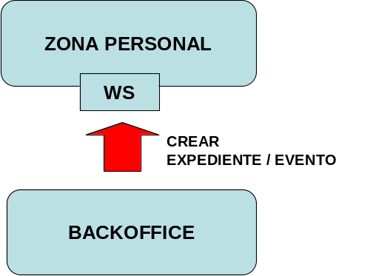

Platform offers a webservice allowing record and event insertion.
BackOffice shall implement a client for this Web service specified in WSDL in the project folder:
/moduls/modul-zonaper/moduls/webservices/wsdl/zonaper/v2/BackofficeFacade.wsdl.

Available operations are:

SERVICE | altaExpediente
DESCRIPTION | It allows to publish a record in citizen personal area
PARAMETERS | - expediente: data of record to publish:  - identificadorProcedimiento:procedure identifier to which record belongs.It isn’t necessary to indicate it if numeroEntradaBTE parameter is set, so that procedure identifier is read from entry.  - identificadorExpediente: record identifier  - unidadAdministrativa: administrative unit to which record belongs  - claveExpediente: record password  - idioma: record processing language  - descripcion: record description  - autenticado: it indicates if record is published for an authenticated user. If so, nif in nifRepresentante must have activated his personal area.  - nifRepresentante: representative nif  - nifRepresentado [OPTIONAL]: represented nif  - nombreRepresentado [OPTIONAL]: represented name  - numeroEntradaBTE [OPTIONAL]: it can be specified input number that originated the record. In this way process will related with record in personal area.  - configuracionAvisos [OPTIONAL]: warning setting for record:  - habilitarAvisos: it indicates if processing warnings were enabled  - avisoSMS: mobile for warnings  - avisoEmail: email for warnings  - eventos [OPTIONAL]: Specifies events associated to a record at the time of publication. To see event fields read altaEventoExpediente service.
RETURN | It returns nothing

SERVICE | altaEventoExpediente
DESCRIPTION | It allows publishing a record event in citizen personal area
PARAMETERS | - identificadorExpediente: record identifier  - unidadAdministrativa: administrative unit to which record belongs  - claveExpediente: record password  - evento: record event with next fields:  - titulo: event descriptive title.  - texto: event description.  - textoSMS [OPTIONAL]: if it warns through SMS, a customized text can be written different than default one.  - accesiblePorClave [OPTIONAL]: it points out that event will be accessible through a password. This key will be provided in warning mail.  - documentos [OPTIONAL]: documents can be associated to an event. A document has following fields:  - titulo: document description.  - nombre / contenidoFichero [OPTIONAL] file name (with extension) and document content will be pointed out in case that document binary is directly attached.  - codigoRDS / claveRDS [OPTIONAL]: code and password will be indicated If attached document was previously inserted in RDS.
RETURN | It returns nothing

SERVICE | existeZonaPersonalUsuario
DESCRIPTION | It lets verify if citizen has his personal area activated (if he ever entered in Sistra)
PARAMETERS | - nif: citizen nif
RETURN | - true / false

SERVICE | obtenerEstadoPagosTramite
DESCRIPTION | It checks payment status of a process
PARAMETERS | - identificadorPersistenciaTramite processing persistence id
RETURN | - Estado Tramite: processing status:  - PENDIENTE_ENVIAR: in persistence, it wasn’t sent  - ENVIADO: shipped (registry / pre-registry)  - NO_EXISTE: it doesn’t exist  - Estado Pagos: process payment status. For each processing payment it returns:  - idDocumento: document identifier in the process and instance number (fi PAGO-1)  - estado: payment status:  - PAGADO: payment performed  - PENDIENTE_CONFIRMAR: confirmation pending the payment against the entity  - NO_PAGADO: unpaid

SERVICE | altaZonaPersonalUsuario
DESCRIPTION | It activates citizen personal area to create records, events and notifications. When citizen enters for first time, a welcome filter will be displayed to confirm his personal data.
PARAMETERS | - nif: citizen nif  - nombre: citizen name  - apellido1: citizen first surname  - apellido2: citizen second surname
RETURN | - Generated user code. This user code will be temporary until citizen access for first time when it will be replaced by user code provided by authentication system.

Telematic Registry (REGTEL)
Sistra provides telematic registry interface implementing a logic layer on organization registry, allowing its publication for telematic processing.
Different involved elements are shown in figure below:

TELEMATIC REGISTRY
ORGANIZATION REGISTRY
APPLICATION
RDS
(Secure Document Repository)

- Application: management system that interacts with telematic registry (fi Sistra)
- RDS (Secure Document Repository): document container in electronic format.
- Telematic Registry: api that implements an interface to input/output registry based on registry notes in Sicres format.
- Organization Registry: organization registry

Telematic Registry interface provides next functions:
- Input registry: il allows that an application can perform a telematic input registry. Sistra uses this function internally to register online processes that it implements. This registering function could be used by an application other than Sistra that implement a certain telematic process (in this case telematic registry would be done but it wouldn’t be integrated with the Sistra Telematics Box because this box is only for Sistra implemented processes).
- Output registry: it allows that BackOffice applications can generate telematic notifications. A notification should always be generated within a record and it will be published in citizen personal area associated to this record. Citizen consent is required to generate a telematic notification. This consent can be given on start request (this data appears in request detail) but citizen can change his decision later. So this consent data must be handled externally to Sistra. Depending on warning configuration indicated on the record, citizen will be warned of new notification by email / SMS. We distinguish two notifications types:
  - notification with acknowledgment: citizen must digitally sign an acknowledgement of receipt to be able of querying it, giving legal proof that citizen has received such notification. It makes sense when start counting legal deadlines to correct the process after notification generation.
  - notification without acknowledgment: citizen doesn’t need acknowledgement of receipt to be able of querying it. It makes sense when it is a communication to citizen about record status but it doesn’t exist any period of time for responding.
- Get acknowledgment of receipt: for telematic notifications with acknowledgment of receipt, it can be queried if it was delivered to citizen and delivery date. Sistra can be configured to control delivery period (see zonaper properties). If Sistra is not configured for period control, it’s a BackOffice task to control it according to delivery date because personal area won’t control it.

As a result of input and output registry operations, Telematic Registry interface will generate a proof signed with organization registry certificate.

When an output registry (notification) is generated, it can be established the option that citizen can initiate a correcting process. It’s necessary to indicate process identifier and version (some parameters of process start may also be added). Thus, when citizen open the notification he will find a link to initiate the process. This correcting process is like other processes from definition point of view excepting it will receive record code and other parameters pointed out in notification as startup parameters. Once processed this process in Telematic Box, record code will also appear as input data allowing BackOffice to associate this input to the record.

When an output registry (notification) is generated, it can be indicated that it is accessible through password. This password will be generated automatically by the system and it will be communicated in warning mail of new notification.
Platform offers a webservice allowing access to telematic registry functions specified in WSDL from project folder:
/moduls/modul-regtel/moduls/webservices/wsdl/regtel/v2/BackofficeFacade.wsdl

Available operations are:

SERVICE | registroEntrada
DESCRIPTION | It performs a telematic input registration
PARAMETERS | - entrada: input registry data that contains:  - oficinaRegistral: registry office where registration is done:  - codigoOficina: office Code (according organization registry code)  - codigoOrgano: destination organization code (according organization registry code)  - datosInteresado: applicant data containing:  - autenticado: it indicates whether registration was done by an authenticated user. If so indicated nif must have its personal area activated.  - nif: applicant nif  - nombreApellidos: full name (format: "lastname, firstname")  - codigoPais: country code  - nombrePais: country name  - codigoProvincia: province code (INE)  - nombreProvincia: province name  - codigoLocalidad: town code (INE)  - nombreLocalidad: town name  - datosRepresentado [OPTIONAL]: If representation exists it will indicate the represented:  - nif: represented nif.  - nombreApellidos: full name (format: "lastname, firstname")  - datosAsunto: registry subject  - idioma: language used in registration  - asunto: subject description  - tipoAsunto: subject type (according to organization registry coding)  - codigoUnidadAdministrativa: administrative unit  - documentos: documents associated to registry. A document can reference a previously inserted document  - referenciaRDS: RDS reference  or specify necessary data:  - modelo: document model  - version: model version  - nombre: document name  - extension: extension  - datosFichero: file content  - plantilla [OPTIONAL]: specific formatting template  - firmas [OPTIONAL]: document signatures
RETURN | - ResultadoRegistro: it returns registry result:  - numeroRegistro: registry number  - fechaRegistro: registry date  - referenciaRDSJustificante: RDS reference of proof generated by telematic registry
COMMENTS | This record wouldn’t be signed by citizen

SERVICE | prepararRegistroEntrada
DESCRIPTION | It prepares a telematic input registry to be signed by citizen before it is registered (registroEntradaConFirma service)
PARAMETERS | - entrada: input registry data to be added  - diasPersistencia (optional): days that generated note will be stored waiting for registration end. If this parameter is not set, the note will be purged in next process execution for removing documents without RDS uses.
RETURN | - ReferenciaRDSAsientoRegistral: it returns generated registry note to be signed by citizen:  - asientoRegistral: RDS reference of the note  - anexos: RDS reference list of note annexes

SERVICE | registroEntradaConFirma
DESCRIPTION | It generates a signed entry record from generated note signature with previous service (prepararRegistroEntrada).
PARAMETERS | - ReferenciaRDSAsientoRegistral: generated registry note signed by citizen:  - asientoRegistral: RDS reference of the note  - anexos: RDS reference list of note annexes  - firma: note signature containing fields:  - formato: signature format (depending on signature plug-in)  - firma: signature content. parseFromBytes method from signature plug-in is used to interpret signature. So this content should be according to used format in signature plug-in.
RETURN | - ResultadoRegistro: it returns registry result:  - numeroRegistro: registry number  - fechaRegistro: registry date  - referenciaRDSJustificante: RDS reference of proof generated by telematic registry

SERVICE | registroSalida
DESCRIPTION | It generates a telematic output registry (telematic notification). When notification is generated, it is published in citizen personal area sending necessary warnings (sms / email).  A notification must be generated in a record, so a previous step to notification generation is to publish this record in personal area.
PARAMETERS | - notificacion: output registry data contains:  - datosExpediente: reference to record containing notification:  - identificadorExpediente: record identifier  - unidadAdministrativa: administrative unit to which record belongs  - claveExpediente: Password to access record  - oficinaRegistral: registry office where it is registered:  - codigoOficina: office code (according to organization registry coding)  - codigoOrgano: destination organization code (according to organization registry coding)  - datosInteresado: applicant data stating:  - autenticado: it indicates whether registration isperformed for an authenticated user. If so indicated nif must have its personal area activated  - nif: recipient nif.  - nombreApellidos: full name (format: "lastname, firstname")  - codigoPais: country code  - nombre Pais: country name  - codigoProvincia: province code (INE)  - nombreProvincia: province name  - codigoLocalidad: town code (INE)  - nombreLocalidad: town name  - datosRepresentado [OPTIONAL]: If there is representation, it will indicate the represented:  - nif: represented nif  - nombreApellidos: full name (format: "lastname, firstname")  - datosNotificacion: notification data  - idioma: language used for registration  - tipoAsunto: subject type (according to organization registry coding)  - acuseRecibo: it states if notification requires acknowledgment of receipt (true / false)  - aviso: notification warning data for citizen to be showed before notification is opened.  - titulo: warning title  - texto: warning descriptive text  - textoSMS [OPTIONAL]: it sets customized text for SMS warning. If not specified, default text will be used.  - accesiblePorClave [OPTIONAL]: it indicates that notification can be accessed through a password. This password will be provided in warning mail.  - oficioRemision: reference notice data. This information will be showed once notification is opened (together with annex document list).  - titulo: notice title  - texto: notice descriptive text  - tramiteSubsanacion [OPTIONAL]: it allows specifying a correcting process:  - descripcionTramite: descriptive text to be displayed as a link in personal area to start correcting process.  - identificadorTramite: process identifier  - versionTramite: process version  - parametrosTramite [OPTIONAL]: it allows to set startup parameters to the process (data preload, etc.). Record code will pass automatically as startup process parameter.  - Documentos [OPTIONAL]: documents associated to registry. A document can reference a previously inserted document:  - referenciaRDS: RDS reference  or specify necessary data:  - modelo: document model  - version: model version  - Nombre: document name  - extension: extension  - datosFichero: file content  - plantilla [OPTIONAL]: specific formatting template  - firmas [OPTIONAL]: document signatures
RETURN | - ResultadoRegistro: it returns registry result:  - numeroRegistro: registry number  - FechaRegistro: registry date  - referenciaRDSJustificante: RDS reference of proof generated by telematic registry

SERVICE | obtenerAcuseRecibo
DESCRIPTION | It lets obtain delivery date of a notification with acknowledgement of receipt
PARAMETERS | - numeroRegistro: registry number
RETURN | - fechaAcuseRecibo: acknowledgment of receipt date, fi when a notification was delivered to citizen. If it is null, it states that it wasn’t delivered yet.
COMMENTS | Sistra can be configured to control delivery period (see zonaper properties). If Sistra is not configured to control this period, it’s a BackOffice task to control notification period observance according to delivery date (personal area won’t control it).

SERVICE | obtenerDetalleAcuseRecibo
DESCRIPTION | it gets notification delivery detail.
PARAMETERS | - numeroRegistro: registry number
RETURN | - estado: notification status (PENDING/DELIVERED/REJECTED)  - fechaAcuseRecibo: acknowledgment of receipt date, fi when notification was delivered to citizen. If null, it states that it wasn’t delivered yet (for notifications with acknowledgment of receipt)  - ficheroAcuseRecibo: RDS reference of acknowledgment of receipt  - avisos: warning list for citizen to warn about notification. Each warning contains next message:  - Tipo: EMAIL / SMS  - destinatario: recipient (email address list separated by,)  - enviado: it states if it was sent (true / false)  - fechaEnvio: shipping date  - confirmarEnvio it indicates if it’s marked for confirming shipment  - confirmadoEnvio: it states if shipment was confirmed (UNKNOWN/NOT_SEND / SENT)
COMMENTS | Sistra can be configured to control delivery period (see zonaper properties). If Sistra is not configured to control this period, it’s a BackOffice task to control notification period observance according to delivery date (personal area won’t control it).

Mobility (MOBTRATEL)
This module will give scheduled shipment functionality of email and/or SMS messages in the platform. Any platform module or management applications can remotely request a shipment to mobility module. A shipment will be composed of n email and/or SMS messages.

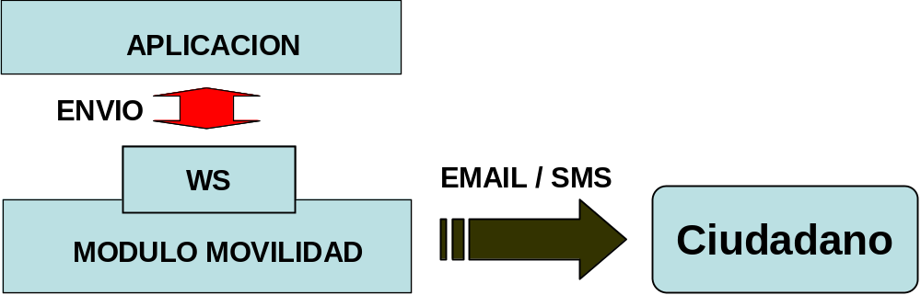

The mobility module allows to define different message sending accounts so that when a shipment is performed to this module, it will be necessary to state transmitting account to execute it (fi it allows different email senders, etc.)

Two messages types are distinguished:
- scheduled: a start date is given from which shipment will be made
- immediate: shipment will be send once mobility module receives corresponding request.

An expiration date can be assigned to shipments. That way, if shipment errors are found, system will continue trying until expiration date is reached. If expiration date isn’t assigned, it will be set a default period (according to module properties file).

For email submissions, mail-services will be defined in Jboss stating sending SMTP accounts (see Administration document). For SMS shipments, SMS shipment plug-in from organization will be used interacting with specific solution for SMS shipments adopted by organization.

Platform offers a webservice that allows accessing to shipping functions specified in WSDL from project folder:
/moduls/modul-mobtratel/moduls/webservices/wsdl/mobtratel/v2/BackofficeFacade.wsdl

Available operations are:

SERVICE | enviarMensaje
DESCRIPTION | It allows to perform a scheduled shipment
PARAMETERS | - mensaje: data of message to send  - nombre: message descriptive name.  - cuentaEmisora: account used for sending the message  - inmediato: it indicates if message will be sent just after being received (true / false)  - fechaProgramacionEnvio [OPTIONAL]: if not immediate, a scheduled shipment date should be specified.  - fechaCaducidad [OPTIONAL]: expiration date. if shipment errors are found, system will continue trying until this expiration date is reached. If expiration date isn’t assigned, it will be set a default period  - emails [OPTIONAL]: email messages list to send. An email message has next fields:  - destinatarios: email address list separated by ;  - titulo: message title  - texto: message content  - html: it indicates whether message content is in HTML format (true/false)  - verificarEnvio (optional): it indicates if message shipment must be verified (true / false). Email shipment plug-in must support this functionality.  - smss [OPTIONAL]: SMS messages list to send.. An SMS message has following fields:  - destinatarios: mobile number list separated by ;  - texto: SMS message content. It cannot exceed maximum number of characters (it’s set in module properties file).  - verificarEnvio (optional): it indicates if message shipment must be verified (true / false). SMS shipment plug-in must support this functionality.
RETURN | - codigoEnvio: it returns shipment code.

