Liberación SISTRA: módulo Pagos

Code: DSI-LIBSISTRA-PAYMENTS

DOCUMENT CONTROL SHEET

 |  | DOCUMENT / FILE
Title: Liberación SISTRA: módulo Pagos |  |  |  |  |  |  |  |  |  | File Name / s:0000.doc
Code: DSI-LIBSISTRA-PAYMENTS |  |  |  |  |  |  |  |  |  | Software: Word
Date: 01/20/2014
Version: 9
 |  |  |  | RECORD OF CHANGES
 | Version |  |  | Pages |  |  | Reason for change
 | 1 |  |  | 12 |  |  | Document Creation
 | 2 |  |  | 12 |  |  | Functionalities reviewing
 | 3 |  |  | 12 |  |  | Pending confirmation status added
 | 4 |  |  | 12 |  |  | Customized proof functionality removed
 | 5 |  |  | 12 |  |  | Rate ammount consult funcitonality added
 | 6 |  |  | 12 |  |  | Payment session status property added
 | 7 |  |  | 11 |  |  | IdentificadorPago and fechaPago properties redefinition in payment sesión status in order to allow to be used for in person confirmed payments too.  New properties in DatosPago: modeloTramite, versionTramite and IdentificadorTramite in order to better identify the process (before it only existed process name).
 | 8 |  |  | 11 |  |  | New property in DatosPago for identifying payment responsible organization
 | 9 |  |  | 12 |  |  | It allows to set a maximum time length for payment process
 |  |  |  |  |  | DISTRIBUTION OF DOCUMENT
 |  |  | Name |  |  |  |  | Staff
 |  |  | Andreu Font |  |  |  |  | DGTIC
 |  |  | Antonio Reus |  |  |  |  | IBIT
 |  |  | Rafael Barceló |  |  |  |  | IBIT
 |  |  |  | DOCUMENT CONTROL
PREPARATION |  |  |  |  | REVISED / APPROVED |  |  |  |  |  |  |  | ACCEPTED |  | ACCEPTED
Rafael Sanz |  |  |  |  | José Vicente Juan Pérez |  |  |  |  |  |  |  | Andreu Font |  | Rafael Barceló
Complete with the name, signature and date |  |  |  |  |  |  |  |  |  |  |  |  |  |  |  | Customers only

INDEX
1. Goal 4
2. Subclass 5
3. Plug-in interface 6
4. Payment plug-in implementation 7
4.1. Components to develop 7
4.2. Payment session 7
4.3. Browser redirection between SISTRA and payment plug-in 8
4.4. Payment assistant 9
4.5. Proof of payment 10
5. ANNEX: Payment XML 11

Goal
The purpose of this document is to define the interface to be implemented by a payment plug-in to operate with SISTRA platform.

Subclass
The scheme works as follows:
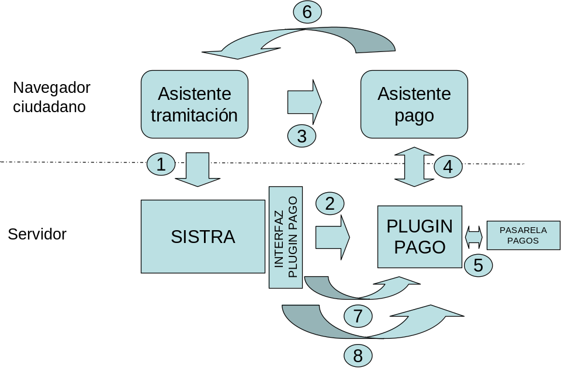

- Citizen can initiate payment process through processing assistant.
- Processing assistant tells to payment plug-in payable rate data and processing assistant URL to be returned after finishing payment. As response, payment plug-in points out reference identifying payment session and URL to redirect for initiating payment process.
- Processing assistant redirects citizen browser to URL established by payment plug-in.
- Payment plug-in collects necessary data from citizen for payment.
- Payment plug-in communicates with payment gateway for completing the payment
- When payment process is finished, citizen browser is redirected to processing assistant URL.
- Sistra updates payment status with payment session reference.
- Sistra tells payment plug-in that payment session data can be removed.

Plug-in interface
Communication interface between SISTRA and payment plug-in is as follows:
Method | Description | Parameters | Result
iniciarSesionPago | It initiates a payment session. After session begins, citizen browser is redirected to payment assistant. | DatosPago: Payable rate data  SesionSistra: Return data to SISTRA | SesionPago: Payment session reference and payment process start URL.
reanudarSesionPago | It resumes a payment session initiated before. After session resuming, citizen browser will be redirected to payment assistant. | Localizador: Payment session reference  SesionSistra: Return data to SISTRA | SesionPago: Payment session reference and payment process start URL.
comprobarEstadoSesionPago | It checks the status of a payment session. | Localizador: Payment session reference | EstadoSesionPago: indicates payment status:  - Payment Type: in person or telematic  - Status: it does not exist, in process, pending confirmation or confirmed
finalizarSesionPago | It finishes a payment session started earlier.  Then, plug-in can remove session data:  - Payment in progress: payment process is cancelled  - Confirmation pending payment: it won’t be allowed to finish the session  - Confirmed payment: payment process done | Localizador: Payment session reference | Nothing returned
consultarImporteTasa | Allow to query rate amount | IdTasa: rate identifier | Rate amount in cents (for instance, 10.20 € = 1020 cents)
For more information on fields refer to javadoc.

Payment plug-in implementation
Below there are details to be considered in payment plug-in implementation.

Components to develop
Components to develop for a payment module integration are next:
  - payment plug-in interface: it implements functions that handle communication between SISTRA and payment plug-in. Communication between both applications can be solved through webservices or EJBs calls.
  - payment plug-in: a web application including logic and screens (payment assistant) for payment process management. It will receive payment start data from payment plug-in interface. This payment plug-in will communicate with underlying payment gateway (taxpayer portal from DGTIC, la Caixa gateway for City Council, Red.es gateway, etc.). Payment and processing assistant screens should have a similar look so that citizen cannot realize when he jumps between them.

Payment session
The interaction between SISTRA and payment plug-in is based on 'payment session'. SISTRA invokes payment plug-in passing data of payment to perform and payment plug-in returns a session reference. Through this reference, SISTRA will be able to initiate or resume a payment session, execute payment status or proof queries, etc. Therefore payment plug-in shall contain necessary logic for creating and storing these payment sessions (storage in DB is advised) and for status management. Once SISTRA informs payment plug-in that payment session is finished (finalizarSesionPago method), payment plug-in can remove payment session data (although if wanted, this information can be kept as a log of performed payments).

Information regarding a payment session is as follows:

Estado | - No existe: It doesn’t exist payment session for a particular session reference  - En curso: Payment session in progress. Existing payment session should be resumed.  - Pago pendiente confirmación: It waits for payment gateway response confirming payment was made. This intermediate step can exist depending on payment gateway.  - Pago confirmado: Payment session completed with confirmed payment.  - Excedido tiempo pago: Payment session exceeded maximum time for paying
Tipo de pago | Presencial (P) / Telemático (T)  For payment gateways non accepting in person type, it will always use type T.
Identificador pago | It sets payment identifier for confirmed payments (identifier used by gateway: DUI, NRC, etc) (Mandatory for telematics)
Fecha pago | It sets payment date for confirmed payments (Mandatory for telematics)
Recibo pago telemático | For confirmed payments, it can collect an electronic receipt (base 64) from the payment gateway that identifies the transaction (Not mandatory)
Descripción estado | Debug message from payment plug-in (Not mandatory)

Browser redirection between SISTRA and payment plug-in
Payment plug-in provides an url based on an access token when an operation is invoked forcing a citizen browser redirection. This access token will be a randomly generated string that will be valid only for a few seconds and it will allow to relate the url with payment session.

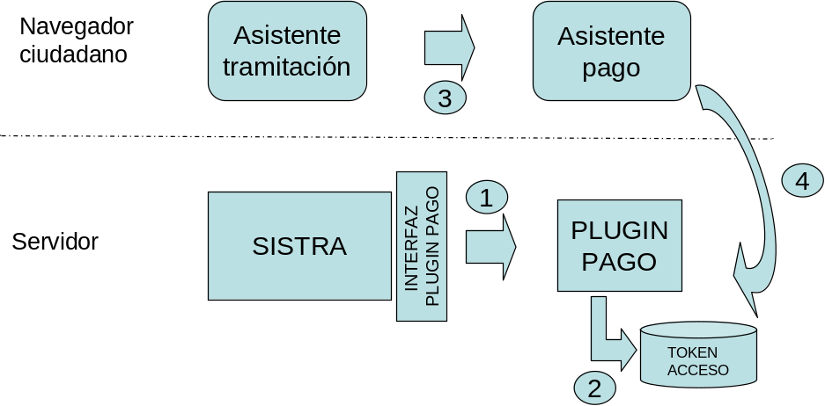

Below we see an example of payment session start management:
- IniciarSesionPago method is invoked through the interface
- Payment plug-in creates a payment session assigning a session reference and storing data of payment to perform. To redirect to payment assistant it generates a random access token valid for few seconds allowing to redirect to created payment session.
- Processing assistant redirects payment assistant through url with access token (it wouldn’t appear any additional information in this url)
- Payment plug-in receives this url and it gets session reference from access token. Previously, it was verified that this token is valid: it has not expired and it corresponds to payment session reference.

Payment assistant
Payment plug-in will be responsible for showing necessary screens and collecting citizen data for carrying out payment process.

Information received from SISTRA when a payment session is started is next:

tipoPago | It indicates allowed payment type: In person (P) / Telematic (T) / Both (A)  For payment gateways non accepting in person payment, T type will be always used
language | Language used for payment (es,ca)
identificadorOrganismo | Payment responsable organization identifier
model | Rate model (fi 046)
idTasa | Rate identifier
concepto | Rate description
importe | Rate amount in cents (fi 1045 cents → 10.45 €)
fechaDevengo | Payment calculated date
nifDeclarante | Deponent NIF / CIF corresponding to rate payment
nombreDeclarante | Complete person name performing rate payment
identificadorTramite | Process identifier in which the payment is made.
modeloTramite | Process model in which payment is made.
versionTramite | Process version in which payment is made.
nombreTramite | Process name where payment is made. It will be used for achieving that payment assistant header be processing assistant.
nombreUsuario | User name performing the process It will be used for achieving that payment assistant header be processing assistant.
fechaMaximaPago | It sets maximum date for starting payment
mensajeTiempoMaximoPago | Message to display if maximum date for starting payment is exceeded

From these data and according to features offered by its payment platform, payment plug-in should manage payment process (fi asking for bank details, etc.).

Proof of payment
Proof of payment for citizen is generated by SISTRA through a PDF display template for payment document in document repository (GE0006PAGO model in REDOSE).
This template is customizable by each organization including logos, texts, etc.
Currently, DGTIC template for this document is next:

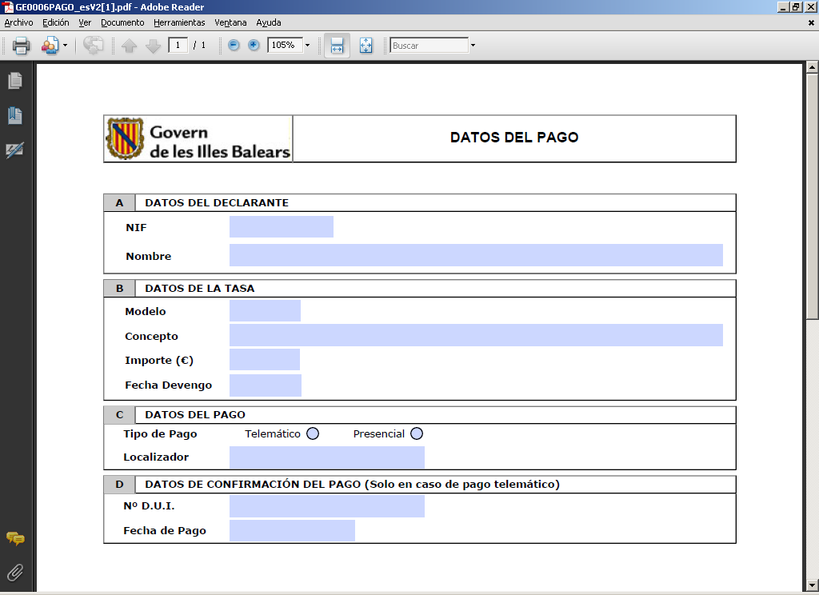

You can define a customized template including organization logo, text, formatting and it can show only data related with telematic payment if payment gateway doesn’t allow in person payment.

ANNEX: Payment XML
Payment data will be stored in SISTRA as a XML document. This XML document will be displayed to the user through a PDF display template (see point 4.5).
An example of payment XML is next:

<? Xml version = "1.0" encoding = "UTF-8"?>
<PAYMENT model = "GE0006PAGO" version = "1">
<! - Data set by the processing platform ->
<DATOS_PAGO>
<! - Plugin Id Payment (Optional, only if there are more than one plugin surcharge) ->
<PLUGIN_ID> POS </ PLUGIN_ID>
<! - P / T (Face / Telematics) ->
<TYPE> T </ TYPE>
<! - S / N (Paid / Unpaid) ->
<STATE> S </ STATE>
<! - Issuer Organo rate (Optional) ->
<ORGANO_EMISOR> ieb </ ORGANO_EMISOR>
<- Model ->
<MODEL> 046 </ PATTERN>
<- Rate ->
<ID_TASA> 7.2 </ ID_TASA>
<! - Amount in cents: 1305 = 13.05 ->
<AMOUNT> 1305 </ AMOUNT>
<! - Accrual date (AAAAMMDDHHMISS format) ->
<FECHA_DEVENGO> 20081021000000 </ FECHA_DEVENGO>
<! - Start limit for payment (AAAAMMDDHHMISS format) Date ->
<FECHA_LIMITE_PAGO> 20081021000000 </ FECHA_LIMITE_PAGO>
<! - Definition ->
<CONCEPT> Rate for the first issue or renewal of recreational fishing license </ CONCEPT>
<! - Reporting data: nif and name ->
<REPORTING>
<NIF> 0000000T </ NIF>
<NAME> Jose Garcia Gomez </ NAME>
</ REPORTING>
</ DATOS_PAGO>
<! - Data generated by the payment gateway ->
<DATOS_PASARELA>
<! - Billing identification number, would be equivalent to NRC ->
<NUMERO_DUI> 1234567890 </ NUMERO_DUI>
<! - Session Locator payment ->
<LOCATOR /> 0462801010944 </ LOCATOR>
<! - Date of payment (AAAAMMDDHHMISS format) ->
<Date_paid> 20081021005000 </ date_paid>
<! - Proof in B64 xml returned by the payment gateway (optional) ->
<RECEIPT />
</ DATOS_PASARELA>
</ PAYMENT>

