Liberación SISTRA: módulo envío SMS

Code: DSI-LIBSISTRA-SMS

DOCUMENT CONTROL SHEET

 |  | DOCUMENT / FILE
Title: Liberación SISTRA: módulo envío SMS |  |  |  |  |  |  |  |  |  | File Name / s:0000.doc
Code: DSI-LIBSISTRA-SMS |  |  |  |  |  |  |  |  |  | Software: Word
Date: 03/04/2012
Version3
 |  |  |  | RECORD OF CHANGES
 | Version |  |  | Pages |  |  | Reason for change
 | 1 |  |  | 6 |  |  | Document Creation
 | 2 |  |  | 6 |  |  | Functionalities Review
 | 3 |  |  | 7 |  |  | Functional verification shipping
 |  |  |  |  |  | DISTRIBUTION OF DOCUMENT
 |  |  | Name |  |  |  |  | Staff
 |  |  |  | DOCUMENT CONTROL
PREPARATION |  |  |  |  | REVISED / APPROVED |  |  |  |  |  |  |  | ACCEPTED |  | ACCEPTED
Rafael Sanz |  |  |  |  | José Vicente Juan Pérez |  |  |  |  |  |  |  | Jerome Navarrete |  | Bernat Alberti
Complete with the name, signature and date |  |  |  |  |  |  |  |  |  |  |  |  |  |  |  | Customers only

INDEX
1. Goal 4
2. Subclass 5
3. Interface plug-in 6

Goal
The purpose of this document is to define actions to perform in order to achieve that SISTRA platform can interact with SMS shipment platform from each organization.

Subclass
The scheme works as follows:

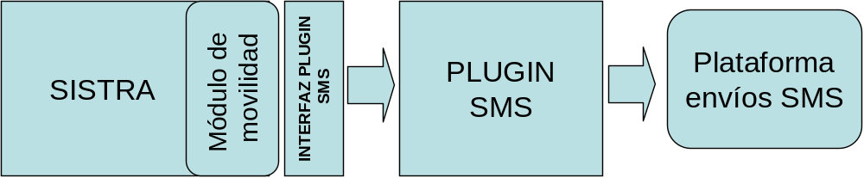

Mobility module will perform SMS shipment through customized plug-in from each organization.

If an organization does not have a SMS shipment platform, it won’t be necessary to implement this plug-in because SMS shipment will be disabled through configuration.

Interface plug-in
Communication interface between SISTRA and SMS plug-in is as follows:
Method | Description | Parameters | Result
enviarSMS | It performs SMS shipment | idEnvio: Shipping code  cuentaSMS: SMS account for shipment gateway. It allows to define different shipment accounts to be used by SMS shipment gateway if it supports this functionality  telefono: Phone number to send the message  mensaje: SMS message  inmediato: It indicates whether SMS should be sent immediately. It allows to set message priorities if shipment gateway supports this functionality | No
consultarEstadoEnvio | Check shipment status. This functionality can be implemented if supported by shipment gateway | idEnvio: Shipping code | EstadoEnvio: delivery and description status. Possible status are:  - X: Not implemented  - D: Unknown  - Q: Pending  - E: Submitted  - N: Not sent

For more information consult javadoc.

