SISTRA - ADMINISTRACIÓN

Code: SISTRA-ADMIN

DOCUMENT CONTROL SHEET

 |  | DOCUMENT / FILE
Title: SISTRA - ADMINISTRACIÓN |  |  |  |  |  |  |  |  |  | File Name / s:0000.doc
Code: 0000.doc |  |  |  |  |  |  |  |  |  | Software: Word
Date: September 2010
Version: 2
 |  |  |  | RECORD OF CHANGES
 | Version |  |  | Pages |  |  | Reason for change
 | 1 |  |  | 40 |  |  | Document Creation
 | 1 |  |  | 42 |  |  | Access permission administration to processes and forms  List of automatic processes
 | 2 |  |  | 26 |  |  | Name and Location of FORMS document (Antoni Nadal, IBIT)
 |  |  |  |  |  | DISTRIBUTION OF DOCUMENT
 |  |  | Name |  |  |  |  | Staff
 |  |  | INDRA Sistemas, SA
 |  |  | DGTIC
 |  |  |  | DOCUMENT CONTROL
PREPARATION |  |  |  |  | REVISED / APPROVED |  |  |  |  |  |  |  | ACCEPTED |  | ACCEPTED
Roberto Lorenzo Calpe  Rafael Sanz Villanueva  Guillermo Corullón Lake  Vicent Ferrer i Pérez |  |  |  |  | José Vicente Juan Pérez |  |  |  |  |  |  |  | Jerome Navarrete |  | Bernat Albertí
Complete with the name, signature and date |  |  |  |  |  |  |  |  |  |  |  |  |  |  |  | Customers only
INDEX
1. Introduction 4
2. Telematics Platform Administration 5
2.1. SISTRA - SISTRAADMIN, SISTRABACK 5
2.1.1. Add Responsible Authority 5
2.1.2. Process Add 7
2.1.3. Deleting a process 9
2.1.4. Process import (Importación de trámites) 11
2.1.5. Locking / Unlocking of a process version 14
2.1.6. Presentation period modification 16
2.1.7. Elimination of a process version 16
2.1.8. Process export 18
2.1.9. Domain configuration 19
2.1.9.1. Domain Add 20
2.1.9.2. Domain Query / Modification 21
2.1.10. Access permission to processes 22
2.2. FORMS - Formadmin, Formback 22
2.2.1. FORMS configuration - FORMADMIN 22
2.2.1.1. MASKS 22
2.2.1.2. PATTERNS 23
2.2.1.3. PROFILES 23
2.2.2. Import / export of forms - FORMBACK 23
2.2.2.1. Forms import 24
2.2.2.2. Forms export 24
2.2.3. Access permissions to forms 25
2.3. REDOSE - REDOSEBACK 26
2.3.1. Definition of document models 26
2.3.1.1. Model add 26
2.3.1.2. Version add 29
2.3.1.3. Template add 30
2.3.1.4. Model query 31
2.4. BANTEL - BANTELBACK 33
2.4.1. Process definition and processing configuration 34
2.4.1.1. Add of a reference to a process 35
2.4.1.2. Query/Modification of a reference to a process with warnings to BackOffice 37
2.4.2. Manager definition and access to processes 38
2.4.2.1. Manager add 38
2.5. MOBTRATEL - MOBTRATELBACK 40
2.5.1. Shipping account definition 40
2.5.2. Permission assignment 41
3. Automatic processes 42

Introduction
This document describes administration options of modules composing telematic processing platform.

These options are summarized as:
- SISTRA module: import/export of processes and domain configuration. Access permission administration for processes.
- FORMS module: mask, pattern and profile definition and import/export of forms. Access permission administration for forms.
- REDOSE module: document module definition
- BANTEL module: process definition and processing configuration
- MOBTRATEL module: shipping account definition.

NOTE:
It is important to note that screens shown in this document may vary from those shown in application. This paper aims to present main administration options and not latest version of screens.

Telematics Platform Administration

As result of process development, Developer will deliver a Load Log to Administrator for process deployment. In this load log it is indicated what steps must be followed for process installation in corresponding environment. It is detailed how to perform these steps. SISTRA-CUADERNOCARGA document proposes a model for specifying these installation instructions.

SISTRA - SISTRAADMIN, SISTRABACK
Administrator can perform next tasks from SISTRABACK module:
- Import/export processes
- Domain configuration
Administrator can assign access permission to processes from SISTRAADMIN module

Add Responsible Authority
Here are steps to take for creation/modification of a Responsible Authority within Telematic Processing System:
- SISTRABACK module relevant to specific environment where you want to act (Development, Pre-production, Production) must be accessed through web browser. For example, following URL: http://caibCD:8080/sistraback/ would be used to enter to test environment.
It is necessary to identify a user who has permissions (role STR_ADMIN) to initiate a session in SISTRABACK.

- Once user access to environment is validated, SISTRABACK environment main window is displayed in browser window with following items (Figure 1.- ):
- SISTRABACK management menu located on the left side of browser window.
It allows to perform different actions on documents contained in Processing System:
  - Display Responsible Authorities list defined in Processing System (Figure 1.- ). In this list you can:
    - Define a new Responsible Authority within Processing System
    - Select a Responsible Authority for edition and/or modification.
    - Delete an existing Responsible Authority in Processing System.
    - Display processes associated to a particular Responsible Authority.
  - Display list of Domains defined in Processing System (See section 3.1.9 Domain configuration).

To define a new Responsible Authority just press New Record button of Figure 1.- .
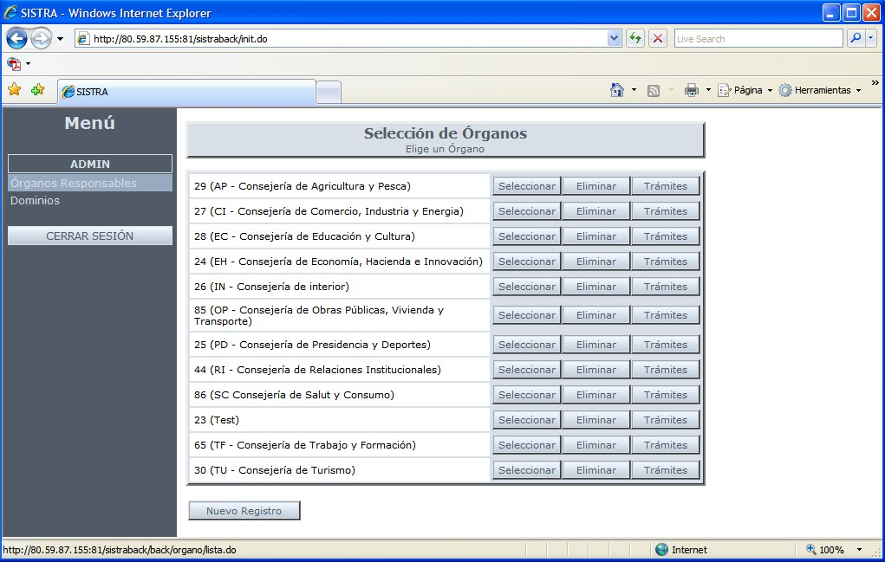
Figure 1.- Main window of SISTRABACK module - Responsible Authorities Management.

- Once inside of a new Responsible Authority add window in SISTRABACK (Figure Figure 1), Administrator user must fill following data:
- Description: it allows to briefly indicate what type of Responsible Authority it is (usually a Ministry).
To register new Responsible Authority just press Insertar button located at the bottom left of the window.

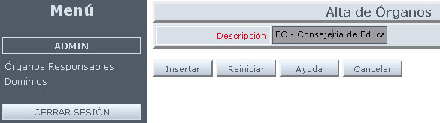
Figure 1.- Responsible Authority add window in SISTRABACK.

Once Responsible Authority is added, add window is updated to modification one (Figure 2), in which Insertar button becomes Modificar.
To discard any changes simply press Cancelar button which returns the user to the window with Responsible Authorities shown in Figure Figure 1.

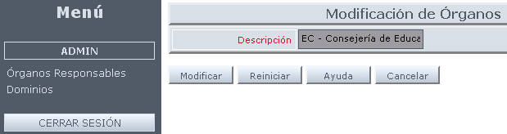
Figure 2.- Responsible Authority modification window in SISTRABACK.

Once done, SISTRABACK main window updates its Responsible Authorities list (Figure 1.- ), including just defined one by user.

Process Add
Steps to add a process in Telematic Processing System:
- Accessing to window showing Responsible Authorities list in SISTRABACK (Figure 1.- ), it’s necessary to select Responsible Authority to which process belongs and press Tramites button to access to list of processes associated with this Responsible Authority.
Management window structure for processes associated with Responsible Authortrities is split into two zones (Figure Figure 3):
- Upper zone: it displays the set of processes associated with selected Responsible Authority. It’s presented as a component tree defining each existing process.
- Lower zone: it shows definition screens and/or edition of selected items in the tree of Upper zone.

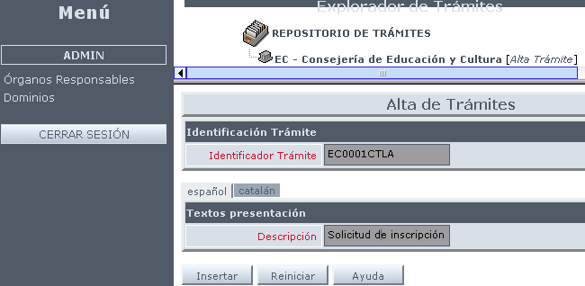
Figure 3.- Window of Process Browser and Definition inside SISTRABACK.

New process definition window is accessed clicking on identified tree branch as Process Add (Alta de Trámite). Its appearance is shown in Figure Figure 3.
Data to fill to define a new process in SISTRABACK associated with our Responsible Authority is next:
- Process Identifier (Identificador Trámite): Brief description (10 characters) identifying easily the process to define.
A concrete structure of naming processes was established in Digital Administration project, following nomenclature schema defined by CAIB.
- Description (Descripción): Free text for identifying the type of process to create.

NOTE: A Help (Ayuda) button is available in all Web module screens from SISTRABACK. When pressed, it gives detailed information of each field for each particular window where user is working (see Figure 4).

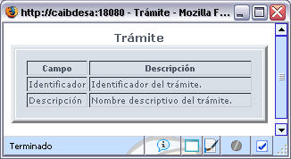
Figure 4.- Help for process definition in SISTRABACK.

- Once new process data was entered, it will be added in the Platform after clicking on Insert (Insertar) button and Figure 4 window updates its content to that shown in Figure Figure 5:
- Process edition window (bottom area of ​​the screen) updates its buttons and it displays content entered by user.
- Component tree updates its content with a new branch corresponding to defined process showing three options:
  - Change process definition.
  - Import a new process version from an external XML file.
  - Define a new version of process (In Figure Figure 5, it doesn’t exist any version yet).

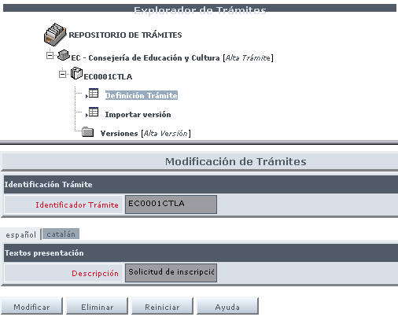
Figure 5.- Repository tree update for Responsible Authority processes in SISTRABACK, once a new process is defined.

Deleting a process

Steps for removing a process in Telematics Processing System:
- Accessing window showing Responsible Authorities list in SISTRABACK (Figure 1.- ), Responsible Authority should be selected to which process belongs and press Processes (Trámites) button to access process list associated with this Responsible Authority.
Management window structure for processes associated with Responsible Authorities is split into two zones:
- Upper zone: it displays the set of processes associated with selected Responsible Authority. It’s presented as a component tree defining each existing process.
- Lower zone: it shows definition screens and/or edition of selected items in the tree of Upper zone.
- Pressing on tree branch identified with process name for which you want to import a new version, three options are deployed whose appearance is shown at the top of Figure Figure 5.
- If you click on Process Definition (Definición Trámite), bottom of Figure Figure 6 will be displayed.
- It’s necessary to press Delete (Eliminar) button in Figure Figure 6 and a popup warning window of delete confirmation is displayed.
- If you click on Accept (Aceptar), process is removed from Platform and confirmation message related with this operation is displayed (Figure Figure 7).

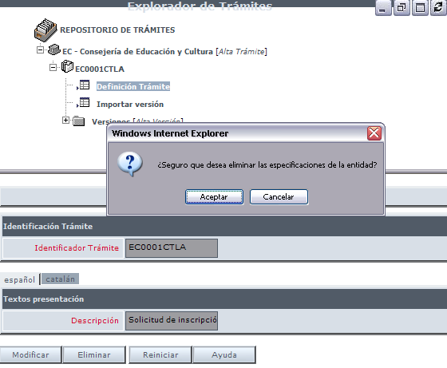
Figure 6.- Detail of process delete in SISTRABACK.

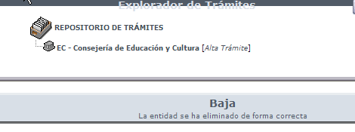
Figure 7.- Confirmation message of process delete in SISTRABACK.

Process import (Importación de trámites)
Steps for importing a new process version in Telematic Processing System:
- Accessing window showing Responsible Authorities list in SISTRABACK (Figure 1.- ), Responsible Authority should be selected to which process belongs and press Processes (Trámites) button to access process list associated with this Responsible Authority.
Management window structure for processes associated with Responsible Authortrities is split into two zones:
- Upper zone: it displays the set of processes associated with selected Responsible Authority. It’s presented as a component tree defining each existing process.
- Lower zone: it shows definition screens and/or edition of selected items in the tree of Upper zone.
- Pressing on tree branch identified with process name for which you want to import a new version, three options are deployed whose appearance is shown at the top of Figure 9.
- If you click on Import version (Importar versión) option, bottom of Figure Figure 8 is displayed.
Where it’s sufficient fulfilling next input data:
File to import: local path where xml file containing process definition is located. This file was exported previously through export application (see 3.1.8 Process export).
- Version: Number to identify process version to create. Maximum 3 digits.

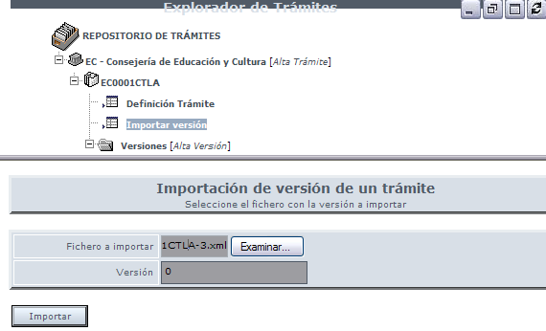
Figure 8.- Screen to import a new version of a process in SISTRABACK.

After clicking on Import (Importar) button, new process version will be in the Platform. The bottom of the screen will display something similar to Figure 9 where component tree of new imported process version can be seen with new branches.

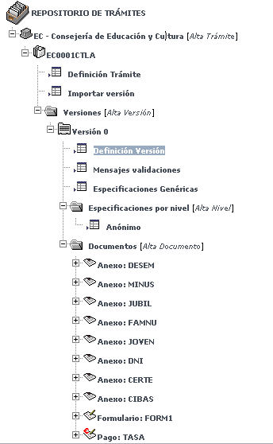
Figure 9.- Component tree update for a process in SISTRABACK, once imported a new process version

As a curiosity you can click on Version Definition (Definición Versión) and version definition detail of imported process can be seen at the bottom of the screen (Figure Figure 10).

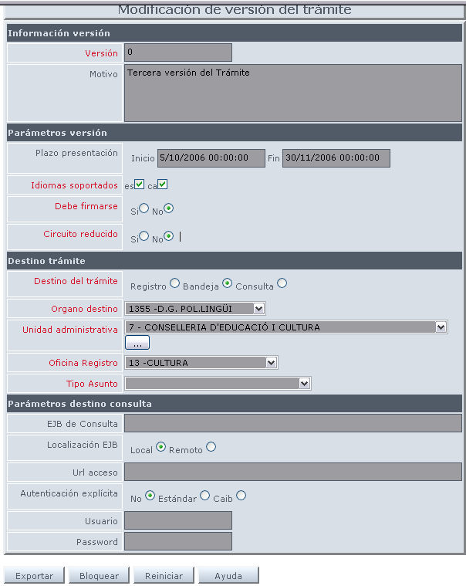
Figure 10.- Version definition detail of an imported process in SISTRABACK.

Locking / Unlocking of a process version
It’s mandatory to block process version for modification (remove a process version, perform a modification in any field of Figure 11 or in other fields belonging to process version definition). A new button appears at the bottom of version edition window (Figure Figure 10) to set this blockade:
- Block (Bloquear): It allows user to reserve modification right on process version definition, so it cannot be changed by any other SISTRABACK user until first user unlocks it.
This functionality is very important when two users try to modify the same process simultaneously.
After pressing aforementioned button, this version will be blocked for the second user and the same version definition window will appear for him but with a different button bar at the bottom of the screen.
To restore previous version status, it’s necessary to press on Unlock (Desbloquear) button and button bar of Figure 11 will reappear allowing to block this version by another user.

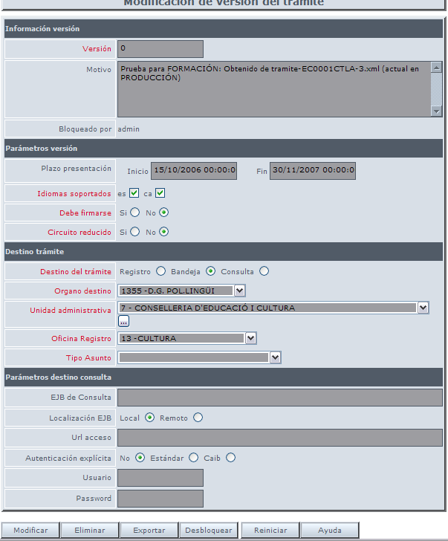
Figure 11.- Version definition detail of a process locked by a SISTRABACK user.

Presentation period modification
Steps to modify presentation period of a process version in Telematic Processing System:
- Block process version to remove (Locking / Unlocking a version of a process section).
- Different features of process version can be edited. However, only two files use to be changed at Administration level, those related with Presentation Period (Plazo Presentación) which indicate dates (in format dd/MM/yyyy HH:mm:ss) between which process version is valid. When no value appears in these fields, it indicates that there are no time limitations.
- It’s necessary to press on Modify (Modificar) button for taking effect new values ​​entered into these fields.
- Unlock process version to remove (Locking / Unlocking a version of a process section).

NOTE: It’s important to remember that field values only can be modified if process version was previously blocked by user who wants to perform this change.
Similarly, it is important to unlock process version once necessary changes were performed on it.

Elimination of a process version
Steps to remove a process version in Telematic Processing System:
- Block process version to remove (Locking / Unlocking a version of a process section).
- Press Remove (Eliminar) button and a warning popup window is displayed for delete confirmation (Figure 12).
- If Accept (Aceptar) button is clicked, version is removed from Platform and confirmation message of version delete will be showed (Figure 13).
- Unlock process version to remove (Locking / Unlocking a version of a process section).

NOTE: It’s important to remember that field values only can be modified if process version was previously blocked by user who wants to perform this action.
Similarly, it is important to unlock process version once necessary changes were performed on it.

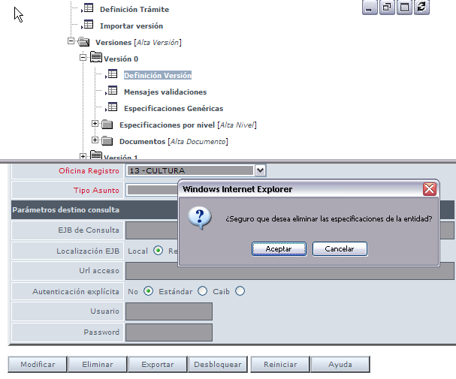
Figure 12.- Process version removing detail in SISTRABACK.

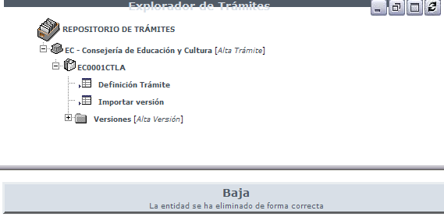
Figure 13.- Message confirming process version deletion in SISTRABACK.

Process export
Steps to export a process version in Telematic Processing System:
- Accessing window showing Responsible Authorities list in SISTRABACK (Figure 1), Responsible Authority should be selected to which process belongs and press Processes (Trámites) button to access process list associated with this Responsible Authority.
Management window structure for processes associated with Responsible Authortrities is split into two zones:
- Upper zone: it displays the set of processes associated with selected Responsible Authority. It’s presented as a component tree defining each existing process.
- Lower: it shows definition screens and/or edition of selected items in the tree of Upper zone.
- Pressing on tree branch identified with process name for which a version will be exported, three options deployed whose appearance is shown at the top of Figure 14.

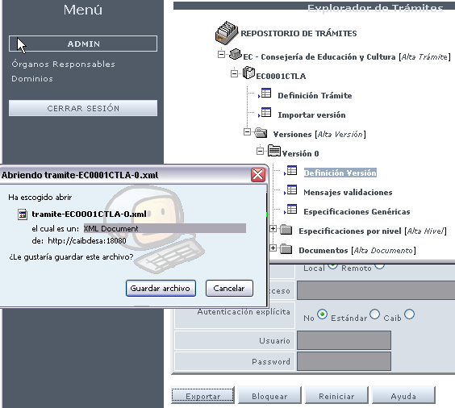
Figure 14.- Export detail for a process version in SISTRABACK.
- All existing versions for this process are displayed deploying Version [Add Version] component.
- Version definition detail for process to export can be seen deploying appropriate version and pressing on Version Definition (Definición Versión) at the bottom of the screen.
- A button appears at the bottom of version edition window to perform export (Figure 14):
    - Export: it allows user to export process definition to a file with XML extension.

Domain configuration
Steps to configure a Domain (queries and validations to DB or other management systems) in Telematic Processing System:
1) and 2) (see 3.1.1 Add Responsible Authority section steps)
3) Once domain management main window is accessed (Figure 15), defined domain list in Processing System will be displayed. In this list you can:
    - Select a Domain for its query and/or modification. Pressing on Select (Seleccionar) button.
    - Delete an existing Domain in Processing System. Pressing on Delete (Eliminar) button.
    - Define a new Domain in Processing System. Pressing on New record (Nuevo registro) button (Figure 16).

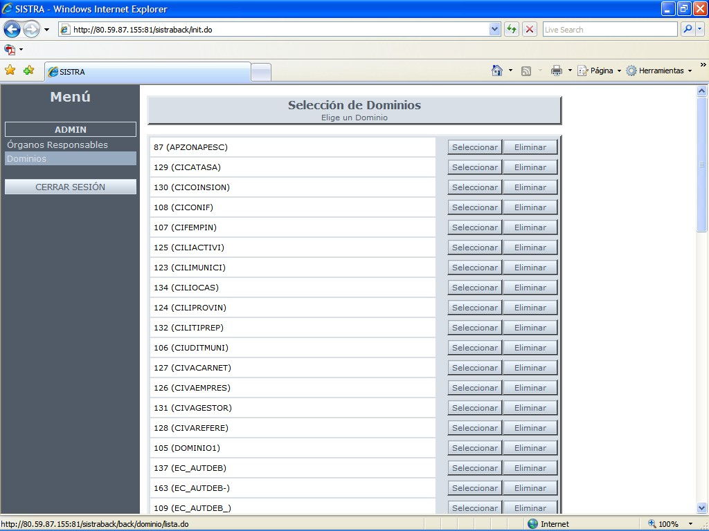
Figure 15.- Main window of SISTRABACK module - Domain Management.

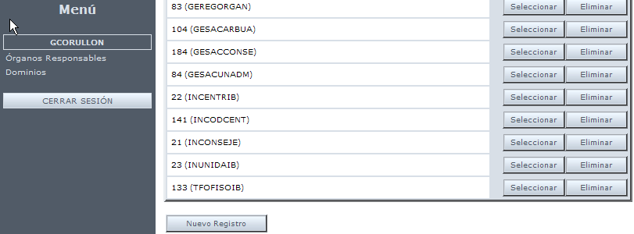
Figure 16.- Main window of SISTRABACK module - Domain Management.

Domain Add
Figure 18 is displayed after pressing New registration (Nuevo registro) button where fields defining a new domain will be set.

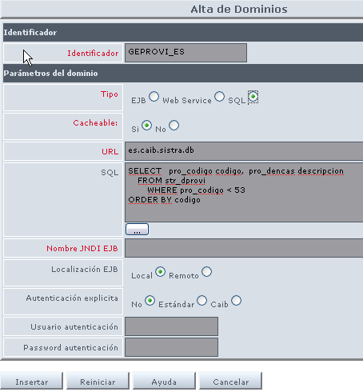
Figure 17.- Domain add detail in SISTRABACK

Figure 18 where each field is detailed appears after clicking Help (Ayuda) button.

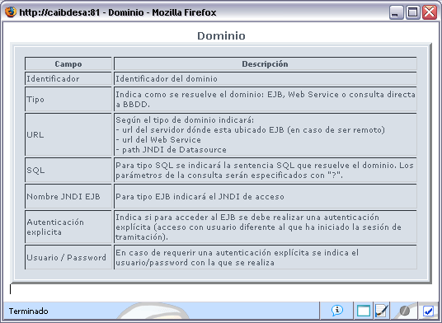
Figure 18.- Help about domain add in SISTRABACK

Domain Query / Modification
Figure 19 is displayed after pressing Select (Seleccionar) button of an existing domain. It’s possible to query and edit fields defining a domain.
If you want to change existing field values, just press Modify (Modificar) button.

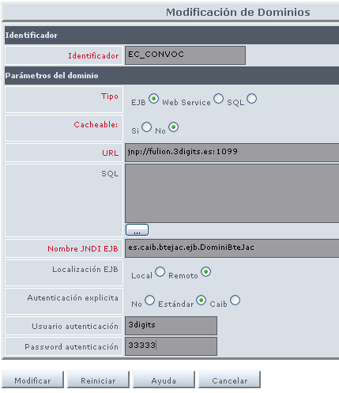
Figure 19.- Domain Query / Modification detail in SISTRABACK

Access permission to processes
Administrator can give process access permission to developers from SISTRAADMIN module. Permission control over sistra module must be enabled in order to achieve that previous permissions are effective (see this module configuration in installation document).
Access permissions to process can be applied to:
- Users
- User groups
User groups can be created and users can be assigned to them from this module.
Process creator is automatically enabled to access the process when he creates it.

FORMS - Formadmin, Formback
From these two modules FORMS Web application, Administrator can perform next management tasks from both web modules of FORMS application:
- FORMS configuration (from Formadmin)
- Import / export of forms (from Formback)

FORMS configuration - FORMADMIN
To read details of available operations with FORMS application in its FORADMIN module, there is a manual prepared by IBIT: TOL Project - Backoffice - Manual.doc.

Here we merely indicate FORMS features used in Digital Administration project, others were not used: Signature validators,Output points,...

MASKS
Figure 20 lists all existing masks in production systems of Digital Administration project currently.
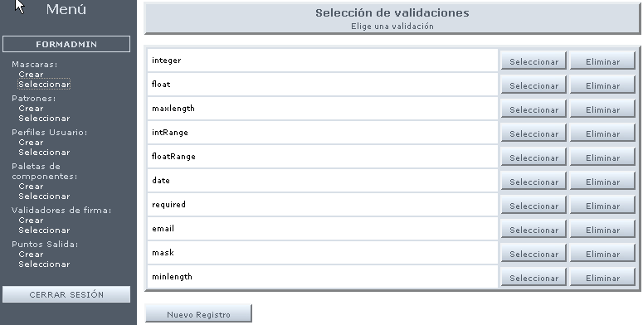
Figure 20.- List of Masks in FORMADMIN module.

PATTERNS
Figure 21 lists all existing patterns in production systems of Digital Administration project currently.

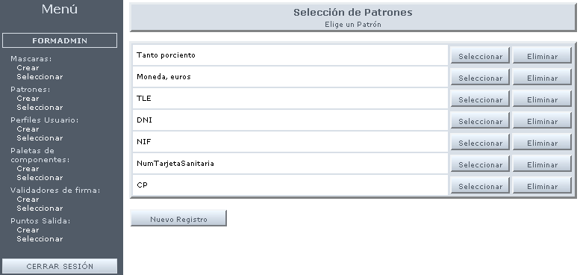
Figure 21.- List of Patterns in FORMADMIN module.

PROFILES
Figure 22 lists all existing profiles in production systems of Digital Administration project currently.

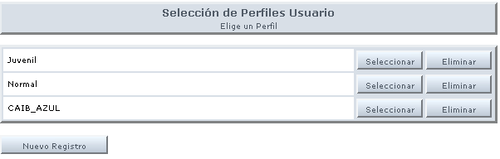
Figure 22.- List of Profiles in FORMADMIN module.

Import / export of forms - FORMBACK
There are two usual operations in FORMBACK module for Administrators:
- Importing forms
- Exportin forms

To read details of available operations with FORMS application in its FORMBACK module, there is a manual prepared by IBIT (FORM_ManualBackOffice_ROL.odt) that can be found in doc directory of sourceforge project.

Forms import
This operation is detailed in Section 12 of FORM_ManualBackOffice_ROL.odt manual.

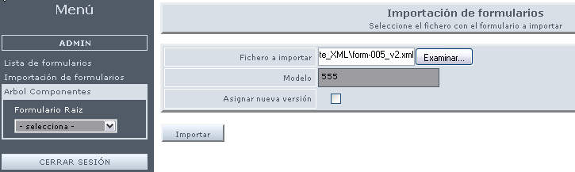
Figure 23.- Form import detail in Formback.

Forms export
This operation is detailed in Section 7.3 of FORM_ManualBackOffice_ROL.odt manual.

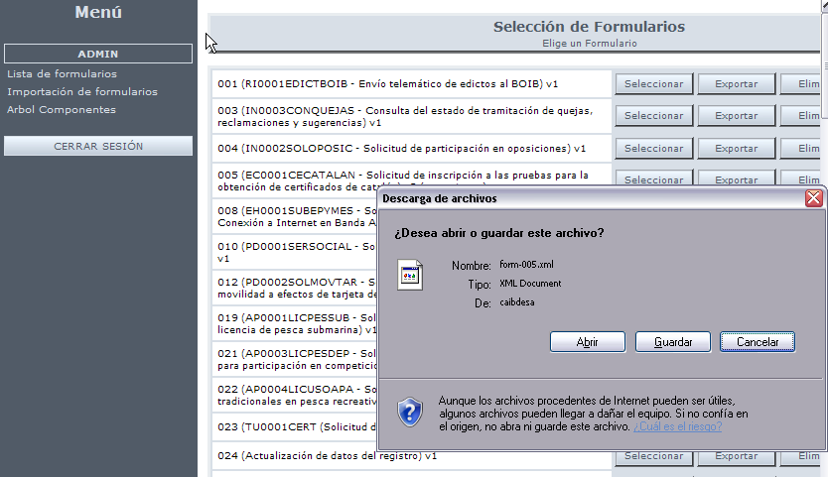
Figure 24.- Form export detail in Formback.

Access permissions to forms
Administrator can give forms access permission to developers from FORMADMIN module. Permission control over Forms module must be enabled in order to achieve that previous permissions are effective (see this module configuration in installation document).
Access permissions to process can be applied to:
- Users
- User groups
User groups can be created and users can be assigned to them from this module.
Form creator is automatically enabled to access the form when he creates it.

REDOSE - REDOSEBACK
Administrator can perform next task from this Web module:
- Definition of document models.

Definition of document models
Different types of documents (forms, annexes, payments) are associated with a process when it’s defined through Telematic Processing Platform. Each of these documents must have an associated model in RDS.
Administrator uses REDOSEBACK module to define models in RDS:
- For each Model, one or several Versions should be set,
- For each Version, one or more Templates should be established.
- For each Template, a File should be established for each language included in the process.
In following points relationship MODELS -> VERSIONS -> TEMPLATES -> FILES can be seen following creation of each one step by step.

Model add
Steps to create a document model in Telematic Processing System:
  - REDOSEBACK module relevant to specific environment where you want to act (Development, Pre-production, Production) must be accessed through web browser. For example, following URL: http://caibCD:8080/redoseback/.
It is necessary to identify a user who has permissions (role RDS_ADMIN) to initiate a session in REDOSEBACK.

  - Once user access to environment is validated, REDOSEBACK environment main window is displayed in browser window with following items (Figure 25):
  - REDOSEBACK management menu located on the left side of browser window.
It allows performing different actions on RDS:
  - It displays Model list defined in RDS (Figure 25). It’s possible to:
    - Define a new Model in RDS.
    - Select a Model for edition and/or modification.
    - Delete an existing Model in RDS.
  - Display Locations list defined in RDS (it doesn’t apply to this course).
  - History operations: log of actions performed in RDS.
  - Generic Models set existing actually in Production environment is listed on the right side of Figure 25. They are essential to provide features functionalities as Proof of Delivery, Payment of fees, registration note generation,…

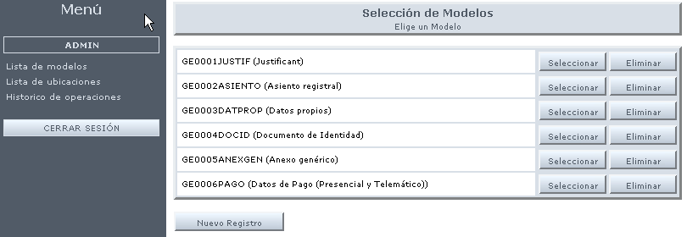
Figure 25.- Main window of REDOSEBACK module - Model Management.

To create a new document Model in RDS, it’s necessary to press on New Record (Nuevo Registro) button of Figure 25. Then screen showed at Figure 26 is displayed.

  - Once inside Model addition window in REDOSEBACK, Administrator user must fulfill next data:
- Model: Brief description (10 characters) for easily identifying model to define.
A specific structure of Model naming was established in Digital Administration project following naming scheme defined by CAIB.
- Name: Free text for identifying model to create.
- Description: Free text to detail the model to create.
- Structured: Check indicating if document associated to a model and defined in SISTRABACK by process developer is Structured (Platform treats it as a XML data structure, it’s marked as structured because its structure is known, also which fields compose it, etc.) or Unstructured (any binary file). If model is selected as structured (XML), then it makes sense to associate visualization templates (render to PDF) otherwise it wouldn’t proceed to associate templates.
STRUCTURED:
- GE0002ASIENTO (Registration note), GE0003DATPROP (Own data), GE0001JUSTIF (Proof), GE0006PAGO (Payment data (In person and Telematic)) and suitable from process forms.
UNSTRUCTURED:
- GE0004DOCID (Identity document), GE0005ANEXGEN (Generic annex).

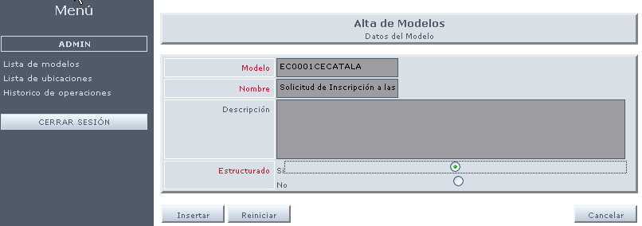
Figure 26.- Model addition detail in REDOSEBACK associated to FORMS form for a SISTRA process.

Screen of Figure 27 is presented after clicking Insert (Insertar) button where new model creation is confirmed and some entered field content can be changed clicking on Modify (Modificar).

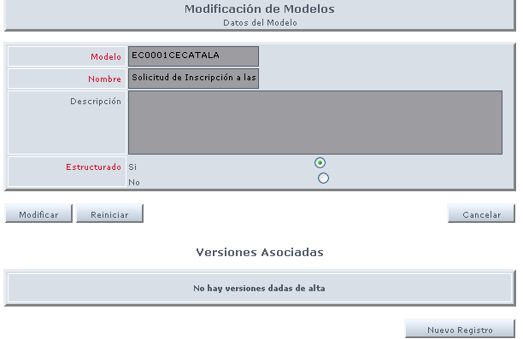
Figure 27.- Model Addition/Modification confirmation in REDOSEBACK.

Version add
To create a new version associated with model created in previous step, it’s necessary to click on New Record (Nuevo Registro) button of Figure 27. Then a screen similar to Figure 28 one is displayed.
Data to fulfill for defining a new version in REDOSEBACK are next:
- No. de versión: number to identify model version to create. Maximum 3 digits.
- Description: Free text to detail version to create.

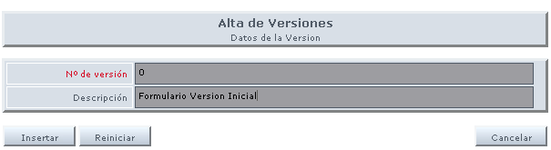
Figure 28.- Version add detail associated to a model in REDOSEBACK.

Figure 29 appears after clicking Insert (Insertar) button where new version creation is confirmed screen will be presented where the creation of the new version is confirmed and some entered field content can be changed clicking on Modify (Modificar).

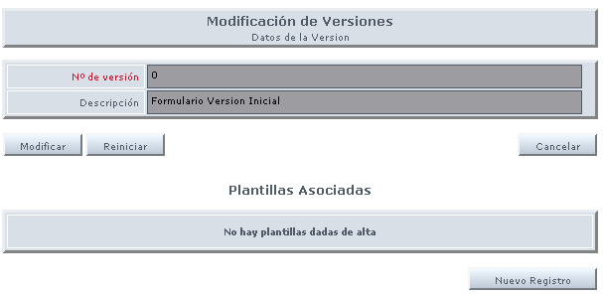
Figure 29.- Version Addition/Modification confirmation associated to a model in REDOSEBACK.

Template add
To create a new template associated to version created in previous step, it’s necessary to press on New Record (Nuevo Registro) button of Figure 29. Then screen appearing in Figure 30 is displayed.
Data to fill for defining template in REDOSEBACK is next:
- Tipo: Text to identify template type to create. Maximum 3 characters. It uses to be PDF.
- Formateador: Drop-down list where an existing formatters should be selected (see Figure 31).
- Defecto: Check that indicates if this template will be used as default for version to which it is associated. A version can have multiple templates.
- Fichero: Text field to enter local path where PDF or RTF files associated with template are located. One of them must be established for each language in which associated process is defined in SISTRABACK.

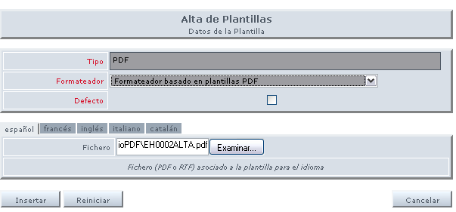
Figure 30.- Template add detail associated to a model version in REDOSEBACK.

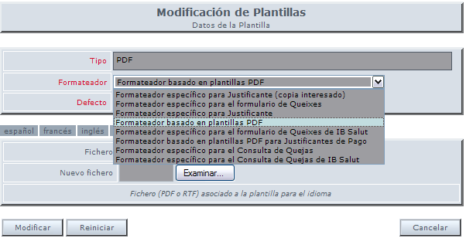
Figure 31.- Existing formatter detail for a template associated to a version.

Figure 32 appears after clicking Insert (Insertar) button where new template creation is confirmed and some entered field content can be changed clicking on Modify (Modificar).

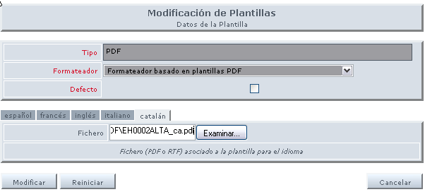
Figure 32Confirmation .- High / Modifying a template associated with a version of a model in REDOSEBACK.

Model query
This point simply shows screens that would appear if a query is executed against model created according previous steps with its associated versions and templates.
In this case queried model from REDOSEBACK has 2 associated Versions (Figure 33).

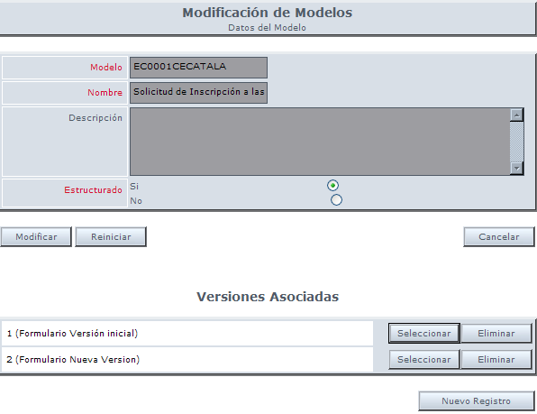
Figure 33.- Model modification detail in REDOSEBACK with its associated versions.

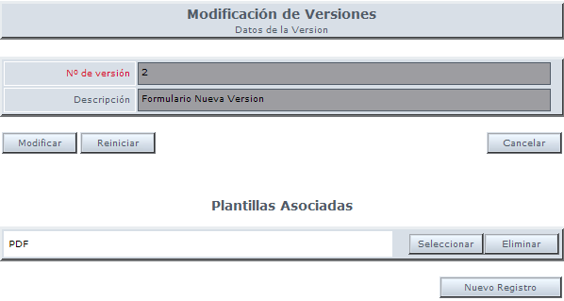
Figure 34.- Model version modification detail in REDOSEBACK with its associated templates

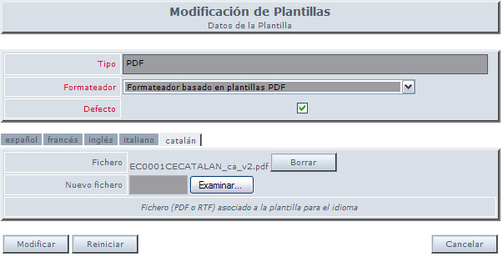
Figure 35.- Model version template modification detail in REDOSEBACK with its associated files

BANTEL - BANTELBACK
Administrator can perform next tasks from web module:
- Process definition and processing configuration.
- Manager definition and access to processes

Before specifying different administration tasks lets comment how automatic warning process works with management applications. This automatic procedure is specified for each process and it has sense to enable it only when management application (or BackOffice) is integrated with Telematic Box. If not integrated, Managers can use visual interface of Box (BantelFront) to manually collect inputs.
As a result of Telematic Processing, forms and documents provided by citizens are left in Telematic Input Box. BackOffice should access Telematic Input Box to collect new inputs to be processed.

Figure 36 shows different calls between BackOffice and Telematic Box:

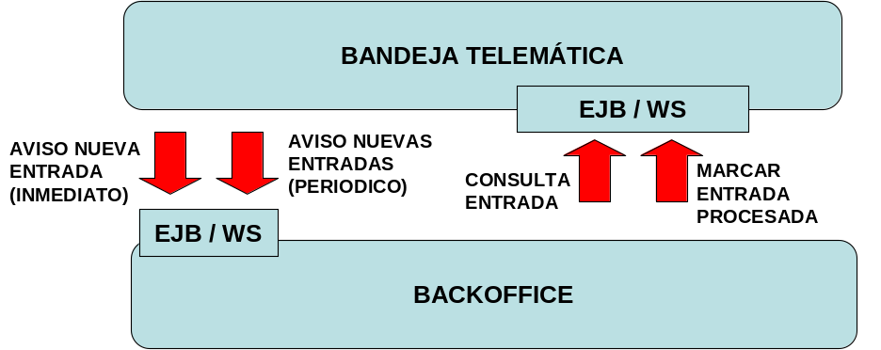

Figure 36.- Scheme of calls between BackOffice and Telematic Input Box.

- New inputs warning: it can be set in Telematic Box (by process) that Box warns BackOffice about new arriving inputs (inputs marked as non processed in the Box). There are two types of warnings:
  - Immediate: Just input arrives, BackOffice is warned indicating input number.
  - Periodic: BackOffice is warned about new inputs every certain period of time.
An EJB or Webservice should be implemented in BackOffice to collect these warnings.
- Input query: once warning is received, BackOffice can query input data through an EJB or Webservice found in Telematic Box. This data contains forms and documents sent by citizen.
- Mark processed input: once input is processed by BackOffice, this entry should be marked as processed in Telematic Box, otherwise this input would be included another time in next warning about new inputs.

Process definition and processing configuration
Steps to define a Reference to a Process in Telematic Box Backoffice:
  - BANTELBACK module relevant to specific environment where you want to act (Development, Pre-production, Production) must be accessed through web browser. For example, following URL: http://caibCD:8080/bantelback/ would be used to enter to test environment.
It is necessary to identify a user with sufficient level of access (BTE_ADMIN role) to launch corresponding session in BANTELBACK.

  - Once user access to the environment is validated, main window of BANTELBACK environment is shown through browser where next items appear (Figure 37):
BANTELBACK management menu is located on the left side of browser window.
It allows performing different actions on BTE:
  - It shows References to defined Process list in BTE (Figure 37). In this list, it’s possible:
    - Select a reference to a Process for query and/or modification. Pressing on Select (Seleccionar) button.
    - Remove a reference to an existing Process. Pressing Eliminar (Delete) button.
    - Define a new reference to a Process. Pressing New registration (Nuevo Registro) (Figure 38).
  - Display Manager list defined in BTE (see 3.4.2 Manager definition and access to processes section).

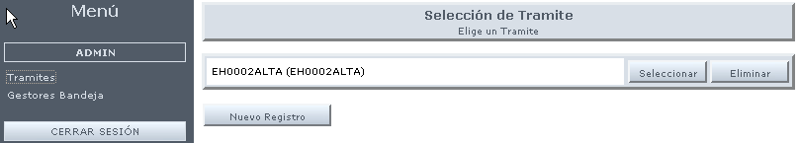
Figure 37.- BANTELBACK main window, list of references to existing processes.

Add of a reference to a process
To create a new reference to a process, it’s necessary to click on New Record (Nuevo Registro) button and a screen similar to Figure 38 appears.
Data to fill for defining a new reference to a process in BANTELBACK:
- Identifier (Identificador): Process identifier. It must match with name given in Process Add from SISTRABACK (See Process Add).
- Description (Descripción): Free text to identify reference to the process to create.
- Warning interval (minutes) / Intervalor avisos (minutes): Number of minutes to pass before platform sends automatically a new warning to BackOffice with new inputs occurred from Processing Assistant for process in question. It warns about all pending to process regardless they were already included in a previous warning.
- Immediate warning (Aviso inmediato): Check to indicate if warning should be produced immediately or it has to wait for next automatic warning interval.
- BackOffice access (Acceso a BackOffice): Way of access BackOffice for performing warnings. Can be EJB, Webservice or without value
(This field only makes sense if a value is set in Warning interval field).
- URL: Depending on BackOffice access type:
  - Server URL where EJB is located.
  - Web Service URL.
This field only makes sense if a value is set in Warning interval field).
- JNDI Ejb: For EJB BackOffice access type, it indicates JNDI access.
This field only makes sense if EJB value is set in BackOffice access field).
- Location (Localización): Check to indicate if BackOffice access through EJB is Local or Remote.
This field only makes sense if EJB value is set in BackOffice access field.
- Authentication type (Tipo autenticación): Check to indicate if access to EJB should be performed by explicit authentication (access with a user other than who initiated processing session) or not, and if it must be standard or from CAIB.
This field only makes sense if EJB value is set in BackOffice access field
- User / Password: Username/password used in authentication against BackOffice.
This field only makes sense if EJB value is set in BackOffice access field and Authentication type field is set to Standard).
- Role Access (Rol de acceso): This field is not being used. It’s under revision to decide if it is removed. It indicates role for Backoffice user to access telematic box for processing. Currently BTE_GESTOR role is enough.

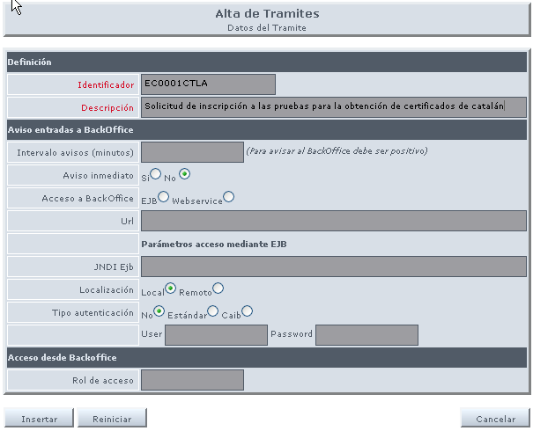
Figure 38.- Detail of reference add to a process in BANTELBACK. When management application (or BackOffice) isn't integrated with Telematic Box

Query/Modification of a reference to a process with warnings to BackOffice
Figure 39 shows detail of a reference to a process when management application (or BackOffice) is integrated with Telematic Box. It’s achieved specifying values for corresponding fields. In this case, Warning to BackOffice is performed every 2 minutes and immediately when a new entry of this process is created in Telematic Box. Access type is via EJB, so URL and JNDI of this EJB should be specified (in this case Ejb is located in a different server than platform one, so Location field has Remote value.

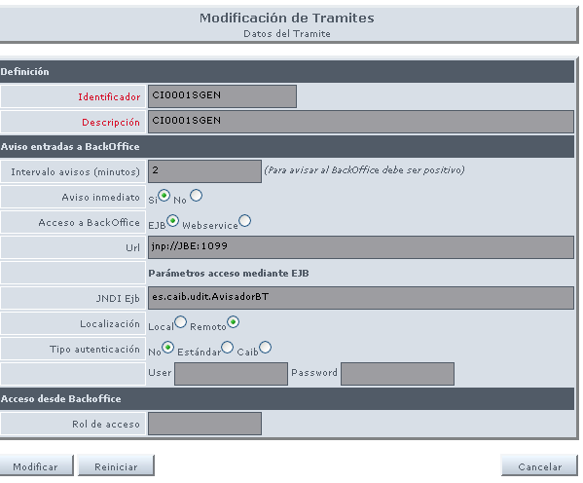
Figure 39.- Detail of a reference to a process in BANTELBACK when management application (or BackOffice) is integrated with Telematic Box.

Manager definition and access to processes
Once Administrator is authenticated in BANTELBACK web module (3.4.1 Process definition and processing configuration section), screen of Figure 37 will appear. Box Managers (Gestores Bandeja) option is choosed and existing manager list for Telematic Box (Figure 40) appears. In this list, it’s possible to:
- Select a Manager for query and/or modification. Pressing on Select (Seleccionar) button.
- Delete an existing Manager. Pressing on Delete (Eliminar) button.
- Define a new Manager. Clicking New registration (Nuevo Registro) button.

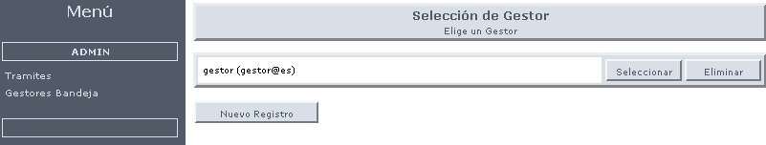
Figure 40.- List of existing managers in BANTELBACK.

Manager add
To create a new Telematic Box Manager, it’s necessary to click on New Record (Nuevo Registro) button on Figure 40 and screen of Figure 41 is displayed.

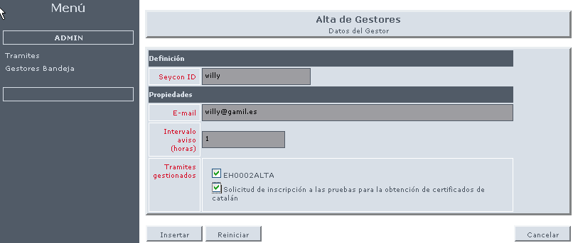
Figure 41- Manager add detail in BANTELBACK.

Data to fill for defining a new manager in BANTELBACK are next:
- Seycon ID:: User identifier that exists in seycon to be added as telematic box manager.
- E-mail: Free text to enter Manager email address.

- Warning interval (hours) / Intervalo avisos (horas): Number of hours to pass before platform sends a new email to Manager E-mail address informing about new inputs occurred from Processing Assistant, and only for processes managed by this Manager since last warning
- Managed processes (Trámites gestionados): Listing of all references to processes added in BANTELBACK, allowing select/deselect those references considered as appropriate.
Clicking on Insert (Insertar) button, new manager is created in BTE with process list to which he will have access from BTE FrontOffice.

MOBTRATEL - MOBTRATELBACK
Administrator can perform next tasks from this web module:
- Shipment account definition
- Permission assignment to managers for shipment accounts

Shipping account definition
To define a shipping account, it’s necessary to specify if he can send by email and/or sms.
If he can send by email, it will necessary to set the JNDI reference of mail datasource including email account configuration used for shipments.
If he can send SMS, it must specify account identifier to be transferred to shipment sms plug-in when shipment is performed.

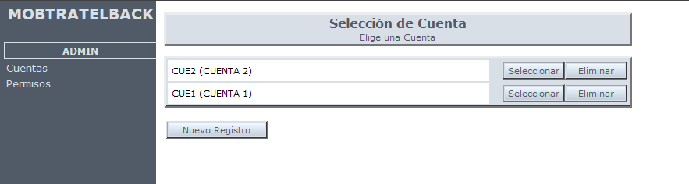
Figure 42.- Account list in MOBTRATELBACK

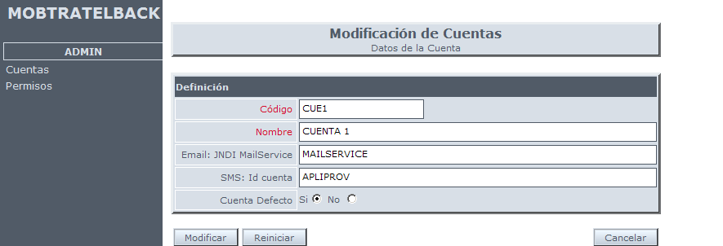

Figure 43.- An account record in MOBTRATELBACK

Permission assignment
A manager will be able to perform shipments through an account when he has corresponding permissions.

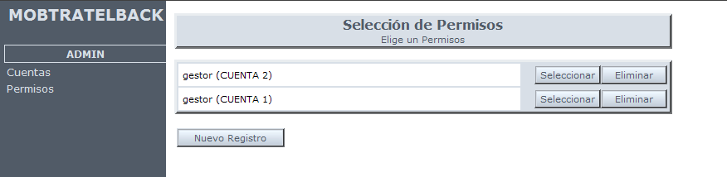
Figure 44.-Permission list in MOBTRATELBACK

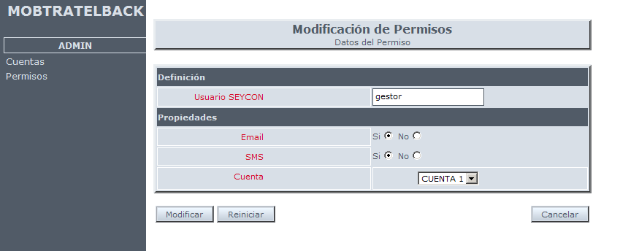
Figure 45.- Permission configuration for manager over an account in MOBTRATELBACK

Automatic processes
List of automatic processes running periodically to keep in mind its programming avoiding to interfere with other system processes (system shutdown, security copies, etc.)
These processes are configured in properties file associated with module they belong.

MODULE | PROCESS | DESCRIPTION | PROGRAMMING
REDOSE | Deletion of documents without uses | Check documents without uses and it marks them as deleted | 5 a.m.
REDOSE | Definitive purge of documents without uses | Documents marked for deletion are permanently removed after a configured period of time | 5 a.m.
REDOSE | Deletion of documents in custody | If documental custody plug-in is activated, it deletes old in custody versions. | 5 a.m.
REDOSE | Document manager consolidation | If document manager plug-in is enabled, it consolidates pending documents to consolidate | Every 10 min.
BANTEL | Warning to backoffices | It checks if warning period to any backoffice is accomplished. If yes, it wans backoffice about pending entries. | Every minute
 | Warning to managers | It checks if warning period to any manager is accomplished. If yes, it warns manager about input processing status | Hourly
ZONAPER | Deletion of expired processes | It checks expired processes and it pass them to delete area. | 4 a.m.
 | Definitive deletion of expired processes | Process marked as deleted are permanently removed after a configurable period of time | 4 a.m.
 | Record review | It verifies that registrations communicated to registry were really done. This revision mechanism allows non transactional communication with registry. | Hourly
MOBTRATEL | Scheduled shipments | It checks if warning period for a scheduled shipment is accomplished. If yes, it is sent. | Hourly
 | Immediate shipments | It checks if immediate warnings pending to send exists. | Every minute
AUDITA | Statistics generation | It is responsible for statistics generation. | 1 a.m.

