SISTRA - ARQUITECTURA

Code: SISTRA-ARQ

DOCUMENT CONTROL SHEET

 |  | DOCUMENT / FILE
Title: SISTRA - ARQUITECTURA |  |  |  |  |  |  |  |  |  | File Name / s:0000.doc
Code: SISTRA-ARQ |  |  |  |  |  |  |  |  |  | Software: Word
Date: September 2012
Version6
 |  |  |  | RECORD OF CHANGES
 | Version |  |  | Pages |  |  | Reason for change
 | 1 |  |  | 29 |  |  | Document Creation
 | 2 |  |  | 29 |  |  | Update
 | 3 |  |  | 29 |  |  | Review of webservices and explicit authentication plug-in
 | 4 |  |  | 25 |  |  | New warnings/notifications generation module inbantelfront  New custody plug-in
 | 5 |  |  | 27 |  |  | New delegation module  New document management plug-in  Revision of webservices Services v2
 | 6 |  |  | 29 |  |  | Disk storage in REDOSE
 |  |  |  |  |  | DISTRIBUTION OF DOCUMENT
 |  |  | Name |  |  |  |  | Staff
 |  |  |  | DOCUMENT CONTROL
PREPARATION |  |  |  |  | REVISED / APPROVED |  |  |  |  |  |  |  | ACCEPTED |  | ACCEPTED
Rafael Sanz |  |  |  |  | José Vicente Juan Pérez |  |  |  |  |  |  |  | Jerome Navarrete |  | Bernat Alberti
Complete with the name, signature and date |  |  |  |  |  |  |  |  |  |  |  |  |  |  |  | Customers only

INDEX
1. Introduction 4
2. SISTRA architecture 5
2.1. Functionalities 5
2.2. Subclass 6
2.3. Actors 7
2.4. Platform modules 8
2.4.1. SISTRA 9
2.4.2. FORMS 11
2.4.3. REDOSE 12
2.4.4. REGTEL 14
2.4.5. BANTEL 14
2.4.6. ZONAPER 17
2.4.7. AUDITA 19
2.4.8. MOBTRATEL 20
2.5. Used technologies 21
3. Integration Organization 22
3.1. Corporate image 22
3.2. Connection plug-ins with organization 22
3.3. Integration with management applications 23
3.3.1. Offered services 23
3.3.2. Invoked services 27

Introduction
This document describes telematic processing platform architecture (SISTRA) developed by Govern de les Illes Balears and at Balearic institutions disposal.
Its purpose is to allow citizens to perform telematic processes avoiding trips and speeding up management procedures. A process may consist of one or more forms, electronic documents or files to attach, with the possibility of accessing to online payment. Moreover, the system has a persistence mechanism storing data until user decides to send it allowing process fulfillment in different sessions.
Citizen access can be done in different ways: digital certificate, user/password and anonymous. Platform will control action flow to perform depending on selected way.
The platform allows integration with existing management systems, enabling automatic data inclusion from these telematic processes. Furthermore, this platform allows telematic notification shipment to citizens by management systems through citizen personal area as well as email and SMS alert shipment.
SISTRA has different customizable plug-ins by each organization to integrate the platform with different particular solutions from each organization (authentication, input/output registry, telematic payment and SMS shipment). So, an organization must develop connection plug-ins with their systems to implement SISTRA.

SISTRA architecture

Functionalities
Main features of SISTRA are:
- Different accessing ways: digital certificate, user/password and anonymous.
- Intelligent forms with direct validations on management systems.
- Binary file attachment.
- Digital signature (@firma and signaturaCAIB are supported).
- Telematic payment integrated with defined solution by each organization for its payment management.
- It implements different processing circuits:
  - Registry: request goes through input registry passing to manager box later.
  - Box: request doesn’t go through input registry and it passes directly to manager box.
  - Preregistration: request consists of two phases: telematic presentation of information and in person presentation of required documentation.
  - Print assistant: citizen fills request forms through smart forms to be printed in order to deliver them in person.
  - Query: citizen can access customized information (certificates, etc.) after filling a data form.
- Correcting or document provision processes notified through telematic notifications.
- Personal user area with personal data and various processes he carries out with the organization. It is also the access point to his telematic notifications.
- Delegation can be activated for an entity in personal area so that an entity representative is named who can designate other delegated people. Delegates may perform processes on behalf of the entity. In addition, a signature mini-box is enabled to allow delegates to sign documents belonging to processes.
- Implementation of manager box allowing its integration with management systems for automatic processing of requests.
- Programming email and SMS shipments.
- Platform usage statistics.

Subclass
SISTRA architecture scheme is shown in next figure. Different platform elements, organization particular elements and plug-in to connect the platform with organization particular elements appear in different color.

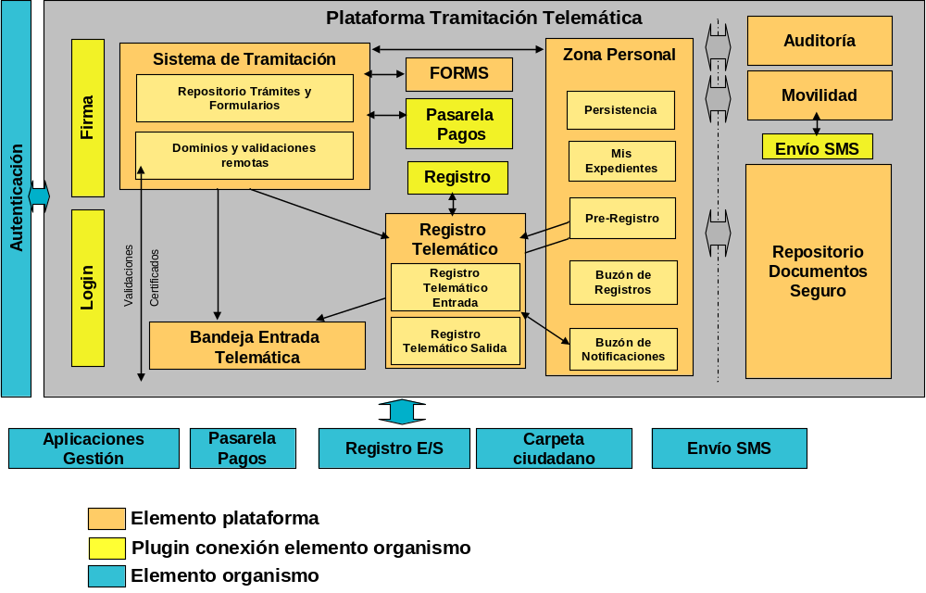

Platform elements
Processing System | SISTRA | Process definition and processing assistant logic
Forms Manager | FORMS | Smart form definition
Personal Zone | ZONAPER | It contains citizen data (processes, records, etc.)
Insurance Documents Repository | REDOSE | It stores documents involved in procedure (forms, annexs, etc.). Other modules will work with references to documents.
Online Register | REGTEL | It implements telematic registry layer on I/O registry.
Telematics Input Tray | BANTEL | Processing assistant puts performed processes to be processed by management applications.
Audit | AUDITA | Usage and processing statistics
Mobility | MOBTRATEL | Module for scheduled shipment of emails and SMS

Body elements
Authentication | Organization authentication system.
Applications management | Processing management applications
Payments Gateway | Gateway for telematic payments
Register E / S | Input/output registry
Folder citizen | Folder citizen.
SMS Shipping | SMS shipment gateway

Actors
Following figure shows platform interaction with different involved actors:
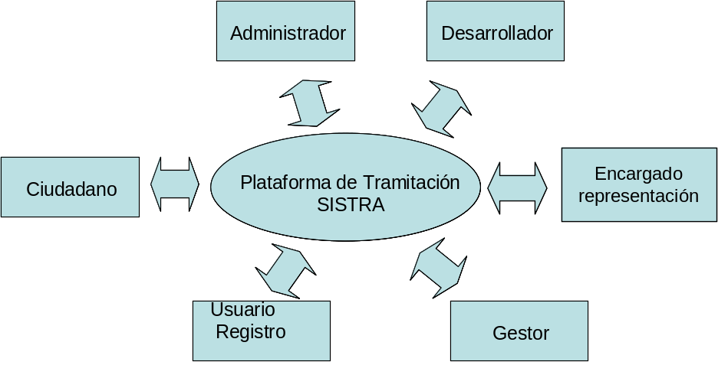

Citizen | He uses Processing Platform through Processing Assistant and he goes to his personal area to access his data (performed processes, telematic notifications, records, etc.)
Developer | He uses Processing Platform to define processes in SISTRA module and forms in FORMS module, all in development environment.  As result, he will obtain a process load log with necessary export files that will be send to Administrator for passing the process to production.
Administrator | He is responsible for putting processes sent by the Developer into production and setting up different platform modules (access to domains, access to management applications, etc.)
Registry | There are processes requiring in person documentation delivery.  A pre-registration scheme is enabled for these processes. Once documentation is delivered in person in a registry point, pre-registration is confirmed passing the process to the Telematic Box.
Manager | The manager or Management application collects processes in Telematic Box and processes it
Person in charge of representation | Person in charge of enabling delegation against an entity and designate a representative of it. It will be responsible of assigning representation power according to organization rules.  When delegation on an entity is enabled, it allows that other people process on behalf of the entity.

Platform modules
Next table shows different platform modules:

SISTRA | SISTRABACK | Used by Developer for telematic process definition (development environment).  Used by Administrator for process import formalities and domain configuration (pre-production and production environments).
SISTRA | SISTRAFRONT | Used by Citizen to access to Processing Assistant.
SISTRA | SISTRAADMIN | Used by Administrator to audit load logs.
SISTRA | SISTRALISTAR | Used by Developer to display process list and it allows to initiate them and as opening them. Application context is "tramites".
FORMS | FORMADMIN | Used by Developer (development environment) and Administrator (pre-production and production environments) for configuring Forms.
FORMS | FORMBACK | Used by Developer to define forms (development environment).  Used by Administrator to import forms (pre-production and production environments).
FORMS | FORMFRONT | Used by Developer to test and fullfill forms that later will be invoked directly from Processing Assistant used by citizen.
REDOSE | REDOSEBACK | Used by Administrator for RDS configuration: document model definition, templates, etc.
REDOSE | REDOSEFRONT | Module for validating printed documents using a verifier barcode.
BANTEL | BANTELBACK | Used by Administrator to configure BANTEL: definition of managers and access to processes, warning procedure of processes, etc.
BANTEL | BANTELFRONT | Used by Manager User as visual interface to access to Telematic Input Box.  This interface is designed for those processes in which Management Application is not integrated with Telematic Input Box, preventing automatic processing of performed processes.  A module allows manager to manually publish records in citizen personal area citizens and generate warnings and notifications
ZONAPER | ZONAPERBACK | Used by Input Registry User for pre-registrations confirm.
ZONAPER | ZONAPERFRONT | Used by Citizen to access to his processing folder, from which you have access to performed processes, telematic notifications, records, etc.
ZONAPER | ZONAPERDELEGA | Used by Person in charge of representation to enable delegation on an entity and designated his representative.
ZONAPER | ZONAPERHELPDESK | Module used by Helpdesk for processing troubleshooting resolution (loss of processing key, see process status, etc.)
AUDITA | AUDITFRONT | Used by User Manager to access to usage statistics of Telematics Processing Platform.
MOBTRATEL | MOBTRATELBACK | Used by Administrator to configure different shipment accounts of mobility module.
MOBTRATEL | MOBTRATELFRONT | Used by Manager User as visual interface for performing SMS and emails scheduled shipments to citizens.

SISTRA
This module provides a tool that allows definition of new processes. For each process, it’s possible to define forms to fulfill, annexes to deliver, taxes to pay, etc.
It also allows detail logic customization for each process through control scripts (fi startup validations, obligatory nature control for a form, etc.)
This tool allows process versioning and process packing in a XML file to import in different environments (development, preproduction and production).

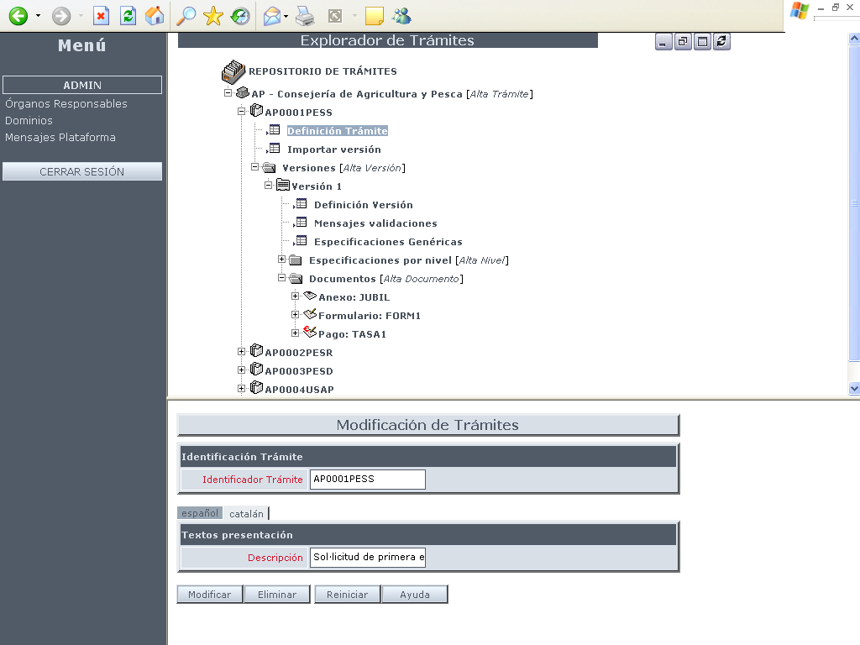

SISTRABACK

An assistant is presented to the citizen guiding him in different processing steps according to the information defined by previous tool.

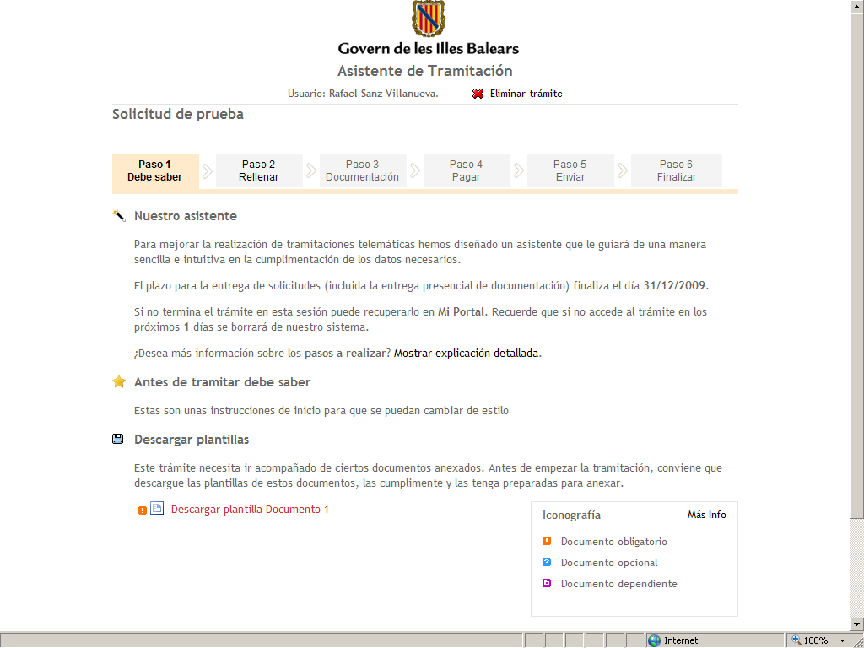

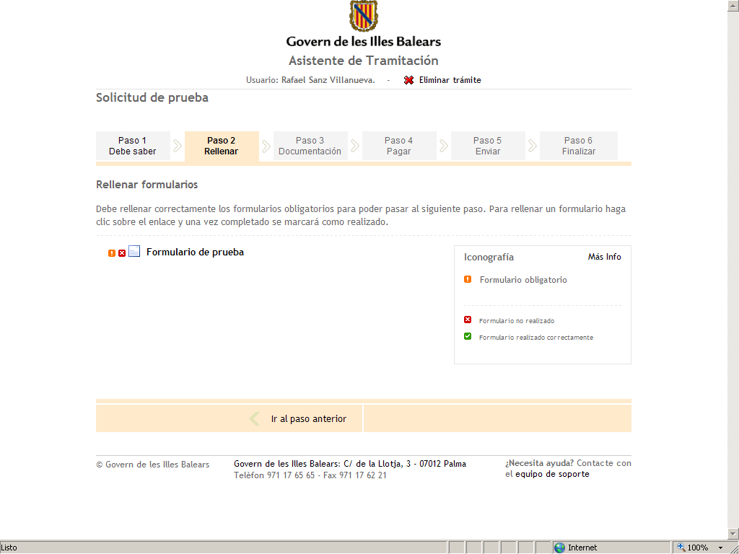

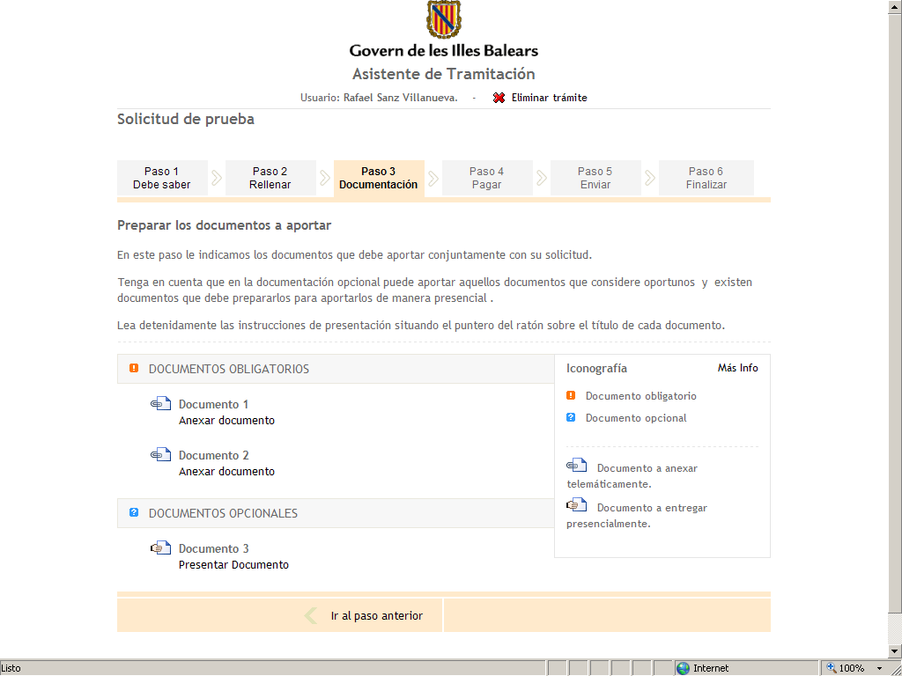

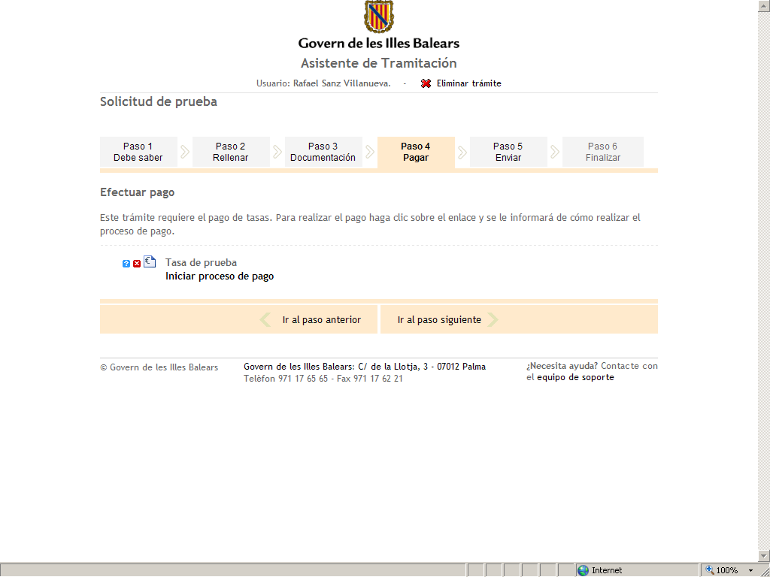

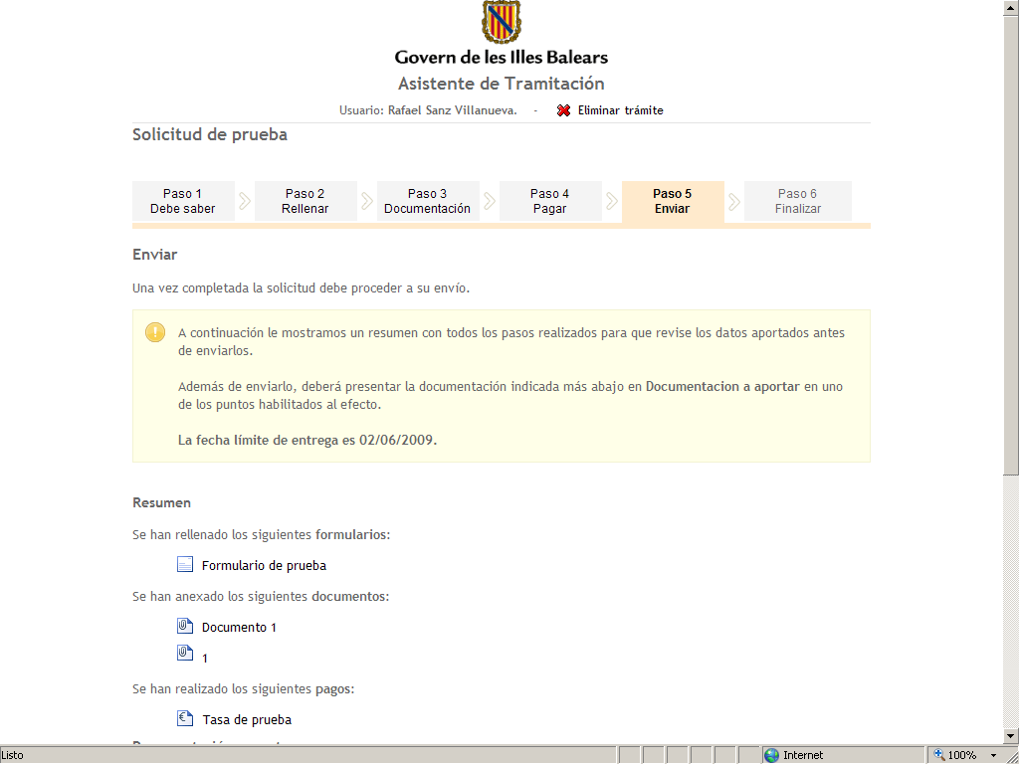

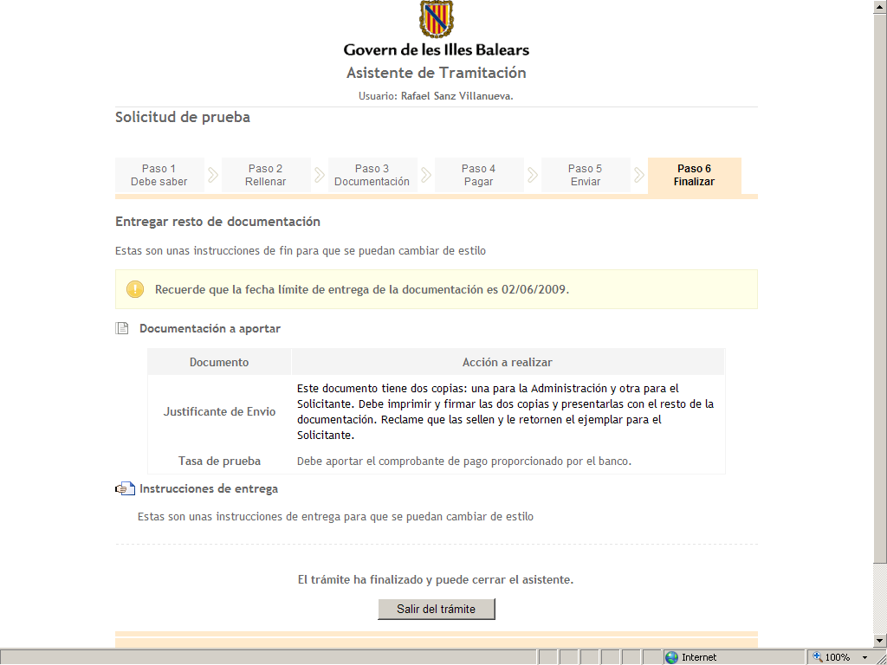
SISTRAFRONT

FORMS
This tool generates Web forms to be used by processing assistant when data should be entered into a form.
This tool allows to split input form in several screens containing different fields for data entry (text field, value lists, verification field, etc.). It’s possible to associate scripts to each fields allowing navigation logic control, verification, auto calculation between fields, etc.

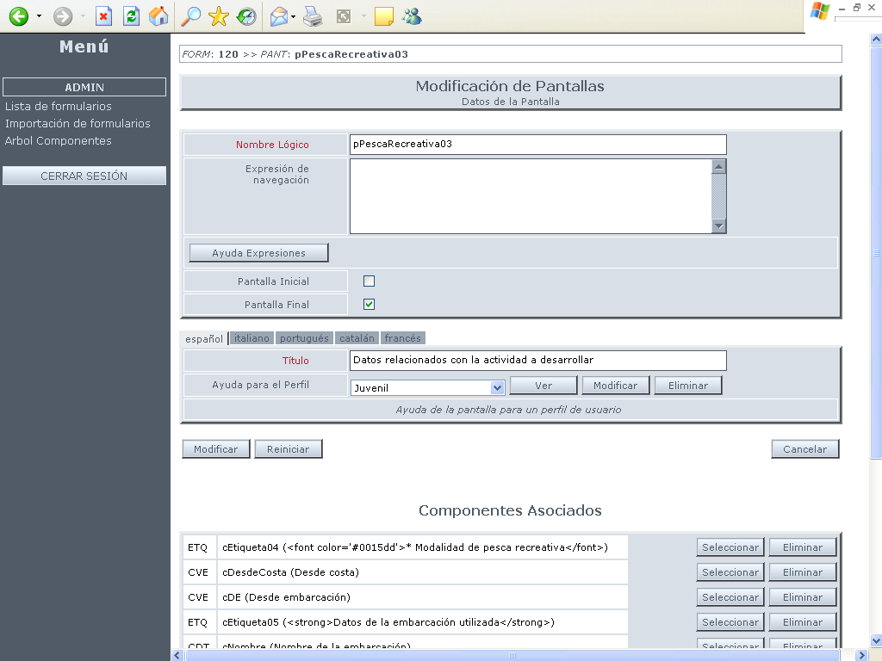

Formback

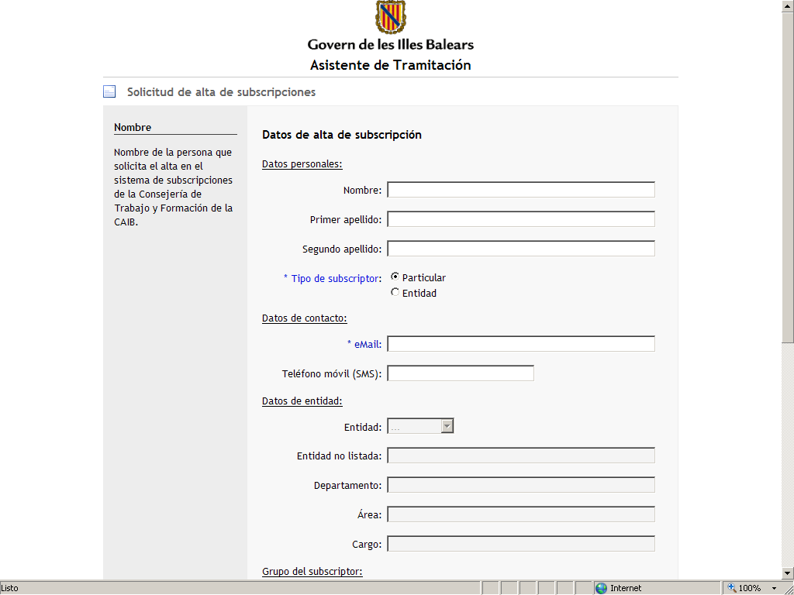
FORMFRONT

REDOSE
Electronic documents are generated and used in Telematic Processing and Notifying Processes. Additionally, these documents can be signed.
Document Security Repository (REDOSE) is a system giving custody to such documents, managing access to them by authorized systems.
REDOSE has an audit system registering accesses and document status changes.
Electronic documents can be incorporated into REDOSE:
  - In ​​persistence area of a telematic processing
  - From management systems in Telematic Notification generation (Telematic Output Registry).
  - From management systems in record warning generation.

REDOSE eliminates file transfers between different systems and optimize telematic procedures in all processing circuit.

REDOSE registers all document models including its versioning. Moreover, it’s possible to define visualization templates (PDF) for XML structured document models.

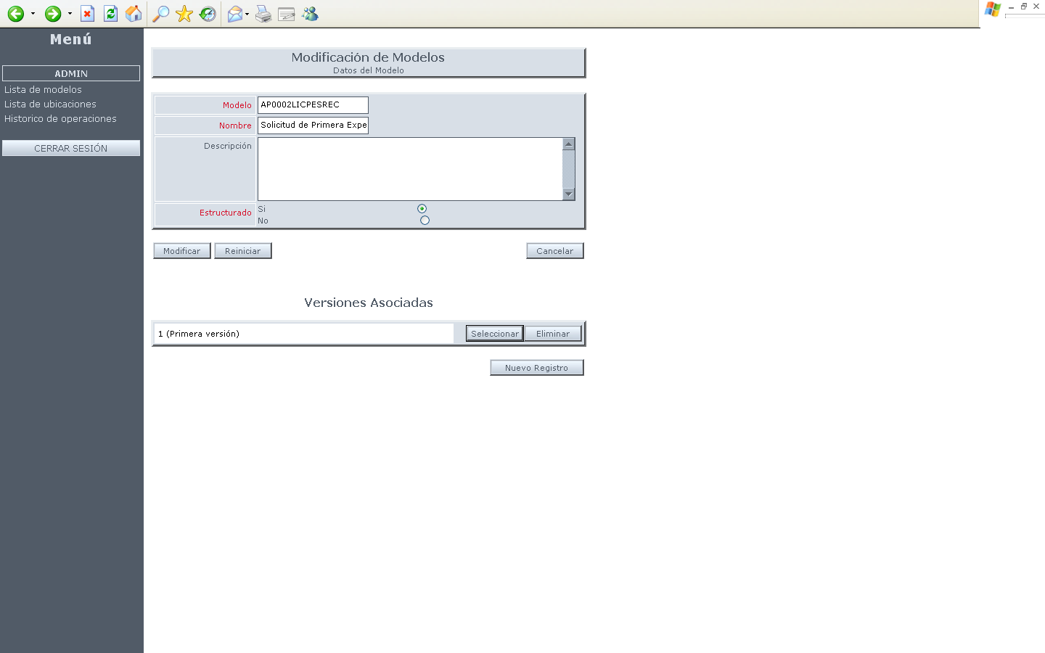
REDOSEBACK

For PDF documents rendered by REDOSE through visualization templates it’s possible to set verification codes in a matrix barcode allowing copy certification of the document.

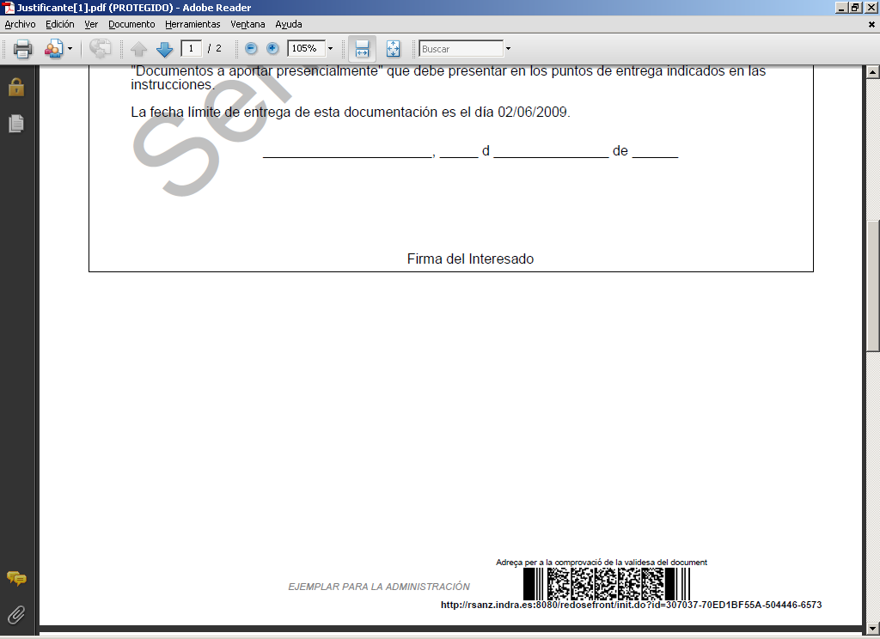

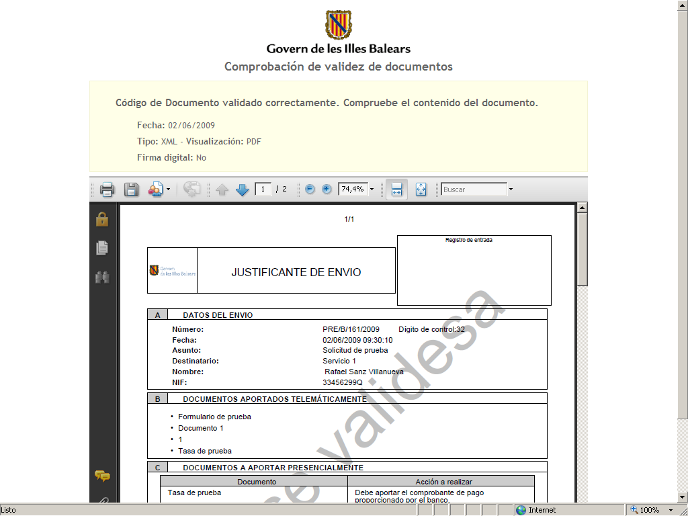

PDF

REDOSEFRONT

There are two possibilities regarding file storage:
- DB Storage: files are stored in database, in REDOSE scheme
- Disk Storage: files are stored externally on a disk path.
Storage type is configured in REDOSEBACK establishing default storage plug-in.

REGTEL
Telematic registry module is a layer located between platform and organization input/output registry and it allows working with registry notes in Sicres format. Moreover, a signed electronic proof with a certificate identifying organization registry is generated as result of a note registration.

BANTEL
Forms and documents delivered by citizen are left in Input Telematic Box as result of Telematic Processing. This process should be processed by management applications (BackOffice). This processing may be:
- Manual: manager accesses to Box viewer (BANTELFRONT) and it accesses to inputs (and its documents)
- Automatic: a program is scheduled collecting inputs and transferring them automatically to BackOffice program.

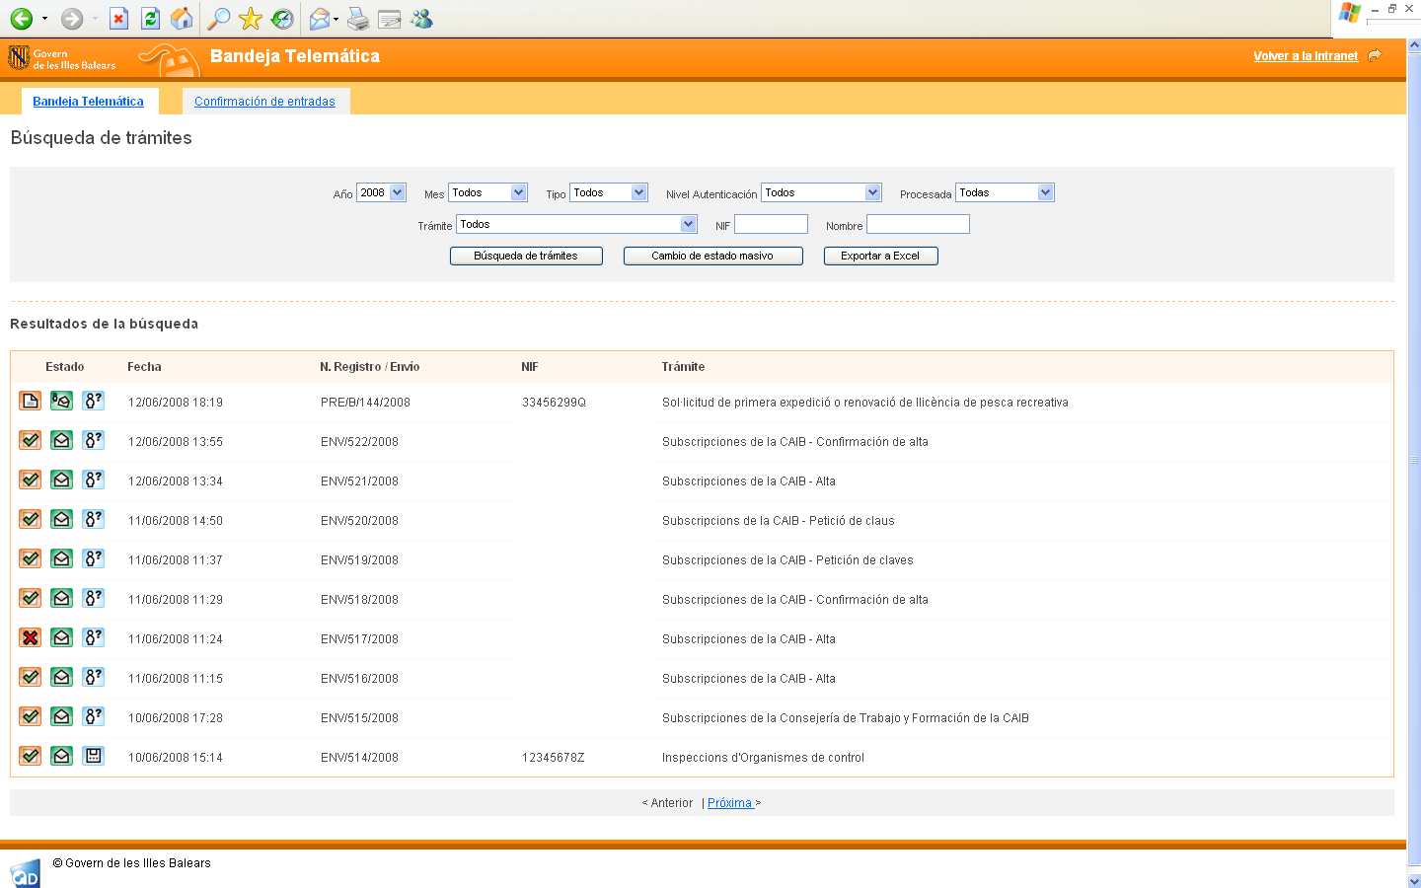
BANTELFRONT

Below we see different calls between BackOffice and Telematic Box when an automatic processing is required:

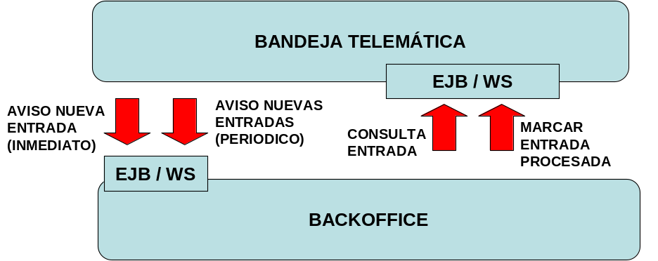

- New inpput warning: it’s possible to configure (by process) that Telematic Box warns BackOffice about new arrived inputs (inputs marked as non processed in Box). There are two types of warnings:
  - Immediate: BackOffice is warned as soon as input arrives indicating entry number.
  - Periodic: BackOffice is warned every certain period of time about new arrived entries.
An EJB or Webservice must be implemented in BackOffice to collect these warnings
- Input query: once warning is received, BackOffice can query entry data through an EJB or Webservice found in Telematic Box. This data contains forms and documents sent by citizen.
- Mark processed entry: once input is processed by Backoffice, it should be marked in Telematic Box as processed if not it would be included in next input warning. If BackOffice cannot process an entry due to an internal error (fi error inserting information into BackOffice tables, etc.) it should be marked as entry processed with errors since otherwise it would try to reprocess it. It’s a BackOffice task to control such errors and inform users about this situation. Users can access this information to be processed manually through Telematic Box viewer.

Box viewer (BANTELFRONT) has a module that allows manager to publish manually records in citizen personal area and generate warnings and notifications.

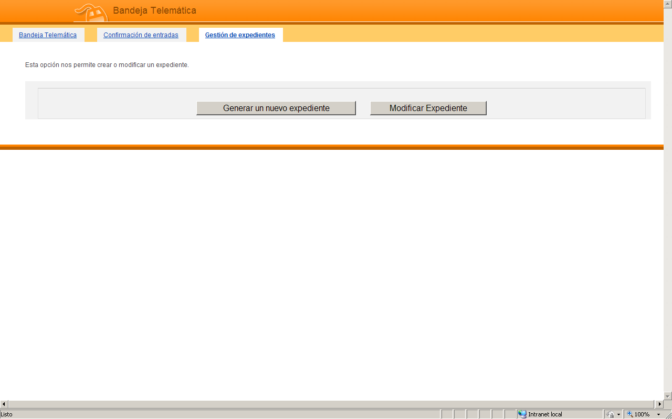

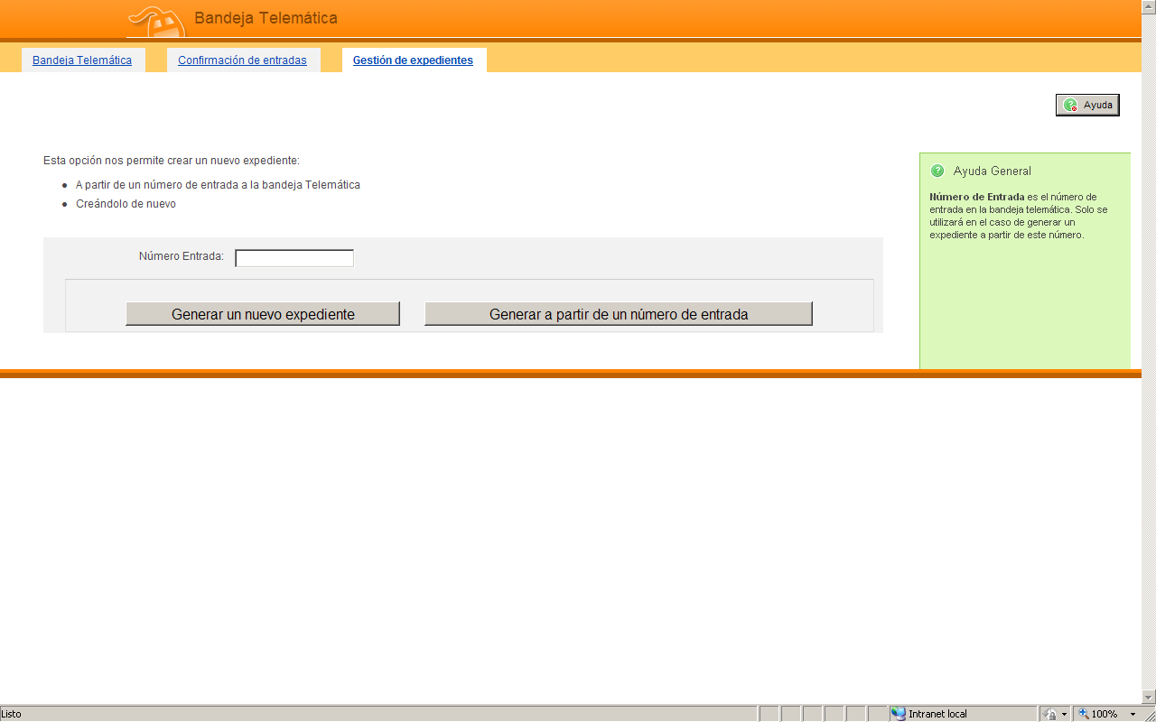

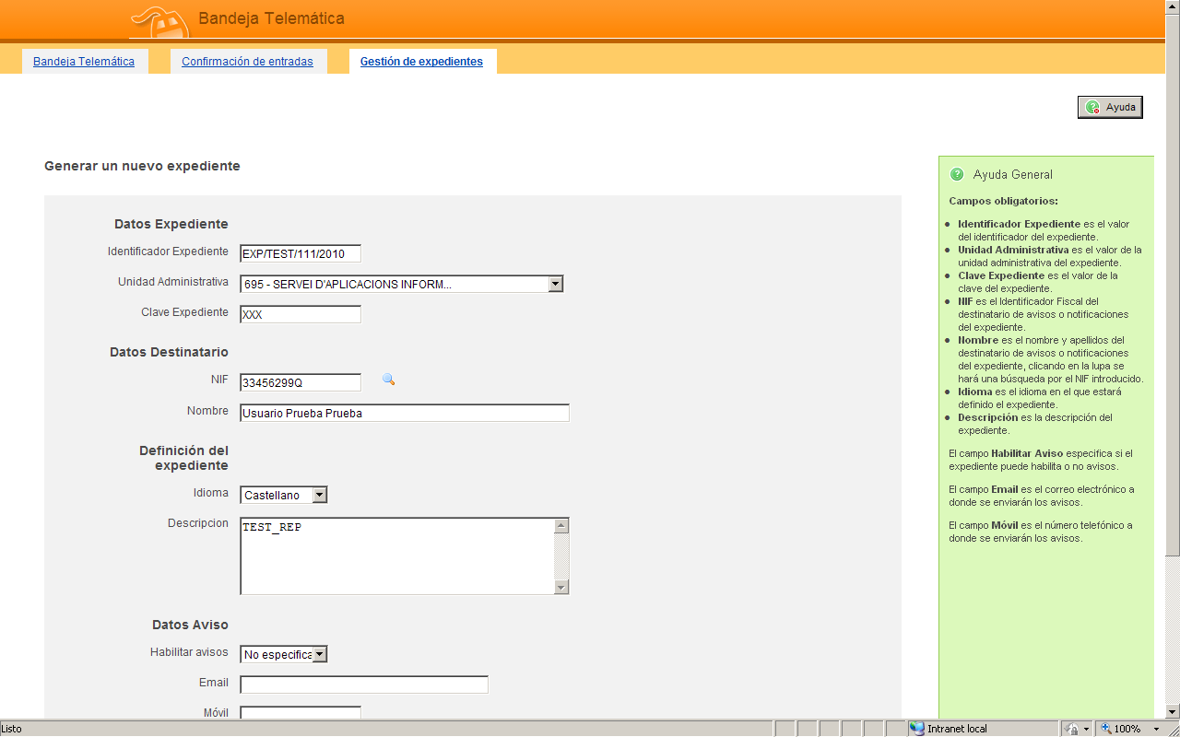

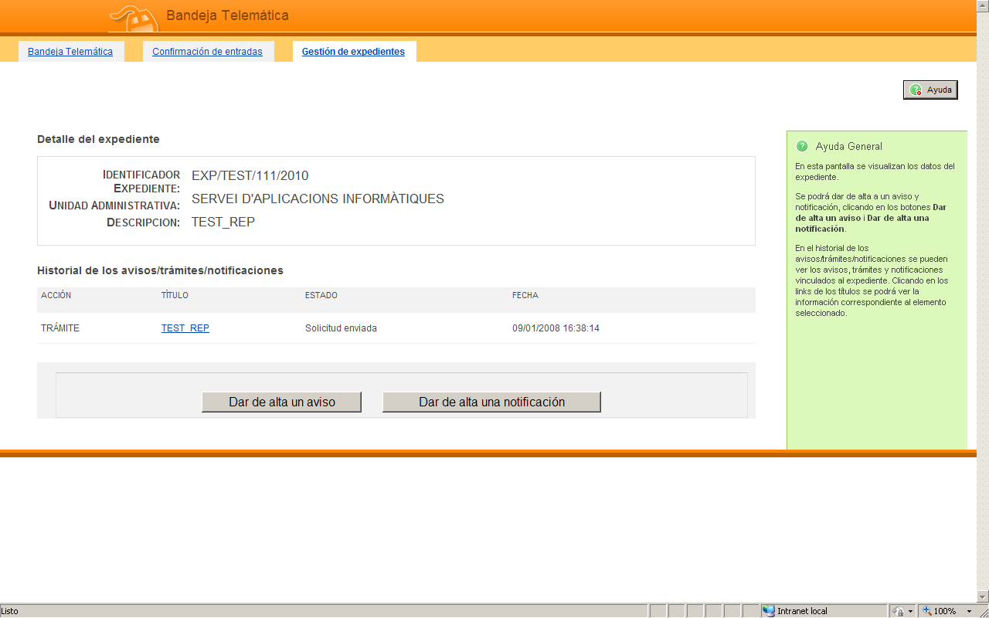

It’s possible to attach documents in word and odt format during warning/notification generation. They are automatically converted to PDF/A adding a verification code. OpenOffice is required for aforementioned conversion (see installation documentation).

ZONAPER
Citizen can authenticate through digital certificate or username/password in his personal area. This authentication guarantees user identity.
Authenticated users can enter in their personal area accessing to their personal data including pending and completed processes, telematic notifications, records,etc.

Entry without authentication is also possible. A processing reference will be asked to the citizen to be able to inform about his process situation.

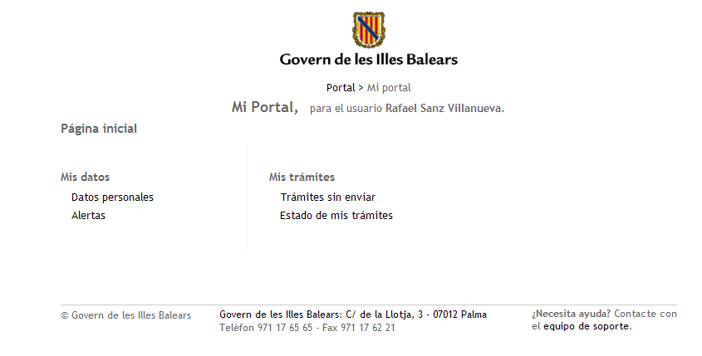

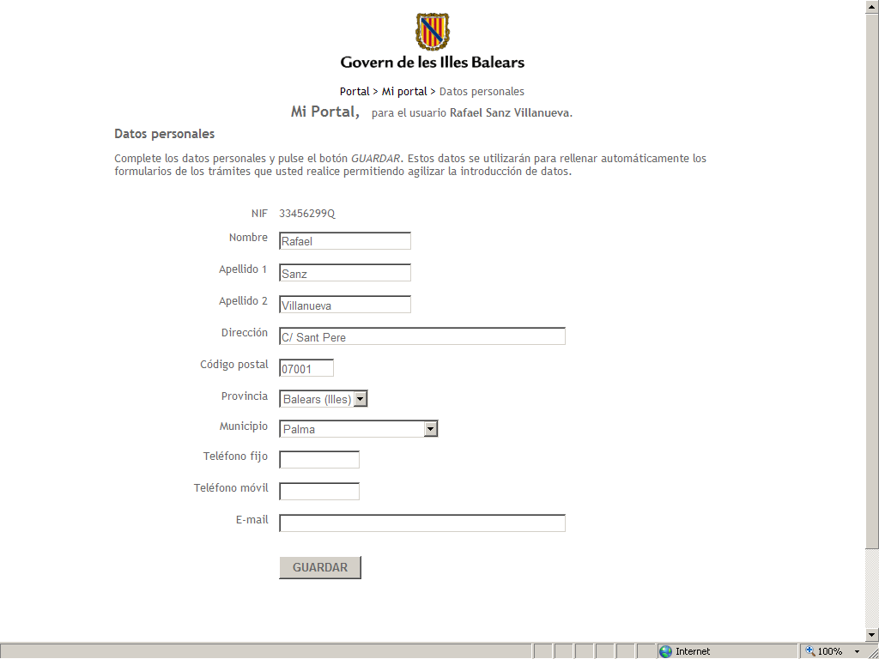
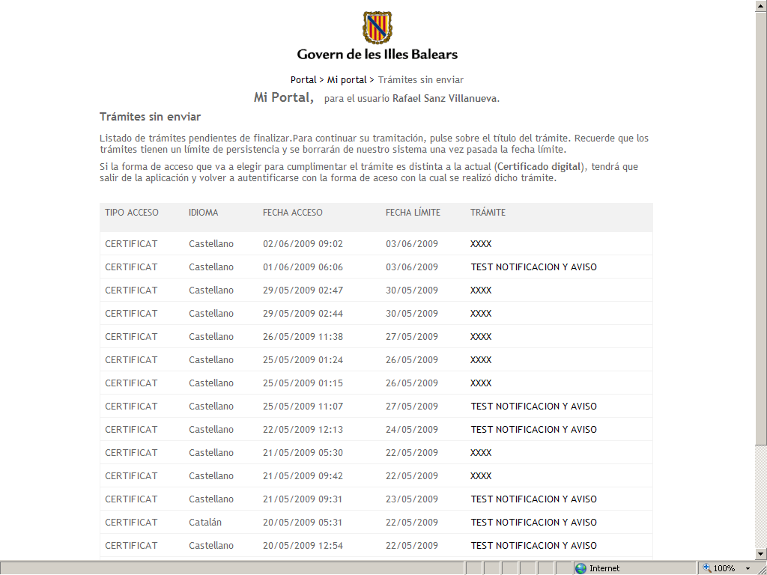
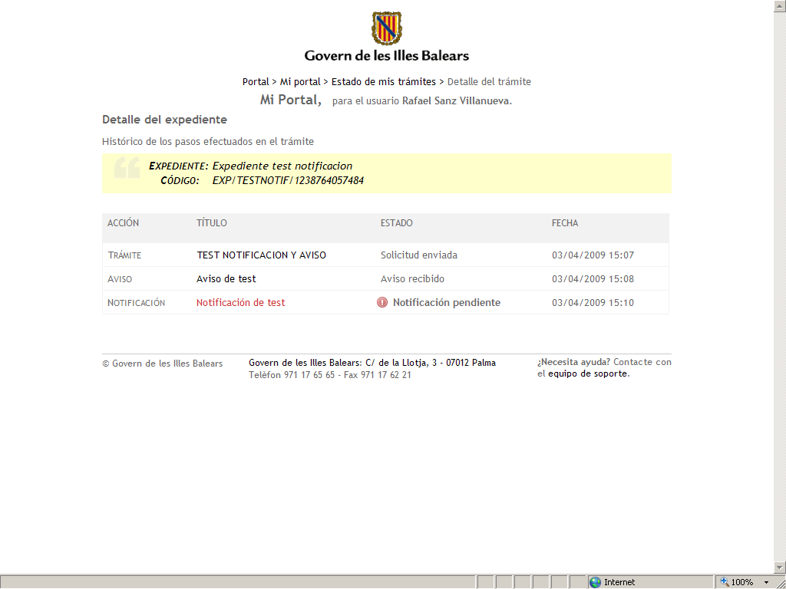
ZONAPERFRONT

"My delegations" option will appear if delegation is enabled on personal area of an entity:

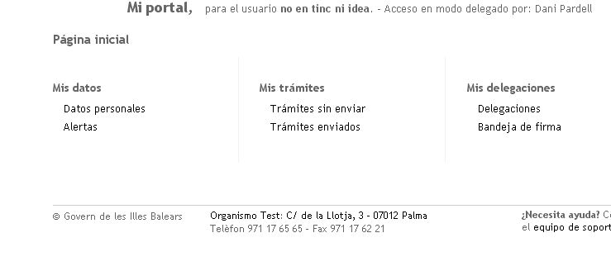
DelegationsAllows the representative of the entity appoint delegates from the same

Tray signature: Access to delegates to sign documents

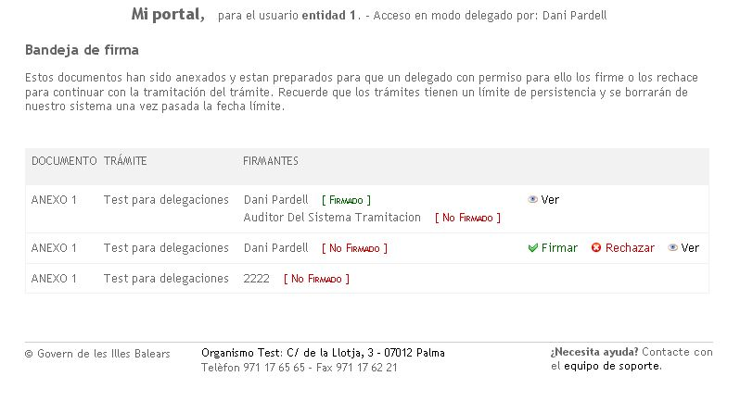
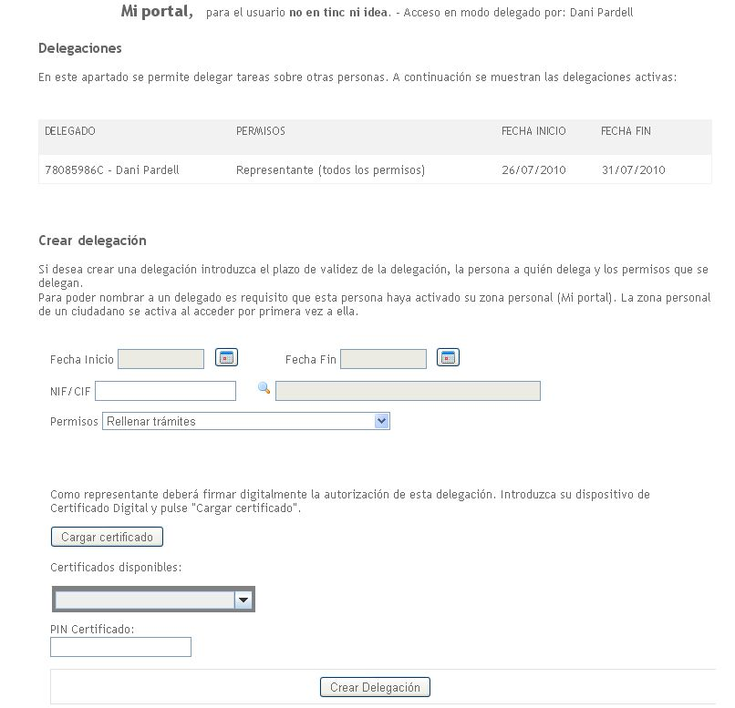

For people who are delegates of some entity, access profile will be requested when they enter in their personal area or during process startup:
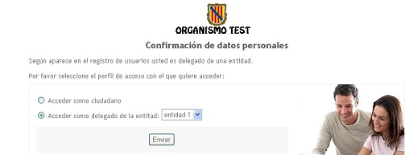

AUDITA
Audit module collects events from different elements of Electronic Administration Platform. These events are displayed through an audit viewer that collects telematic processing data being possible to query by year, month or day and see results broken down into detail boxes or graphics.

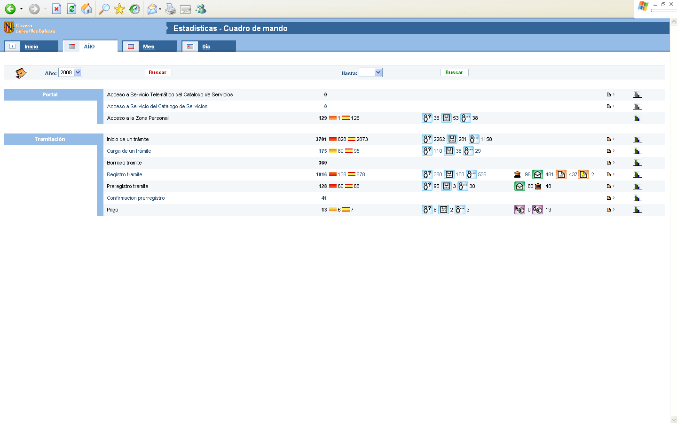

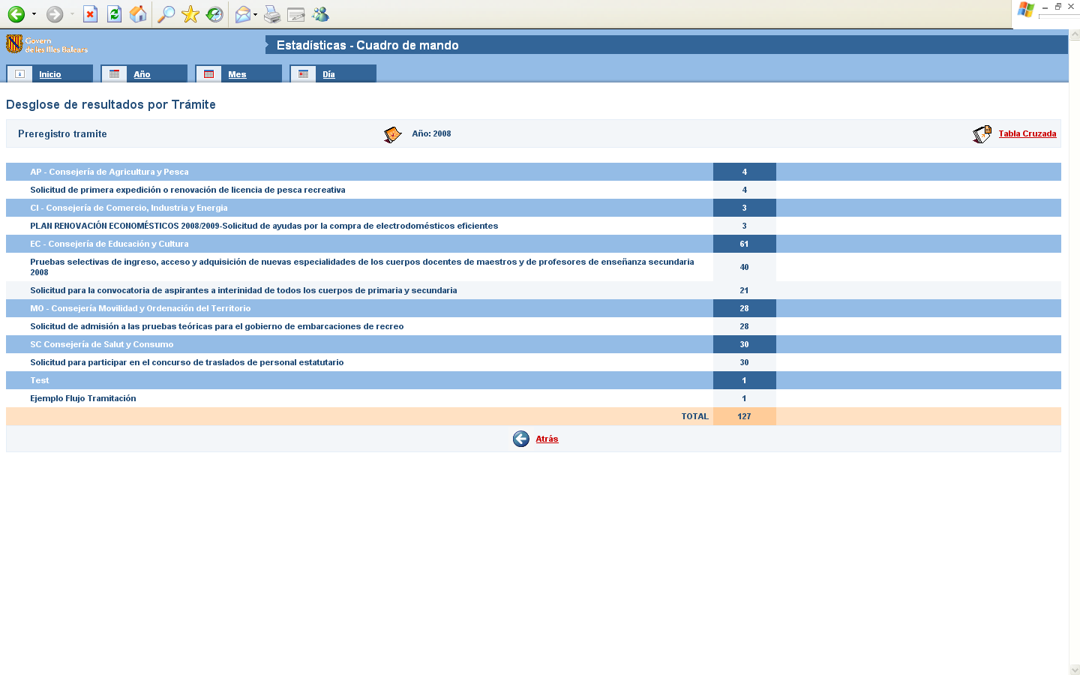

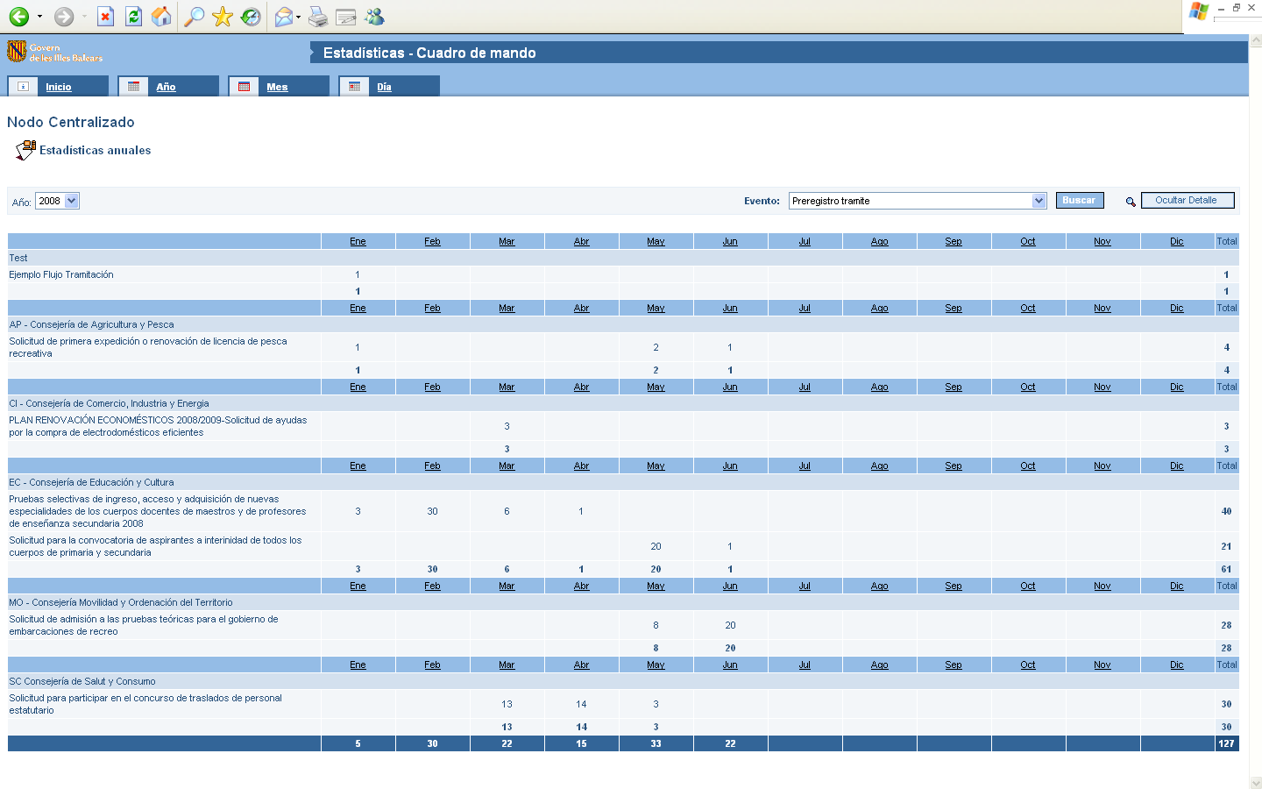

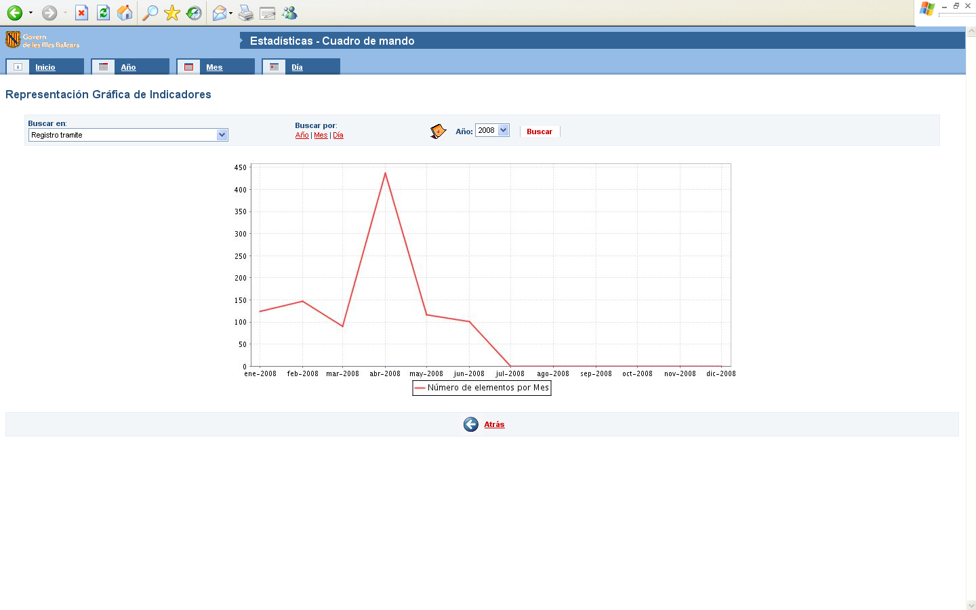
AUDITFRONT

MOBTRATEL
Mobility module allows programming email and sms shipments. This module is used by platform for sending emails to managers with information of his request box. If citizen enables his alerts, platform will also use this module to warn the citizen when a warning or notification is produced for one of his records. In addition, this module provides an interface to different management systems so they can perform this kind of shipments.

Different shipment accounts can be defined though administration tool. Mail datasource for email shipment and account identifier of sms shipment are set (SMS shipment plug-in will know how to send sms). Permissions over accounts can also be assigned to determine which managers can perform shipments against which accounts.

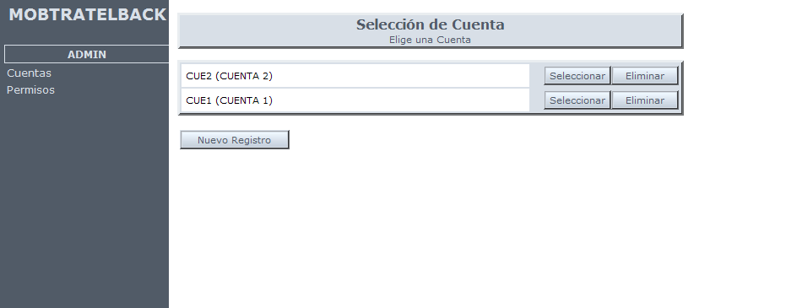
MOBTRATELBACK

A viewer shows shipment schedule and its status:

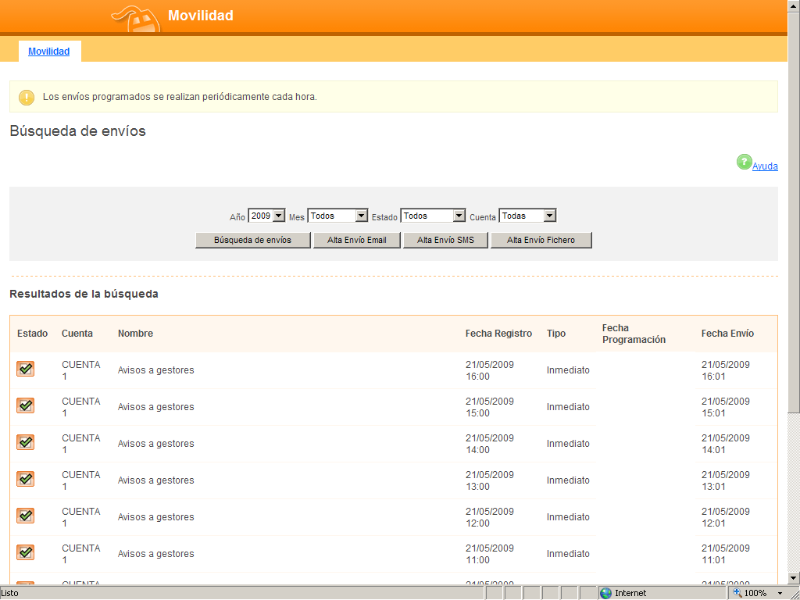
MOBTRATELFRONT

Used technologies
Platform has been built using open source technologies based on J2EE:
- JBoss, Servlet 2.2, JSP 1.1, EJB 2.0, Struts 1.2, Hibernate 2 Quartz, iText, Apache Commons, Jasper Reports, etc.

Integration Organization

Corporate image
Platform will maintain corporate image of each organization through a custom style sheet that allows to customize public module styles (processing assistant, personal area and forms) to maintain corporate image between organization portal and platform.

Connection plug-ins with organization
SISTRA platform can be integrated with organization elements through next plug-ins:

PLUGIN | DESCRIPTION | FUNCTIONAL DOCUMENT
Signature plug-in | Platform supports two signature system: @firma and signaturaCAIB. | SISTRA-PLUGINFIRMA
Login plug-in | It integrates platform with organization corporate login module | SISTRA-PLUGINLOGIN
Registry plug-in | It integrates platform with organization registry | SISTRA-PLUGINREGISTRO
Payment plug-in | It integrates platform with organization telematic payment gateway | SISTRA-PLUGINPAGO
SMS plug-in | It integrates platform with organization SMS shipment gateway | SISTRA-PLUGINSMS
Explicit authentication plug-in | It sets a user/password given by organization for domain invocation, etc. | SISTRA-PLUGINAUTEX
Custody plug-in | It integrates signed documents in a custody system. This plug-in is optional, but document won’t be in custody if not configured. | SISTRA-PLUGINCUSTODIA
Document Management plug-in | It consolidates documents associated to processes, record events and notifications in organization document manager. | SISTRA-PLUGINGESTDOC

Details of each plug-in implementation is available in functional document where each plug-in is defined.

Integration with management applications
SISTRA platform provides an interface based on web services for integration with organization management applications and back-offices.
We can distinguish:
- services offered by SISTRA: services invoked from management applications
- services invoked by SISTRA: services invoked from SISTRA to management applications
Platform supports webservices versioning allowing to add features while maintaining compatibility with previous integrations.

Offered services
Services provided by SISTRA platform for backoffices are:

Services offered by Telematic Box
These services will be invoked by backoffice integration procedures to process inputs arriving to telematic box.

SERVICE | DESCRIPTION | PARAMETERS | RETURNS
obtenerNumerosEntradas | It gets input numbers of a specific process allowing to filter by status and date | Id tramite: process identifier  Estado: processing status of entries to retrieve (all, unprocessed, processed with the error or correctly processed)  Desde: search start date  Hasta: search end date | List with entry numbers
obtenerEntrada | It gets box entry from input number | Numero entrada: input number to retrieve | Entrada Bandeja: it contains information of an entry in Input Telematic Box. It shows main data from registry note and document list associated with the entry.
establecerResultadoProceso | It sets processing result of an entry | Numero entrada: input number on which result is established  Resultado: it indicates processing result (correctly processed or processed with error)  Descripcion error: if it was processed with error, it indicates error description. | Returns nothing

Services offered by Personal Area
These services will be used by backoffices to inform citizen about his telematic processing progress. Citizen has a bulletin board in his personal area where management applications can generate processing records and events related with record (fi events can be generated in record life as under study, resolution pending, solved, etc. where citizen is being informed about its processing).

SERVICE | DESCRIPTION | PARAMETERS | RETURNS
altaExpediente | It adds a record in citizen personal area. | Expediente: record data to add (record id, description, user, ...). You can include events. | Returns nothing
altaEventoExpediente | It adds an event to a record. An event allows informing citizen about record evolution. | Evento: record event (title, description, annexes, ...) | Returns nothing
existeZonaPersonalUsuario | It indicates whether citizen has activated his personal area (Has citizen entered in Sistra?) | Nif / Cif | Returns true / false

Services offered by telematic registry
Telematic registry layer implemented by the SISTRA platform makes next operations possible:
- about output registry: it adds telematic notifications and it queries if citizen received them later.
- about input registry: it allows to perform an input telematic registration by an application other than SISTRA platform.

SERVICE | DESCRIPTION | PARAMETERS | RETURNS
registroSalida | It performs an output registration (notification). Registry note and annexes should be inserted in RDS previously. | DatosRegistroSalida: output registration data to perform | ResultadoRegistro: number and date of registration
obtenerAcuseRecibo | It queries to management application if notification was delivered to citizen | numeroRegistro: output registration number | Datos del acuse de recibo: indicator whether it was delivered, delivery date, etc.
registroEntrada | It performs an input registration (for applications other than Sistra requiring telematic registry) | DatosRegistroEntrada: input registration data to perform | ResultadoRegistro: number and date of registration

Services offered by Document Repository
These services allow following to management applications:
- query documents: access to annexes of Telematic Box input,etc.
- insert documents: insert documents required for a notification (registry note and note annexes), insert documents attached to a record event, etc.

SERVICE | DESCRIPTION | PARAMETERS | RETURNS
insertarDocumento | It inserts a document for performing operations related with it later (output registry, add an event, ...) | DocumentoRDS: document data to insert (title, data, model, version, etc.) | ReferenciaRDS: reference to document in the repository
insertarDocumentoConTransformacion | It inserts a document for performing operations related with it later (output registry, add an event, ...) | DocumentoRDS: document data to insert (title, data, model, version, etc.)  TransformacionRDS: document changes: convert to PDF and stamp a verification barcode | ReferenciaRDS: reference to document in the repository
consultarDocumento | It queries a document | ReferenciaRDS: it references the document inside the repository | DocumentoRDS: document data (title, data, model, version, etc.)
consultarDocumentoFormateado | It allows to query a structured document (XML) that it’s formatted through a display template | ReferenciaRDS: it references the document inside the repository  TipoPlantilla: (Optional) It lets specify a specific template.  Idioma (Optional) It indicates a specific language for formatting | DocumentoRDS: formatted document data (title, data, model, version, etc.)

Services offered by Mobility module
Mobility module allows backoffice applications to generate emails and/or SMS scheduled shipments.

This module allows defining shipping accounts where email and sms addresses are configured and it sets which managers have permissions to perform shipments to this account

Shipping account, scheduled date and message set (sms and/or emails) to send are indicated when a shipment to mobility modules is done

SERVICE | DESCRIPTION | PARAMETERS | RETURNS
enviarMensaje | It sends a programmed message through mobility module | MensajeEnvio: shipping information: account, scheduled date, email and sms messages. | Shipping code

Invoked services

Services invoked from SISTRA platform to backoffices are:

Services invoked from processing Assistant

It may be necessary to access data located in backoffices from processing assistant in next cases:
- access to a domain or list of values ​​located in backoffice (fi data associated with a citizen, value lists, etc.).
- resolution of query processes: there is a type of process where backoffice should return documents associated to a query.

SERVICE | DESCRIPTION | PARAMETERS | RETURNS
obtenerDominio | Domain query to a management application | Id dominio: domain identifier to retrieve  Parametros: domain parameters | Valores dominio: domain value list
realizarConsulta | It performs query operation to management application for query processes. | Id tramite: process identifier  Formularios consulta: filled forms through processing assistant with data for query | Documentos consulta: document list resulting from query

Services invoked from Telematic Box

It can be configured that backoffices are notified when new inputs arrive in Telematic Box from managed processes.

SERVICE | DESCRIPTION | PARAMETERS | RETURNS
avisoEntradas | It warns management application that new inputs were registered in Telematic Box. | Numero de entradas: input number list pending to process | Returns nothing

