Definición Gestor Formularios

Code: SISTRA-GSTFRM

DOCUMENT CONTROL SHEET

 |  | DOCUMENT / FILE
Title: Definición Gestor Formularios |  |  |  |  |  |  |  |  |  | File Name / s:0000.doc
Code: SISTRA-GSTFRM |  |  |  |  |  |  |  |  |  | Software: Word
Date: March 2014
Version: 2
 |  |  |  | RECORD OF CHANGES
 | Version |  |  | Pages |  |  | Reason for change
 | 1 |  |  | 10 |  |  | Document Creation
 | 2 |  |  | 11 |  |  | Save unfinished form
 |  |  |  |  |  | DISTRIBUTION OF DOCUMENT
 |  |  | Name |  |  |  |  | Staff
 |  |  |  | DOCUMENT CONTROL
PREPARATION |  |  |  |  | REVISED / APPROVED |  |  |  |  |  |  |  | ACCEPTED |  | ACCEPTED
Rafael Sanz |  |  |  |  | José Vicente Juan Pérez |  |  |  |  |  |  |  | Jerome Navarrete |  | Bernat Alberti
Complete with the name, signature and date |  |  |  |  |  |  |  |  |  |  |  |  |  |  |  | Customers only

INDEX
1. Introduction 4
2. SISTRA - Form manager communication protocol 4
2.1. Operations 4
2.2. Operation sequence 5
2.3. Operation flow 5
2.4. XML Configuration 6
2.5. XML data 8
3. Form manager definition 9
4. Project example 10

Introduction
The purpose of this document is to show how a new form manager, alternative to FORMS, can be defined in processing platform.

SISTRA - Form manager communication protocol

Operations
Transactions between processing system (SISTRA) and form manager are:

- MostrarFormulario:
- User asks Sistra to display a form.
- Sistra passes to form manager: actual form data and a configuration XML to define communication parameters and special form properties
- Form manager receives these parameters and it returns a form access token to Sistra.
- Sistra redirects user request to form manager indicating access token.
- GuardarFormulario:
- User asks form manager to save the form.
- Form manager communicates to Sistra that form will be saved indicating initial data and data to save. Optionally, it can be set in form configuration if uncompleted form can be saved.
- Sistra receives parameters and it returns an access token to resume processing.
- Form manager redirects user request to Sistra indicating token.
- AbandonarFormulario:
- User asks form manager to quit form without saving data.
- Form manager communicates Sistra that form will be quit.
- Sistra returns an access token to resume processing.
- Form manager redirects user request to Sistra indicating token

Operation sequence
Access
form
Save
form
Quit
form
MostrarFormulario
CrearFormulario (XMLConfiguracion, XMLDatosFormulario)
Returns Access Token
Returns URL to access token
MostrarFormulario (tokenAcceso)
Save Form
guardarFormulario (XMLDatosIniciales, XMLDatosActuales)
Returns token to continue processing
Returns URL with token to continue processing
ContinuarTramitacion (token)
AbandonarFormulario
abandonarFormulario
Returns token to continue processing
Returns URL with token to continue processing
User
SISTRA
Forms Manager
MostrarFormulario
CrearFormulario (XMLConfiguracion, XMLDatosFormulario)
Returns access Token
Returns URL to access token
MostrarFormulario (tokenAcceso)
Save Form
guardarFormulario (XMLDatosIniciales, XMLDatosActuales)
Returns token to continue processing
Returns URL with token to continue processing
ContinuarTramitacion (token)
AbandonarFormulario
abandonarFormulario
Returns token to continue processing
Returns URL with token to continue processing
ContinuarTramitacion (token)

Operation flow

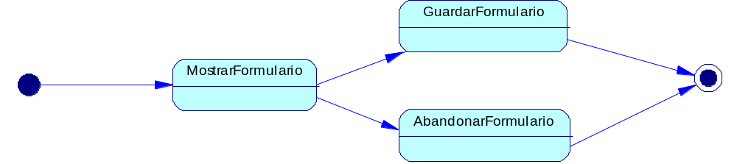

XML Configuration
In SISTRA form display operation, it passes to form manager a configuration XML with parameters for communication and form configuration.
It is not mandatory that manager uses all configuration options offered by this XML, but only needed ones can be used.
This XML schema is as follows:

<?xml version="1.0" encoding="UTF-8"?>
<xs: schema xmlns: xs="Http://www.w3.org/2001/XMLSchema" elementFormDefault="Qualified">

<! - Configuration ->
<xs: element name="Configuration">
<xs: complexType>
<xs: sequence>
<xs: element Inventory="Data"/>
<xs: element Inventory="Properties"/>
<xs: element Inventory="Blockade"/>
</xs: sequence>
</xs: complexType>
</xs: element>

<! - Configuracion.datos ->
<xs: element name="Data">
<xs: complexType>
<xs: sequence>
<xs: element Inventory="Language"/>
<xs: element Inventory="Model"/>
<xs: element Inventory="Version"/>
<xs: element Inventory="CodigoPerfil" minOccurs="0"/>
<xs: element Inventory="Layout" minOccurs="0"/>
<xs: element Inventory="GuardarSinTerminar" minOccurs="0"/>
<xs: element Inventory="UrlSisTraOK"/>
<xs: element Inventory="UrlRedireccionOK"/>
<xs: element Inventory="UrlSisTraCancel"/>
<xs: element Inventory="UrlRedireccionCancel"/>
<xs: element Inventory="UrlSisTraMantenimientoSesion"/>
<xs: element Inventory="NomParamXMLDatosIni"/>
<xs: element Inventory="NomParamXMLDatosFin"/>
<xs: element Inventory="NomParamXMLSinTerminar"/>
<xs: element Inventory="NomParamTokenRetorno"/>
</xs: sequence>
</xs: complexType>
</xs: element>
<xs: element name="Language" type="Xs: string"/>
<xs: element name="Model" type="Xs: string"/>
<xs: element name="Layout" type="Xs: string"/>
<xs: element name="GuardarSinTerminar" type="Xs: string"/>
<xs: element name="NomParamTokenRetorno" type="Xs: string"/>
<xs: element name="NomParamXMLDatosFin" type="Xs: string"/>
<xs: element name="NomParamXMLDatosIni" type="Xs: string"/>
<xs: element name="NomParamXMLSinTerminar" type="Xs: string"/>
<xs: element name="UrlRedireccionCancel" type="Xs: string"/>
<xs: element name="UrlRedireccionOK" type="Xs: string"/>
<xs: element name="UrlSisTraCancel" type="Xs: string"/>
<xs: element name="UrlSisTraOK" type="Xs: string"/>
<xs: element name="UrlSisTraMantenimientoSesion" type="Xs: string"/>

<xs: element name="Version" type="Xs: int"/>
<xs: element name="CodigoPerfil" type="Xs: string"/>

<! - Configuracion.propiedades ->
<xs: element name="Properties">
<xs: complexType>
<xs: sequence>
<xs: element Inventory="Property" maxOccurs="Unbounded"/>
</xs: sequence>
</xs: complexType>
</xs: element>
<xs: element name="Property">
<xs: complexType>
<xs: sequence>
<xs: element Inventory="Name"/>
<xs: element Inventory="Value"/>
</xs: sequence>
</xs: complexType>
</xs: element>
<xs: element name="Name" type="Xs: string"/>
<xs: element name="Value" type="Xs: string"/>

<! - Configuracion.bloqueo ->
<xs: element name="Blockade">
<xs: complexType>
<xs: sequence minOccurs="0">
<xs: element Inventory="Xpath" maxOccurs="Unbounded"/>
</xs: sequence>
</xs: complexType>
</xs: element>
<xs: element name="Xpath" type="Xs: string"/>

</xs: schema>

An example of such XML is:

<?xml version="1.0" encoding="UTF-8" standalone="Yes"?>
<configuration>
<data>
<language>this is</language>
<model>887</model>
<version>One</version>
<codigoPerfil>CAIB_AZUL</codigoPerfil>
<layout>CAIB</layout>
<urlSisTraOK>http://rsanz-port.indra.es:8080/sistrafront/recepcionFormulario?gstfrm=MTE5NjI0MzM0NTU4NQ==& Amp;Instance_ID = e18cf10b88f07d591170ef496dcdff06</urlSisTraOK>
<urlRedireccionOK>/sistrafront/protected/continuarTramitacion.do?gstfrm=MTE5NjI0MzM0NTU4NQ==& Amp;Instance_ID = e18cf10b88f07d591170ef496dcdff06</urlRedireccionOK>
<urlSisTraCancel>http://rsanz-port.indra.es:8080/sistrafront/cancelarForm?gstfrm=MTE5NjI0MzM0NTU4NQ==& Amp;Instance_ID = e18cf10b88f07d591170ef496dcdff06</urlSisTraCancel>
<urlRedireccionCancel>/sistrafront/protected/continuarFormCancelacion.do?gstfrm=MTE5NjI0MzM0NTU4NQ==& Amp;Instance_ID = e18cf10b88f07d591170ef496dcdff06</urlRedireccionCancel>
<urlSisTraMantenimientoSesion>/ Sistrafront / protected / mantenimientoSesionForm? Instance_ID = e18cf10b88f07d591170ef496dcdff06</urlSisTraMantenimientoSesion >
<nomParamXMLDatosIni>xmlInicial</nomParamXMLDatosIni>
<nomParamXMLDatosFin>xmlFinal</nomParamXMLDatosFin>
<nomParamTokenRetorno>TOKEN</nomParamTokenRetorno>
</data>
<properties>
<property> <name>application</name> <value>Processing Assistant</value> </property>
<property> <name>user</name> <value>Rafael Sanz Villanueva</value> </property>
<property> <name>processed</name> <value>TEST_REP</value> </property>
<property> <name>form</name> <value>DATA REPRESENTATION</value> </property>
</properties>
<blockade>
<Xpath> / FORM / DATOSPERSONALES / NIF</ Xpath>
<Xpath> / FORM / DATOSPERSONALES / NAME</ Xpath>
</ Lock
</configuration>

The meaning of the fields is as follows:
- DATA:
  - Idioma: processing language so that form manager shows the form in the same language.
  - Modelo/Version: Form model/version. It allows form manager to manage more than one form
  - CodigoPerfil/Layout: It specifies a processing system customization to form manager.
  - guardarSinTerminar: It indicates if an uncompleted form can be saved (S / N).
  - urlSistraOK: Url to be invoked by form manager to pass form data to save to sistra (initial data and final data). It should add these parameters to this url. Parameters name is given by fields: nomParamXMLDatosIni and nomParamXMLDatosIni.
  - urlRedireccionOK: Once Sistra token is obtained, form manager must invoke this url adding this token as parameter. The name of this parameter is given by field nomParamTokenRetorno.
  - urlSisTraCancel: Url to be invoked by form manager to tell Sistra the form is canceled. Sistra returns a token for resuming processing.
  - urlRedireccionCancel: Once token from Sistra is obtained, form manager must invoke this url adding this token as parameter. This parameter name is given by field nomParamTokenRetorno
  - urlSisTraMantenimientoSesion: url to be invoked periodically from external manager screens to maintain Sistra session active. This invocation can be implemented, f.i. with an ajax call while loading each manager page or with a javascript timeout function every few minutes.

- PROPERTIES:
A number of properties are passed to form manager in this section: sistra application name, user name, process name and form name in sistra.

- LOCK:
This section tells to form manager fields that could be blocked.

XML data
XML is used to point out form data. XML format must follow these rules:
- Encoding should be UTF-8.
- XML root must be 'FORMULARIO'.
- A unique XPATH should exist for each form field.
- For dropdown fields, description will be used as node value and element code in an attribute called ‘indice’.
- if a form field doesn’t appear in XML, it means that its value is empty.

An example of valid XML is next:

<? Xml version = "1.0" encoding = "UTF-8"?>
<FORM>
<DATOSPERSONALES>
<NIF> 33456299Q </ NIF>
<NAME> Rafael </ NAME>
<NAME1> Sanz </ NAME1>
<Surname2> Villanueva </ Surname2>
</ DATOSPERSONALES>
<DATOSSOLICITUD>
<TYPE index = "T2"> Type 2 </ TYPE>
<DETAIL> Sample custom form </ DETAIL>
</ DATOSSOLICITUD>
</ FORM>

Form manager definition
The definition of a new form manager is configured in sistraback Form managers section. An identifier and access urls will be indicated when a form manager is added.

Form manager to use can be chosen when defining a form in SistraBack:

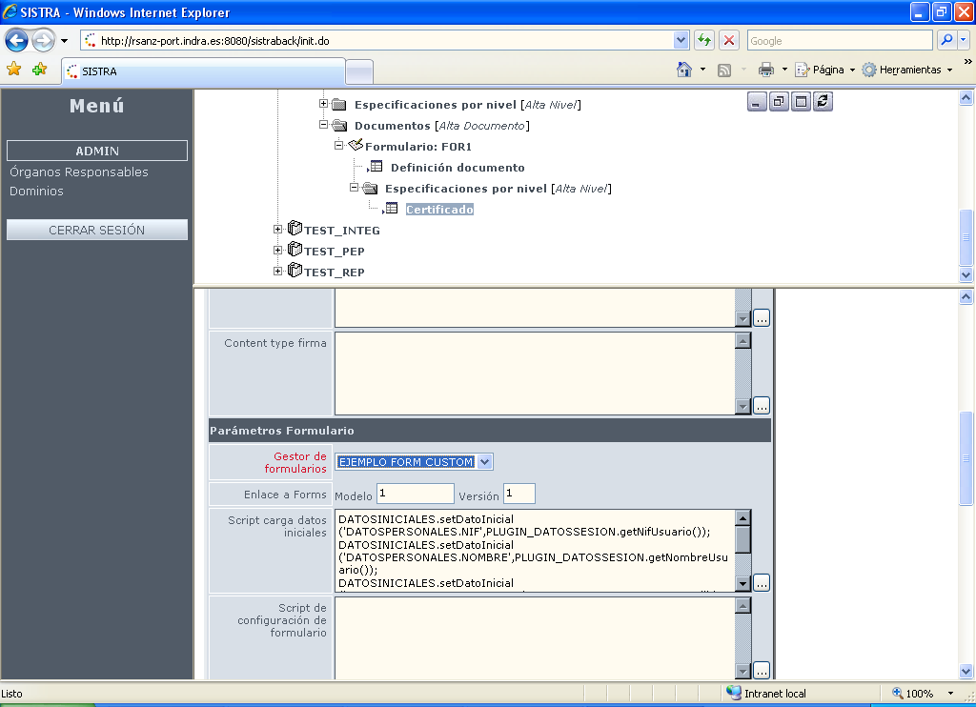

Project example
An eclipse project with basic implementation of a form manager is provided to be used as a base for these manager implementations.

