Nearby Now

Step 1:

• What problem does it solve?

• Who is it for?

• Why now?

Step 2 — Research (browser + notes)
Just Google, Reddit, App Store reviews of competitors. Paste your findings into the same Notion page.

Step 3 — Wireframes (the fun part)
This is where a tool matters. Three options:
Figma — what real companies use, free, runs in browser Excalidraw — even simpler, feels like sketching, also free Paper + pen — honestly the fastest for early ideas, just take a photo

Step 1
When people want to go out, they waste time scrolling through Instagram or Google just to find something happening nearby tonight. Nearby Now shows you real local events — bars, watch parties, pop-ups — happening within the next few hours, so you can just go.

Step 2 — Research (browser + notes)
I googled other event finder apps and websites and I discovered that most of them are events that will happen in a week or in general places to visit or attend. My project is about finding the events happening now and within next 24 hours. Also, my project is more concentrated on precise locations and nearby areas.
"Nearby Now shows you events happening right now and within the next 24 hours, within walking distance of where you are — not next week, not across the city."

1. Time gap — other apps show future events (next week, next month). You show right now and next 24 hours.
2. Location gap — other apps are broad and city-wide. You're hyper-local, precise to your neighborhood.
So in the result of research I discovered some of the competitors and the disadvantages I will face to make my project useful:
• Who are my competitors? (Eventbrite, Facebook Events, Meetup)
Eventbrite – is more focused on general things that will happen in near future, covers all the cities and districts, shows by most popular cities.
Facebook shows by adds and not always shows what is happening right now.
Meetup — focused on recurring group activities and communities, not spontaneous real-time events.
Nearby Now is the app for right now — local events within walking distance, happening in the next 24 hours..
• What's my unfair advantage? — the time + location
Big apps like Eventbrite, Meetup are huge and they are not hyper-local or real-time.
My project is very small and it can go deep and narrow.

Step 3 — Wireframes (the fun part)
For this step for now I sketched 3 pages: Login Page, Home Page, Event Detail Page.
This is my hand sketched version of all 3 pages ;))))

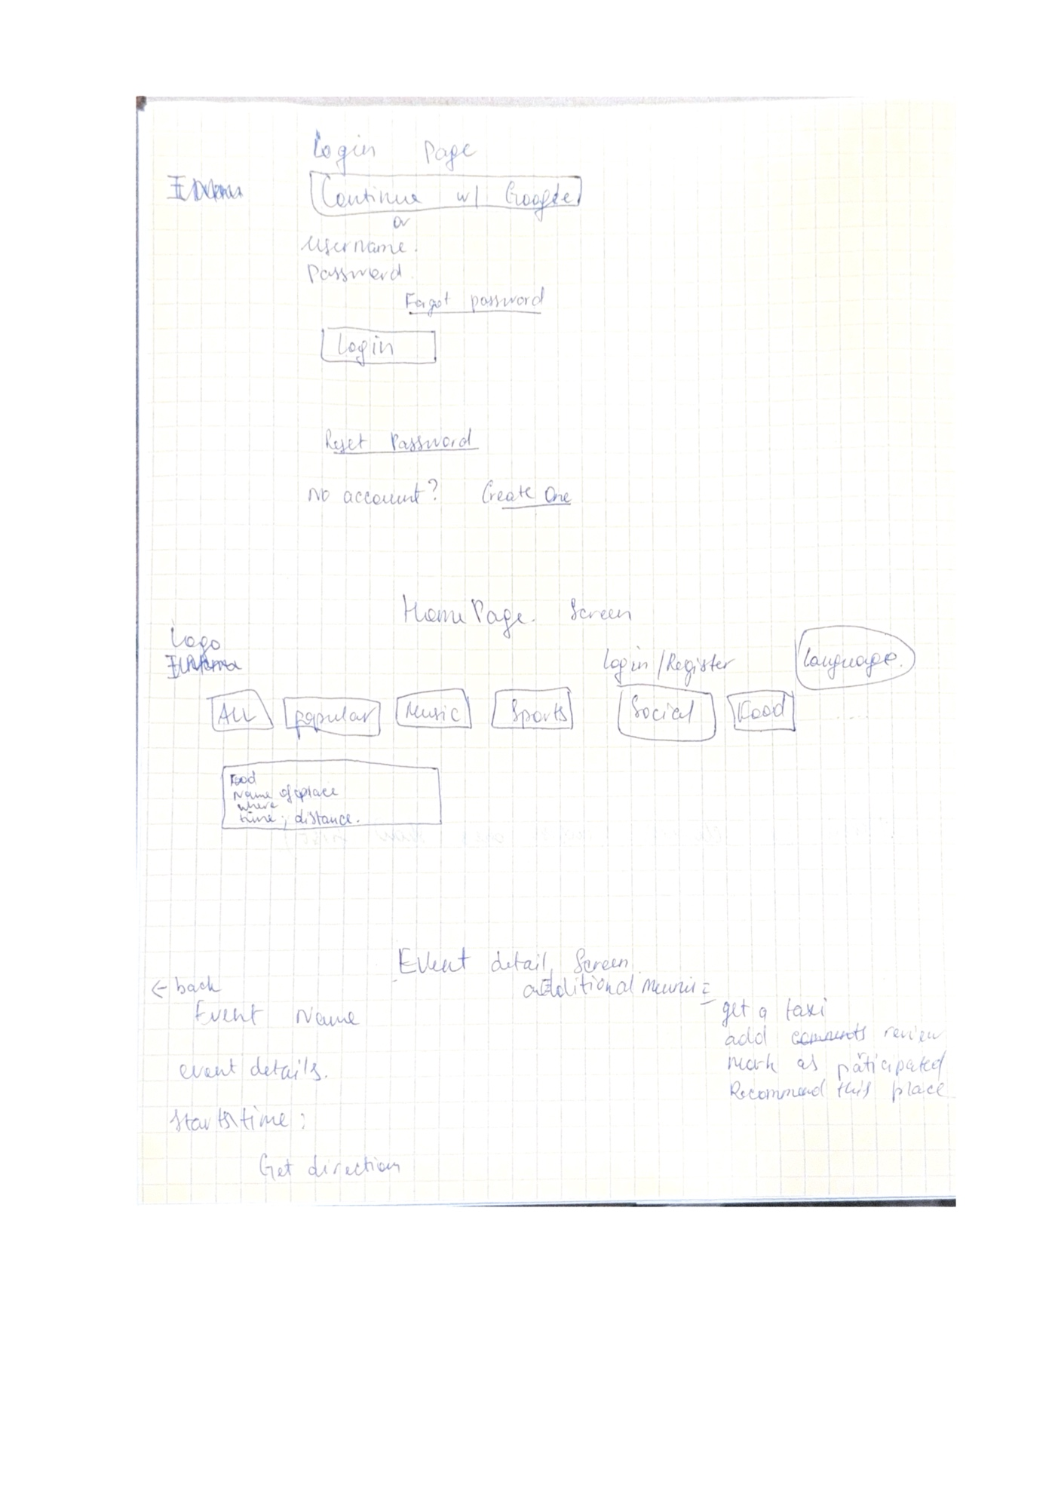

This is Figma version:
- Login Page Layout
Details: For now my login page only let’s the user be a guest or use their Google account to use the app.
Later on features: Later as I try out the simple version there will be signin/signup
Username, password. Forgot password, Reset Password
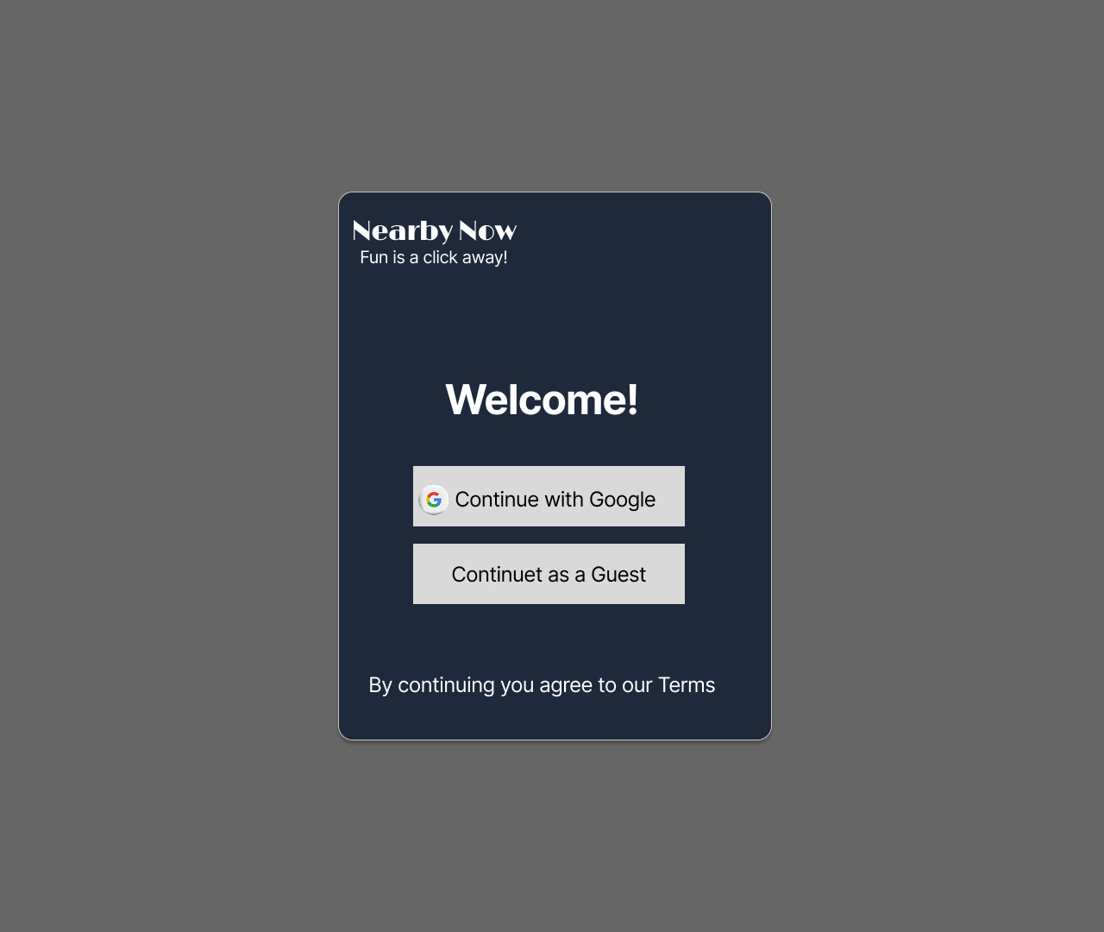

- Home Page Layout
Details: For now Home page will display on the right corner “Login”, on the left side “Logo of the app and the name”, on the top center will be categories of events, by default will be displayed nearby within 1-2 miles of range, but this will depend on the location of a user, if the user is in not big city the range will be farther.

