“Secure Digital Wallet System with Modular Authentication Engine”

ABSTRACT
The rapid advancement of digital technologies has significantly transformed the way financial transactions are performed, leading to the widespread adoption of digital wallet systems. However, ensuring security, consistency, and traceability in such systems remains a major challenge. This project presents the design and implementation of a secure wallet system integrated with a modular authentication engine, aimed at addressing these challenges through a robust and scalable architecture.

The system is developed using a full-stack approach, where the frontend is built using React (Vite) to provide a responsive and user-friendly interface, and the backend is implemented using Node.js with Express.js to manage application logic and API services. The data is stored and managed using MySQL with the InnoDB storage engine, ensuring strong transactional support and data reliability. The architecture of the system is divided into two core components: the authentication engine and the wallet engine. The authentication engine is responsible for user identity management, including secure registration, login, session handling, token generation, refresh token rotation, email verification, and password recovery. The wallet engine manages all financial operations such as deposits, withdrawals, transfers, and balance retrieval, ensuring that every transaction is accurately recorded and processed.

A key aspect of this project is the adoption of a ledger-based design for handling financial data. Instead of storing a mutable balance directly, the system records every transaction as an immutable ledger entry, and the balance is derived dynamically. This approach enhances transparency, traceability, and auditability of financial operations.

To ensure data integrity and system reliability, the project incorporates several advanced database and security mechanisms. All financial operations are executed using ACID-compliant transactions, ensuring atomicity and consistency. Row-level locking is applied during critical operations to prevent race conditions and concurrent data conflicts. Additionally, idempotency is achieved through the use of unique transaction references, preventing duplicate processing of requests. A trigger-based auditing mechanism automatically logs every ledger insertion, providing a tamper-resistant audit trail. The system also emphasizes secure API design by implementing token-based authentication using JSON Web Tokens, input validation, and rate limiting to protect against unauthorized access and common security threats. The database schema is designed using normalization principles, foreign key constraints, and indexing to maintain data consistency and optimize performance. Extensive testing has been conducted to validate the correctness and robustness of the system. This includes unit testing of authentication components, integration testing of API workflows, and database validation tests to ensure proper enforcement of constraints, triggers, and transaction logic.

In conclusion, this project demonstrates the practical implementation of a secure, scalable, and auditable digital wallet system using modern web technologies and database concepts. It highlights the importance of combining strong authentication mechanisms with reliable transaction processing to build real-world financial applications.

1. INTRODUCTION
The rapid growth of digital technologies has significantly transformed financial transactions, shifting from traditional cash-based systems to digital payment solutions. Among these, digital wallet systems have become highly popular due to their convenience, speed, and accessibility. However, developing such systems requires careful attention to security, data integrity, and transaction reliability, as financial applications deal with sensitive and critical data.

This project focuses on designing and implementing a secure wallet system integrated with a modular authentication engine. The system enables users to register, log in, verify their identity, and perform financial operations such as deposits, withdrawals, and fund transfers in a secure and efficient manner.

One of the major challenges in wallet systems is maintaining accurate and consistent financial data. Many basic implementations directly update balances, which can lead to inconsistencies and lack of transparency. To overcome this limitation, the proposed system adopts a ledger-based approach. In this approach, every transaction is recorded as an immutable entry, and the balance is calculated dynamically, ensuring complete traceability and auditability.

The system also emphasizes strong authentication and session management. A dedicated authentication module is responsible for managing user identity and securing access to the system.
Key features include:
- Secure user registration and login
- Token-based authentication using JSON Web Tokens
- Refresh token rotation for enhanced session security
- Email verification and password recovery mechanisms

The wallet module is responsible for handling financial operations while ensuring data consistency and reliability. It supports:
- Balance retrieval using aggregated ledger data
- Deposit and withdrawal operations
- Secure transfer of funds between users

The system is implemented using modern technologies to ensure scalability and performance. The frontend is developed using React (Vite), providing an interactive user interface, while the backend is built using Node.js with Express.js to manage business logic and APIs. The database layer uses MySQL, leveraging its support for transactions, constraints, and indexing.
To ensure reliability, the system incorporates several advanced database concepts:
- ACID transactions to guarantee consistency
- Row-level locking to prevent concurrent conflicts
- Idempotent operations to avoid duplicate transactions
- Trigger-based audit logging for complete traceability

Overall, this project aims to provide a secure, scalable, and efficient digital wallet system while demonstrating practical implementation of database management, backend development, and application security concepts.

2. LITERATURE REVIEW
The design and implementation of a secure wallet system are based on several well-established concepts in database management, software engineering, and web security. This section highlights the key principles and technologies that form the foundation of the project.
Relational database design is a fundamental concept used to organize and manage data efficiently. It involves structuring data into tables with clearly defined relationships, ensuring minimal redundancy and maximum consistency. In this project, normalization techniques are applied to separate user data, session information, and transaction records into distinct tables. This improves maintainability and ensures data integrity through the use of primary keys, foreign keys, and constraints.

The project also adopts concepts from financial accounting systems, particularly ledger-based transaction management. Instead of maintaining a single balance field, every financial operation is recorded as an individual entry in a ledger. This approach ensures that:
- All transactions are permanently recorded
- The balance can be derived accurately at any time
- A complete audit trail is maintained

Authentication and authorization are critical components of modern web applications. The system uses stateless authentication based on JSON Web Tokens, which eliminates the need for server-side session storage. Security is further enhanced through:
- Refresh token rotation to prevent token reuse
- Password hashing to securely store user credentials
- Session validation to manage user access
Secure API design practices are also incorporated to protect the system from common vulnerabilities. These practices include:
- Input validation to prevent invalid or malicious data
- Rate limiting to control excessive requests
- Token-based authorization for protected routes
- Proper error handling to avoid exposing sensitive information

Database transaction management is another key area considered in this project. Financial systems require strict consistency, which is achieved using ACID properties. Transactions are used to ensure that operations either complete fully or do not affect the system at all.
Concurrency control is handled using row-level locking mechanisms. This ensures that multiple operations do not interfere with each other, especially during critical processes like withdrawals and transfers. The project also incorporates trigger-based auditing, where database triggers automatically log every transaction into an audit table. This ensures that all financial activities are recorded without relying on application-level logic.
The development of this system is influenced by widely accepted standards and documentation, including:
- MySQL documentation for database design, transactions, and triggers
- Express.js best practices for backend API development
- JSON Web Token (JWT) standards for secure authentication
- OWASP security guidelines for protecting web applications

In summary, the project integrates concepts from relational databases, secure authentication, transaction management and API security to build a robust and reliable wallet system.

3. SYSTEM ANALYSIS
System analysis involves studying the existing problems, identifying their limitations, and proposing an efficient and secure solution. In the context of digital wallet systems, several challenges arise due to improper design, lack of security mechanisms, and weak transaction handling. This section explains the issues in existing systems and how the proposed system addresses them effectively.

3.1 Existing System
Many basic wallet or transaction systems are designed with simplicity in mind but fail to meet the requirements of real-world financial applications. These systems often lack proper structure, security, and reliability, which can lead to serious issues.
Some common characteristics of existing systems include:
- Direct storage and updating of user balance without maintaining transaction history
- Lack of proper authentication and session management
- Absence of mechanisms to prevent duplicate transactions
- No audit trail for tracking financial activities
- Weak handling of concurrent transactions
These limitations make such systems unreliable and unsuitable for real-world usage, especially where financial accuracy and security are critical.

3.2 Problems in Existing System
The shortcomings of existing systems lead to several practical problems:
- Data Inconsistency:
Directly modifying balances can result in incorrect values, especially when multiple operations occur simultaneously.
- Lack of Transparency:
Without a ledger or transaction history, it becomes difficult to trace how a balance was derived.
- Duplicate Transactions:
Repeated requests (due to network issues or retries) can result in multiple executions of the same transaction.
- Security Vulnerabilities:
Weak authentication systems can lead to unauthorized access and session hijacking.
- Concurrency Issues:
Simultaneous transactions on the same account can cause race conditions and incorrect updates.
- No Audit Mechanism:
Absence of logging makes it impossible to verify or investigate financial activities.

3.3 Proposed System
To overcome the limitations of existing systems, this project proposes a secure and reliable wallet system with a modular architecture. The system is designed to ensure accuracy, security, and traceability of all operations.
The key features of the proposed system include:
- Ledger-Based Design:
All financial transactions are recorded as immutable entries, and the balance is derived dynamically using aggregation.
- Strong Authentication Mechanism:
A dedicated authentication engine manages user identity, sessions, and token-based access.
- Idempotent Transactions:
Unique transaction references ensure that repeated requests do not result in duplicate operations.
- Transaction Management:
All financial operations are executed within database transactions to ensure atomicity and consistency.
- Row-Level Locking:
Prevents concurrent conflicts by locking specific records during critical operations.
- Audit Logging:
Database triggers automatically record every transaction, providing a complete audit trail.
- Secure API Design:
Input validation, token-based authorization, and rate limiting protect the system from misuse.

3.4 Feasibility Study
The feasibility of the proposed system is evaluated based on technical, economic, and operational aspects.
Technical Feasibility:
The system is implemented using widely used and reliable technologies such as React, Node.js (Express), and MySQL. These technologies provide strong community support and are suitable for building scalable applications.
Economic Feasibility:
The project uses open-source tools and frameworks, which reduces development cost. No specialized hardware or licensed software is required.
Operational Feasibility:
The system is designed with a user-friendly interface and clear workflows, making it easy for users to interact with the application. Basic knowledge of digital systems is sufficient for operation.

3.5 Advantages of Proposed System
The proposed system offers several advantages over traditional implementations:
- Improved data consistency through transactional operations
- Enhanced security using token-based authentication
- Complete transparency with ledger-based tracking
- Prevention of duplicate transactions through idempotency
- Reliable handling of concurrent operations
- Automatic audit logging for accountability

4. REQUIREMENT ANALYSIS
Requirement analysis is a crucial phase in system development where the needs and expectations of users are identified and documented. It defines what the system should do and the conditions under which it should operate. This section outlines the functional and non-functional requirements of the proposed wallet system.

4.1 System Purpose
The primary purpose of this system is to provide a secure and reliable digital wallet platform that allows users to manage financial transactions efficiently. The system ensures that every transaction is recorded, every user is authenticated, and all operations are performed with consistency and security.
The system is designed to:
- Enable users to perform financial transactions securely
- Maintain a complete and auditable record of all activities
- Ensure data consistency through proper database mechanisms
- Provide a seamless interaction between frontend and backend

4.2 User Roles
The system supports different types of users, each with specific functionalities and access levels.
Guest User:
A guest user can access basic authentication features such as registration, login, email verification, and password recovery. They do not have access to wallet functionalities until authenticated.
Authenticated User:
An authenticated user can access all wallet-related features, including checking balance, performing deposits and withdrawals, and transferring funds to other users.
Admin (Future Scope):
Although not fully implemented, the system is designed to support administrative roles in the future for managing policies, monitoring activities, and handling system-level operations.

4.3 Functional Requirements
Functional requirements define the specific operations that the system must perform.
The system must support user authentication features such as registration, login, logout, and session management. It should allow users to verify their email and reset their password securely.
The wallet functionality must include the ability to retrieve the current balance, perform deposits, withdraw funds, and transfer money between users. All these operations must be recorded in the ledger and should follow transactional consistency.
Additionally, the system should generate audit logs for every financial operation and ensure that duplicate transactions are prevented using unique references.
Key functional capabilities include:

- User registration and login
- Secure session handling with token management
- Email verification and password reset functionality
- Wallet balance retrieval
- Deposit, withdrawal, and transfer operations
- Audit logging of all financial transactions

4.4 Input and Output Requirements
The system processes various types of inputs and generates appropriate outputs based on user actions.
- Input:
The system accepts user credentials such as email and password, authentication tokens, transaction amounts, and recipient details for transfers.
- Output:
The system produces responses such as authentication tokens, transaction status messages, updated wallet balances, and error messages when operations fail.

4.5 Non-Functional Requirements
Non-functional requirements define the quality attributes and constraints of the system.
- Security:
The system must ensure secure authentication using token-based mechanisms, protect user credentials through hashing, and prevent unauthorized access.
- Performance:
The system should provide fast response times by using optimized queries, indexing, and efficient backend processing.
- Scalability:
The modular architecture should allow the system to scale easily with increasing users and transactions.
- Reliability:
All financial operations must be reliable and consistent, ensured through ACID-compliant transactions and proper error handling.
- Usability:
The user interface should be simple and intuitive, allowing users to perform operations without confusion.

5. SYSTEM DESIGN
System design defines how the system is structured and how its components interact with each other to fulfil the requirements. It provides a blueprint for implementation by describing the architecture, modules, and data flow within the system.
The proposed wallet system follows a layered architecture, separating the application into distinct components to improve maintainability, scalability, and security. Each layer is responsible for a specific set of tasks, ensuring clear separation of concerns.

5.1 High-Level Architecture
The system is designed using a multi-layer architecture consisting of the following layers:
- Presentation Layer:
This layer represents the user interface of the system. It is developed using React (Vite) and provides pages for authentication and wallet operations. It communicates with the backend through HTTP requests.
- API Layer:
The API layer is implemented using Express.js. It handles incoming requests, processes them, and returns appropriate responses. It also performs request validation and routing.
- Service Layer:
This layer contains the core business logic of the application. It is divided into two main engines: the authentication engine and the wallet engine. All major operations such as login, token handling, deposits, and transfers are managed here.
- Persistence Layer:
The persistence layer is responsible for data storage and retrieval. It uses MySQL as the database system and ensures data integrity through constraints, transactions, and indexing.
This layered approach ensures that changes in one part of the system do not directly affect other parts, making the system easier to maintain and extend.

5.2 Module Design
The system is divided into two major modules, each handling a specific set of responsibilities.
Authentication Engine
The authentication engine is responsible for managing user identity and securing access to the system. It includes several sub-components:
- Identity management for user registration and login
- Session management for handling active user sessions
- Token management using JSON Web Tokens
- Refresh token rotation for enhanced security
- Email verification to confirm user identity
- Password reset functionality for account recovery
This module ensures that only authorized users can access the system and perform operations.

Wallet Engine
The wallet engine is responsible for handling all financial operations and maintaining transaction records. It is designed to ensure accuracy, consistency, and traceability.
It includes:
- Business logic for deposit, withdrawal, and transfer operations
- Ledger management for recording all transactions
- Idempotency handling using transaction references
- Database interaction through a structured persistence layer
- API routing for wallet-related endpoints
The wallet engine ensures that every financial operation is processed securely and recorded correctly.

5.3 Data Flow Description
The system follows a structured data flow between components. When a user interacts with the frontend, the request is sent to the backend API. The API validates the request and forwards it to the service layer. The service layer processes the request and interacts with the database to retrieve or modify data. Finally, the response is sent back to the frontend and displayed to the user.
For example, in a transaction operation:
- The user enters transaction details on the frontend
- The request is sent to the API endpoint
- The service layer validates and processes the transaction
- The database executes the operation within a transaction block
- The result is returned to the user

5.4 API Security Design
Security is a critical aspect of the system design. Several measures are implemented to protect the system from unauthorized access and attacks:
- Token-based authentication is used to secure all protected routes
- Input validation ensures that only valid data is processed
- Rate limiting prevents excessive or malicious requests
- Authorization checks ensure that users can only access permitted resources
These measures help maintain the integrity and security of the system.

5.5 Design Advantages
The system design offers several benefits:
- Clear separation of concerns through layered architecture
- Improved maintainability and scalability
- Strong security through modular authentication
- Reliable transaction handling using database features
- Flexibility for future enhancements such as admin roles or multi-tenant support

6. ER MODEL AND RELATIONSHIPS
The Entity-Relationship (ER) model is used to represent the logical structure of the database. It defines the entities involved in the system, their attributes, and the relationships between them. In this project, the ER model plays a crucial role in ensuring proper organization of data, maintaining integrity, and supporting efficient queries.
The wallet system consists of multiple interconnected entities that handle user authentication, session management, and financial transactions. The design follows normalization principles to reduce redundancy and ensure consistency.

6.1 Entities Description
The system includes the following main entities:
- Users:
This entity stores user-related information such as unique identifier, login credentials, and verification status. It acts as the central entity for authentication.
- Sessions:
This entity maintains active user sessions, including refresh token details and expiration time. It allows secure session handling without storing sensitive tokens directly.
- Password Reset Tokens:
This entity stores temporary tokens used for password recovery. Each token is associated with a user and has an expiration time.
- Email Verification Tokens:
This entity manages tokens used for verifying user email addresses during registration.
- Accounts:
This entity represents the wallet account of a user. Each user is associated with a single account.
- Ledger:
This is the most critical entity, storing all financial transactions. Each entry represents a deposit, withdrawal, or transfer and is immutable.
- Transaction References:
This entity ensures idempotency by storing unique references for each transaction, preventing duplicate processing.
- Audit Logs:
This entity stores logs of all ledger operations. It is automatically updated using database triggers.

6.2 Relationships
The relationships between entities define how data is connected within the system:
- A user can have multiple sessions
This represents a one-to-many relationship between users and sessions, allowing multiple active logins.
- A user can generate multiple password reset tokens
This is also a one-to-many relationship, as users may request password resets multiple times.
- A user can have multiple email verification tokens
This supports re-verification if needed.
- A user has exactly one account
This is a one-to-one relationship, ensuring each user has a single wallet.
- An account can have multiple ledger entries
This is a one-to-many relationship, as each account records many transactions.
- A transaction reference is linked to ledger entries
This ensures that each logical transaction is uniquely identified.
- Each ledger entry generates one audit log record
This is a one-to-one relationship enforced through database triggers.

6.3 ER Diagram Explanation
When drawing the ER diagram for your report, follow this structure:
- Place Users at the center
- Connect Users → Accounts (1:1 relationship)
- Connect Users → Sessions (1:N relationship)
- Connect Users → Password Reset Tokens (1:N)
- Connect Users → Email Verification Tokens (1:N)
- Connect Accounts → Ledger (1:N)
- Connect Ledger → Audit Logs (1:1)
- Connect Transaction References → Ledger (1:N)

Use standard ER symbols:
- Rectangles for entities
- Diamonds for relationships
- Ovals for attributes
- Lines with (1:1), (1:N) labels

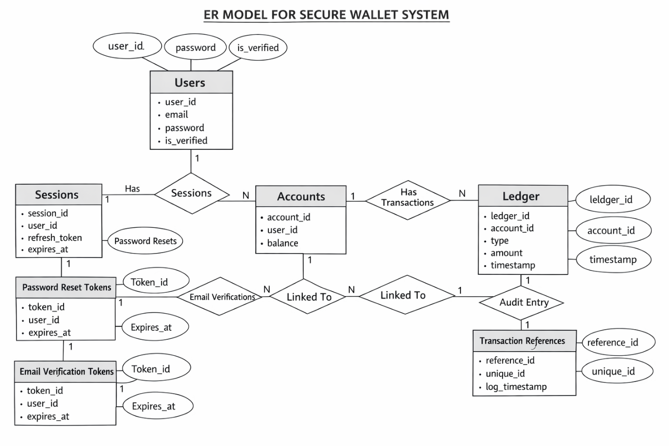

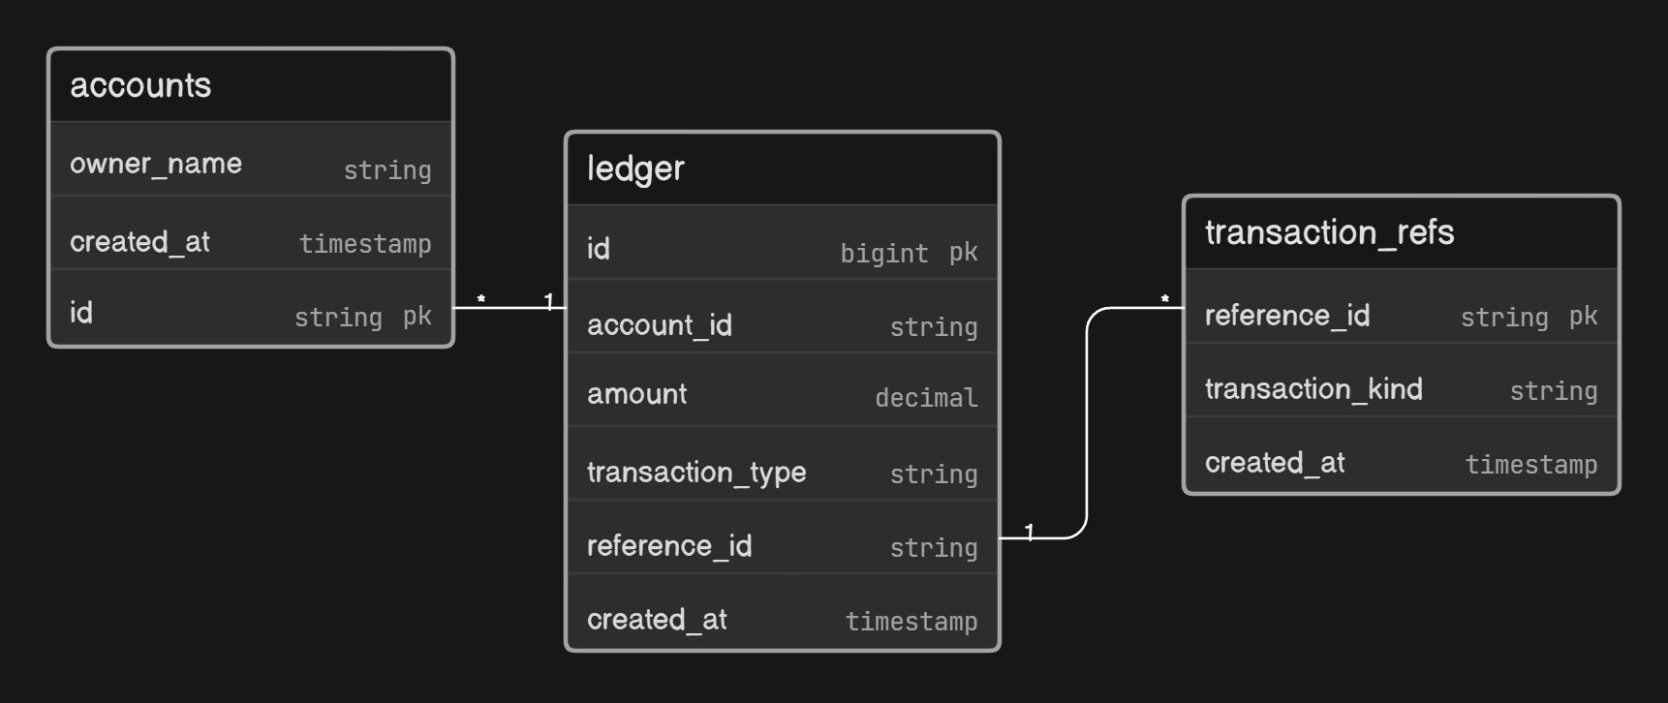

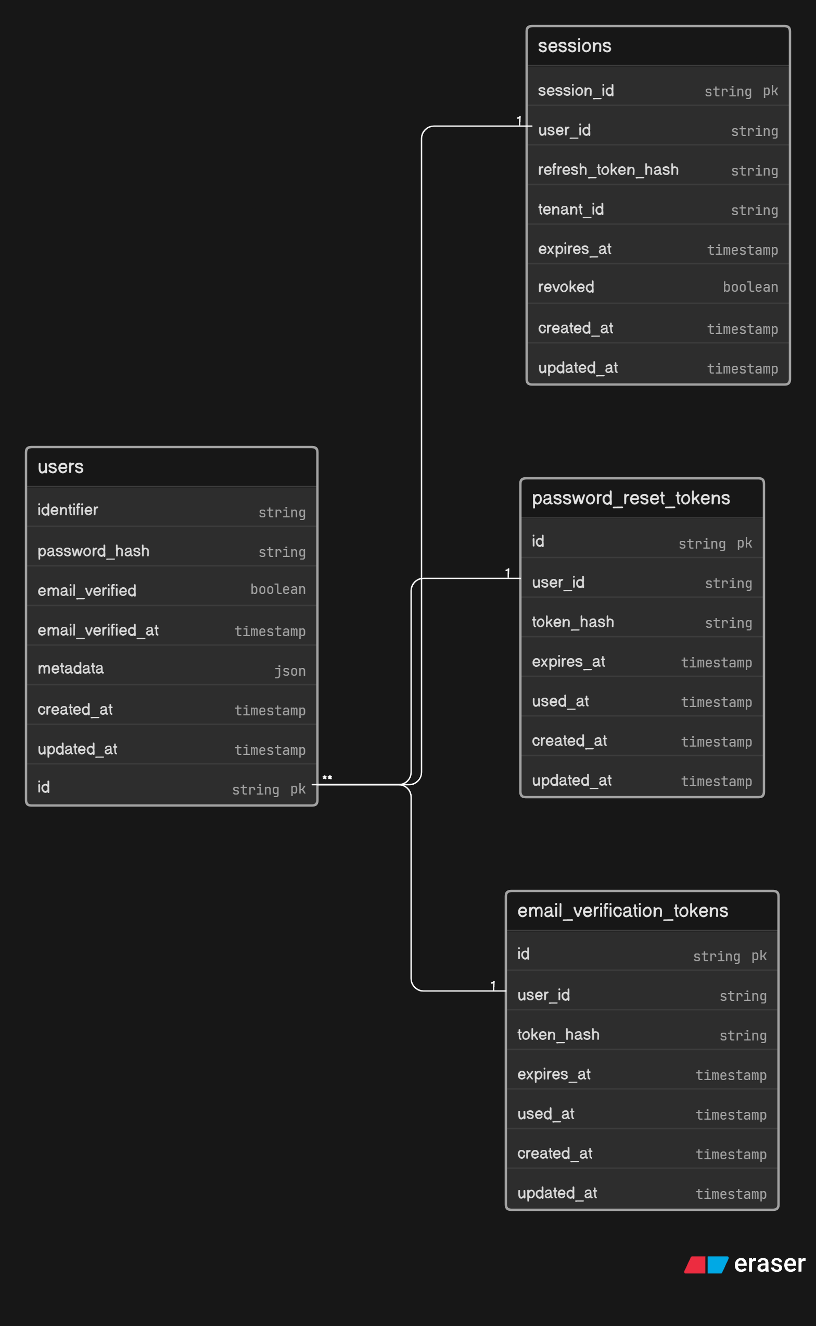

6.4 Design Justification
The ER model is designed to ensure:
- Data normalization and minimal redundancy
- Strong referential integrity using foreign keys
- Efficient querying and indexing
- Complete traceability of transactions
- Separation of authentication and financial data

This structured design supports both performance and security, making it suitable for real-world financial systems.
7. DATABASE SCHEMA
The database schema defines the structure of the database, including tables, attributes, constraints, and relationships. In this project, the schema is designed to ensure data integrity, consistency, and efficient query execution. The design follows normalization principles and uses appropriate constraints such as primary keys, foreign keys, and unique constraints.

The schema is divided into two main parts: authentication-related tables and wallet-related tables.

7.1 Authentication-related Tables

users
Stores core identity records for all system users. The identifier column is used as the login handle (email or username).
Column | Type | Constraints | Description
id | BIGINT UNSIGNED | PK | Auto-increment primary key
identifier | VARCHAR | UNIQUE · NOT NULL | Login identifier (email / username)
password_hash | VARCHAR | NOT NULL | BCrypt hashed password
email_verified | BOOLEAN | NOT NULL · DEFAULT false | Email verification flag
email_verified_at | TIMESTAMP | NULLABLE | Timestamp when email was verified
metadata | JSON | NULLABLE | Flexible user metadata blob
created_at | TIMESTAMP | DEFAULT NOW() | Record creation timestamp
updated_at | TIMESTAMP | DEFAULT NOW() | Last update timestamp

sessions
Tracks active refresh token sessions per user. Supports multi-tenant deployments and soft-revocation for logout/token invalidation.
Column | Type | Constraints | Description
session_id | VARCHAR / UUID | PK | Unique session identifier
user_id | BIGINT UNSIGNED | NOT NULL · FK | References users.id
refresh_token_hash | VARCHAR | NOT NULL | Hashed refresh token (SHA-256)
tenant_id | VARCHAR | NULLABLE | Multi-tenant scope (null = global)
expires_at | TIMESTAMP | NOT NULL | Token expiry datetime
revoked | BOOLEAN | DEFAULT false | Soft revocation flag for logout
created_at | TIMESTAMP | DEFAULT NOW() | Session creation timestamp
updated_at | TIMESTAMP | DEFAULT NOW() | Last update timestamp
ℹ Note: refresh_token_hash should be stored as a SHA-256 hash — never the raw token.

7.2 Wallet & Audit Tables
Created via raw SQL scripts. These tables handle financial ledger entries, transaction references, and a generic audit trail.

accounts
Represents wallet accounts owned by users. Each account is the root entity for all ledger entries.
Column | Type | Constraints | Description
id | BIGINT UNSIGNED | PK | Auto-increment primary key
owner_name | VARCHAR | NOT NULL | Name of account owner
created_at | TIMESTAMP | DEFAULT NOW() | Account creation timestamp

audit_logs
Generic append-only audit log. Captures before/after states for any mutating operation across the system.
Column | Type | Constraints | Description
id | BIGINT UNSIGNED | PK | Auto-increment primary key
table_name | VARCHAR | NULLABLE | Source table of the audited change
record_id | VARCHAR | NULLABLE | Primary key of the affected record
action | VARCHAR | NULLABLE | Action type: INSERT / UPDATE / DELETE
new_data | JSON | NULLABLE | Snapshot of record after change
created_at | TIMESTAMP | DEFAULT NOW() | When the audit event occurred

transaction_refs
De-duplication and categorisation table for transactions. Each ledger entry links here to identify the nature of the operation.
Column | Type | Constraints | Description
reference_id | VARCHAR / UUID | PK | Unique transaction reference ID
transaction_kind | VARCHAR | NOT NULL | Kind of transaction (e.g. CREDIT, DEBIT)
created_at | TIMESTAMP | DEFAULT NOW() | Reference creation timestamp

ledger
Core double-entry financial ledger. Partitioned by created_at for query performance at scale. Uses a composite primary key (id, created_at) as required by MySQL range partitioning.
Column | Type | Constraints | Description
id | BIGINT UNSIGNED | COMPOSITE PK | Part of composite PK with created_at
account_id | CHAR(36) | FK → accounts.id | Associated wallet account
amount | DECIMAL(15,2) | NOT NULL | Transaction amount (up to 13 digits)
transaction_type | VARCHAR | NOT NULL | CREDIT or DEBIT
reference_id | VARCHAR | FK → transaction_refs | Links to transaction_refs.reference_id
created_at | TIMESTAMP | COMPOSITE PK · PARTITION KEY | Partition key for range partitioning

7.4 Design Considerations
The schema is designed with the following considerations:
- Separation of authentication and wallet data for modularity
- Use of indexing for faster query performance
- Support for transaction-based operations
- Scalability for handling large numbers of users and transactions
- Auditability through immutable ledger and logging

8. SQL IMPLEMENTATION
The SQL implementation defines how the database is created, structured, and manipulated. It includes table creation, constraints, indexing, triggers, and transaction handling to ensure data consistency and reliability.

8.1 Database Creation
CREATE DATABASE WalletDB;
USE WalletDB;

8.2 Table Structure

Accounts
CREATE TABLE accounts (
id CHAR(36) PRIMARY KEY,
owner_name VARCHAR(255) NOT NULL,
created_at TIMESTAMP DEFAULT CURRENT_TIMESTAMP
);

Ledger
CREATE TABLE ledger (
id BIGINT UNSIGNED AUTO_INCREMENT PRIMARY KEY,
account_id CHAR(36) NOT NULL,
amount DECIMAL(15,2) NOT NULL,
transaction_type VARCHAR(50) NOT NULL,
reference_id VARCHAR(255),
created_at TIMESTAMP DEFAULT CURRENT_TIMESTAMP,
FOREIGN KEY (account_id) REFERENCES accounts(id)
);

Transaction References
CREATE TABLE transaction_refs (
reference_id VARCHAR(255) PRIMARY KEY,
transaction_kind VARCHAR(50),
created_at TIMESTAMP DEFAULT CURRENT_TIMESTAMP
);

Audit Logs
CREATE TABLE audit_logs (
id BIGINT AUTO_INCREMENT PRIMARY KEY,
table_name VARCHAR(50),
record_id BIGINT,
action VARCHAR(20),
new_data JSON,
created_at TIMESTAMP DEFAULT CURRENT_TIMESTAMP
);

8.3 Indexes
CREATE INDEX idx_ledger_account_id ON ledger(account_id);
CREATE INDEX idx_ledger_reference_id ON ledger(reference_id);

8.4 Data Insertion
INSERT INTO accounts VALUES
('11111111-1111-1111-1111-111111111111', 'Govind Madhav', NOW());

INSERT INTO transaction_refs VALUES
('TX-1001', 'DEPOSIT', NOW());

INSERT INTO ledger (account_id, amount, transaction_type, reference_id)
VALUES ('11111111-1111-1111-1111-111111111111', 5000.00, 'DEPOSIT', 'TX-1001');

8.5 Update and Delete
UPDATE accounts
SET owner_name = 'Govind Madhav'
WHERE id = '11111111-1111-1111-1111-111111111111';

DELETE FROM ledger
WHERE reference_id = 'TX-1001';

8.6 Trigger (Audit Logging)

DROP TRIGGER IF EXISTS trigger_ledger_audit;

CREATE TRIGGER trigger_ledger_audit
AFTER INSERT ON ledger
FOR EACH ROW
INSERT INTO audit_logs (table_name, record_id, action, new_data)
VALUES (
'ledger',
NEW.id,
'INSERT',
JSON_OBJECT(
'id', NEW.id,
'account_id', NEW.account_id,
'amount', NEW.amount,
'transaction_type', NEW.transaction_type,
'reference_id', NEW.reference_id,
'created_at', NEW.created_at
)
);

8.7 Transaction Handling (TCL)
START TRANSACTION;

INSERT INTO transaction_refs (reference_id, transaction_kind)
VALUES ('TX-2001', 'TRANSFER');
INSERT INTO ledger (account_id, amount, transaction_type, reference_id)
VALUES ('11111111-...', -250.00, 'TRANSFER_OUT', 'TX-2001_out');
INSERT INTO ledger (account_id, amount, transaction_type, reference_id)
VALUES ('22222222-...', 250.00, 'TRANSFER_IN', 'TX-2001_in');

COMMIT;

8.8 SQL Implementation Summary

Category | Description
DDL | Table creation and schema design
DML | Insert, update, delete operations
DQL | Data retrieval queries
TCL | Transaction management (COMMIT, ROLLBACK)
Triggers | Automatic audit logging
Indexes | Query performance optimization

9. QUERY IMPLEMENTATION

This section presents the SQL queries used in the system to perform authentication, wallet operations, and data analysis. These queries demonstrate the use of different SQL concepts such as joins, aggregation, subqueries, views, and transaction control.

9.1 Authentication Queries
These queries handle user registration, login, and credential updates.

INSERT INTO users (id, identifier, password_hash, metadata, created_at, updated_at)
VALUES (?, ?, ?, ?, NOW(), NOW());
SELECT * FROM users
WHERE identifier = ?
LIMIT 1;
UPDATE users
SET password_hash = ?, updated_at = NOW()
WHERE id = ?;

9.2 Session Queries
INSERT INTO sessions (session_id, user_id, refresh_token_hash, expires_at, created_at, updated_at)
VALUES (?, ?, ?, ?, NOW(), NOW());
SELECT * FROM sessions
WHERE session_id = ?
LIMIT 1;
UPDATE sessions
SET refresh_token_hash = ?, expires_at = ?, updated_at = NOW()
WHERE session_id = ?;

9.3 Wallet Queries
SELECT COALESCE(SUM(amount), 0) AS balance
FROM ledger
WHERE account_id = ?;
INSERT INTO ledger (account_id, amount, transaction_type, reference_id)
VALUES (?, ?, 'DEPOSIT', ?);
INSERT INTO ledger (account_id, amount, transaction_type, reference_id)
VALUES (?, ?, 'WITHDRAWAL', ?);

9.4 Join Query
SELECT l.id, a.owner_name, l.amount, l.transaction_type, l.created_at
FROM ledger l
JOIN accounts a ON a.id = l.account_id
ORDER BY l.created_at DESC;
This query retrieves transaction details along with account holder names.

9.5 Group By Query
SELECT account_id, SUM(amount) AS balance
FROM ledger
GROUP BY account_id;
This query aggregates transactions to compute account balances.

9.6 Subquery
SELECT *
FROM ledger
WHERE account_id IN (
SELECT id FROM accounts WHERE owner_name LIKE 'A%'
);
This query retrieves transactions for accounts whose names start with a specific pattern.

9.7 View Creation
CREATE VIEW account_balances AS
SELECT account_id, SUM(amount) AS balance
FROM ledger
GROUP BY account_id;
SELECT * FROM account_balances;
Views simplify repeated queries and improve readability.

9.8 Transaction Safety Query
START TRANSACTION;
SELECT id FROM accounts WHERE id = ? FOR UPDATE;
SELECT COALESCE(SUM(amount), 0) FROM ledger WHERE account_id = ?;
INSERT INTO ledger (account_id, amount, transaction_type, reference_id)
VALUES (?, ?, 'WITHDRAWAL', ?);
COMMIT;

9.9 Audit Query
SELECT *
FROM audit_logs
ORDER BY created_at DESC
LIMIT 10;
This query is used to verify that all transactions are properly logged.

10. ADVANCED CONCEPTS
This project incorporates several advanced database and system design concepts to ensure that the wallet system is secure, reliable, and efficient. These concepts are essential in real-world financial applications where accuracy, consistency, and security are critical.

One of the most important concepts used in this system is ACID transactions. Every financial operation such as deposit, withdrawal, and transfer is executed within a transaction block. This ensures atomicity, meaning that all operations either complete successfully or fail together. Consistency ensures that the database always remains in a valid state. Isolation prevents concurrent transactions from interfering with each other, and durability guarantees that once a transaction is committed, it is permanently stored in the database. These properties are crucial for maintaining the correctness of financial data.

Another key concept implemented in the system is row-level locking. During critical operations like withdrawals and transfers, the system locks specific rows in the database to prevent multiple transactions from modifying the same account simultaneously. This avoids race conditions and ensures that balance calculations remain accurate even when multiple users are performing operations at the same time.

The system also implements idempotency, which is essential for handling repeated requests safely. In real-world scenarios, network failures or retries can cause the same request to be sent multiple times. To prevent duplicate transactions, each operation is associated with a unique transaction reference. Before processing a request, the system checks whether the reference already exists, ensuring that the operation is executed only once.

A major design choice in this project is the use of a ledger-based system instead of directly storing and updating balances. Every transaction is recorded as an immutable entry in the ledger table, and the current balance is calculated dynamically by summing all transactions. This approach provides complete transparency, makes the system auditable, and ensures that no historical data is lost or modified.

The system also uses trigger-based auditing to automatically record all financial operations. A database trigger is defined on the ledger table, which inserts a corresponding record into the audit_logs table whenever a new transaction is added. This ensures that every action is logged without relying on application-level logic, providing a secure and tamper-resistant audit trail.

To handle structured data efficiently, the system uses JSON data storage in the audit logs. Transaction details are stored in JSON format, allowing flexible and organized storage of data without requiring complex table structures. This makes it easier to retrieve and analyze audit information when needed.
Performance optimization is achieved through indexing, where indexes are created on frequently accessed columns such as account identifiers and transaction references. This significantly reduces query execution time and improves the overall responsiveness of the system
.
Finally, the system incorporates several security mechanisms to protect user data and prevent unauthorized access. These include token-based authentication using JSON Web Tokens, secure password hashing, input validation, and rate limiting of API requests. Together, these measures ensure that the system is protected against common security threats.

In conclusion, the integration of these advanced concepts enhances the overall quality of the system by ensuring data integrity, improving performance, and providing strong security. These features make the wallet system robust and suitable for real-world applications.

11. FRONTEND AND BACKEND INTEGRATION

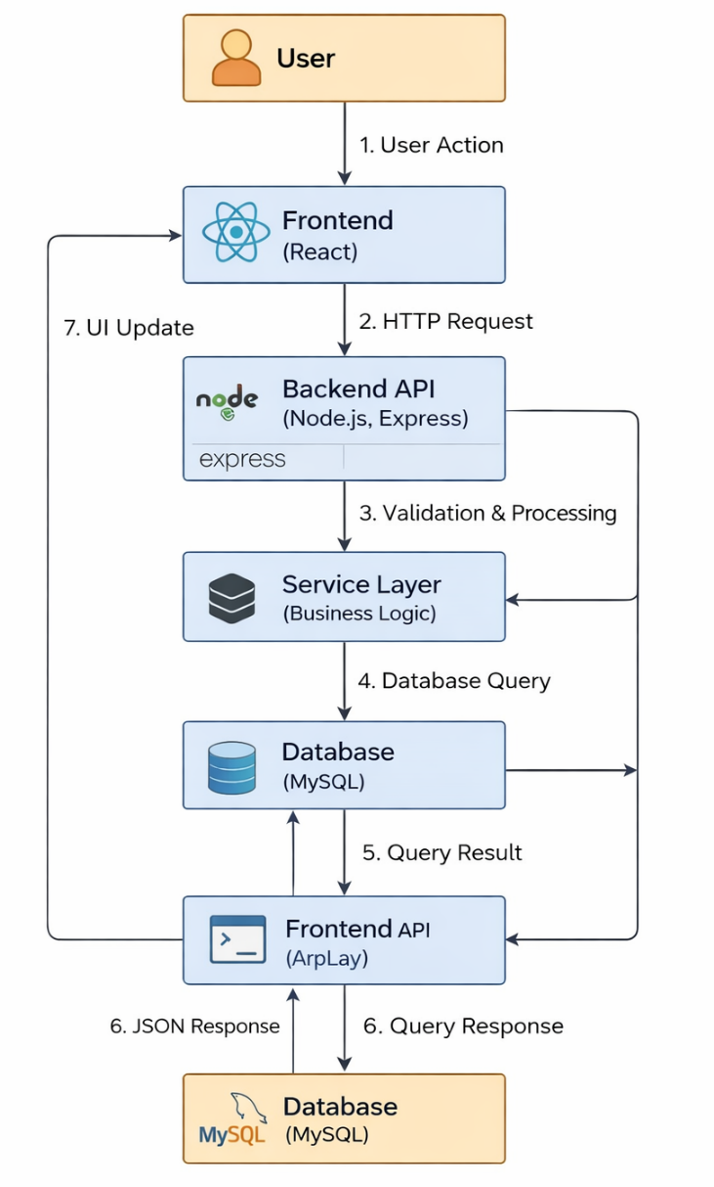

The frontend and backend integration is a crucial part of the system, as it ensures smooth communication between the user interface and the server-side logic. In this project, the integration is achieved using a RESTful API architecture, where the frontend sends HTTP requests to the backend and receives responses in JSON format. The frontend of the system is developed using React (Vite), which provides a fast and responsive user interface. It is responsible for collecting user input, displaying data, and interacting with the backend services. The backend is implemented using Node.js with Express.js, which handles request processing, business logic, authentication, and database operations.

When a user interacts with the application, such as logging in or performing a transaction, the frontend sends a request to a specific API endpoint. The backend receives this request, validates the input, processes the logic through the service layer, interacts with the database if required, and then returns a response to the frontend. The frontend then updates the user interface based on the response received.

The integration follows a structured flow. First, the user performs an action on the frontend interface. This action triggers an API call using HTTP methods such as GET or POST. The backend API validates the request data using schema validation techniques to ensure correctness and security. After validation, the request is passed to the service layer, where the actual business logic is executed. The service layer interacts with the database to fetch or modify data. Once the operation is completed, the backend sends a structured response back to the frontend, which is then displayed to the user.

The authentication flow is an important part of this integration. When a user logs in, the backend generates an access token and a refresh token. The access token is used to authenticate subsequent API requests, while the refresh token is used to obtain new access tokens when the current one expires. These tokens ensure secure and stateless communication between the frontend and backend. The system exposes several API endpoints to handle different functionalities. Authentication-related endpoints include user registration, login, logout, token refresh, email verification, and password reset. Wallet-related endpoints include retrieving balance, depositing funds, withdrawing money, and transferring funds between users. All wallet-related endpoints are protected and require valid authentication tokens.
Error handling is also an important part of the integration. The backend returns appropriate HTTP status codes and error messages when a request fails, such as invalid credentials, insufficient balance, or unauthorized access. The frontend handles these responses gracefully and displays meaningful messages to the user.

Security is maintained throughout the integration by validating all inputs, restricting access to protected routes, and using token-based authentication. Rate limiting is also applied to prevent excessive or malicious requests to the server. Overall, the frontend and backend integration ensures that the system operates smoothly, securely, and efficiently. It enables seamless communication between the user interface and the database, allowing users to perform operations in real time while maintaining data integrity and security.

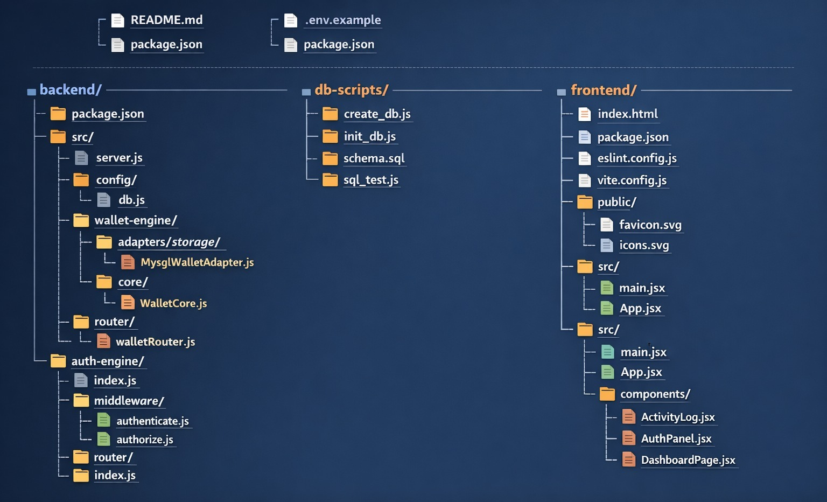

12. TESTING
Testing is an essential phase in software development that ensures the system functions correctly, securely, and efficiently. In this project, multiple levels of testing were performed to validate both the authentication and wallet functionalities, as well as the underlying database operations.
The testing process was designed to verify that all modules work as expected under different scenarios, including normal usage, edge cases, and error conditions.

12.1 Test Strategy
Unit Tests | Token and identity behavior in isolation
Integration Tests | Register, login, protected route, refresh, logout flows
Security Tests | Refresh replay attack, revoked sessions, tampered JWT
Comprehensive Flow Tests | Large multi-case suite covering edge conditions
SQL Parameter Validation | 18-scenario suite validating all DB constraints, triggers, and operations

12.2 Validated Scenarios
- Duplicate registration rejection
- Invalid credential handling
- Policy-based access control – 403 status checks
- Refresh token rotation behavior
- Session revocation behavior
- Tampered JWT rejection

12.3 Auth Engine Test Results
Test Suites Passed | 4 / 4
Total Tests Passed | 57 / 57’
Snapshots | 0
Total Runtime | ~6.3 seconds
Notes | Non-failing console warnings from mocked auth routes (headers sent twice) – do not affect test outcome

12.4 SQL Parameter Validation Tests
A comprehensive SQL test suite validates all database parameters, constraints, and operations across 18 scenarios.

Test | Scenario | Validates
1 | Schema Initialization | DDL idempotency, index creation
2 | Table Verification | All 8 required tables present
3 | Inserts & Trigger Auditing | Ledger inserts trigger audit_logs entry
4 | Unique Constraint | Duplicate reference_id rejected by PRIMARY KEY
5 | Foreign Key Constraint | Ledger insert with missing account rejected
6 | Transaction Rollback | ROLLBACK reverts all changes in transaction block
7 | Balance Query Correctness | SUM(amount) aggregation equals expected balance
8 | NULL Constraints | NOT NULL enforced on id, owner_name, amount, transaction_kind
9 | Transaction Type Validation | DEPOSIT, TRANSFER, WITHDRAWAL types accepted
10 | Transaction Kind Acceptance | DEPOSIT, WITHDRAWAL, TRANSFER, REFUND, ADJUSTMENT supported
11 | Amount Precision & Sign | Positive, negative, zero amounts; DECIMAL(15,2) precision
12 | Ledger Timestamp Auto-Population | created_at auto-populated on insert
13 | Reference Timestamp Auto-Population | transaction_refs.created_at auto-populated
14 | Reference ID Uniqueness | PRIMARY KEY constraint on reference_id enforced
15 | Multi-Transaction Balance | Accurate balance with 4+ transactions (1150.0 validation)
16 | Owner Name Field | Various character formats accepted (spaces, special chars)
17 | Audit Log Integrity | Trigger injects correct JSON data with reference_id and amount
18 | Index Efficiency | Queries on account_id and reference_id return fast results

12.5 SQL Test Results Summary
Test Scenarios Passed | 18 / 18
Coverage Areas | 11 (NULL constraints, type validation, precision, timestamps, triggers, indexes, locking, transactions)
Total Runtime | ~2–3 seconds
Database Operations Validated | DDL, DML, DQL, TCL, constraints, indexing, triggers, transactions, audit trails

All parameter validations executed without errors. The comprehensive test suite ensures data integrity through enforced constraints, automatic audit trail generation via triggers, accurate balance calculations with multi-transaction aggregation, timestamp auto-population on all ledger and reference records, and trigger efficiency with correct JSON serialization.

13. RESULTS AND SCREENSHOTS
The results of the project demonstrate that the wallet system functions correctly and meets all the specified requirements. The system successfully integrates authentication and wallet functionalities, providing a secure and reliable platform for managing financial transactions. Users are able to register, log in, verify their email, and reset their passwords without issues. Once authenticated, they can access wallet features such as checking balance, depositing money, withdrawing funds, and transferring money to other users. All operations are processed accurately and reflected immediately in the system.

The ledger-based implementation ensures that every transaction is recorded and the balance is always derived correctly. The audit logging mechanism successfully records each transaction, allowing complete traceability. The system also handles edge cases such as insufficient balance, duplicate transactions, and invalid inputs effectively.

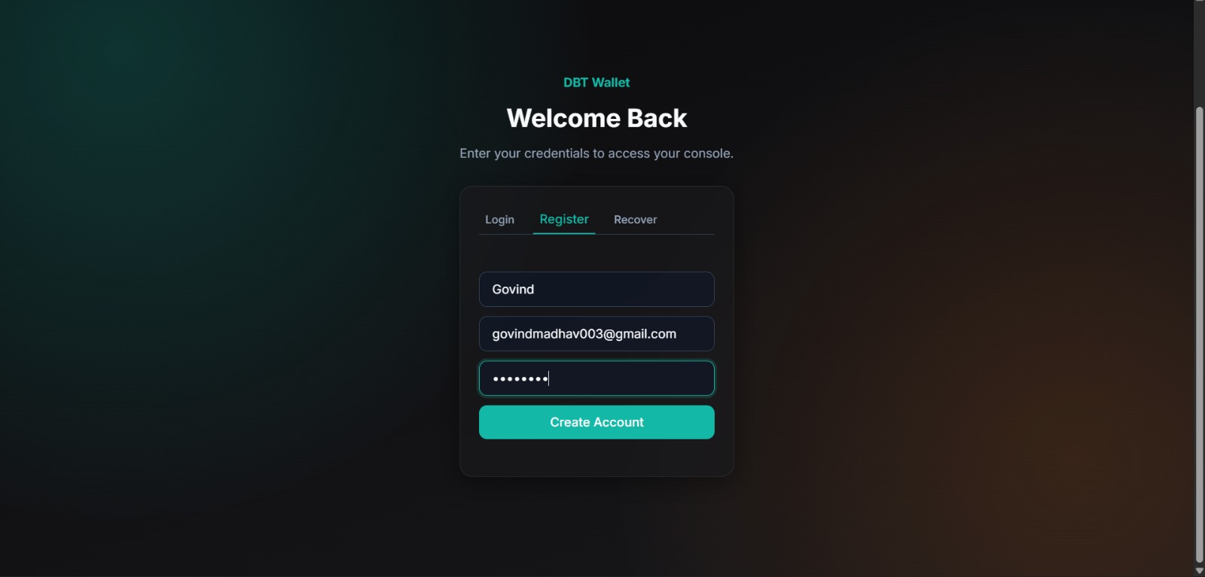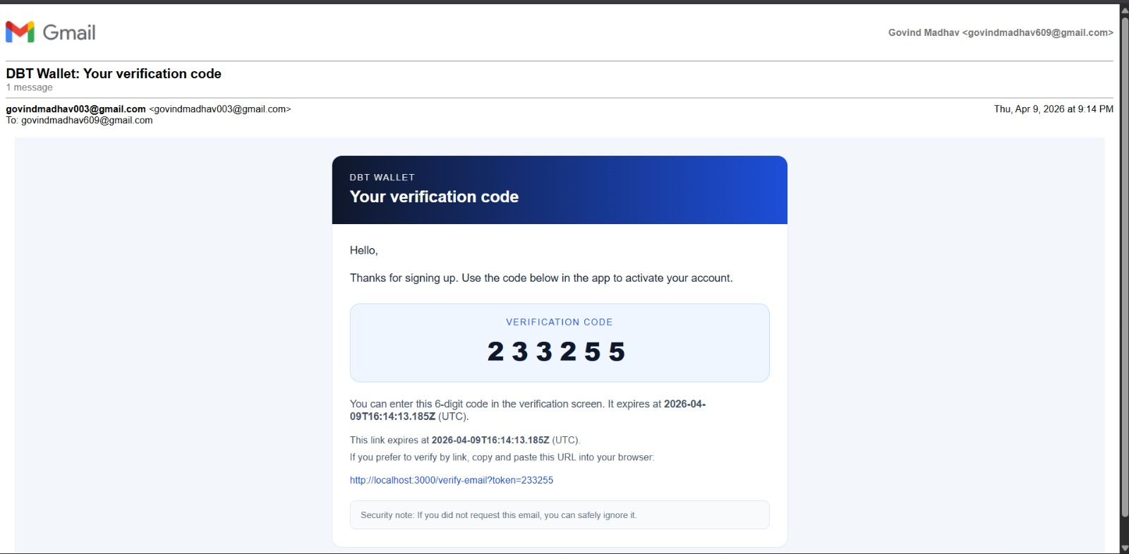

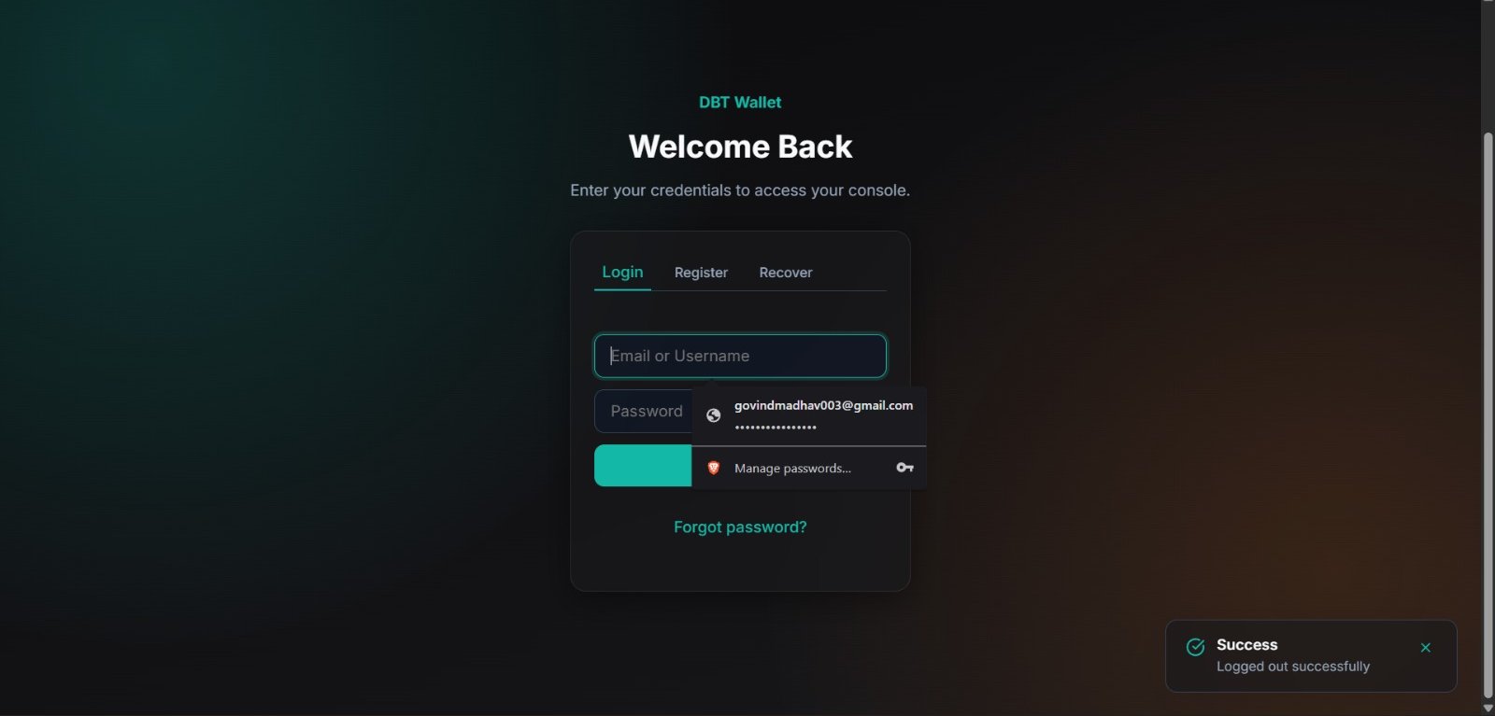

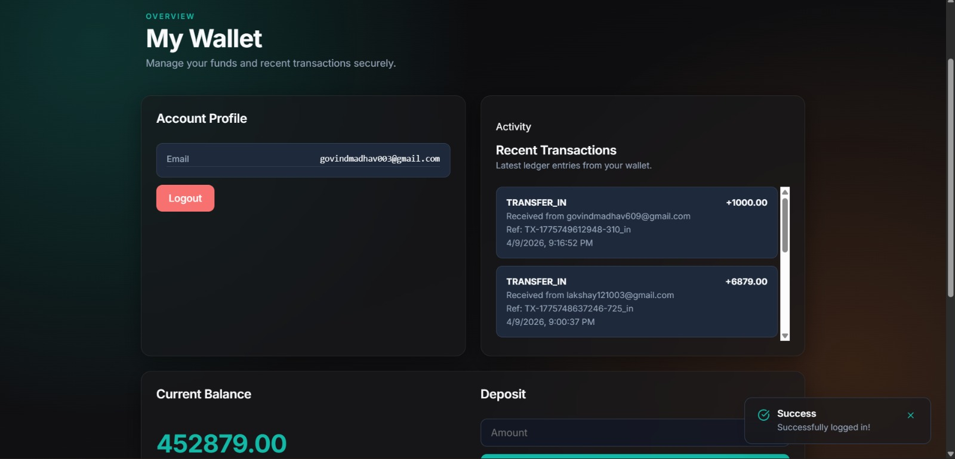

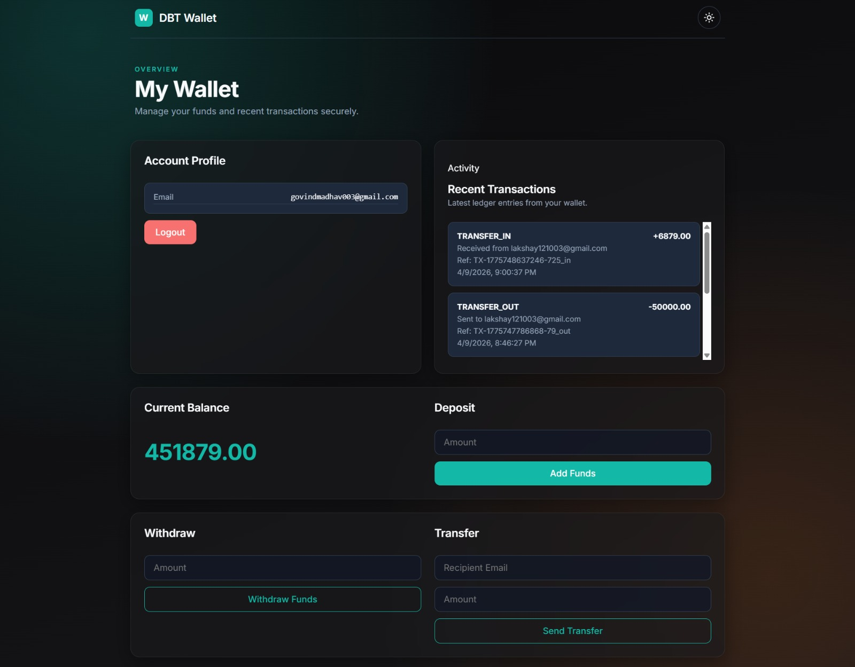

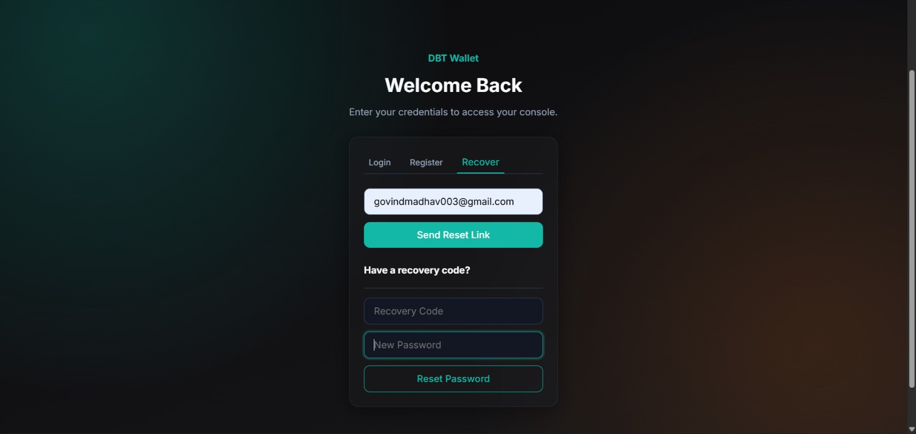

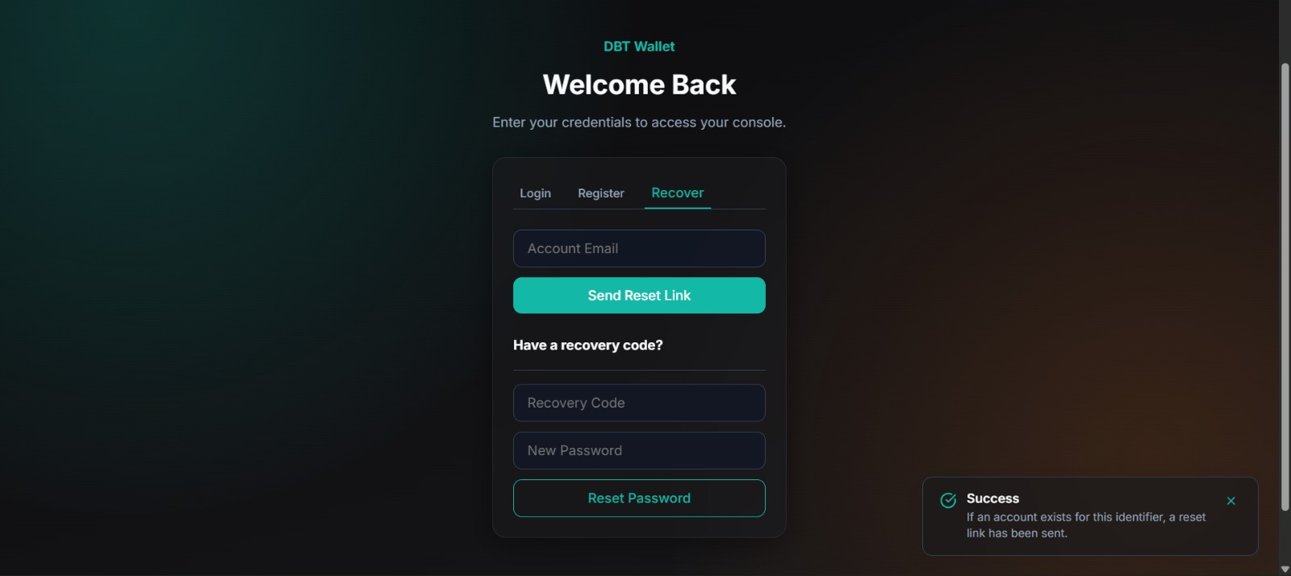

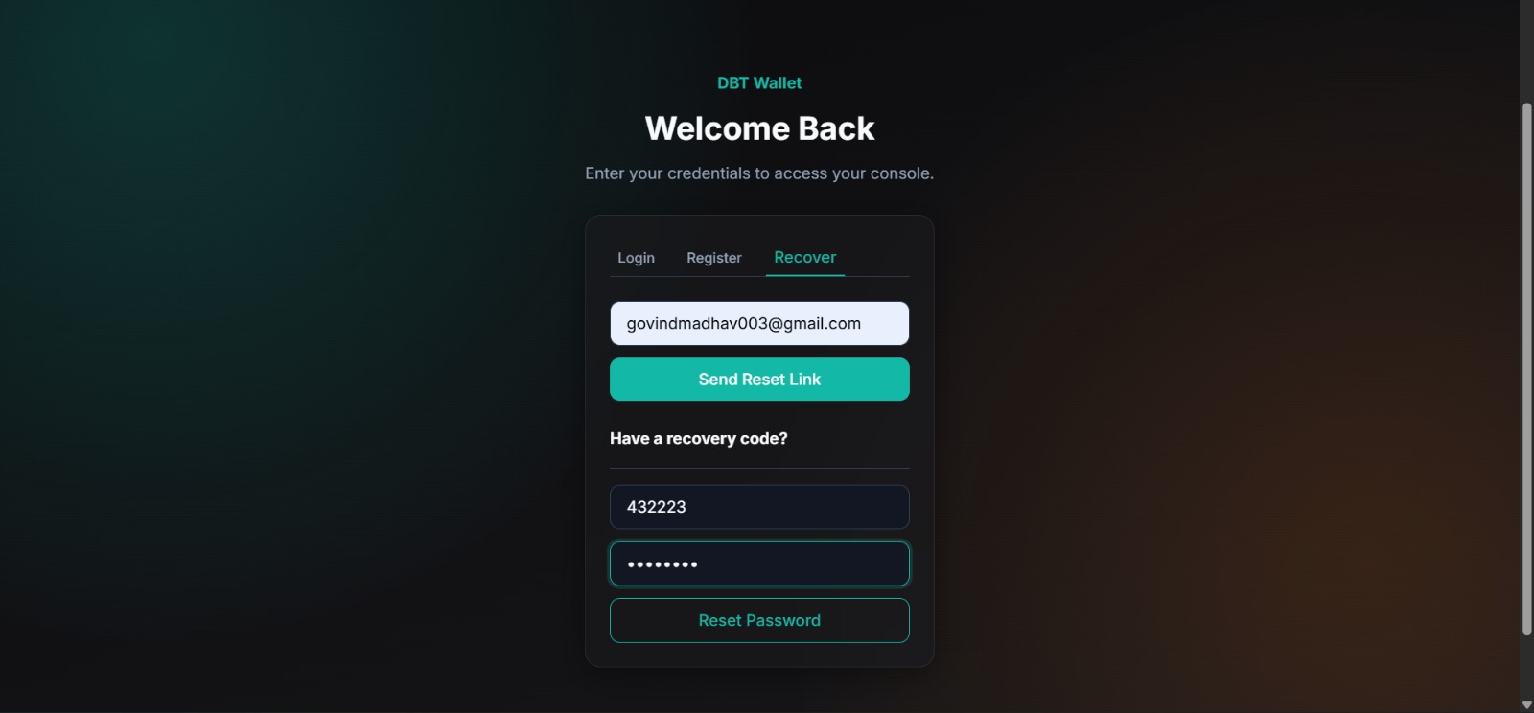

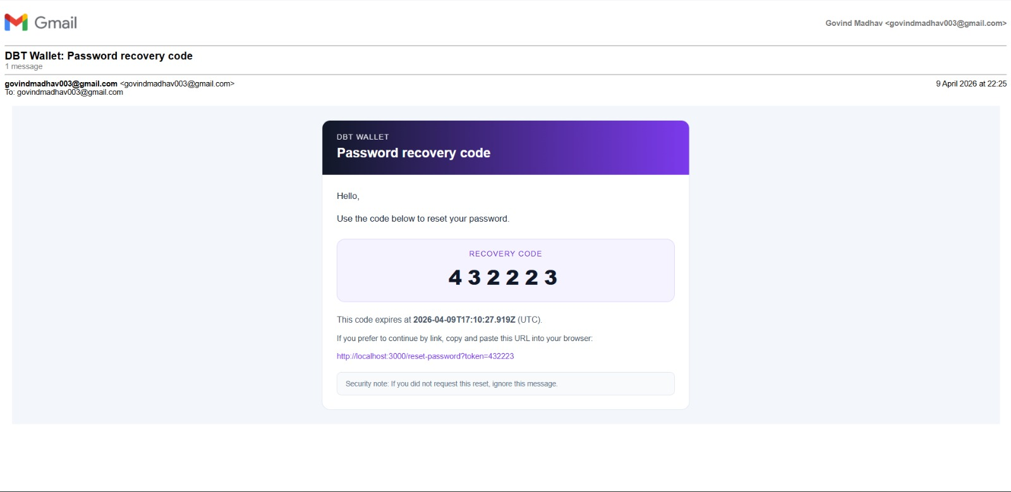

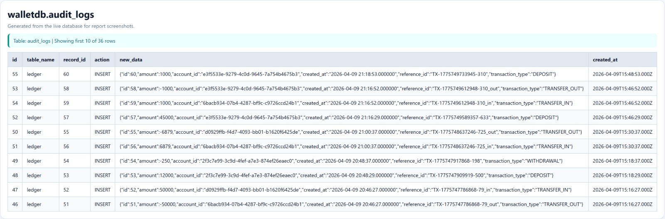

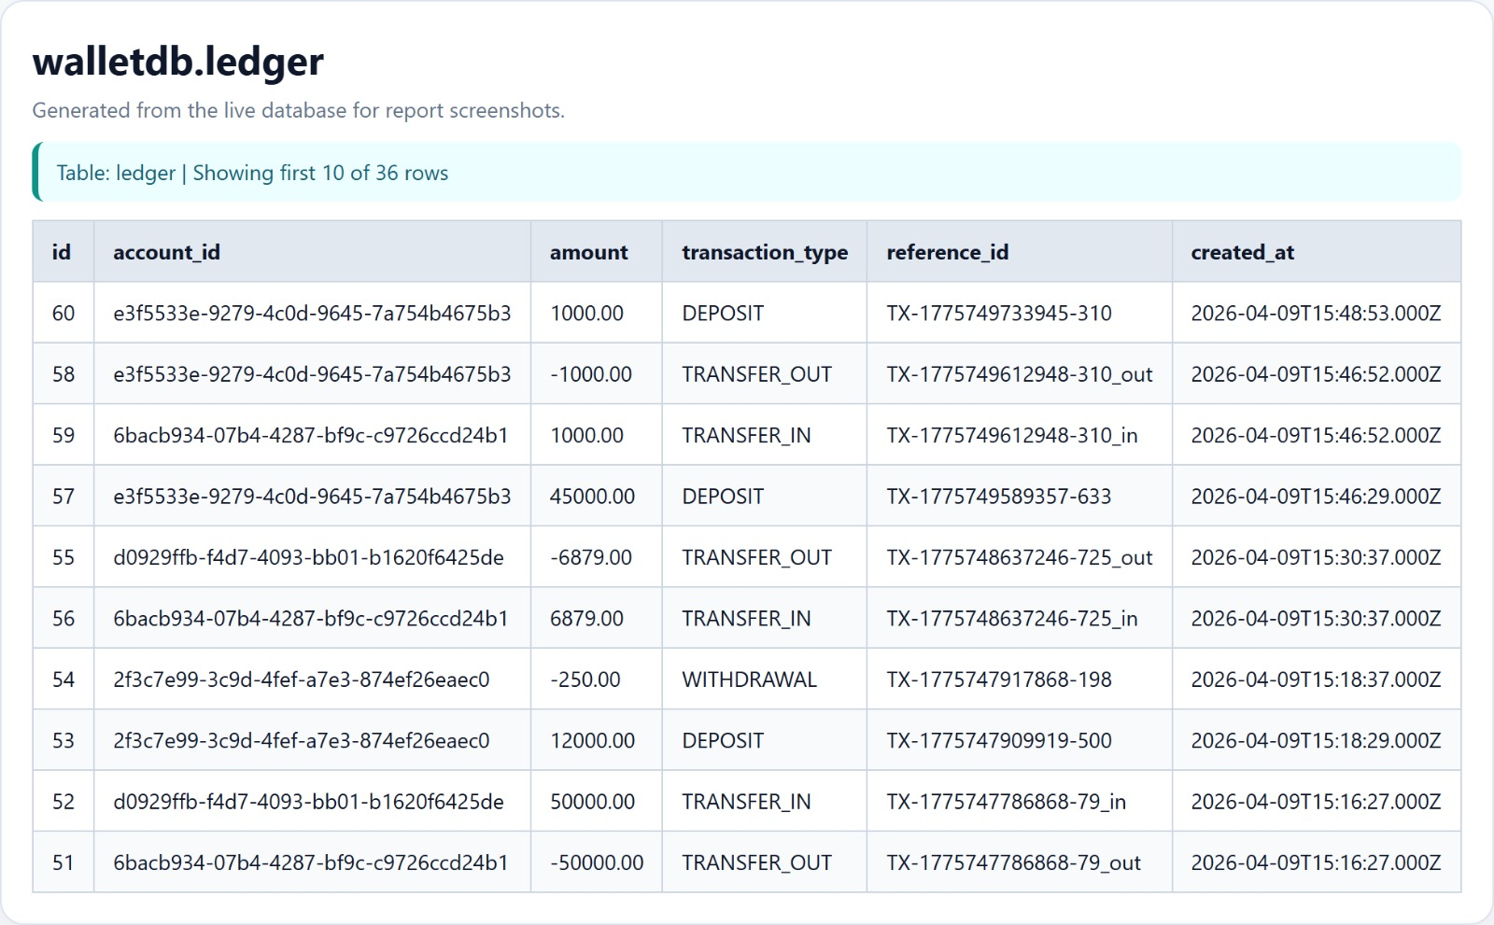
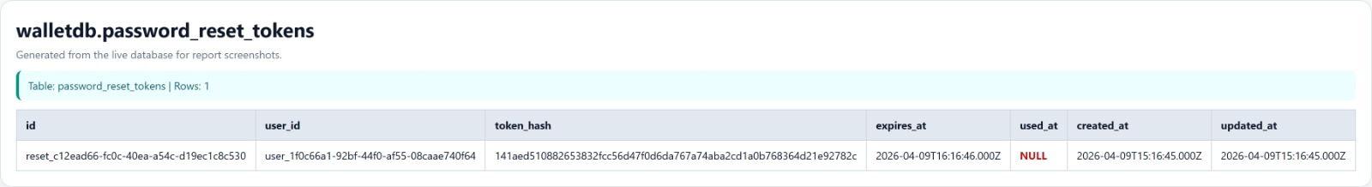

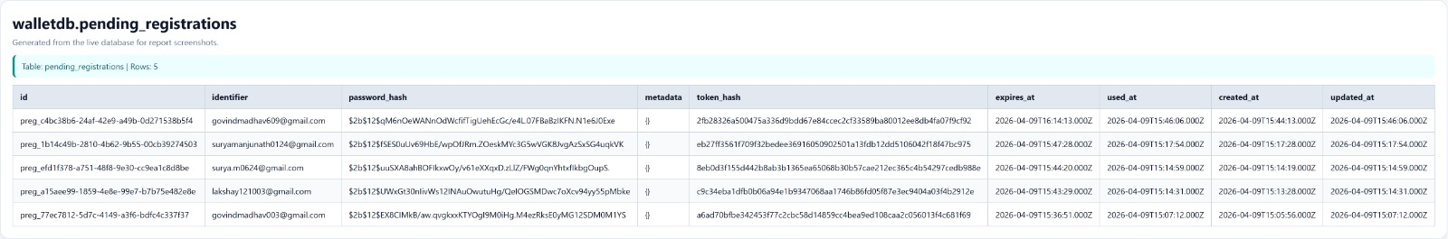

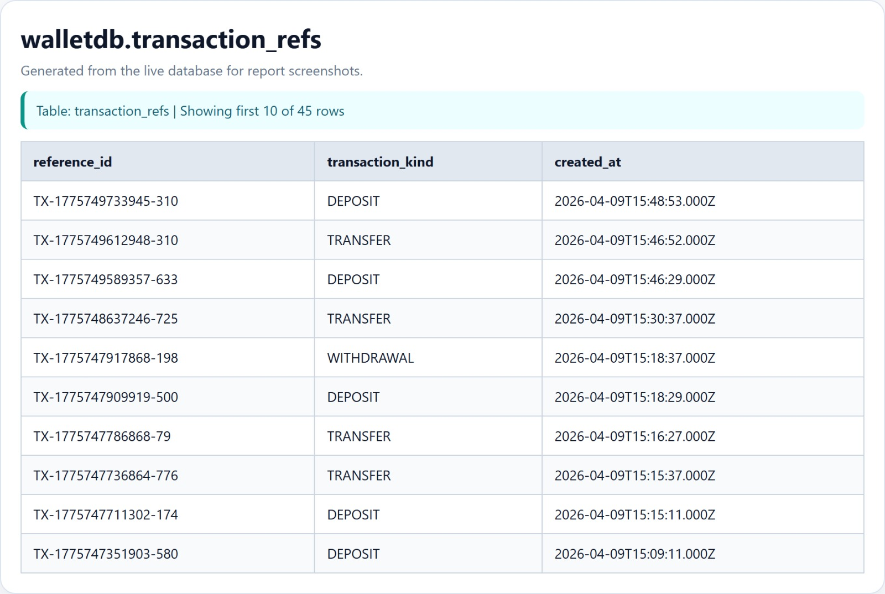

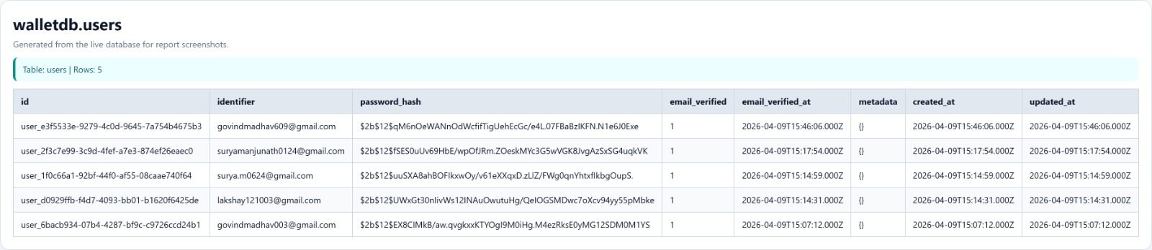
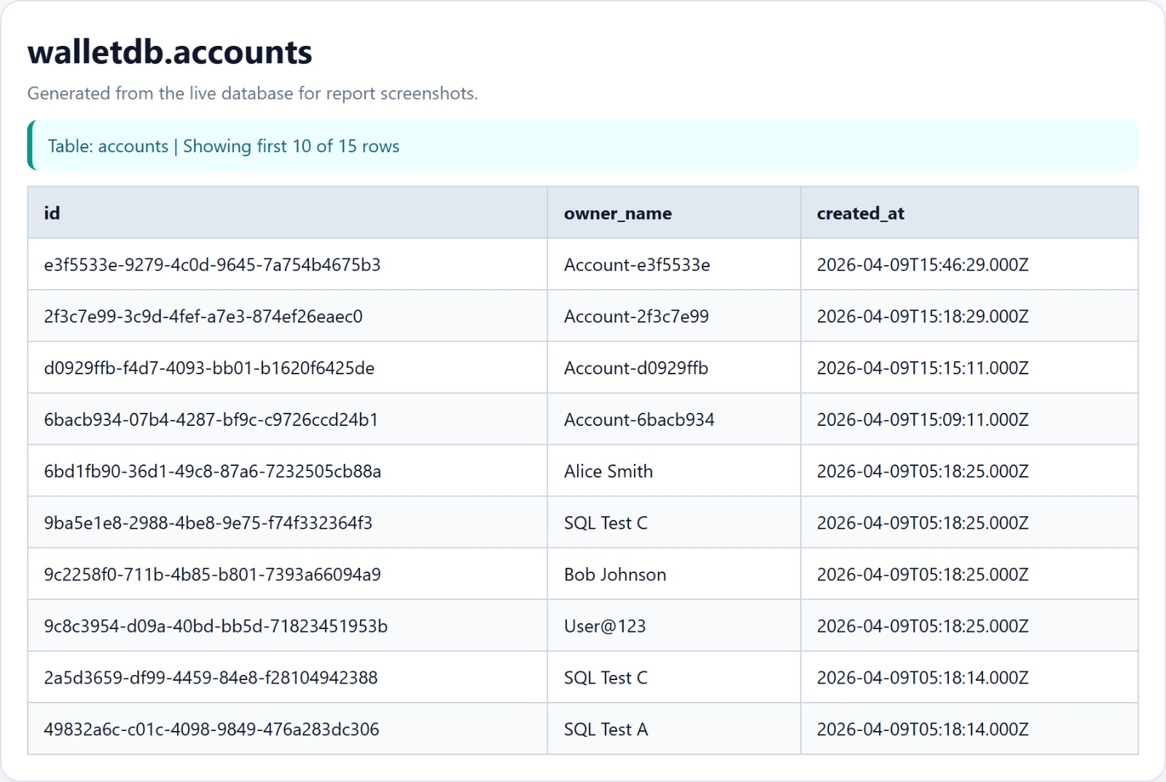

14. CONCLUSION
This project successfully demonstrates the design and implementation of a secure wallet system integrated with a modular authentication engine. The system achieves all the intended objectives, including secure user authentication, reliable transaction processing, and complete auditability of financial operations. A major strength of the system is its use of a ledger-based design, which ensures transparency and traceability by recording all transactions as immutable entries. The use of ACID transactions, row-level locking, and idempotency mechanisms ensures data consistency and prevents errors such as duplicate or conflicting transactions.

The modular architecture, which separates the authentication engine from the wallet engine, improves maintainability and scalability. The frontend and backend integration provides a seamless user experience, while the database design ensures efficient storage and retrieval of data. Additionally, the implementation of security features such as token-based authentication, password hashing, and input validation protects the system from common vulnerabilities. The testing process confirms that the system performs reliably under different scenarios.

Overall, this project provides a practical understanding of database management systems, backend development, and secure application design. It serves as a strong foundation for building real-world financial systems.

15. FUTURE SCOPE
Although the current system meets all basic requirements, there are several areas where it can be further enhanced. The system can be extended to support multi-tenant architecture, allowing multiple organizations to use the platform with proper data isolation. An administrative dashboard can be added to monitor transactions, manage users, and generate reports. Performance improvements can be achieved by implementing materialized views or caching mechanisms for faster balance retrieval. Real-time updates can be introduced using WebSocket technology, enabling users to receive instant notifications for transactions. Additional features such as exporting transaction statements in PDF or CSV format can improve usability. Integration with external payment gateways and notification services can further enhance the system. The testing process can also be expanded to include load testing and stress testing to evaluate system performance under high traffic conditions.

16. REFERENCES
- MySQL Documentation – https://dev.mysql.com/doc/
- Express.js Documentation – https://expressjs.com/
- React Documentation – https://react.dev/
- Knex.js Documentation – https://knexjs.org/
- JSON Web Token (JWT) – https://datatracker.ietf.org/doc/html/rfc7519
- Zod Validation Library – https://zod.dev/
- OWASP API Security Top 10 – https://owasp.org/www-project-api-security/

