1. Provide the list of markets in which customer "Atliq Exclusive" operates its business in the APAC region.

select distinct market

from dim_customer

where customer in ("Atliq Exclusive") and region in ("APAC");

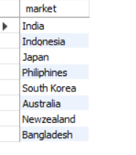

1. What is the percentage of unique product increase in 2021 vs. 2020? The final output contains these fields, unique_products_2020 unique_products_2021 percentage_chg

with product_count_2020 as (

select count(distinct product_code) unique_products_2020 ,fiscal_year

from fact_sales_monthly

where fiscal_year = 2020),

product_count_2021 as (

select count(distinct product_code) unique_products_2021,fiscal_year

from fact_sales_monthly

where fiscal_year = 2021),

product_count_2020_21 as (

select unique_products_2020, unique_products_2021

from product_count_2020 a

cross join product_count_2021 b)

select round((unique_products_2021- unique_products_2020)/ unique_products_2020*100,2) as percentage_chg, unique_products_2020, unique_products_2021

from product_count_2020_21



1. Provide a report with all the unique product counts for each segment and sort them in descending order of product counts. The final output contains 2 fields, segment product_count

select segment, count(distinct product_code) as product_count

FROM gdb023.dim_product

group by segment

order by product_count desc

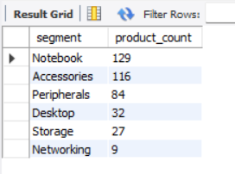

1. Follow-up: Which segment had the most increase in unique products in 2021 vs 2020? The final output contains these fields, segment product_count_2020 product_count_2021 difference

with

fact_sales_product as (

select a.product_code, a.fiscal_year,b.segment

from fact_sales_monthly a

join dim_product b

using(product_code)),

product_cnt_2020 as (

select count(distinct product_code) product_cnt_2020, segment

from fact_sales_product

where fiscal_year = 2020

group by segment ),

product_cnt_2021 as (

select count(distinct product_code) product_cnt_2021, segment

from fact_sales_product

where fiscal_year = 2021

group by segment )

select segment,product_cnt_2020 ,product_cnt_2021,

(product_cnt_2021-product_cnt_2020) difference

from product_cnt_2020

join product_cnt_2021

using (segment)

order by difference desc

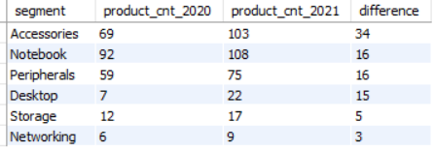

5. Get the products that have the highest and lowest manufacturing costs. The final output should contain these fields, product_code product manufacturing_cost

SELECT a.product_code, a.product, b.manufacturing_cost

from dim_product a

join fact_manufacturing_cost b

using(product_code)

where manufacturing_cost in (select max(manufacturing_cost) from fact_manufacturing_cost)

or manufacturing_cost in (select min(manufacturing_cost) from fact_manufacturing_cost )

order by manufacturing_cost desc

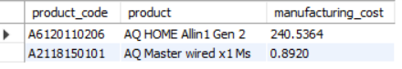

1. Generate a report which contains the top 5 customers who received an average high pre_invoice_discount_pct for the fiscal year 2021 and in the Indian market. The final output contains these fields, customer_code customer average_discount_percentage

SELECT a.customer_code, customer ,round(avg(pre_invoice_discount_pct),2) average_discount_percentage

from fact_pre_invoice_deductions a

join dim_customer b

using(customer_code)

where fiscal_year = 2021 and market= "india"

group by customer,customer_code

order by 3 desc

limit 5

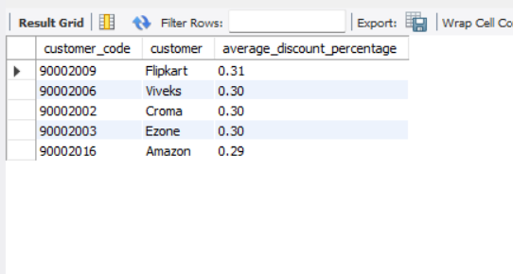

1. Get the complete report of the Gross sales amount for the customer “Atliq Exclusive” for each month. This analysis helps to get an idea of low and high-performing months and take strategic decisions. The final report contains these columns: Month Year Gross sales Amount

CODE: select monthname(a.date) as Month,

year(a.date) as Year,

round(sum(a.sold_quantity*b.gross_price),2) as Gross_sales_Amount

from fact_sales_monthly as a

join fact_gross_price as b

on

a.product_code = b.product_code

join dim_customer as c

on

a.customer_code = c.customer_code

where c.customer='Atliq Exclusive'

group by 1,2

order by 2 , month(a.date)

MAX GROSS SLES AMOUNT:

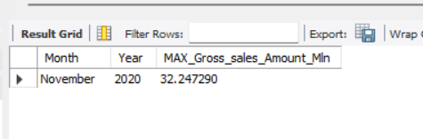

TO CALCULATE MINIMUM GROSS_SALES_AMOUNT :

WITH TEMT AS

(select monthname(a.date) as Month,

year(a.date) as Year,

round(sum(a.sold_quantity*b.gross_price),2) as Gross_sales_Amount

from fact_sales_monthly as a

join fact_gross_price as b

on

a.product_code = b.product_code

join dim_customer as c

on

a.customer_code = c.customer_code

where c.customer='Atliq Exclusive'

group by 1,2

order by 2 , month(a.date))

select *

FROM TEMT

WHERE TEMT.Gross_sales_Amount = (SELECT MIN(TEMT.Gross_sales_Amount) FROM TEMT)

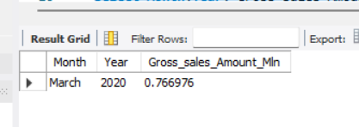

8. In which quarter of 2020, got the maximum total_sold_quantity? The final output contains these fields sorted by the total_sold_quantity, Quarter total_sold_quantity

SELECT sum(sold_quantity) total_sold_quantity,

case

when MONTH(a.date) in (9,10,11) then "Quarter_1"

when MONTH(a.date) in (12,1,2) then "Quarter_2"

when MONTH(a.date) in (3,4,5) then "Quarter_3"

when MONTH(a.date) in (6,7,8) then "Quarter_4"

end Quarter

from fact_sales_monthly a

where fiscal_year = 2020

group by 2

order by 1 desc

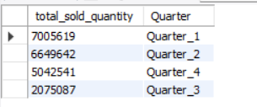

9. Which channel helped to bring more gross sales in the fiscal year 2021 and the percentage of contribution? The final output contains these fields, channel gross_sales_mln percentage

with tab_1 as (

select channel,

sum(sold_quantity*gross_price) sales

from fact_sales_monthly a

join fact_gross_price b

on a.product_code = b.product_code

join dim_customer c

on a.customer_code = c.customer_code

where a.fiscal_year = 2021

group by 1)

select channel,

round(sales/1000000,2) gross_sales_mln,

round(sales*100/sum(sales) over(),2) percentage

from tab_1

order by percentage desc

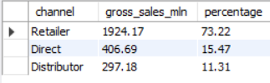

10. Get the Top 3 products in each division that have a high total_sold_quantity in the fiscal_year 2021? The final output contains these fields, division product_code

\

with tab_1 as

(select division, product_code,product,

sum(sold_quantity) total_sold_quantity,

RANK() over( partition by division order by sum(sold_quantity) desc) rank_order

from fact_sales_monthly a

join dim_product

using(product_code)

where fiscal_year = 2021

group by product,product_code,division)

select division, product_code,PRODUCT,total_sold_quantity,rank_order

from tab_1

where rank_order < 4\

