**Cloud computing (ITCS-6190) Project Deliverable 2**

**Group No: 9**

**Team members:**

Anudeep Billa

Aasish Chunduri

Govind Rahul Mathamsetti

Neethika Reddy Arepally

Lavanya Krishnan

**Query1:**

Correlation between Age and Mental Health Indicators: Analyze the correlation between age and mental health indicators such as anxiety, depression, and insomnia. This query can help in understanding if certain age groups are more prone to these mental health issues and their relation to music listening habits.

**SELECT Age, AVG(Anxiety) as Average_Anxiety, AVG(Depression) as Average_Depression, AVG(Insomnia) as Average_Insomnia**

**FROM "ccdadatabase"."ccdaproject"**

**GROUP BY Age**

**ORDER BY Age;**

**Query 2:**

Music Genre Preferences and Mental Health: Investigate if there's a pattern in the preferred music genres of individuals with high levels of anxiety, depression, or insomnia.

**SELECT Fav_genre, AVG(Anxiety) as Average_Anxiety, AVG(Depression) as Average_Depression, AVG(Insomnia) as Average_Insomnia FROM "ccdadatabase"."ccdaproject"**

**GROUP BY Fav_genre**

**ORDER BY Average_Anxiety DESC, Average_Depression DESC, Average_Insomnia DESC;**

Query 3:

Streaming Service Usage and Mental Health Impact: Evaluate how different streaming services are used by individuals with varying levels of mental health issues.

**SELECT Primary_streaming_service, AVG(Anxiety) as Average_Anxiety, AVG(Depression) as Average_Depression, AVG(Insomnia) as Average_Insomnia**

**FROM "ccdadatabase"."ccdaproject"**

**GROUP BY Primary_streaming_service;**

Query 4:

Effect of Music on Mental Health by Age Group: Understand how different age groups perceive the effect of music on their mental health.

**SELECT Age, Music_effects, COUNT(*) as Total FROM "ccdadatabase"."ccdaproject" WHERE Music_effects IS NOT NULL**

**GROUP BY Age, Music_effects**

**ORDER BY Age, Music_effects;**

Query 5:

Frequency of Genre Listening and Mental Health: Analyze the frequency of listening to different music genres and its relation to mental health scores.

**SELECT Fav_genre, AVG(Anxiety) as Average_Anxiety, AVG(Depression) as Average_Depression, AVG(Insomnia) as Average_Insomnia**

**FROM "ccdadatabase"."ccdaproject"**

**GROUP BY Fav_genre;**

Query 6:

Comparison of Mental Health Indicators Among Instrumentalists and Non-Instrumentalists: Check if being an instrumentalist has any correlation with mental health indicators.

**SELECT Instrumentalist, AVG(Anxiety) as Average_Anxiety, AVG(Depression) as Average_Depression, AVG(Insomnia) as Average_Insomnia**

**FROM "ccdadatabase"."ccdaproject"**

**GROUP BY Instrumentalist;**

Query 7:

Impact of Foreign Language Songs on Mental Health: Investigate if listening to music in foreign languages has any unique impact on mental health.

**SELECT Foreign_languages, AVG(Anxiety) as Average_Anxiety, AVG(Depression) as Average_Depression, AVG(Insomnia) as Average_Insomnia**

**FROM "ccdadatabase"."ccdaproject"**

**GROUP BY Foreign_languages;**

**QuickSight:**

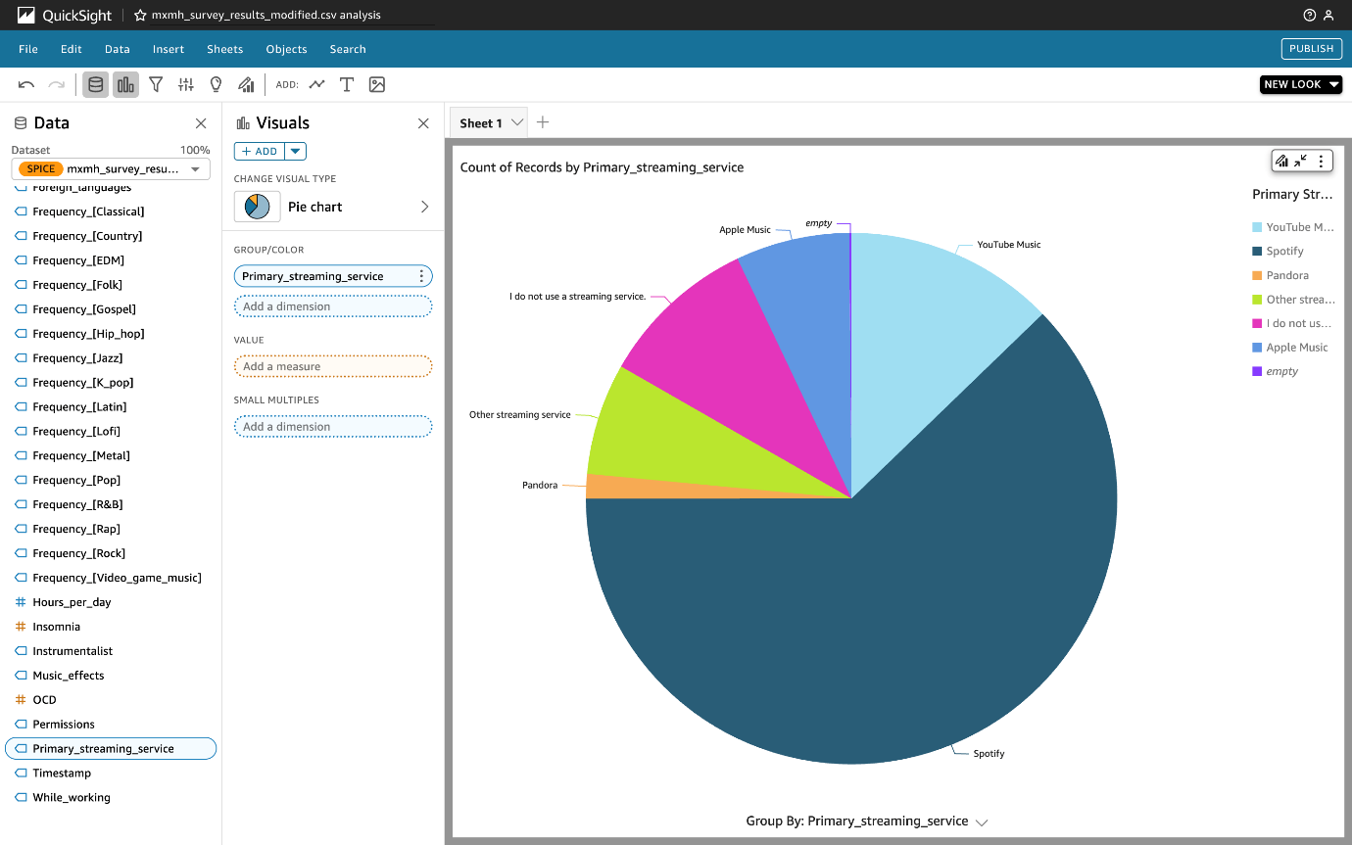

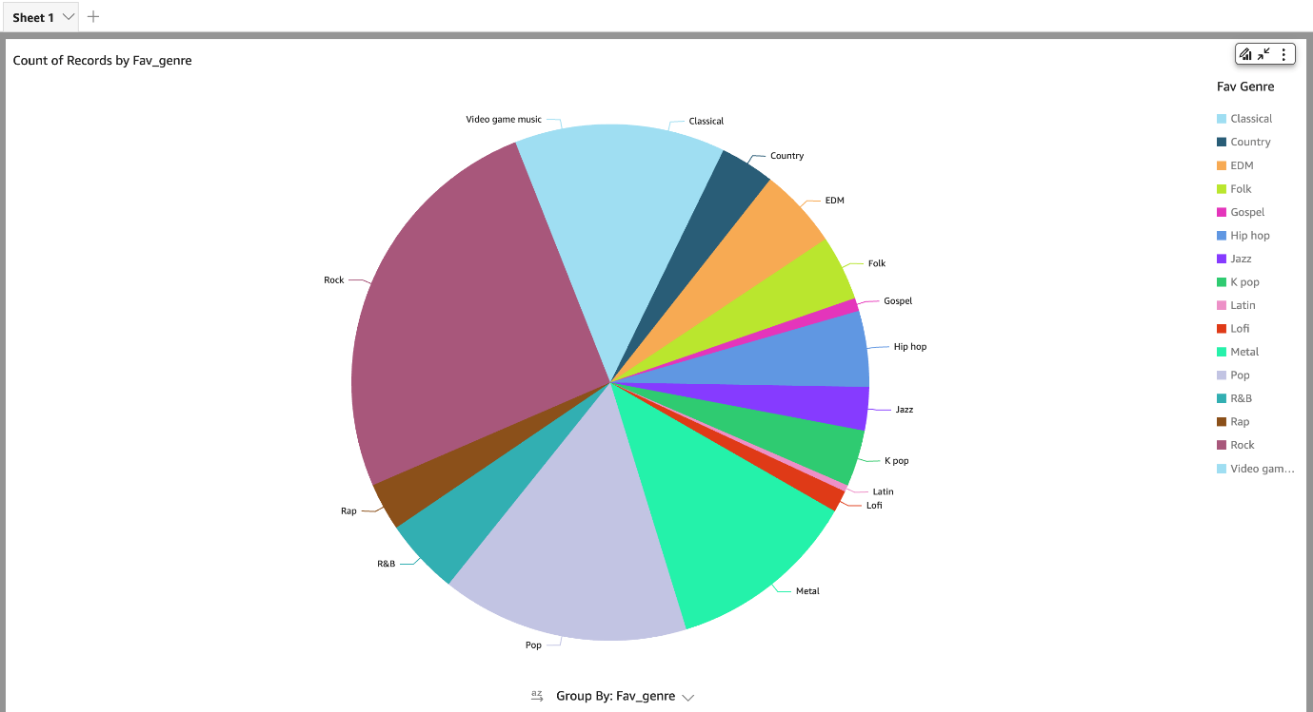

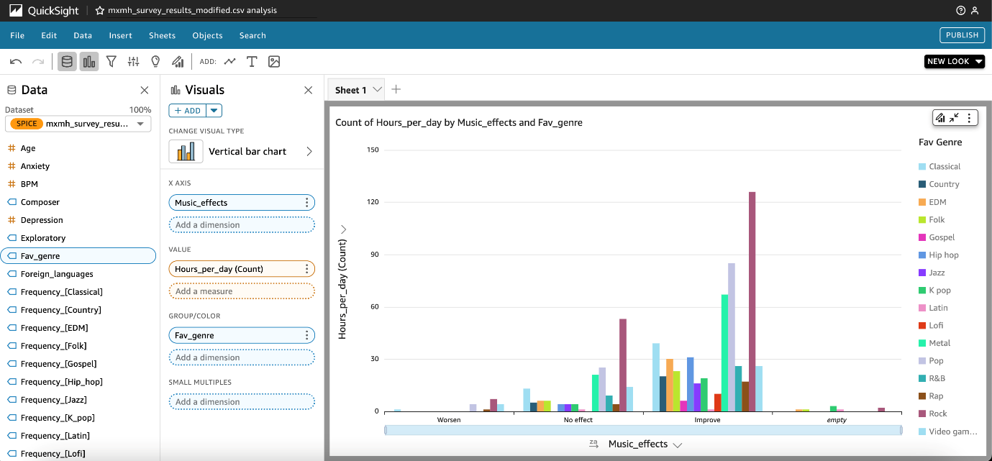

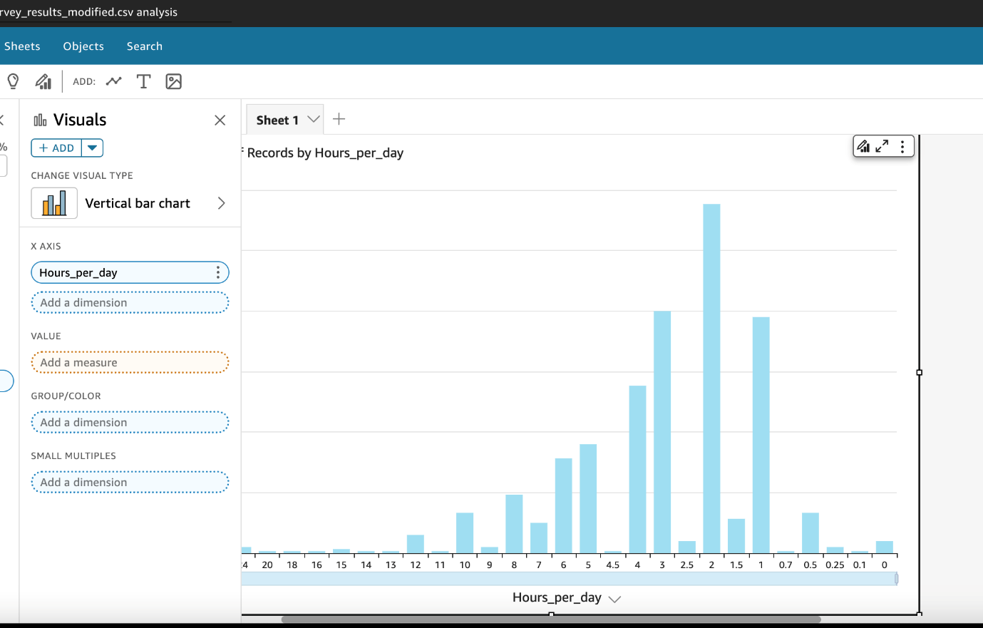

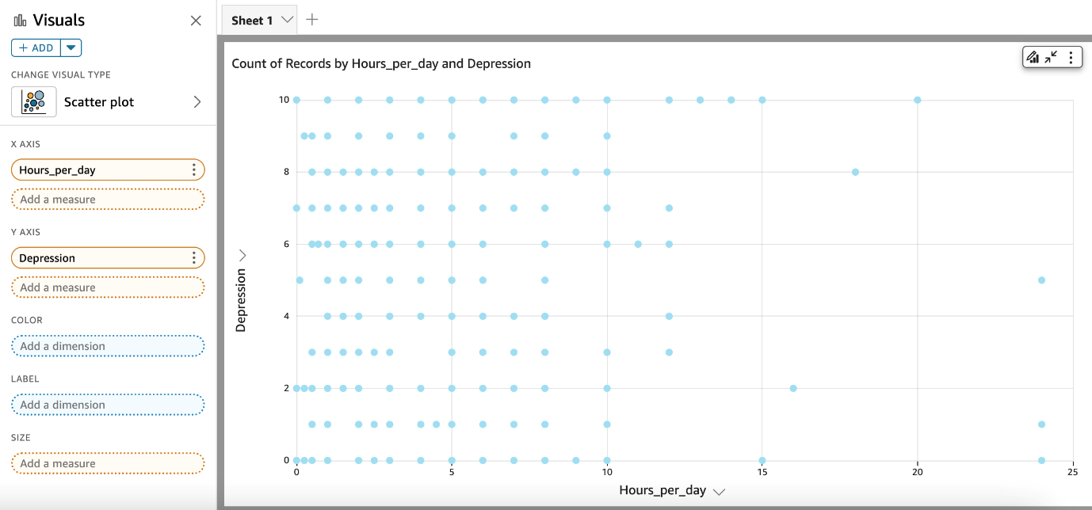

**AWS Glue ETL JOB:**

