**Title: Voting App**

## REGISTRATION MAINACTIVITY RESULT_EXIT ALERTBOX ON RESULT_EXIT

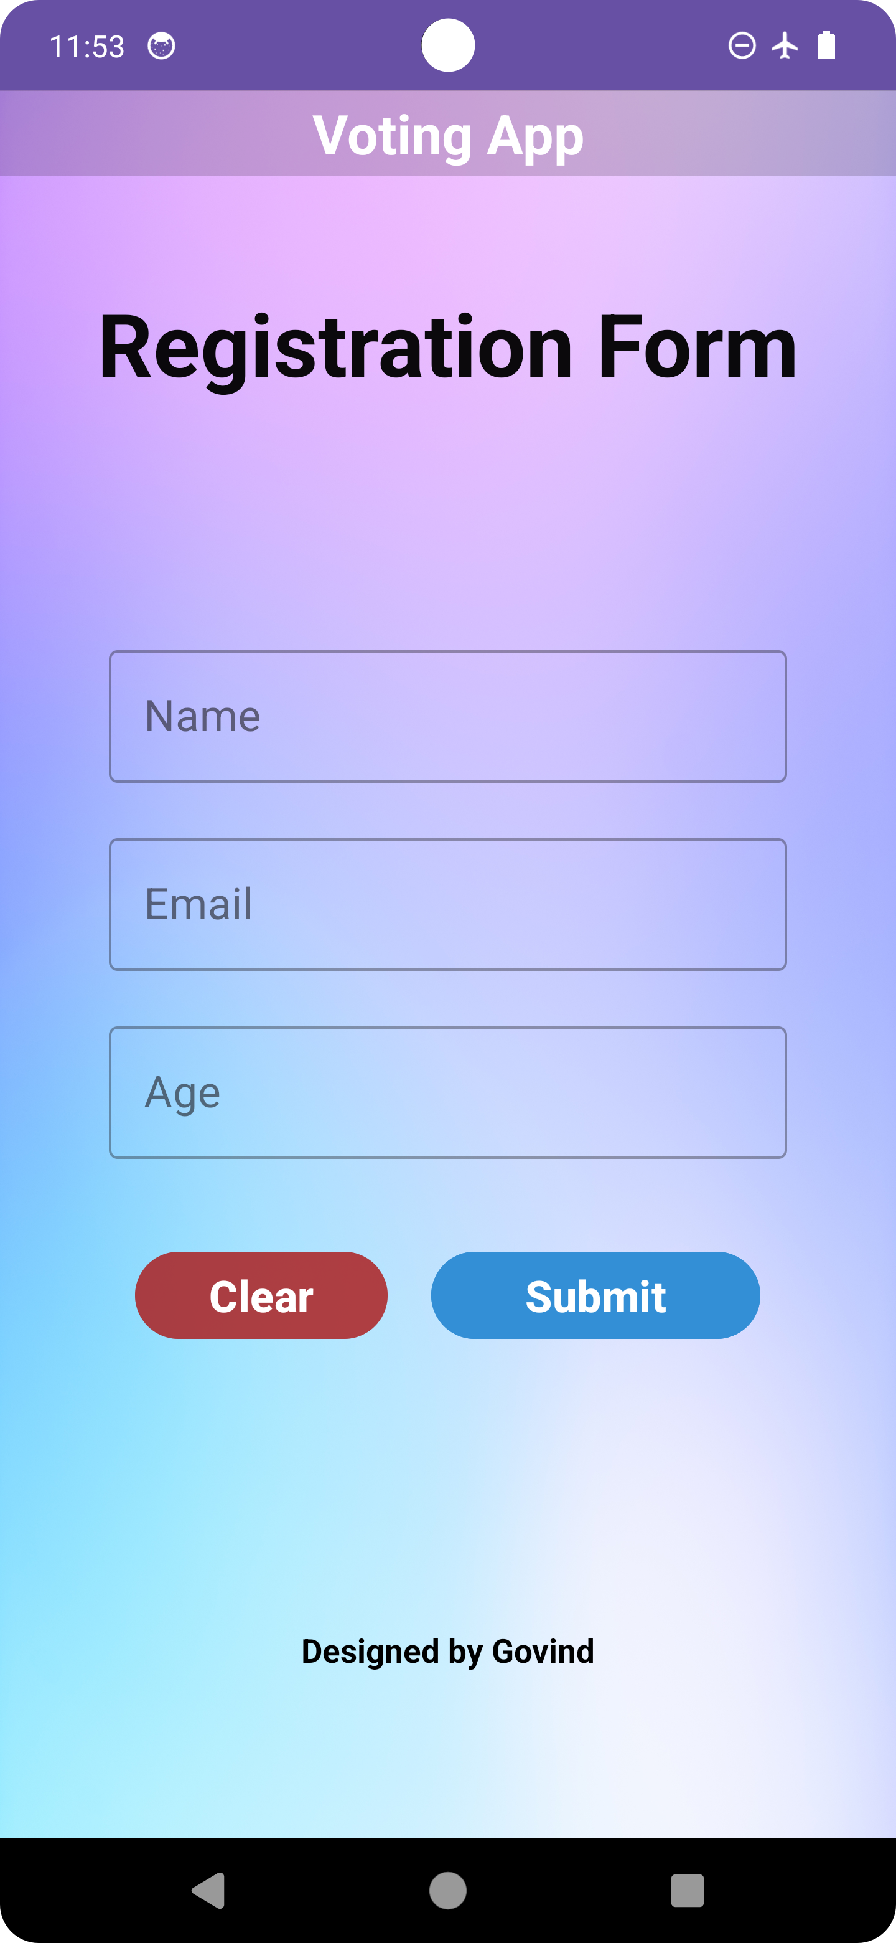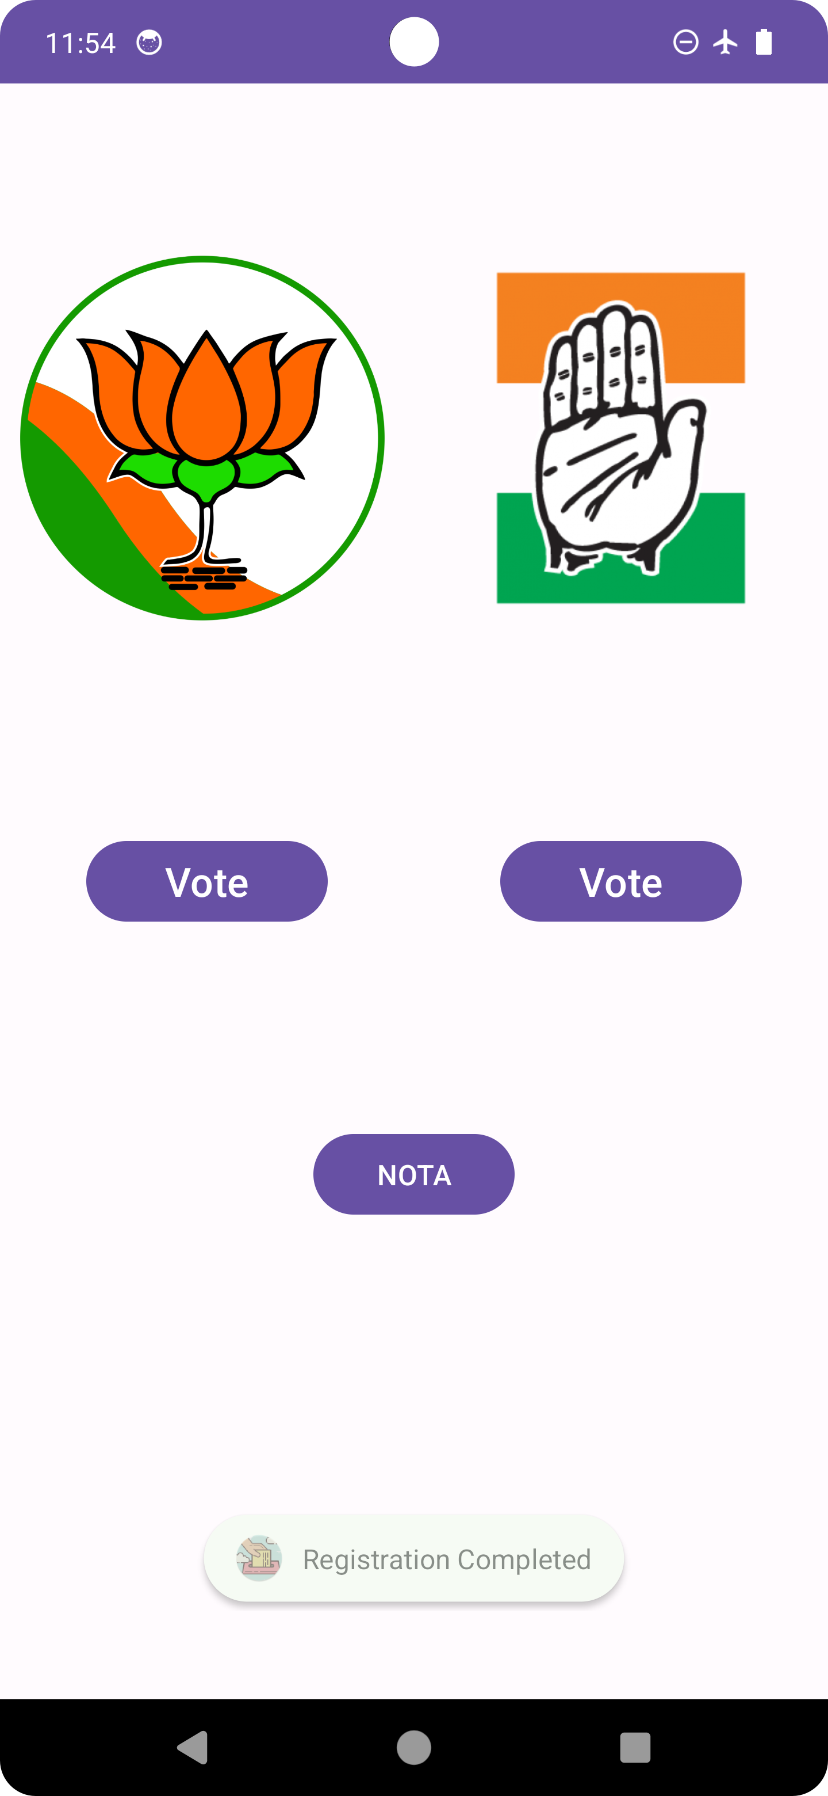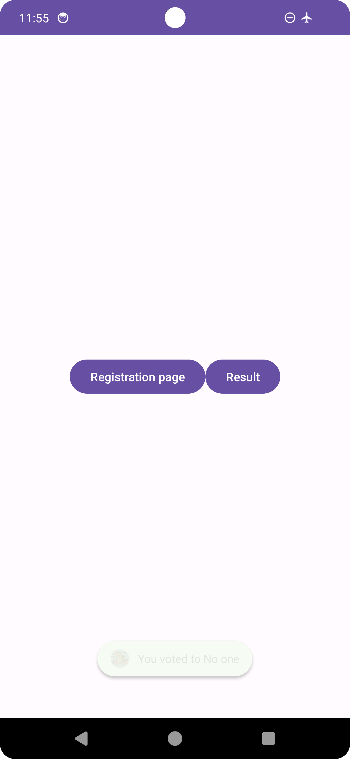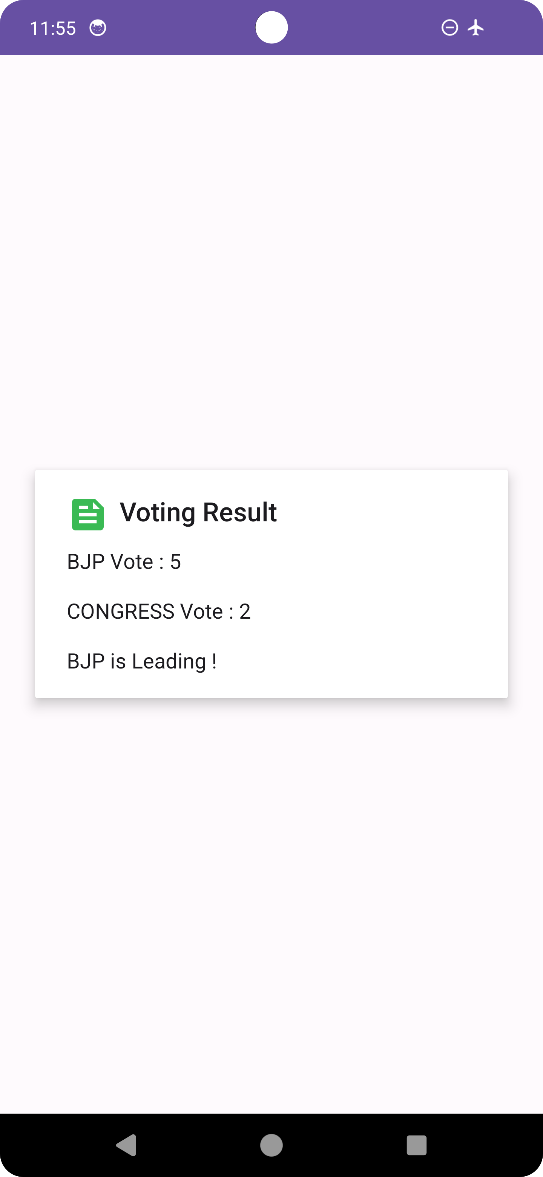

# XML FILE

MAIN ACTIVITY

<?xml version="1.0" encoding="utf-8"?>  
<LinearLayout xmlns:android="http://schemas.android.com/apk/res/android"  
 xmlns:app="http://schemas.android.com/apk/res-auto"  
 xmlns:tools="http://schemas.android.com/tools"  
 android:layout_width="match_parent"  
 android:layout_height="match_parent"  
 tools:context=".MainActivity"  
 android:orientation="vertical">  
<LinearLayout  
 android:layout_width="match_parent"  
 android:layout_height="wrap_content"  
 android:orientation="horizontal">  
  
 <LinearLayout  
 android:layout_width="0dp"  
 android:layout_height="444dp"  
 android:layout_weight="1"  
 android:orientation="vertical">  
  
 <ImageView  
 android:layout_width="191dp"  
 android:layout_height="352dp"  
 android:contentDescription="Bjp Image"  
 android:paddingLeft="10dp"  
 android:src="@drawable/bjp" />  
  
 <Button  
 android:id="@+id/bjpbtn"  
 android:layout_width="120dp"  
 android:layout_height="wrap_content"  
 android:layout_gravity="center"  
 android:layout_marginTop="20dp"  
 android:text="Vote"  
 android:textSize="20dp" />  
 </LinearLayout>  
  
 <LinearLayout  
 android:layout_width="0dp"  
 android:layout_height="444dp"  
 android:layout_weight="1"  
 android:orientation="vertical">  
  
 <ImageView  
 android:layout_width="match_parent"  
 android:layout_height="352dp"  
 android:contentDescription="Congress Image"  
 android:src="@drawable/conngress" />  
  
 <Button  
 android:id="@+id/cgsbtn"  
 android:layout_width="120dp"  
 android:layout_height="wrap_content"  
 android:layout_gravity="center"  
 android:layout_marginTop="20dp"  
 android:text="Vote"  
 android:textSize="20dp" />  
 </LinearLayout>  
  
</LinearLayout>  
  
 <LinearLayout  
 android:layout_width="match_parent"  
 android:layout_height="195dp"  
 android:gravity="center">  
  
 <Button  
 android:id="@+id/nota"  
 android:layout_width="100dp"  
 android:layout_height="wrap_content"  
 android:layout_gravity="center"  
 android:text="NOTA" />  
  
 </LinearLayout>  
</LinearLayout>

REGISTRATION

<?xml version="1.0" encoding="utf-8"?>  
<LinearLayout xmlns:android="http://schemas.android.com/apk/res/android"  
 xmlns:app="http://schemas.android.com/apk/res-auto"  
 xmlns:tools="http://schemas.android.com/tools"  
 android:layout_width="match_parent"  
 android:layout_height="match_parent"  
 tools:context=".Registration"  
 android:orientation="vertical"  
 android:background="@drawable/img2">  
  
 <TextView  
 android:layout_width="match_parent"  
 android:layout_height="39dp"  
 android:text="Voting App"  
 android:textColor="#FFFFFF"  
 android:textSize="25dp"  
 android:textStyle="bold"  
 android:gravity="center"  
 android:background="#2A000000"/>  
  
  
 <TextView  
 android:layout_marginTop="50dp"  
 android:layout_width="match_parent"  
 android:layout_height="wrap_content"  
 android:gravity="center"  
 android:text="Registration Form"  
 android:textColor="#F3000000"  
 android:textSize="40dp"  
 android:textStyle="bold"  
 />  
  
 <com.google.android.material.textfield.TextInputLayout  
 android:layout_width="match_parent"  
 android:layout_height="wrap_content"  
 android:layout_marginTop="109dp"  
 android:layout_marginRight="50dp"  
 android:layout_marginLeft="50dp"  
 style="@style/Widget.MaterialComponents.TextInputLayout.OutlinedBox">  
 <com.google.android.material.textfield.TextInputEditText  
 android:id="@+id/name"  
 android:layout_width="match_parent"  
 android:layout_height="wrap_content"  
 android:hint="Name"  
 android:inputType="text"  
 android:textSize="20sp"  
 />  
 </com.google.android.material.textfield.TextInputLayout>  
  
  
  
  
 <com.google.android.material.textfield.TextInputLayout  
 android:layout_width="match_parent"  
 android:layout_height="wrap_content"  
 android:layout_marginTop="20dp"  
 android:layout_marginRight="50dp"  
 android:layout_marginLeft="50dp"  
 style="@style/Widget.MaterialComponents.TextInputLayout.OutlinedBox">  
  
 <com.google.android.material.textfield.TextInputEditText  
 android:id="@+id/email"  
 android:layout_width="match_parent"  
 android:textSize="20sp"  
 android:layout_height="wrap_content"  
 android:hint="Email"  
 android:inputType="textEmailAddress" />  
 </com.google.android.material.textfield.TextInputLayout>  
  
  
  
 <com.google.android.material.textfield.TextInputLayout  
 android:layout_width="match_parent"  
 android:layout_height="wrap_content"  
 android:layout_marginTop="20dp"  
 android:layout_marginRight="50dp"  
 android:layout_marginLeft="50dp"  
 style="@style/Widget.MaterialComponents.TextInputLayout.OutlinedBox">  
  
 <com.google.android.material.textfield.TextInputEditText  
 android:id="@+id/age"  
 android:layout_width="match_parent"  
 android:textSize="20sp"  
 android:layout_height="wrap_content"  
 android:hint="Age"  
 android:inputType="number" />  
 </com.google.android.material.textfield.TextInputLayout>  
  
 <LinearLayout  
 android:layout_width="match_parent"  
 android:layout_height="105dp"  
 android:layout_marginTop="10dp"  
 android:orientation="horizontal"  
 android:gravity="center">  
  
 <Button  
 android:id="@+id/clear"  
 android:layout_width="116dp"  
 android:layout_height="wrap_content"  
 android:layout_gravity="center"  
 android:layout_marginRight="20dp"  
 android:text="Clear"  
 android:textSize="20dp"  
 android:textStyle="bold"  
 android:backgroundTint="#94AC1A1A"/>  
  
 <Button  
 android:id="@+id/submit"  
 android:layout_width="151dp"  
 android:layout_height="wrap_content"  
 android:layout_gravity="center"  
 android:text="Submit"  
 android:textSize="20dp"  
 android:textStyle="bold"  
 android:backgroundTint="#338FD6"  
 />  
  
 </LinearLayout>  
  
 <TextView  
 android:layout_width="match_parent"  
 android:layout_height="wrap_content"  
 android:gravity="center"  
 android:paddingTop="100dp"  
 android:text="Designed by Govind"  
 android:textColor="#000000"  
 android:textSize="15dp"  
 android:textStyle="bold" />  
</LinearLayout>

RESULT_EXIT

<?xml version="1.0" encoding="utf-8"?>  
<LinearLayout xmlns:android="http://schemas.android.com/apk/res/android"  
 xmlns:app="http://schemas.android.com/apk/res-auto"  
 xmlns:tools="http://schemas.android.com/tools"  
 android:layout_width="match_parent"  
 android:layout_height="match_parent"  
 tools:context=".Result_Exit" android:gravity="center">  
  
 <Button  
 android:id="@+id/button"  
 android:layout_width="wrap_content"  
 android:layout_height="wrap_content"  
 android:text="Registration page"  
 tools:layout_editor_absoluteX="143dp"  
 tools:layout_editor_absoluteY="261dp" />  
 <Button  
 android:id="@+id/result"  
 android:layout_width="wrap_content"  
 android:layout_height="wrap_content"  
 android:text="Result"  
 tools:layout_editor_absoluteX="143dp"  
 tools:layout_editor_absoluteY="261dp" />  
</LinearLayout>

# JAVA FILE

REGISTRATION

package com.example.voterapp;  
  
import androidx.appcompat.app.AlertDialog;  
import androidx.appcompat.app.AppCompatActivity;  
  
import android.content.DialogInterface;  
import android.content.Intent;  
import android.os.Bundle;  
import android.util.Log;  
import android.view.View;  
import android.widget.Button;  
import android.widget.EditText;  
import android.widget.TextView;  
import android.widget.Toast;  
  
  
public class Registration extends AppCompatActivity {  
EditText name,email,age;  
Button clr,sbt;  
DBHelper db;  
  
 @Override  
 public void onBackPressed() {  
// super.onBackPressed();  
 Log.*d*("Govind","BackPressed Called");  
  
 AlertDialog.Builder exit=new AlertDialog.Builder(Registration.this);  
 exit.setTitle("Confirm Exit");  
 exit.setIcon(R.drawable.*exit_app*);  
 exit.setMessage("are you sure you want to exit");  
  
 exit.setPositiveButton("Yes", new DialogInterface.OnClickListener() {  
 @Override  
 public void onClick(DialogInterface dialogInterface, int i) {  
 finish();  
 }  
 });  
 exit.setNegativeButton("No",null);  
 exit.show(); }  
  
 @Override  
 protected void onCreate(Bundle savedInstanceState) {  
 super.onCreate(savedInstanceState);  
 setContentView(R.layout.*activity_registration*);  
  
  
 name=findViewById(R.id.*name*);  
 email=findViewById(R.id.*email*);  
 age=findViewById(R.id.*age*);  
 clr=findViewById(R.id.*clear*);  
 sbt=findViewById(R.id.*submit*);  
 db=new DBHelper(this);  
  
 //clear button action  
 clr.setOnClickListener(new View.OnClickListener() {  
 @Override  
 public void onClick(View view) {  
 name.setText(null);  
 email.setText(null);  
 age.setText(null);  
 }  
 });  
  
 //submit button action  
 sbt.setOnClickListener(new View.OnClickListener() {  
 @Override  
 public void onClick(View view) {  
  
 String n=name.getText().toString().trim();  
 String e=email.getText().toString().trim();  
 String a=age.getText().toString().trim();  
  
 if(n.equals("")||e.equals("")||a.equals("")){  
 Toast.*makeText*(Registration.this,"plaese fill all details",Toast.*LENGTH_SHORT*).show();  
 }else{  
  
 int ages = Integer.*parseInt*(a);  
  
 if (ages>= 18) {  
  
 boolean insert = db.insertdata(n, e, a);  
  
 if (insert == true) {  
  
 Toast.*makeText*(Registration.this, "Registration Completed", Toast.*LENGTH_SHORT*).show();  
 Intent inet=new Intent(Registration.this, MainActivity.class);  
 startActivity(inet);  
 }  
 }else{  
 Toast.*makeText*(Registration.this,"You are not eligible for voting",Toast.*LENGTH_SHORT*).show();  
 }  
 }}  
 });  
  
  
  
  
  
  
  
  
  
 }  
}

MAIN ACTIVITY

package com.example.voterapp;  
  
import androidx.appcompat.app.AlertDialog;  
import androidx.appcompat.app.AppCompatActivity;  
  
import android.content.DialogInterface;  
import android.content.Intent;  
import android.os.Bundle;  
import android.util.Log;  
import android.view.View;  
import android.widget.Button;  
import android.widget.TextView;  
import android.widget.Toast;  
  
public class MainActivity extends AppCompatActivity {  
  
 Button bjpbtn,cgsbtn,notabtn;  
  
 Result dbr;  
  
 @Override  
 protected void onCreate(Bundle savedInstanceState) {  
 super.onCreate(savedInstanceState);  
 setContentView(R.layout.*activity_main*);  
  
 //finding the component by id  
 bjpbtn=findViewById(R.id.*bjpbtn*);  
 cgsbtn=findViewById(R.id.*cgsbtn*);  
 notabtn=findViewById(R.id.*nota*);  
 dbr=new Result(this);  
  
  
 bjpbtn.setOnClickListener(new View.OnClickListener() {  
 @Override  
 public void onClick(View view) {  
  
 cgsbtn.setVisibility(view.*INVISIBLE*);  
 bjpbtn.setVisibility(view.*INVISIBLE*);  
 notabtn.setVisibility(view.*INVISIBLE*);  
 Intent inet=new Intent(MainActivity.this,Result_Exit.class);  
 startActivity(inet);  
  
 //vote method by database  
 boolean insert = dbr.insertvote("1",null);  
 Toast.*makeText*(MainActivity.this, "You voted to BJP", Toast.*LENGTH_SHORT*).show();  
  
 }  
 });  
  
 cgsbtn.setOnClickListener(new View.OnClickListener() {  
 @Override  
 public void onClick(View view) {  
 cgsbtn.setVisibility(view.*INVISIBLE*);  
 bjpbtn.setVisibility(view.*INVISIBLE*);  
 notabtn.setVisibility(view.*INVISIBLE*);  
  
 Intent inet=new Intent(MainActivity.this,Result_Exit.class);  
 startActivity(inet);  
  
 boolean insert = dbr.insertvote(null,"1");  
 Toast.*makeText*(MainActivity.this, "You voted to CONGRESS", Toast.*LENGTH_SHORT*).show();  
  
 }  
 });  
  
 notabtn.setOnClickListener(new View.OnClickListener() {  
 @Override  
 public void onClick(View view) {  
 Intent inet=new Intent(MainActivity.this,Result_Exit.class);  
 startActivity(inet);  
  
 boolean insert = dbr.insertvote(null,null);  
 Toast.*makeText*(MainActivity.this, "You voted to No one", Toast.*LENGTH_SHORT*).show();  
  
 }  
 });  
  
  
 }  
}

RESULT_EXIT

package com.example.voterapp;  
  
import androidx.appcompat.app.AlertDialog;  
import androidx.appcompat.app.AppCompatActivity;  
  
import android.content.DialogInterface;  
import android.content.Intent;  
import android.database.Cursor;  
import android.os.Bundle;  
import android.util.Log;  
import android.view.View;  
import android.widget.Button;  
import android.widget.Toast;  
  
public class Result_Exit extends AppCompatActivity {  
  
 Button btn,res;  
 Result dbr;  
  
 @Override  
 protected void onCreate(Bundle savedInstanceState) {  
 super.onCreate(savedInstanceState);  
 setContentView(R.layout.*activity_result_exit*);  
 btn=findViewById(R.id.*button*);  
 res=findViewById(R.id.*result*);  
 dbr=new Result(this);  
  
 btn.setOnClickListener(new View.OnClickListener() {  
 @Override  
 public void onClick(View view) {  
 Intent inet=new Intent(Result_Exit.this,Registration.class);  
 startActivity(inet);  
 }  
 });  
  
 res.setOnClickListener(new View.OnClickListener() {  
 @Override  
 public void onClick(View view) {  
  
 Cursor cdata = dbr.view_data();  
  
 if(cdata.getCount()>=1){  
// Toast.makeText(Result_Exit.this,"recore found",Toast.LENGTH_SHORT).show();  
  
 StringBuffer buffer=new StringBuffer();  
 while(cdata.moveToNext()) {  
 buffer.append("BJP Vote : " + cdata.getString(0)+"\n\n");  
 buffer.append("CONGRESS Vote : " + cdata.getString(1)+"\n\n");  
 int B=Integer.*parseInt*(cdata.getString(0));  
 int C=Integer.*parseInt*(cdata.getString(1));  
  
 if(B>C){  
 buffer.append("BJP is Leading ! ");  
 }else if(C>B){  
 buffer.append("Congress is Leading !");  
 }else{  
 buffer.append("Both are Equal!");  
 }  
  
 }  
 AlertDialog.Builder build=new AlertDialog.Builder(Result_Exit.this);  
 build.setCancelable(true);  
 build.setTitle("Voting Result");  
 build.setIcon(R.drawable.*result*);  
 build.setMessage(buffer.toString());  
 build.show();  
 }  
 }  
 });  
 }  
  
 @Override  
 public void onBackPressed() {  
// super.onBackPressed();  
// Intent tent=new Intent(Result_Exit.this,Registration.class);  
// startActivity(tent);  
 Log.*d*("Govind","BackPressed Called");  
  
 AlertDialog.Builder exit=new AlertDialog.Builder(Result_Exit.this);  
 exit.setTitle("Confirm Exit");  
 exit.setIcon(R.drawable.*exit_app*);  
 exit.setMessage("are you sure you want to exit");  
  
 exit.setPositiveButton("Yes", new DialogInterface.OnClickListener() {  
 @Override  
 public void onClick(DialogInterface dialogInterface, int i) {  
 finish();  
 Intent tent=new Intent(Result_Exit.this,Registration.class);  
 startActivity(tent);  
 Toast.*makeText*(Result_Exit.this,"You Redirect To Registratoin Page",Toast.*LENGTH_LONG*).show();  
 }  
 });  
 exit.setNegativeButton("No",null);  
 exit.show();  
 }  
}

DATABASE FILE FOR VOTE COUNTING

package com.example.voterapp;  
  
import android.content.ContentValues;  
import android.content.Context;  
import android.database.Cursor;  
import android.database.sqlite.SQLiteDatabase;  
import android.database.sqlite.SQLiteOpenHelper;  
  
import androidx.annotation.Nullable;  
  
public class DBHelper extends SQLiteOpenHelper {  
  
 public static final String *DBNAME*="REGISTR.db";  
  
 public DBHelper(Context context) {  
 super(context, "REGISTR.db",null,1);  
 }  
  
 @Override  
 public void onCreate(SQLiteDatabase Mydb) {  
 Mydb.execSQL("create table usr(id INTEGER primary key autoincrement," +  
 "name TEXT," +  
 "email TEXT," +  
 "age INTEGER)");  
 }  
  
  
 @Override  
 public void onUpgrade(SQLiteDatabase Mydb, int i, int i1) {  
 Mydb.execSQL("drop table if exists usr");  
 }  
  
 public boolean insertdata(String name,String email,String age){  
 SQLiteDatabase Mydb=this.getWritableDatabase();  
 ContentValues cv=new ContentValues();  
 cv.put("name",name);  
 cv.put("email",email);  
 cv.put("age",age);  
  
 long r=Mydb.insert("usr",null,cv);  
 Mydb.close();  
 if(r>0)  
 return true;  
 else  
 return false;  
 }  
  
  
 }

DATABASE FILE FOR VOTE DISPLAYING

package com.example.voterapp;  
  
import android.content.ContentValues;  
import android.content.Context;  
import android.database.Cursor;  
import android.database.sqlite.SQLiteDatabase;  
import android.database.sqlite.SQLiteOpenHelper;  
  
public class Result extends SQLiteOpenHelper {  
 public static final String *DBNAME*="RESULT.db";  
  
 public Result(Context context) {  
 super(context, "RESULT.db", null,1);  
 }  
  
 @Override  
 public void onCreate(SQLiteDatabase Mydb) {  
  
 Mydb.execSQL("create table vote_count(id INTEGER primary key autoincrement,bjpvote integer,cgsvote integer)");  
  
 }  
  
 @Override  
 public void onUpgrade(SQLiteDatabase Mydb, int i, int i1) {  
 Mydb.execSQL("drop table if exists vote_count");  
  
 }  
 public boolean insertvote(String bjp,String cgs){  
 SQLiteDatabase Mydb=this.getWritableDatabase();  
 ContentValues cv=new ContentValues();  
 cv.put("bjpvote",bjp);  
 cv.put("cgsvote",cgs);  
  
 long r=Mydb.insert("vote_count",null,cv);  
 Mydb.close();  
 if(r>0)  
 return true;  
 else  
 return false;  
 }  
 public Cursor view_data(){  
 SQLiteDatabase db=this.getReadableDatabase();  
 String q="select sum(bjpvote),sum(cgsvote) from vote_count";  
 Cursor cr=db.rawQuery(q,null);  
 return cr;  
 }  
  
}