**NITTE MEENAKSHI INSTITUTE OF TECHNOLOGY**

AN AUTONOMOUS INSTITUTION, AFFILIATED TO VISVESVARAYA TECHNOLOGICAL UNIVERSITY, BELGAUM, APPROVED BY AICTE & GOVT.OF KARNATAKA



**A PROJECT REPORT**

**“Hand cricket game”**

*Submitted in partial fulfillment of the requirement for the award of Degree of*

**Bachelor of Engineering**

**in**

**Information Science and Engineering**

**Under the guidance of**

**Dr. Mohan S G**

**Submitted by:**

Golla pallavi

Govind raj

Rajesh C

**NITTE MEENAKSHI INSTITUTE OF TECHNOLOGY**

(AN AUTONOMOUS INSTITUTION, AFFILIATED TO VISVESVARAYA TECHNOLOGICAL UNIVERSITY BELGAUM,

APPROVED BY AICTE & GOVT.OF KARNATAKA)



**CERTIFICATE**

This is to certify the project report entitled **“hand cricket game”** is an authentic work carried out by K.**GOLLA PALLAVI(1NT21IS402),GOVIND RAJ(1NT20IS069) ,RAJESH C(2NT21IS408)** bonafied students of **Nitte Meenakshi Institute of Technology,** Bangalore in partial fulfilment for the award of the degree of ***Bachelor of Engineering*** in **Department of Information Science and Engineering** of Visvesvaraya Technological University, Belagavi during the academic year ***2021-22.***

|  |  |
| --- | --- |
|  | **Signature of the HOD** |

**ABSTRACT**

**Hand Cricket** is a very famous game among the school kids in India. There are two players i.e. one the human player, and other the computer who will be playing the game, and after performing a ‘toss’, one chooses to bat and the other has to bowl. Both the players will simultaneously signify a number between 1 to 10. If both the players point out the same number, the player who is batting gets ‘out’, else, this is repeated and whatever number the batting player keeps throwing are added and that becomes score. After the batsman gets out, the bowling player gets a chance to bat and vice-versa. Now, the process is repeated again and finally, if the original bowler scores more than the original batsman, bowler wins. If they both score the same runs, both get ‘out’, then it is declared as a tie. If the original batsman scores more than the original bowler, batsman wins.

**TABLE OF CONTENTS**

|  |  |  |
| --- | --- | --- |
| **Chapter No** | **Title** | **Page No** |
| 1 | Introduction | **1** |
| 2 | Objectives | **2** |
| 3 | Problem Statement | **3** |
| 4 | Methodology | **4** |
| 6 | Code Snippets | **5** |
| 7 | Snapshots | **8** |
| 8 | Conclusion | **10** |
| 9 | References and bibliography | **11** |

**CHAPTER 1**

**INTRODUCTION:**

Hand Cricket is a very famous game among the school kids in India. Traditionally, the hand cricket game consists of two players, one is the player and the other is computer. The game decides whether bat or bowl by a 'toss', either a player or a computer. The game is just like a "rock, paper and scissors". Hand cricket is played through gestures called as throws similar to rock paper scissors. The total number of fingers extended equates to the equivalent number, with a thumb counting as 6. Throws are made simultaneously by both players, one designated as the batter and the other as the bowler. Runs scored according to the batter's throws until the bowler throws the same, in which case the batter is "out".

**CHAPTER 2**

**OBJECTIVES:**

* The main objective of the hand cricket game is to score as many points as possible against the opponent.
* Understanding the real world scenario and implementing it.
* The model will recognize the number that player shows and the bot will randomly generate a number.
* When both Player and computer play the same number the user batting will get out and the other tries to beat them.

**CHAPTER 3**

**PROBLEM STATEMENT**

* Hand Cricket is a game in which two players show scores on their respective fingers.
* On the basis of toss results, the player can choose either batting or bowling.
* Both the players get equal chance for batting as well as bowling.
* The scores showed by the hand gestures of both the players will get added and stored in score box.
* If the hand gestures of both the players are same, then the player batsman is declared as out.
* Depending on the scores of each players, winner is declared.
* If the total score of both the players are same then match gets tie.

**CHAPTER 4**

**CODE SNIPPETS**

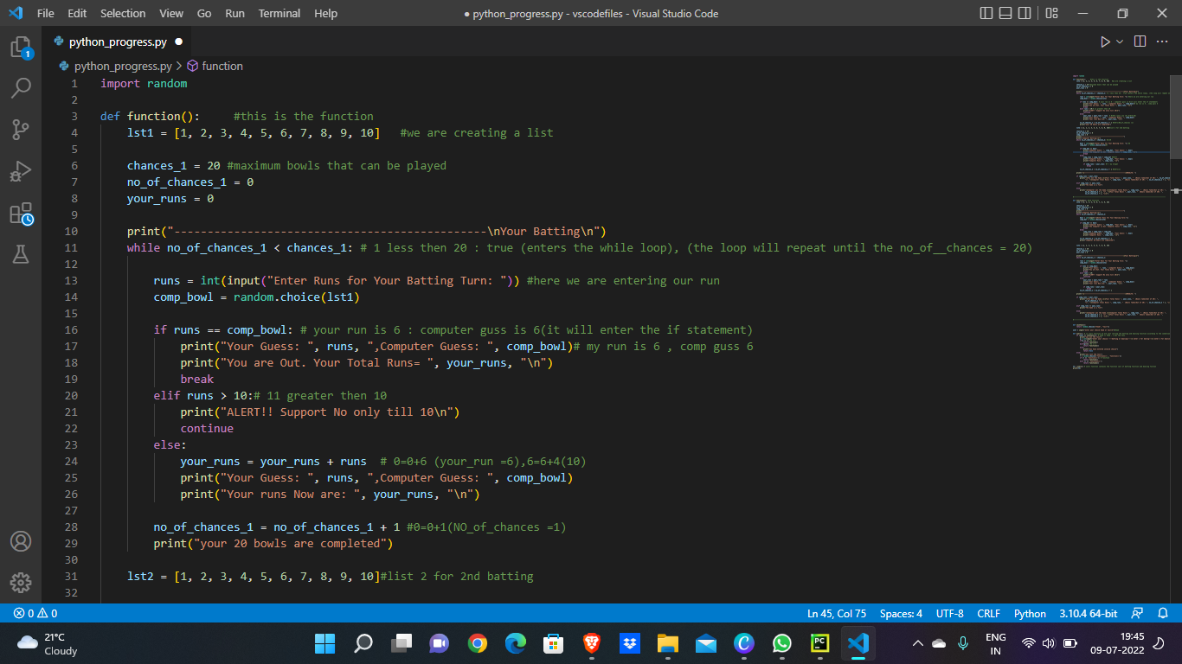

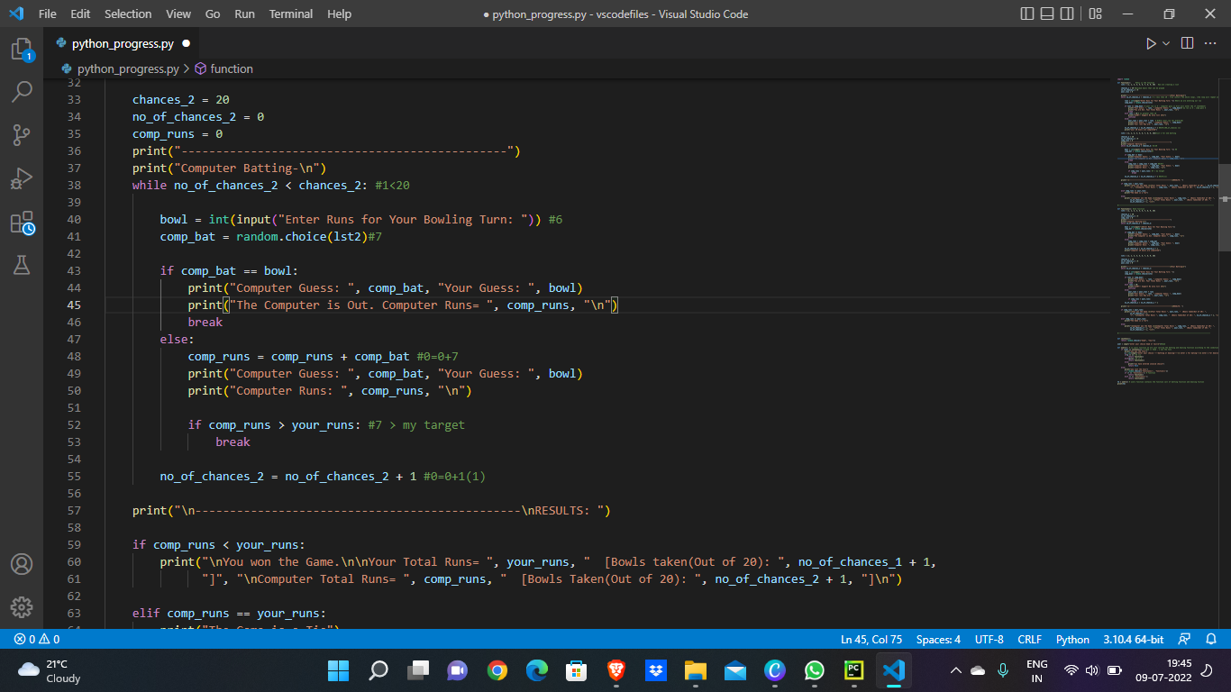

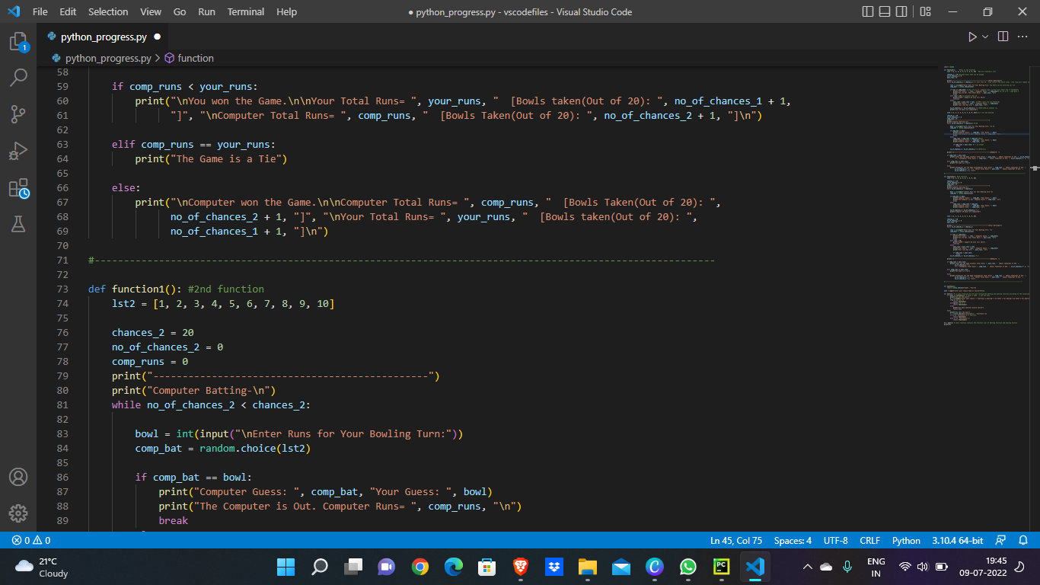

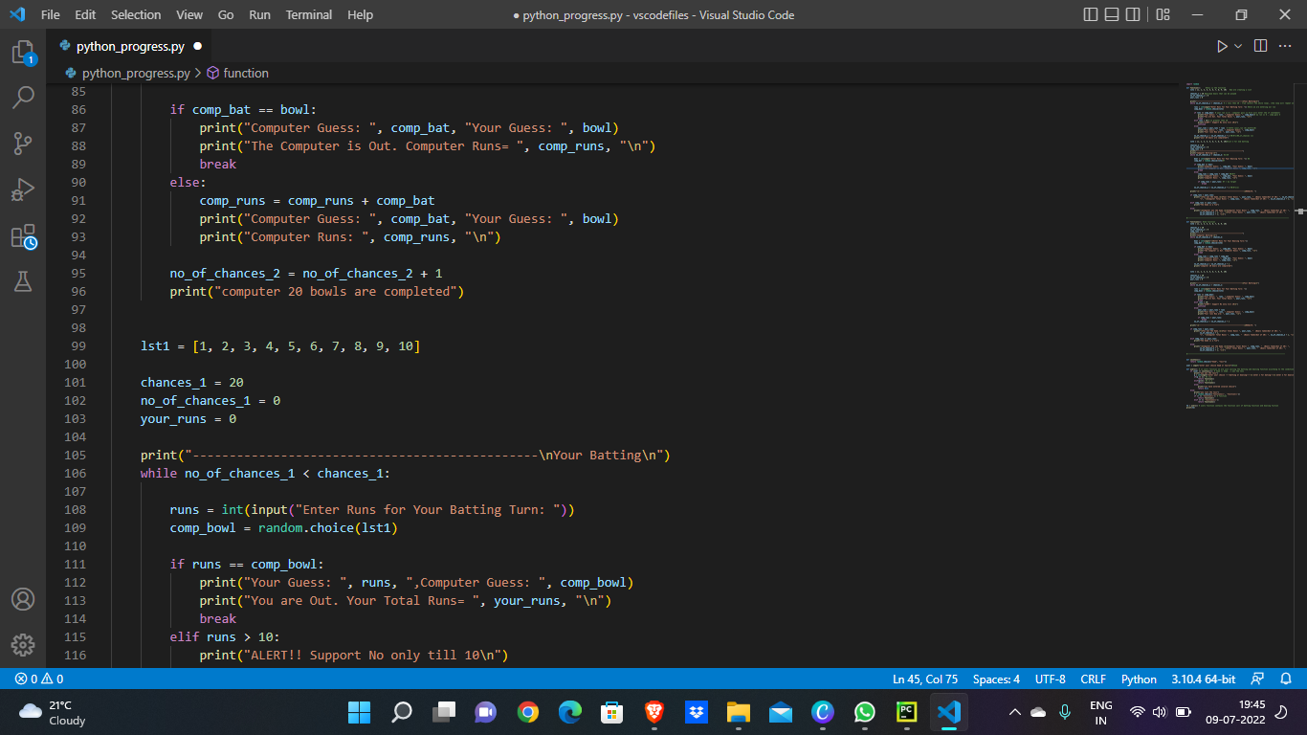

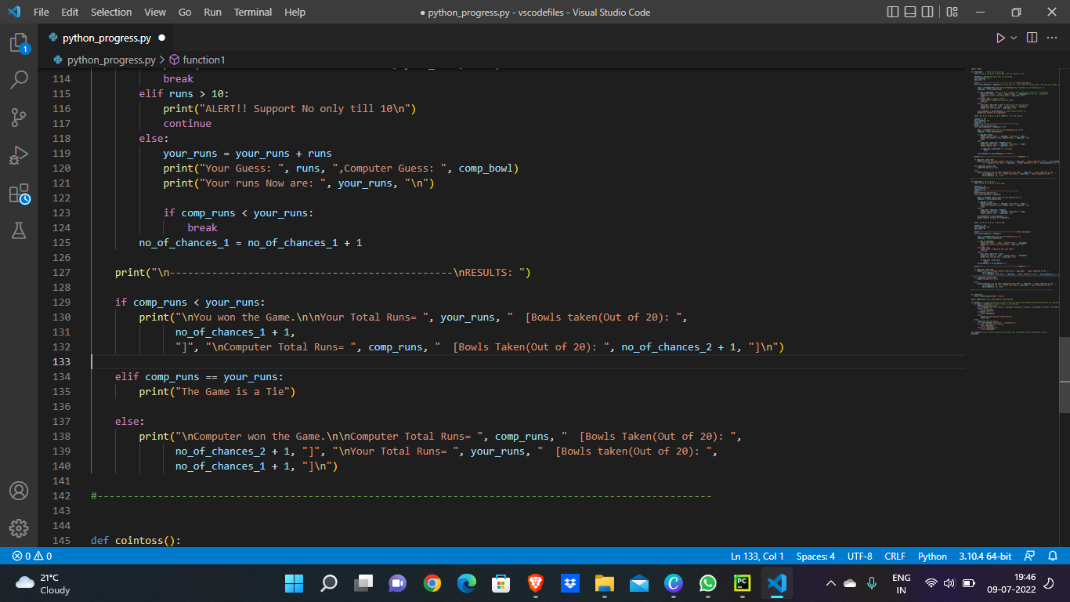

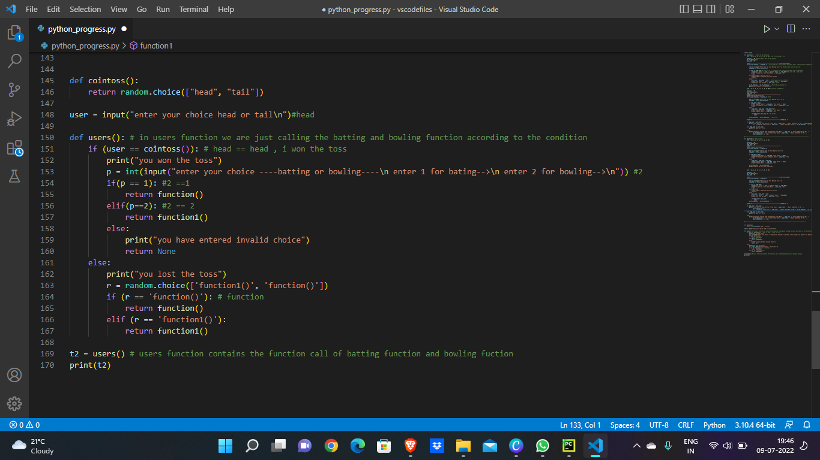

**CHAPTER 5**

**SNAPSHOTS**

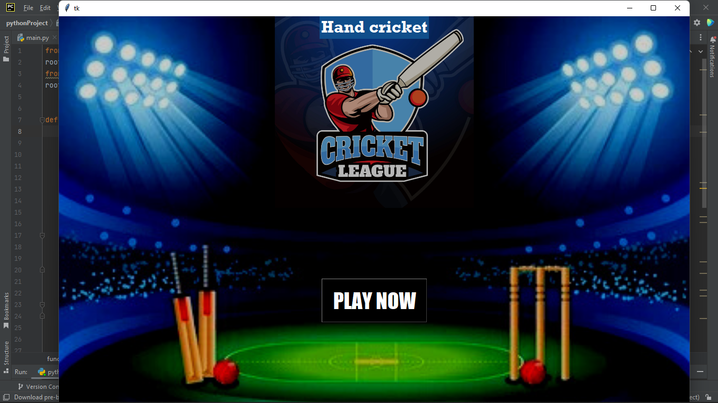

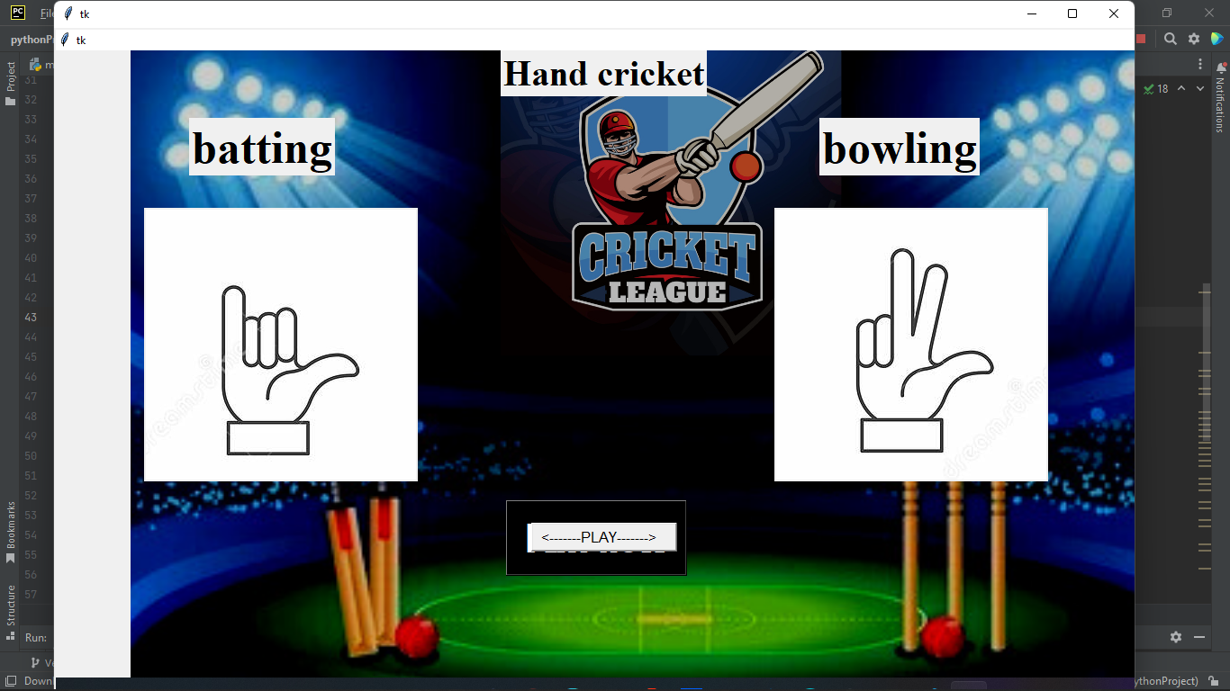

**CHAPTER 6**

**CONCLUSION**

Hand Cricket is a very famous game among the school kids. Children’s special interested to play. In the excisting system, there was a game who used to play with hand gestures inorder to overcome with this we done with the small project using python. A mini project which can be played by a computer and a player.

**CHAPTER 7**

**REFERENCES AND BIBLIOGRAPHY**

**Code**: <https://codingdiksha.com/hand-cricket-game-in-python/>

**Youtube:** <https://youtu.be/YXPyB4XeYLA>

**Software:** “PYCHARM 11.0.15”