Installing and configuring sakis3g to connect to 3g mobile usb dongle on bootup:

1. Install usb_modeswitch on Pi:

sudo apt-get install usb_modeswitch

2. Download the tarball from sakis website:

wget www.sakis3g.com/downloads/sakis3g.tar.gz

3. Extract it:

tar -xkvf sakis3g.tar.gz

4. Make a new directory for installation:

sudo mkdir -p /opt/sakis3g/

5. Place the extracted file in the new directory:

sudo mv sakis3g /opt/sakis3g/

6. Make it executable:

sudo chmod +x /opt/sakis3g/sakis3g
sudo chown root:root /opt/sakis3g/sakis3g
sudo ln -s /opt/sakis3g/sakis3g /usr/bin

7. Edit visudo file to give permissions to run this without password:

sudo visudo
Goto the end of the file and write in the following lines:
pi ALL=(ALL) NOPASSWD: ALL
webide ALL=(ALL) NOPASSWD: ALL
pi ALL = NOPASSWD: /opt/sakis3g/sakis3g
Write out by CTRL+O

8. Install ppp program for point to point communication:

sudo apt-get install ppp

9. Connect manually once in order to configure automation later:

sudo sakis3g –interactive
This will open the following GUI window:
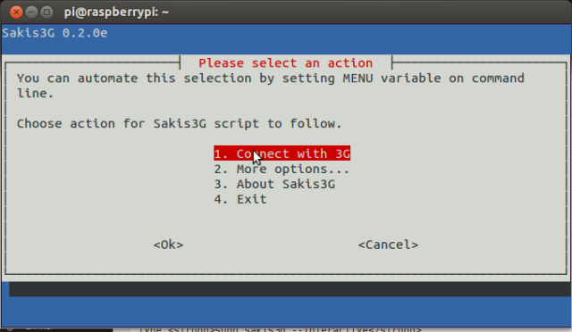
→ Select connect with 3g
→ If the modem is being connected for the first time then may the prompt will ask you to select the type of device (which should be USB, followed by choosing from the Usb deices list, your modem), the interface to be used (Just select interface #0), etc.
→ Then you'll be asked to choose your ISP. Choose the SIM you are using in the modem.
→ The APN code and username is asked both of which are generally a blank space.
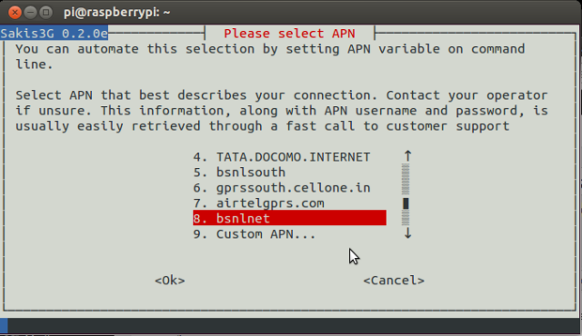
Following these, you will see a prompt indicating that you have successfully connected:
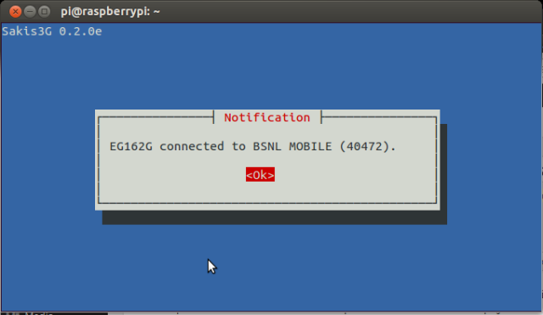
→ Once connected goto “More option” and generate success report:
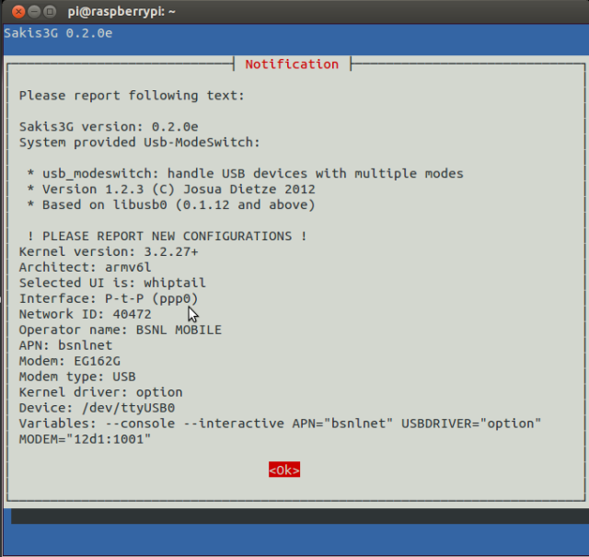
We will use the information in the above picture to set the configuration file.
10. Create a configuration file and edit it:

sudo vim /etc/sakis3g.conf
Enter the following things into the file:
USBDRIVER="option"
USBINTERFACE="0"
APN="airtelgprs.com"
APN_USER=" "
APN_PASS=" "
MODEM="12d1:1436"
Enter the information according to the connection details shown in your success report. Most things shall be the same, just watch out for MODEM and the APN provider name.

11. Make sure that manual connection does not require any user interaction now:

sakis3g - -sudo “connect”
Followin this the modem should connect without any user interaction.
Similarly to disconnect, use”
sakis3g - -sudo “disconnect”

12. Make it connect automatically on bootup:

Open file: /etc/rc.local
sudo vim /etc/rc.local
Enter the following command in the file before the exit 0 command:\
sakis3g - - sudo “connect” - - console

13. Test to see if it is working by rebooting. If it is connected then you should see an IP in the ppp section of the output of the command:

ifconfig

