Single Row functions

1. To list all employees and their email, to generate email use 2 to 5 characters from ename Concat it with 2 to 4 characters in job and then concat it with ‘@mycompany.com’

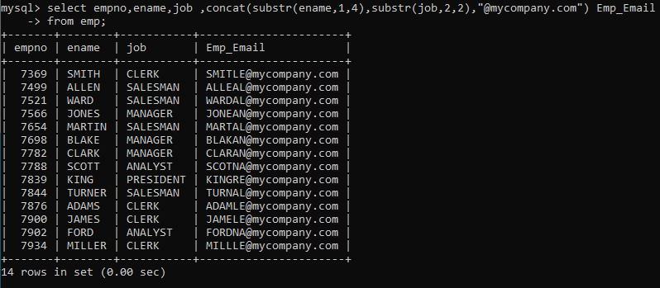

1. List all employees who joined in September.

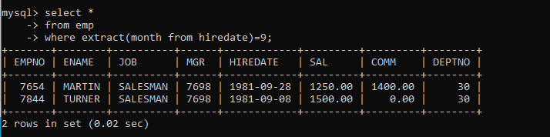

3.List the empno, name, and department number of the emp who have experience of 18 or more years and sort them based on their experience.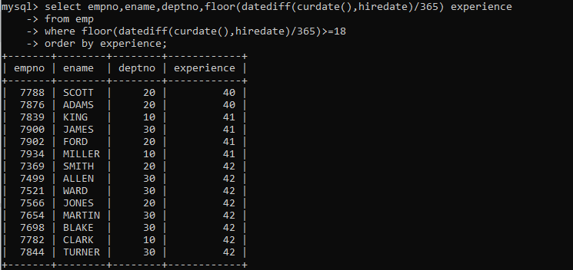

1. Display the employee details who joined on 3rd of any month or any year

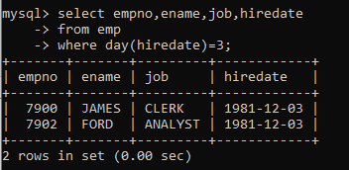

1. display all employees who joined between years 1981 to 1983.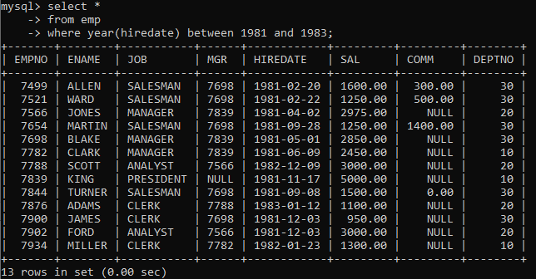

Group functions

1. Display the Highest, Lowest, Total & Average salary of all employee. Label the columns Maximum, Minimum, Total and Average respectively for each Department. Also round the

result to the nearest whole number.

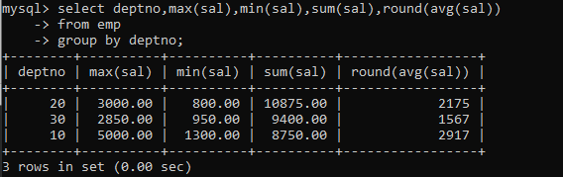

1. Display Department no and number of managers working in that department. Label the

column as ‘Total Number of Managers’ for each department.

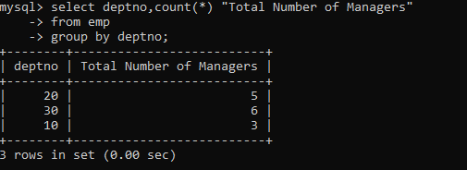

8. Get the Department number, and sum of Salary of all non managers where the sum is

greater than 20000.

