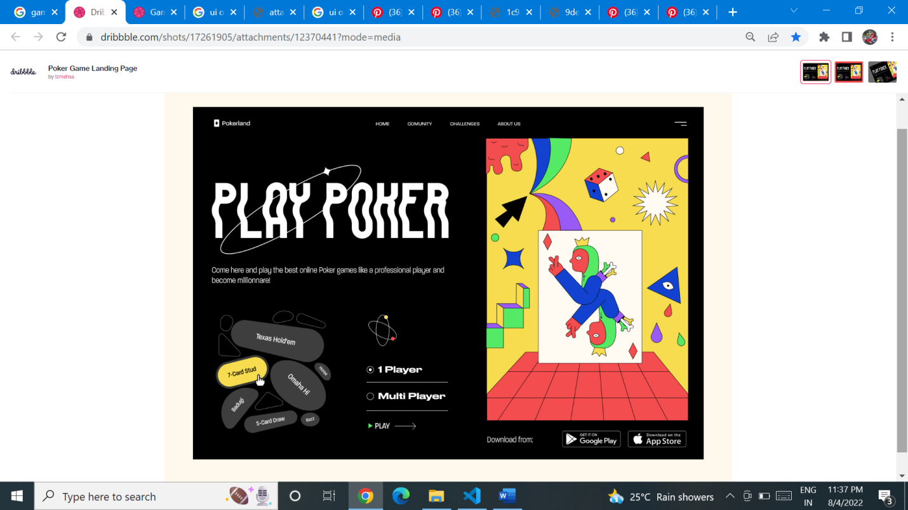

<https://dribbble.com/shots/17261905/attachments/12370441?mode=media>

