KRISHNA DEV SAH

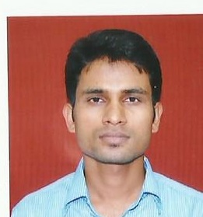
E-mail: kdev.sah@gmail.com
Mobile: +9779809249069

OBJECTIVE

Strive for excellence through teamwork and perseverance in every endeavor and in the process add value to the organization I am working with.

Education

QUALIFICATION | INSTITUTE /SCHOOL | BOARD | STREAM | PERCENTAGE/  CGPA
B .Tech | Gandhi Institute Of  Engineering  &  Technology | BPUT,  Rourkela, Orissa | Mechanical  Engineering | 7.0
+2(Science) | Hari Khetan Multiple Campus, Birgunj, Parsa | HSEB | SCIENCE | 55.20%
10th | Gyan Vatika Boarding English School, Birgunj | NEPAL  BOARD |  | 81.75%

ADEPT IN COMPUTER

- Operating system: MICROSOFT WINDOWS XP, VISTA,WINDOWS 7, 8.
- Programming languages : DATASTRUCTURE, DBMS
- Application Package : AUTOCAD

TRAINING AND PROJECT DONE

- Industrial Training at Jagdamba Steels PVT. LTD.

ACHEIVEMENTS AND EXTRA CURRICULAR ACTIVITES
- Have participated in various sports, cultural, athletic events, and won prizes in school.
- Participated in 6 days workshop on Automobile Engineering held at GIET, Gunupur.
- Participated in the State Level Science And Tech Expo 2014 and designed a Line Follower Robert.
- Successfully completed the Workshop/Training Programmed in ROBOTICS AND EMBEDED SYSTEM.

HOBBIES
- Playing games
- Reading newspaper
- Listening music

PERSONAL INFORMATION

Date of Birth : 18.07.1991
Gender : Male
Father’s name : Birendra Prasad Sah
Nationality : Nepali
Languages : English, Nepali, Hindi and Bhojpuri
Permanent address : Bairiya Birta-2, Parsa, Nepal.
Temporary address : Birgunj, panitanki-15 ,parsa

PLACE: Birgunj ,Panitaki-15 . Parsa .Nepal.

KRISHNA DEV SAH

