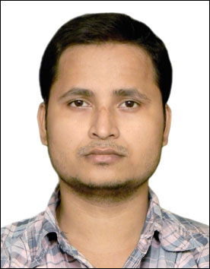
SAMARESH CHAKRABORTY Bachelor of Engineering (BE)
CURRICULUM VITAE
Department of Mechanical Engineering,
Bengal Engineering and Science University, Shibpur. (IIEST)
Contact no: 9681386293/8599914830
E-mail: schakraborty.gist@gmail.com

Career Objective:
- To work on such a platform, which will help to enhance my Technical Knowledge & there by help in excellent development of your organization.
Strength:
  - Self-motivated, Positive thinker.
  - Hard Worker.
  - Works cooperatively, in a planned way.
  - Can easily adjustable in any environment.
Educational Qualification:

Examination | Board/University | Year of passing | Marks (%)
BE in mechanical engineering | Bengal Engineering & Science University shibpur | 2014 | 61.93
Diploma | WBSCTE | 2010 | 71
HS | WBCHSE | 2006 | 49.2
Secondary Exam. | WBBSE | 2004 | 65.25

Major Subject: Thermodynamics, Machine Tools, I C Engine
Computer Awareness:
• Designing software: AUTO CAD.
•MS Office (Word, Excel, Power Point) • MAT LAB
•Undergraduate Project: Final Year Project on “Photovoltaic Power Generation Using Hybrid Concentrated Solar power”, under the guidance of Prof S. Ghosh, Department of Mechanical Engineering, BESU.
•Industrial Training:
> Hooghly Met Co & Power Co Ltd. Haldia (4weeks).
>West Bengal Power Development Corporation Ltd. Sagardighi (3 weeks).
Co-Curricular Activities:
•Participated in different workshop and seminars in school as well as in college.
•Playing Cricket.
•Reading News Paper.
•Personal Information:
Date of Birth: 07th January, 1989
Father Name: Arun Chakraborty
Passport No: N2256064
Gender: Male
Religion: Hinduism
Communicating Languages: Bengali (Mother Tongue), English (Full Professional
Proficiency), Hindi (Full Professional Proficiency)
•Experience under Diploma:
>Electro Steel Casting Ltd. (Haldia).
>Carnation Industries Ltd. (Liluah). (5months)
•Declaration:
I hereby declare that the information given above is true at the best of my knowledge.
Date:
Place: Howrah samaresh chakraborty

