PEMA NAMGYAL SHERPA
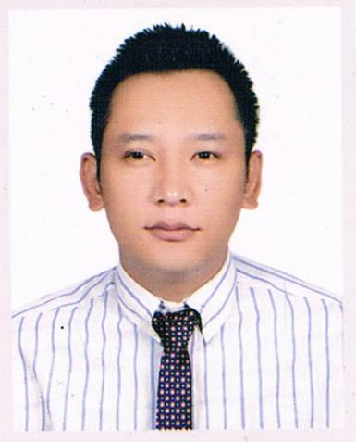
pemsher11@gmail.com
Cell No. - 9841314337
Boudha, Kathmandu,
Nepal

CAREER OBJECTIVE:
“To serves an organization through upgrading human resources skills in cutting edge.”

ACADEMIC QUALIFICATION:
- Master of Business Administration (Score – 3.56 GPA) (2011 - 2013)
Specialization: Strategic Human Resource Management, Organization Development, International Human Resource Management, Compensation Management.
Himalayan White House International College, Kathmandu, Nepal.
Purbanchal University, Biratnagar, Nepal.

- Bachelor’s Degree in Business Studies (Score - 53.71%) (2006 - 2008)
Specialization: Corporate Finance, Fundamental of Investment, Banking and Insurance, Project Management.
Pashupati Multiple Campus, Kathmandu, Nepal.
Tribhuvan University, Kathmandu, Nepal.

PROFESSIONAL EXPERIENCE:
- HR cum Admin Officer (5th January, 2015 to 12th Feburary, 2016)
Indreni Food World and Banquet Pvt. Ltd.
Duties/Responsibilities:
To update the logistic to performs the overall HR operational activities.

- HR cum Admin Officer (5th May, 2013 to 31st December, 2014)
Kathmandu Alfa Beta Institute
Duties/Responsibilities:
To update the logistic to performs the overall HR operational activities.

- Business Development Officer (3rd January, 2010 – 4th Feb, 2011)
Standard Commodity Private Limited, Kathmandu, Nepal.
Duties/Responsibilities:
Accomplish the sales performance target.

PROFESSIONAL SKILLS & TRAININGS:
- Employability Skill level 2 (Nov, 2013)
LCCI Nepal Pvt. Ltd. , Lalitpur, Nepal.

- General Banking Course (11th May, 2009 – 10th June, 2009)
Banking Training Institute, Kathmandu, Nepal.

- Small Hotel Management (26th April, 2005 – 25th May, 2005)
Pacific Manpower Training Centre Pvt. Ltd., Kathmandu, Nepal.

INTERNSHIP:

- Intern in Credit Department ( 1st Oct, 2012 – 23rd Nov, 2012)
Kumari Bank Limited, Kathmandu, Nepal.

REPORT:
- Job Satisfaction at Kumari Bank Limited (June, 2014)
Kumari Bank Limited, Kathmandu, Nepal.

REFERENCE:
- Ram Hari Lammichhane, PhD
Member Secretary, Mobile Number - 9851067067
Council for Technical Education and Vocational Training, Bhaktapur, Nepal

- Pradeep Thapa
Advocate - 9851059026
Prime Law Associates Advocates & Legal Consultant, Kathmandu, Nepal

I do here by declare that the information given above is true.

Pema Namgyal Sherpa

