MUKESH CHOUDHARY 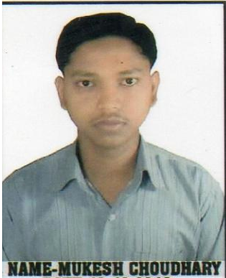
Email:mukeshchoudhary.ct11@gmail.com
Hanuman Nagar, Nai Basti, Near Durga Mandir,
Ward No.-14, Post-Birla Colony
Satna –Madhya Pradesh - 485005
Mobile no. : +919993487240

Career Objective:

To pursue a challenging career with a progressive organization where I can utilize my knowledge, abilities and hard work and enhance my skills by gaining comprehensive understanding of different aspects of operations in the organization in-line with company’s aims and objectives.

Educational Qualification:

Diploma in Engineering (Cement Technology)
Govt. Polytechnic College, Satna, M.P
RGPV, Bhopal

Examination | Board/University | Percentage
DIPLOMA OF ENGINEERING | RGPV University Bhopal(2014) | 75.89%
12th (Intermediate) | MP BOARD(2010) | 58.40%
10th (High school ) | MP BOARD(2007) | 70.50%

Software Proficiency:

- PLATFORMS : Windows 98/XP, Windows Vista, Windows 7.

Project Undertaken:

Major Project

TITLE: Vertical Roller Mill

Areas Of Interest:
- POWER SAVING
- USING LATEST TECHNOLOGY
- QUALITY CONTROL

Credentials:

- Organized & actively participated in school & college function & sports.
- Participated in ‘‘Bharatiya Snskriti Gyan Pariksha’’ on 2003-2010

Industrial and Vocational Training:

- One month in plant training (Industrial Training) on “CEMENT MANUFACTURING PROCESS” in Birla Corporation Ltd. SATNA

Personal Strength:

- Self-Motivated
- Achievement oriented with an ability to design something new.
- Positive attitude and self-discipline.
- Proven strength in problem solving, coordination and analysis.
- Good verbal and written Communication

Personal Profile:

Father’s Name : Mr. Ram Sunder Choudhary

Mother’s Name : Mrs. Lal Muni Choudhary

Date of Birth : 05 March, 1992

Marital Status : Single

Languages : English and Hindi

Hobbies : Learning new things, Listening Songs

Nationality : Indian

Address : Mukesh Choudhary
S/O- Mr.Ram Sunder Choudhary
Hanuman Nagar, Nai Basti, Near Durga Mandir
Satna- 485005

DECLARATION:

I hereby declare that all the above information is correct

PLACE-SATNA (MUKESH CHOUDHARY)

