DEVARAJ V  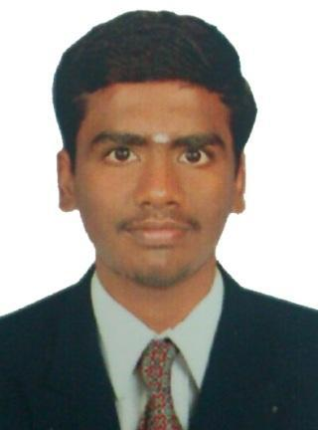  Email: vdevaraj2010@gmail.com  Mobile no: +91 – 7418541587  Permanent / Communication Address:  555/36,West street,Kalugasalapuram,  Kovilpatti(tk),Tuticorin(dist).628714  Personal Information:  Date of Birth :15.11.1992  Age :21  Marital status :Single  Father’s Name : Mr.R.Venkatasamy  Languages known:  Speak: Tamil, English, and Telugu.  Write & Read: Tamil, English.  Hobbies:  Playing cricket, chess carom, Reading books  Surfing net. | Objective  To seek a position to utilize my skills and abilities in the Industry that offers professional growth while being resourceful, innovative and flexible.  Education Qualifications  B.E Mechanical Engineering 2010 – 2014 Unnamalai Institute Of technology. (Anna University),Kovilpatti,Tamilnadu. AGGREGATE CGPA:6.87  HSC, 2010: Passed out with 68.33% from H.N.Higher Secondary School, Kadambur.  SSLC, 2008: Passed out with 87% from H.N.Higher Secondary School, Kadambur.  Personal Assets  - Perfection, Ability to deal with people diplomatically, working together in a group.  Computer Proficiency  - Platforms : Windows  - Auto CAD.  - Basic Pro/E wildfire.  - Microsoft Office Package  Area of Interest  Production, Maintenance & CAD design.  Industrial Exposure & In-Plant Training attended  - “TNSTC” at Tirunelveli  - “Thermal Power Plant” at Tuticorin and  - “Hydroelectric Power Plant” at Papanasam.  - “Alangulam Tamilnadu Cements Ltd.”, Alangulam and  - “Vishal Precision Products pvt. Ltd.”, Coimbatore.  Feats and Accolades:  - Scored 16 marks in GATE 2014.  - Scored department 2nd mark in TANCET model Examination.  - Presented a paper in Technical Symposium held at an our College  - Held the position of Class Representative during the academic year 13-14  Projects:  - Cam operating water pump as Mini project.  - Multi operational Jigs and Fixtures as Main project in  “Vishal Precision Products pvt. Ltd.”, Coimbatore.  Personal Strength and Extra Curricular Activities  - Very strong in Non-verbal, General Aptitude & Logical problem solving skill.  - Self motivated, quick learner, hard work with dedication and commitment.  - Won at intra departmental cricket league under my captaincy
Place: Kalugasalapuram 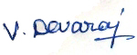
(DEVARAJ.V)

