## C++ Interview Questions & Answers

1. **Is there any chance of pointer automatically getting deleted if the allocation is inside a loop?**

Yes, there is chance using Smart pointer we can achieve same. Look at the below example program.

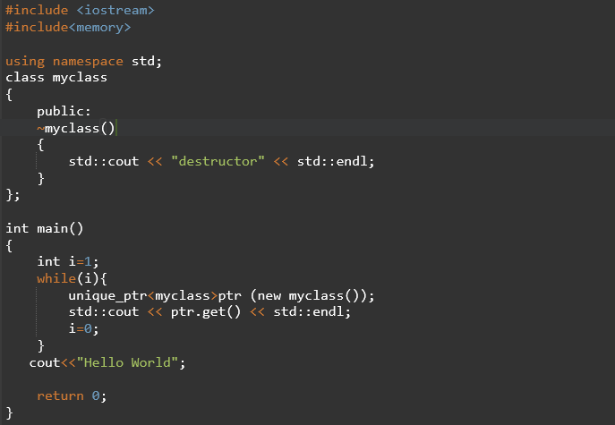

Run program and you could observe below result.

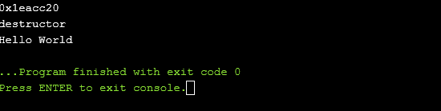

1. **How do you debug memory leaks in C++?**

We can identify the memory leaks using Val grind tool in Linux systems.

Look at the below example program.

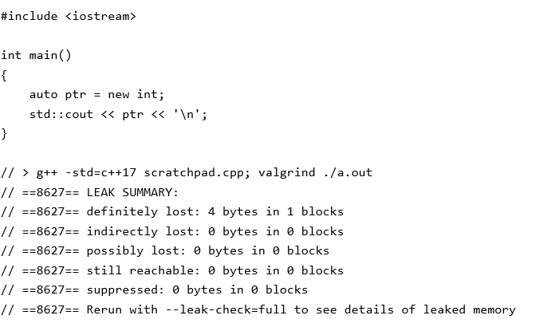

1. **Explain some scenarios for segmentation faults?**

Core Dump/Segmentation fault is a specific kind of error caused by accessing memory that “does not belong to you.”

* When a piece of code tries to do read and write operation in a read only location in memory or freed block of memory, it is known as core dump.
* It is an error indicating memory corruption.

Common segmentation fault scenarios:

* **Modifying a string literal**.
* **Accessing out of array index bounds**
* **Accessing an address that is freed**