Use Case Specification

Project Code | PRJ_UniversityAdmissionSystem_001
Project Name | University Admission System

TABLE OF CONTENTS

1. Use Case Name: Withdraw of the money from ATM 5
2. Actor(s): 5
3. Preconditions 5
4. Flow of Events 5
4.1 Basic Flow 5
4.2 Alternative Flows 6
4.2.1 Alternate Flow 1 6
4.2.2 Alternate Flow 2 6
4.2.3 Alternate Flow 3 7
Exception Flow 1: Exceeded Login Attempts 7
Exception Flow 2: Web Server Down 7
Exception Flow 3: Database Connectivity Error 7
Exception Flow 4: Network Connectivity Error 7
5. Post Conditions 7
6. Special Requirements 8
Performance 8
Availability 8
User Interface 9
Security 9
7. Extension Points 9
Extension in Alternate Flow 1: 9
Extension in Alternate Flow x: 9
8. Business Rules 9
9. Diagrams 10
Use Case Diagram for User 10
Activity Diagram 11
10. Scenarios 12
Success Scenarios 12
Failure Scenarios 12
11. Issues 12
12. UI Specifications 12
13. Inter System Dependencies 13
14. Integration with an already existing System of the <<Customer>><<Not Applicable>> 13
15. Assumptions 13

- Use Case Name: Login to the University Admission System

Use Case ID: UAS.USER.WITHDRAW_001

This Use Case describes the process by which users withdraw the money from their accounts by checking if the user has the sufficient amount through ATM.

- Actor(s):
1. User

Account holder
- Preconditions
- User has a bank account and a valid ATM card.
- User has valid pin.

- Flow of Events

4.1 Basic Flow
<< Basic Flow is the main flow or heart of the Use case. Use case starts when the actor does some action i.e. an actor always initiate a use Case. The use case should describe what the actor does and what the system does in response. It should be phrased in the form of a dialog between the actor and the system.
The use case should describe what happens inside the system, but not how or why. If information is exchanged, be specific about what is passed back and forth. For example, it is not very illuminating to say that the Actor enters customer information; it is better to say the Actor enters the customer’s name and address. A Glossary of Terms is often useful to keep the complexity of the use case manageable; it defines things like customer information there, to keep the use case from drowning in details. >>
Name: Successful withdrawal of the money
- System displays “Welcome! Enter your ATM card”.
- User inserts the ATM card.
- The system checks whether the user inserts the card properly.
- The system checks the validity of the card.
- The system displays the selection of language.
- The user selects the language.
- The system displays the current and savings option.
- The user selects the savings option.
- The system displays the withdraw,deposit, balance enquiry, change ATM pin and ministatement option.
- The user selects the withdraw option.
- The system asks for the amount.
- The user enters the amount.
- The system asks for pin.
- The user enters the pin.
- The system validates the pin.
- The system checks whether the sufficient amount is present in the account and the amount is within the limit.
- The system displays “collect the money” and “Please collect your card”.
- The user collects the money and card.
- The system displays “Your transaction is successful”.

  - Alternative Flows
<<More complex alternatives should be described in a separate section, which is referred to in the basic flow of events section. Think of the alternative flow sections like alternative behaviour – each alternative flow represents alternative behaviour (many times, because of exceptions that occur in the main flow). They may be as long as necessary to describe the events associated with the alternative behaviour. When an alternative flow ends, the events of the main flow of events are resumed unless otherwise stated.
Note: Alternate flow should resume back to Basic Flow or Use case Ends. Always define the return or exit step>>
    - Alternate Flow 1
1. System displays “Welcome! Enter your ATM card”.
2. User inserts the ATM card.
3. The system checks whether the user inserts the card properly.

4. The system checks the validity of the card.
5. The system validation fails due to invalid card.
6. The system displays “Your card is invalid”.

    - Alternate Flow 2
1. System displays “Welcome! Enter your ATM card”.
2. User inserts the ATM card.
3. The system checks whether the user inserts the card properly.
4. The card is not inserted properly and the system displays “Insert the card properly”

    - Alternate Flow 3
- System displays “Welcome! Enter your ATM card”.
- User inserts the ATM card.
- The system checks whether the user inserts the card properly.
- The system checks the validity of the card.
- The system displays the selection of language.
- The user selects the language.
- The system displays the current and savings option.
- The user selects the savings option.
- The system displays the withdraw,deposit, balance enquiry, change ATM pin and ministatement option.
- The user selects the withdraw option.
- The system asks for the amount.
- The user enters the amount.
- The system asks for pin.
- The user enters the pin.
- The system validates the pin.
- The pin is incorrect and system displays “Please enter a valid pin”.

    - Alternate flow 4
- System displays “Welcome! Enter your ATM card”.
- User inserts the ATM card.
- The system checks whether the user inserts the card properly.
- The system checks the validity of the card.
- The system displays the selection of language.
- The user selects the language.
- The system displays the current and savings option.
- The user selects the savings option.
- The system displays the withdraw,deposit, balance enquiry, change ATM pin and ministatement option.
- The user selects the withdraw option.
- The system asks for the amount.
- The user enters the amount.
- The system asks for pin.
- The user enters the pin.
- The system validates the pin.
- The system checks whether the sufficient amount is present in the account and the amount is within the limit.
- The amount is insufficient and the system displays “Please enter sufficient amount”.

    - ALTERNATE FLOW 5
- System displays “Welcome! Enter your ATM card”.
- User inserts the ATM card.
- The system checks whether the user inserts the card properly.
- The system checks the validity of the card.
- The system displays the selection of language.
- The user selects the language.
- The system displays the current and savings option.
- The user selects the savings option.
- The system displays the withdraw,deposit, balance enquiry, change ATM pin and ministatement option.
- The user selects the withdraw option.
- The system asks for the amount.
- The user enters the amount.
- The system asks for pin.
- The user enters the pin.
- The system validates the pin.
- The system checks whether the sufficient amount is present in the account and the amount is within the limit.
- The amount is exceeding the limit and system displays “You exceed the limit”.

Exception Flow 1: Web Server Down
- System displays “We can’t provide you services, reach out later”.

Exception Flow 2: Database Connectivity Error
- System displays “Welcome! Enter your ATM card”.
- User inserts the ATM card.
- The system checks whether the user inserts the card properly.
- The system checks the validity of the card.
- The system displays an error message regarding database connectivity problem.

- Post Conditions
<< Post conditions are the STATE where the system, sub-system and /or entities will be after Basic and /or Sub flow and/or Alternate flows are executed.
State the Post conditions for Basic flow + each and every Sub flow and Alternate flow.>>
Flow Name | Post Condition
Successful withdrawal of the money | User will enter the card, selects the options provided, enters the pin and withdraw the amount successfully.
Web Server Down | The system should display an error message to the user regarding web server unavailability problem
Database Connectivity Error | The system should display an error message to the user regarding the database connectivity problem

- Special Requirements
<<A Special Requirement is typically a non-functional requirement that is specific to a use case but is not easily or naturally specified in the text of the use case’s event flow.
Examples of special requirements include legal and regulatory requirements, application standards, and quality attributes of the system to be built, including usability, reliability, performance or supportability requirements. Additionally, other system common requirements such as operating systems and environments, compatibility requirements, and design constraints should be captured in Supplementary Specification.>>

Performance
- The request should be processed within 30 seconds.

Availability
  - The user can withdraw the amount 24*7.

User Interface
  - The letters on Menus shall be bold.
  - The logout and back button should be available on every page of the application.

Security
- The system shall display the letters of PIN numbers in a masked format when they are entered by the customer.
- User login should not have admin rights.
- After clicking on back, it should takes you back to the previous page in the list
- After click ing on Forword, it should takes you forword to the next page in the list.
- User Session should get expire if user is inactive for 2 mins.

- Business Rules
<<Identify any Business Rules applicable to this Use Case. Any generic business rule should be captured in a separate Common Business rules document or in the supplementary specification>>

Business Rule Name | Business Rule Description | System action (if BR fails)
BR01 | User must be valid | User is prompted to re-enterr the login credentials
BR02 | Same user cannot register for two courses at a time | Displayes error message “You have already registered for a course”
BR03 | User can view his application status only by entering valid Application_Id | Displays error message “Invalid Application_Id”

- Diagrams

Use Case Diagram for User
<< Gives the relationship between Actors and Use cases [i.e. Main Use case, Include and Extends called by Main use case>>

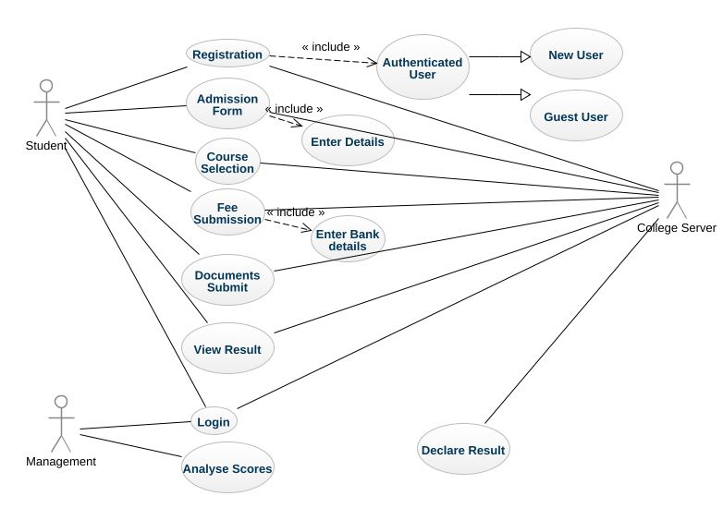

Activity Diagram<<Not Applicable>>
<< Activity Diagram gives the high level interaction between the user, system and sub systems. Ideally only one activity diagram should be made per use case. >>
- Scenarios
[Identify the scenarios using Basic Flow, Sub flow and Alternate flows]

Success Scenarios
[List different success scenario.]
- Successful user login to the University Admission System
- Login to the University Admission System with reattempt
- Login to the University Admission System using Apply for Courses option

Failure Scenarios
[List different failure scenario]
<< Failure scenarios should include exceptions, validation of Use case and Common Business Rules, UI Validation and other failure conditions of the use case>>
- Exceeded Login Attempts
- Web Server Down
- Database Connectivity Error
- Network Connectivity Error

- Issues
<< List any potential problems or known dependencies that are likely to cause this use case to fail (technical failure, staff absence, etc).
Note that this section should not have Queries related to this use case here, they should be tracked in a separate excel. If you wish you could link to that excel? >>
- What is the maximum size of username and password that a user can have ?
- What if the user is blocked after invalid login attempts for three times ?
- UI Specifications
<< Provide a link to the UI specification document of the Use case. Please don’t embed the document here>>
- Inter System Dependencies
<<Mention the related functionality within the application that is impacted because of this use case. E.g variable or value settings in this use-case which will have a direct impact on the functionality of another use-case. Or vice-versa.>>
Module: ‘Apply Online for Course’ gets impacted due to :

Use case name: Alternate Flow 1

Impact: If the user tries to apply for a course without login, he should be denied so. <<Mention the impact on the above mentioned Use case because of this use case>>

- Integration with an already existing System of the <<Customer>><<Not Applicable>>

<< This is especially applicable if the project at hand is an enhancement to an existing system.>>

- Assumptions
<< List down all the assumptions considered by this use case>>

- The User should be authenticate.
- User should know the valid URL of University Admission System.
- User should have Google chrome browser for best view of site.

