The Need for Maven
Maven is chiefly used for Java-based projects, helping to download dependencies, which refers to the libraries or JAR files. The tool helps get the right JAR files for each project as there may be different versions of separate packages.
After Maven, downloading dependencies doesn’t require visiting the official websites of different software. You can visit mvnrepository to find libraries in different languages. The tool also helps to create the right project structure in struts, servlets, etc., which is essential for execution.
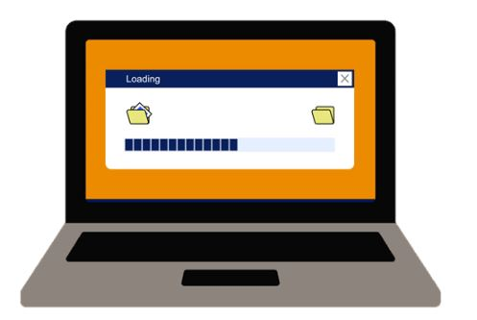

POM :

Maven projects are configured using a Project Object Model (POM), which is stored in a pom.xml-file. An example file looks like:
<project>
<!-- model version is always 4.0.0 for Maven 2.x POMs -->
<modelVersion>4.0.0</modelVersion>
<!-- project coordinates, i.e. a group of values which uniquely identify this project -->
<groupId>com.mycompany.app</groupId>
<artifactId>my-app</artifactId>
<version>1.0</version>
<!-- library dependencies -->
<dependencies>
<dependency>
<!-- coordinates of the required library -->
<groupId>junit</groupId>
<artifactId>junit</artifactId>
<version>3.8.1</version>
<!-- this dependency is only used for running and compiling tests -->
<scope>test</scope>
</dependency>
</dependencies>
</project>

Maven Lifecycle

Some of the important phases are listed below:
- Validate Verifies if all the prerequisite data for the build to complete are available.
- Compile: Source code is compiled.
- Test- compile: Test source code is compiled.
- Test: Unit test cases are executed.
- Package: Source code is compiled and packaged into JAR or ZIP files.
- Integration- test: The package is deployed and if there are any issues, integration test cases are executed.
- Install-Package: It is installed in the local repository.
- Deploy: A copy of the package is made available from the remote repository.
These phases have to be executed in order. Also, if the deploy phase i.e. the end phase of the Maven cycle has to be executed then all the prior phases to that cycle have to be completed successfully.

The operational steps of how Maven works are diagrammatically shown below:
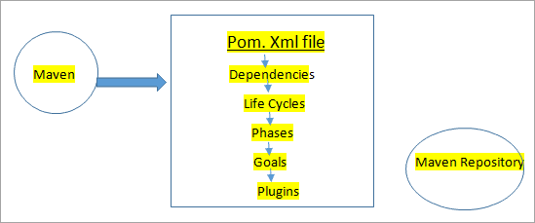

Terminologies In Maven
- POM: It stands for Project Object Model. It is an XML file that has information about the project, the dependencies present in the project, the directory of the source file, plugin information, and so on. These are the necessary data for Maven to completely build the project. Maven reads the pom file to get all this information.
Maven project in Eclipse IDE with a code snippet from the POM XML file is shown below.
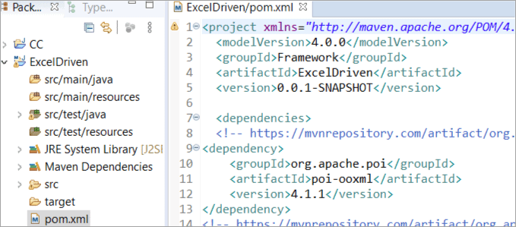
- GroupId: Recognizes our project uniquely from all the projects. GroupId is a part of the pom file. It is often said as an identity for the group of projects.
- ArtifactId: A jar file that is deployed to the Maven repository. ArtifactId is a part of the pom file. It is often said to be the identity and name of our project.
- Version: Specifies the version of the jar of the project. Version is also a part of the pom file.
As depicted in the image above, we can see that <groupId> , <artifactId> and <version> tags form the part of the dependencies defined for the project.
- Maven Central Repository: This is the placeholder where jars, libraries, plugins, and configuration data required by Maven for building the project are present.
If we want to add Selenium dependencies to our project, then we need to have the below code snippet in the pom file.
<!-- https://mvnrepository.com/artifact/org.seleniumhq.selenium/selenium-java -->
<dependency>
<groupId> org.seleniumhq.selenium </groupId>
<artifactId> selenium-java </artifactId>
<version> 4.0.0-alpha-5 </version>
</dependency>

Maven Repository
Maven Repository can be of three types:
- Local Repository
- Remote Repository
- Central Repository
Once Maven reads the dependencies from the POM file, it first searches them in the local repository, then to the central, and finally to the remote repository. If the dependencies are not found in any of the three repositories, then the user is notified with an error and the process is stopped.

#1) Maven Local Repository
The local repository is located in our local system – mostly in .m2 (C:/Users /superdev /.m2) directory which shows its presence once Maven is installed in our system and we have been able to successfully execute a Maven command.
It is also possible to modify this location in settings.xml (MAVEN_HOME /conf /settings.xml) with the help of the localRepository tag.
Below xml code snippet, that shows how to change the locations of the local repository:
<settings>
<localRepository>
C: \Maven \m2
</localRepository>
</settings

#2) Maven Central Repository
Central repository is developed by the Apache Maven group and is hosted on the web. This is considered as the central repository and it has all the common libraries. Like a local repository, we can also modify the location where they are to be downloaded by default by changing the setting.xml.

#3) Maven Remote Repository
A remote repository is also hosted on the web. In some scenarios, a company can develop its own remote repository and perform deployments on its private projects. These will be owned by that specific company and can be operated only inside it.
The remote repository has similar working patterns to a central repository. Whenever any dependencies or configurations are required from these repositories, they shall first be downloaded into our local and then used.

