**Use case diagrams**

Upon launching the application it directs to a login form where both the instructor and the student can Sign In. Once the either of them successfully login they can perform their respective tasks. There is no need for a special sign up since they are already provided with university credentials.

**Use case 1: Student Login**

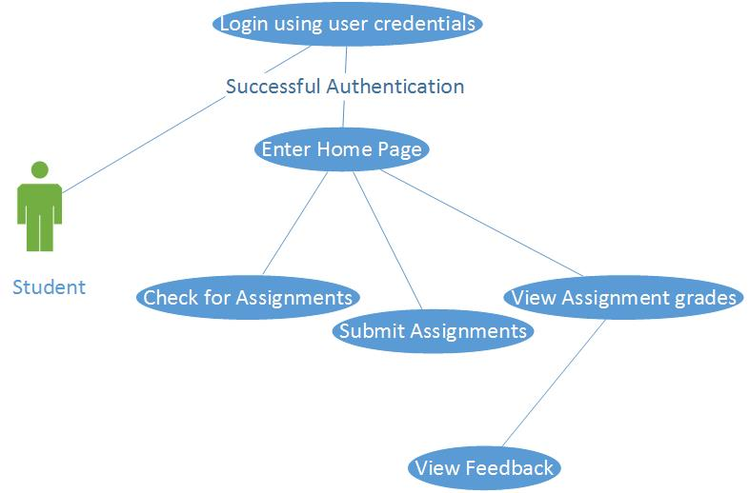

**Step by step description:**

1. Student opens the web page and clicks on login button
2. A login form with fields for username, password and one drop down for category are shown
3. Student fills the form and clicks sign in
4. After successful authentication, it directs to the home page
5. The user is presented with a table of assignments. Assignment is provided in the form of a hyperlink followed by due date and its status
6. Once the user clicks on the hyperlink, he is directed to a page with the assignment.
7. Student is provided with three different options in the navigation bar. He/she can choose to upload a file, view the grade or view the feedback.
8. File Upload: A button to choose the file from the computer system is provided. Once he selects the file he can upload it using submit button or cancel the upload by clicking on the cancel button
9. Grade: Student can view the grade by clicking on the grade button in the navigation bar once the grades are released
10. Feedback: Student can view the feedback by clicking on the feedback button in the navigation bar. Feedback is provided in the form of a file and the user can download it using the hyperlink provided.

**Use case 2: Instructor Login**

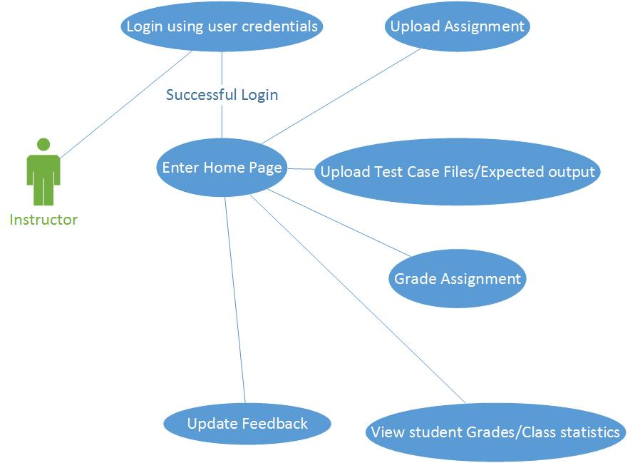

**Step by step description:**

1. Instructor opens the web page and clicks on login button
2. A login form with fields for username, password and one drop down for category are shown
3. Instructor fills the form and clicks sign in
4. After successful authentication, it directs to the home page
5. He is provided with a screen consisting of a button for uploading new assignment and a table with student assignment details to grade them.
6. A grade button in the sixth column for each student is clicked and the assignment would be automatically graded and the application generates the feedback for each assignment which is uploaded to the Student assignment table in the instructor grade table.
7. The instructor can sign out by clicking on the logout button present on top right corner on each page.

**Use case 3: Login Failure**

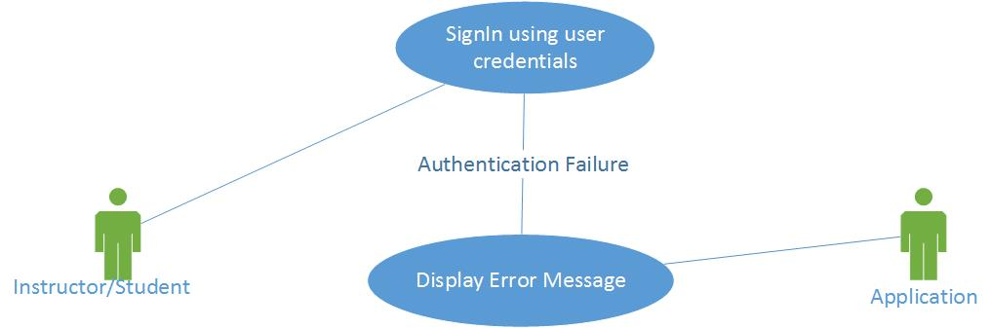

**Step by step description:**

1. **The user (instructor/student) enters wrong password/wrong username**
2. **He clicks on the login button**
3. **An error message is displayed and the user is not authenticated to sign into the system.**

**Use case 4: Student successful file upload**

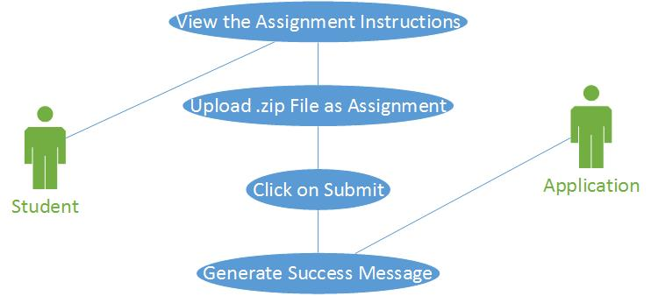

**Step by step description:**

1. The student clicks on the hyperlink of an assignment
2. The applications directs it to a page where the assignment details are provided
3. Student clicks on choose file and choses a .zip file for assignment
4. Uploads the assignment by clicking on submit button.
5. A message for successful submission is displayed below the assignment details

**Use case 5: Student Unsuccessful file upload**

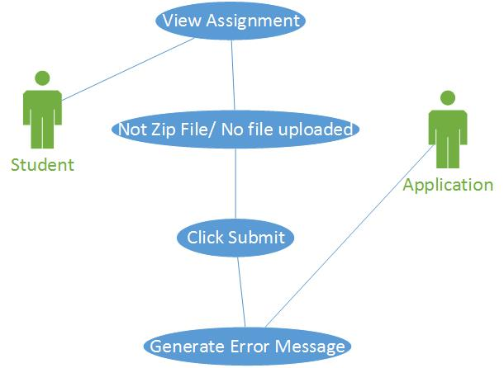

**Step by step description:**

**Case i:-**

1. The student clicks on the hyperlink of an assignment
2. The applications directs it to a page where the assignment details are provided
3. Student clicks on choose file and uploads a .doc file
4. Clicks on submit button
5. Error message stating “wrong file format chose” is displayed and file is not uploaded

**Case ii:-**

1. The student clicks on the hyperlink of an assignment
2. The applications directs it to a page where the assignment details are provided
3. Student clicks on submit button
4. Error message stating “no file chosen” would be displayed

**Use case 6: Successful source code compilation**

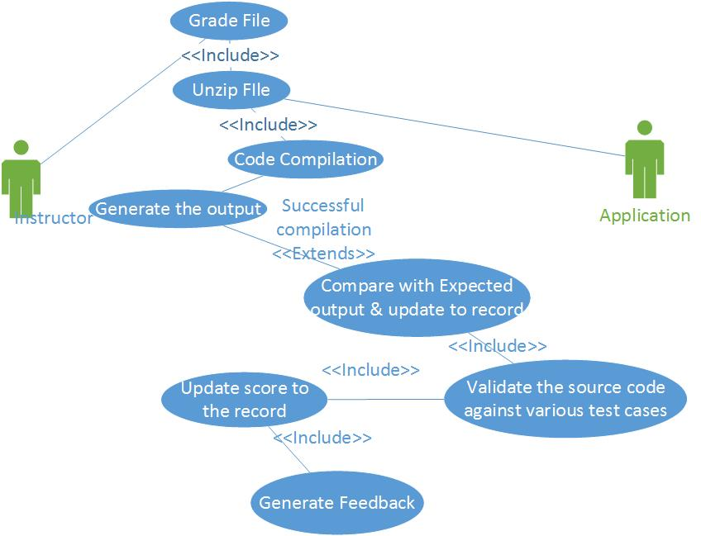

**Step by step description:**

1. Instructor clicks on grade button
2. The file is automatically unzipped
3. The source code is tested for compilation
4. The output for the student written code is generated
5. Output is compared with the expected output uploaded by the instructor and the score for the output is updated to the record
6. The source code is then validated against the test cases
7. Score for each test case is updated to the record
8. Feedback is generated in the form of an excel file. Score and description for each test case is displayed.

**Use case 6: Unsuccessful source code compilation**

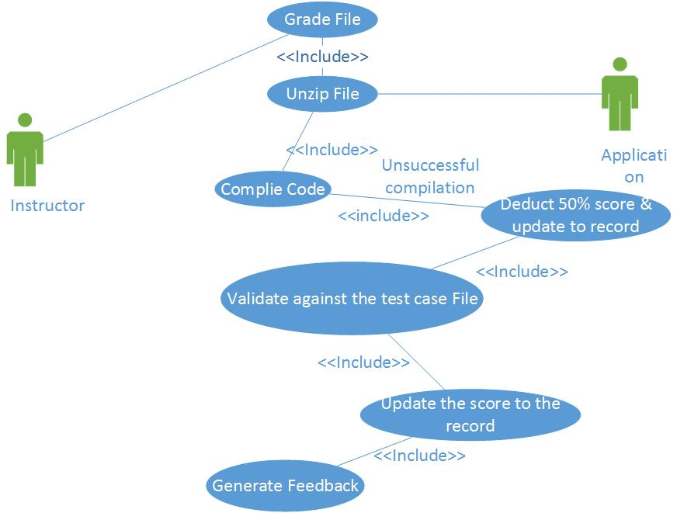

**Step by step description:**

1. Instructor clicks on grade button
2. The file is automatically unzipped
3. The source code is tested for compilation
4. Source code is tested for compilation
5. Code is not compiled and no output is generated
6. 50% of the total score is deducted for not compiling and updated to the record
7. Source code is then validated against the test cases
8. Score for each test case is updated to the record
9. Feedback is generated in the form of an excel file. Score and description for each test case is displayed.