1a. Create smoke test for [facebook](https://www.facebook.com/) registration form.

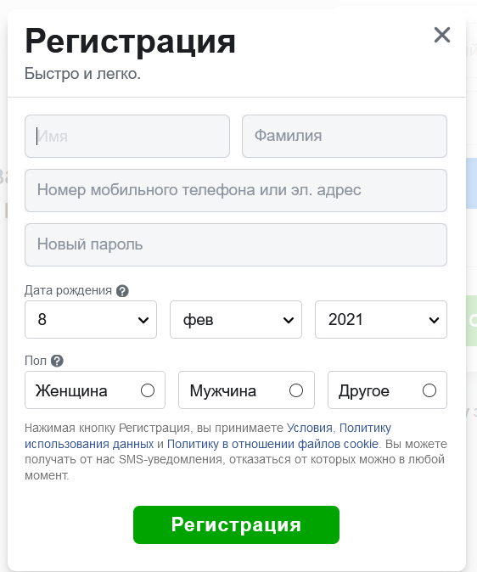

**Smoke test for Facebook registration form has the next view:**

|  |  |
| --- | --- |
| Checking | Expected result |
| Enter correct information in all fields and press button “Register” | 1. A successful message appears.  registration with indication of further  actions (go to the form  login / need for confirmation  registration).  2. The user receives the appropriate  mailbox notification indicating  further actions. |
| In the notification of successful registration,  received to the mailbox, go to  provided link for  confirmation of registration. | 1. The user is redirected to  an appropriate form indicating  successful account activation.  2. User can login with  with the data specified during registration. |
| Do not fill in required fields  (marked with an asterisk) and press the button  ‘Register’. | Error messages appear for fields,  marked as required. |
| Enter spaces in all fields marked with  as required, and click the "Register" button | Error messages appear for fields,  marked as required. |
| Insert spaces before and after the main  text in all text boxes. For example,  '_Name_' and press the button  ‘Register’. After  account confirmation log in and  go to the form for editing personal  data. | Inserted spaces before and after body text  ‘Cut off’. Correct data display:  'Name'. |
| Fill in all fields with correct or  incorrect information and click  Cancel button. | Values entered are cleared / user  redirects to the previous form. |
| Enter more in text boxes  permissible maximum number  symbols and press the button  ‘Register’. | Error messages appear stating that  the maximum allowed quantity has been exceeded  characters. |
| Enter html tags / wildcards / special  characters in the text boxes and click the button  ‘Register’.  After confirming your account, log in to  system and go to the view form  personal data (user profile).  Example html tag: <b> text </b>  Example wildcards: & copy  Example of special characters:  ! @ # $% ^ & * () _ + | The information is displayed in the same form in  which it was entered on the registration form. |
| Enter an incorrect format in the E-mail/phone field  mailbox. For example:  1. not containing @ / containing  multiple @ symbols  2. does not contain a top domain  level (.com / .org, etc.)  After entering, press the button  ‘Register’. | An error message appears about the incorrect  E-mail address format. |
| Precondition: register user.  In the E-mail/phone field, enter E-mail just now registered user. | Error messages appear stating that  the user with the specified E-mail is already  registered in the system. |
| In field E-mail/phone enter phone number in incorrect format (without ‘+’, for example) | Error message appear stating that phone number has incorrect format |
| In the field ‘Date of birth’ select the date in  the future. After filling in the rest  required fields click the button  ‘Register’. | Error messages appear stating that  the selected date of birth is incorrect. |

1b. Make a screenshot showing a request, response and status code for this form when you click the Registration button. What tool was used for catching?

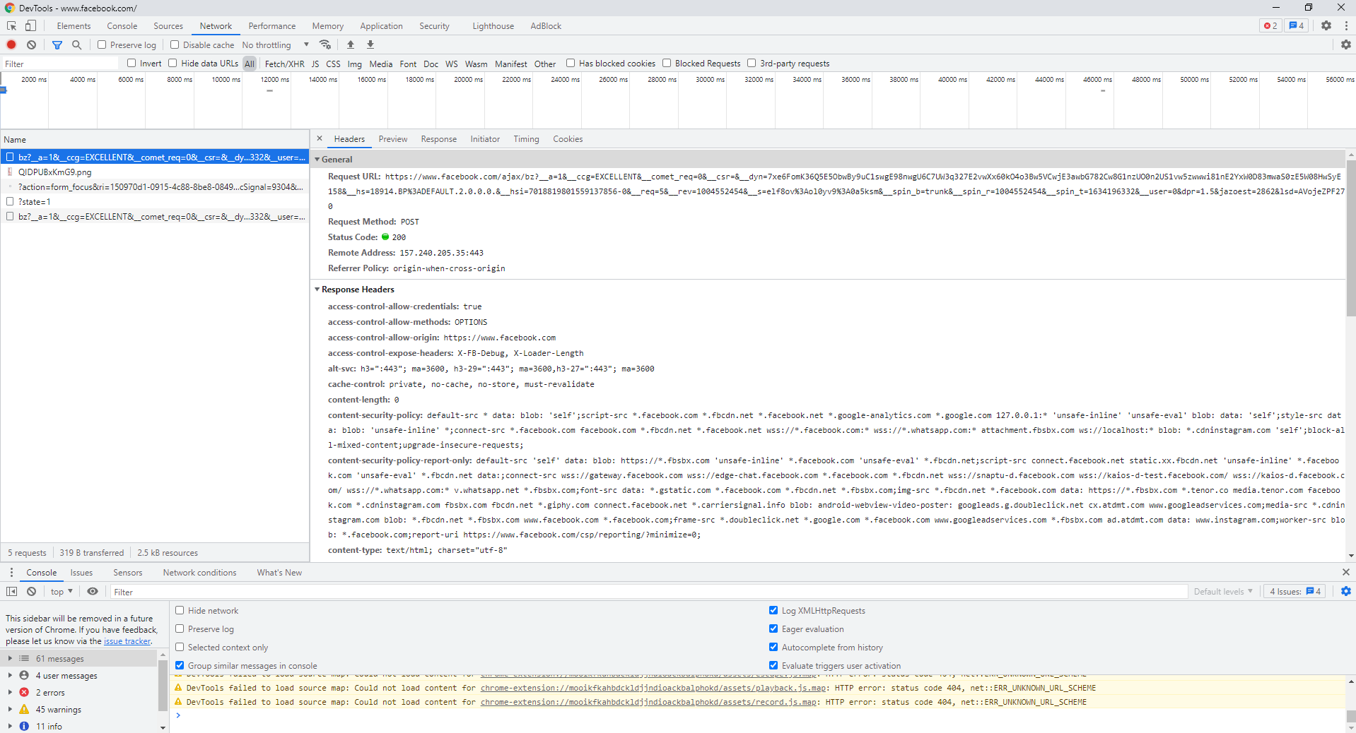

I used Chrome devtools (network tab). It also possible do in Postman, but necessary know name of parameters which will be using in query.

2. Write SQL statement to select name, active flags of all Actions with action option class name "User Actions" and action option value "Scroll" (result data should be ordered by Name in ascending order). You can find [DB Schema](https://prnt.sc/yxzc6f) below.  
  
Select A1.Name, A1.Active   
From Action A1 inner join Action Option value A2

On A1.id = A2.ActionId

Inner join Action Option A3

On A2.ActionOptionId = A3.id

Inner join Action Option Class A4

On A3.ClassId = A4.id

Where A4.Name = ‘User Actions’ AND A2.Value = ‘Scroll’

Order by A1.Name ASC;

3. Go to <https://lightpointglobal.com/>

Change site logo to Google logo. Take a screenshot. Describe how you did that.

How to do it:  
1. Go to <https://lightpointglobal.com/>  
2. Press Ctrl+Shift+I  
3. Go to Element  
4. Find necessary element  
5. Write   
<img class="logo" alt="Lightpoint logo" src="https://habrastorage.org/files/b82/7e0/5dc/b827e05….png" width="200px" height="46px"> instead   
<img class="logo" alt="Lightpoint logo" src="/images/logo.svg">

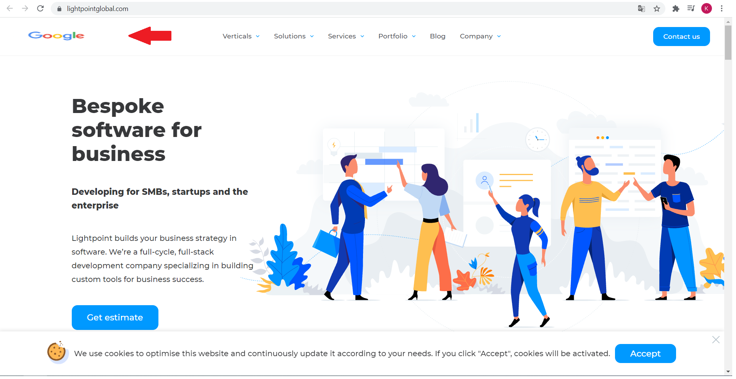

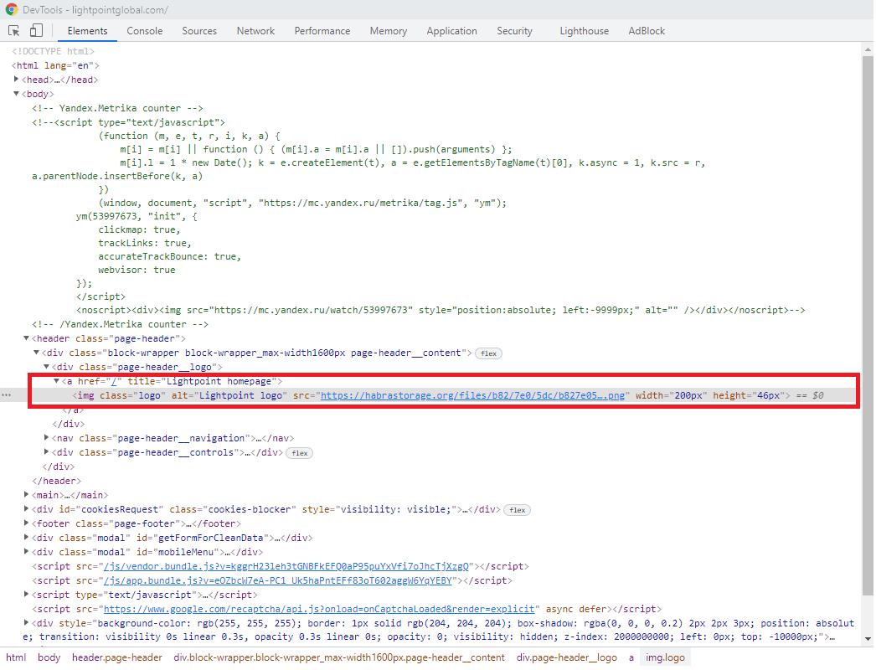

4. Generate a request to the public API of National Bank of Belarus that returns the Euro exchange rate for August 9, 2020

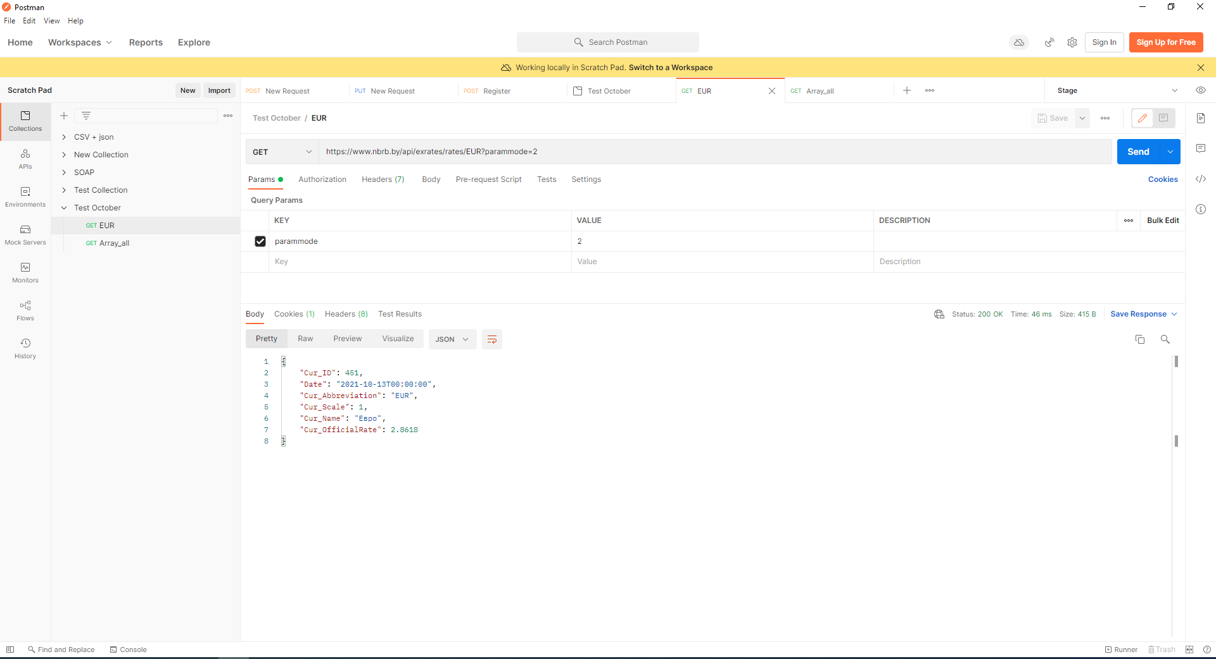

5. Please, analyze the next part of specification. Make a list of any comments, questions, inaccuracies you would ask before the start of testing.

1). How many invitations can have the user  
2). In phrase “the amount of remaining registered users.” Maybe it mean the amount of remaining unregistered users?  
3). Where information that determined the amount of privilege?  
4). What the differences between owner and guest?

5). In case of several invitations which will be choose?

6). Requirements for this form (specific for fields First Name, Last Name, Email, Type)

7). Which messages can be in case of non-trivial work?