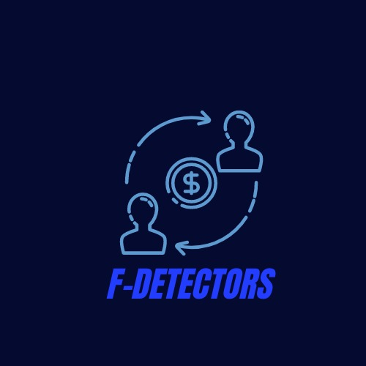

A FLAGSHIP PRODUCT FROM TEAM GT HACKERS

F-DETECTORS

WHAT IS F-DETECTORS?

F-DETECTORS is a case filtering assistant which works on a highly trained ML model and the users can interact with it through a website by uploading the case details and the filtering assistant will predict whether a certain money transaction was fraud which may involve money laundering etc..

WHY F-DETECTORS AND TO WHOM IT MAY BE USEFUL?

As the digital payment revolution continues to evolve,the number of cases on money fraud through online modes are increasing day by day and government,financial and investigation agencies are finding it difficult to manage the investigations of all of the complaints it receives daily.But though a huge number of complaints are registered the percentage of cases proven fraud are less and the above said agencies will also be wasting their time solving a non-fraud case,so this is where the filtering assistant comes in handy.

HOW IT WORKS?

The case filtering assistant takes the case details as input and predicts whether the given case is more likely to be fraud or not.The assistant works on a ML model which is highly trained with millions of data and interacts with the user through a professionally designed and interactive website.

WHAT MAKES F-DETECTORS STAND OUT WITH OTHER CASE FILTERING ASSISTANTS?

With the current version of F-detectors the model working behind it is highly efficient,fast,flexible and reliable and it learns from mistakes it rarely makes so that the more we use it the more the model becomes accurate and also the website with which the user interacts is highly user friendly.

WHAT COULD YOU EXPECT FROM US IN THE COMING VERSIONS OF F-DETECTORS?

We always believe to improve our product so that it adapts with the current Global Finance scenario so we hope to add a few more features to our product,speaking of some,

1.Our team is planning to add a database that stores account numbers which have been proven guilty of fraud in the past so that each time at present when the model works on a case it would consult the database and if it finds an account matching it would blacklist the current case.

2.In the coming versions of F-detectors it would include a feature in which we could input custom case details apart from the regular inputs and we are planning to develop another model using deep learning(neural networks) which would classify these custom details based on similarity also forming subgroups and trains the prediction model for better accuracy also we are adding more input attributes like the country of transaction etc which would be crucial in the predictions.

3.Another crucial feature we are yet to add is the percentage of fraud as output.In the current version of the project the output has only two options that is whether the case is fraud or not but due to the present dataset constraints it cannot predict the expected percentage of fraud so we hope to acquire the proper datasets and the new model will predict different classes as output where each class corresponds to a percentage of fraud so it will be helpful for the concerned users whether to proceed on a particular case for further investigation on not.

HOW THE WEBSITE WORKS?

WEBSITE LAYOUT(HOME PAGE)

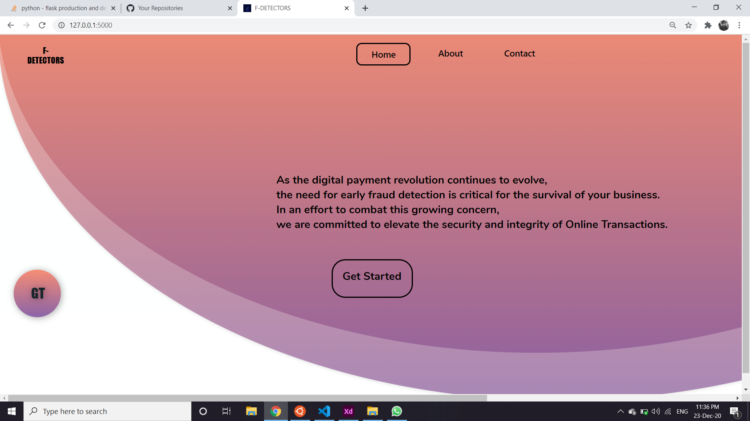

IF you click on ‘Get Started’,the prediction tab appears.

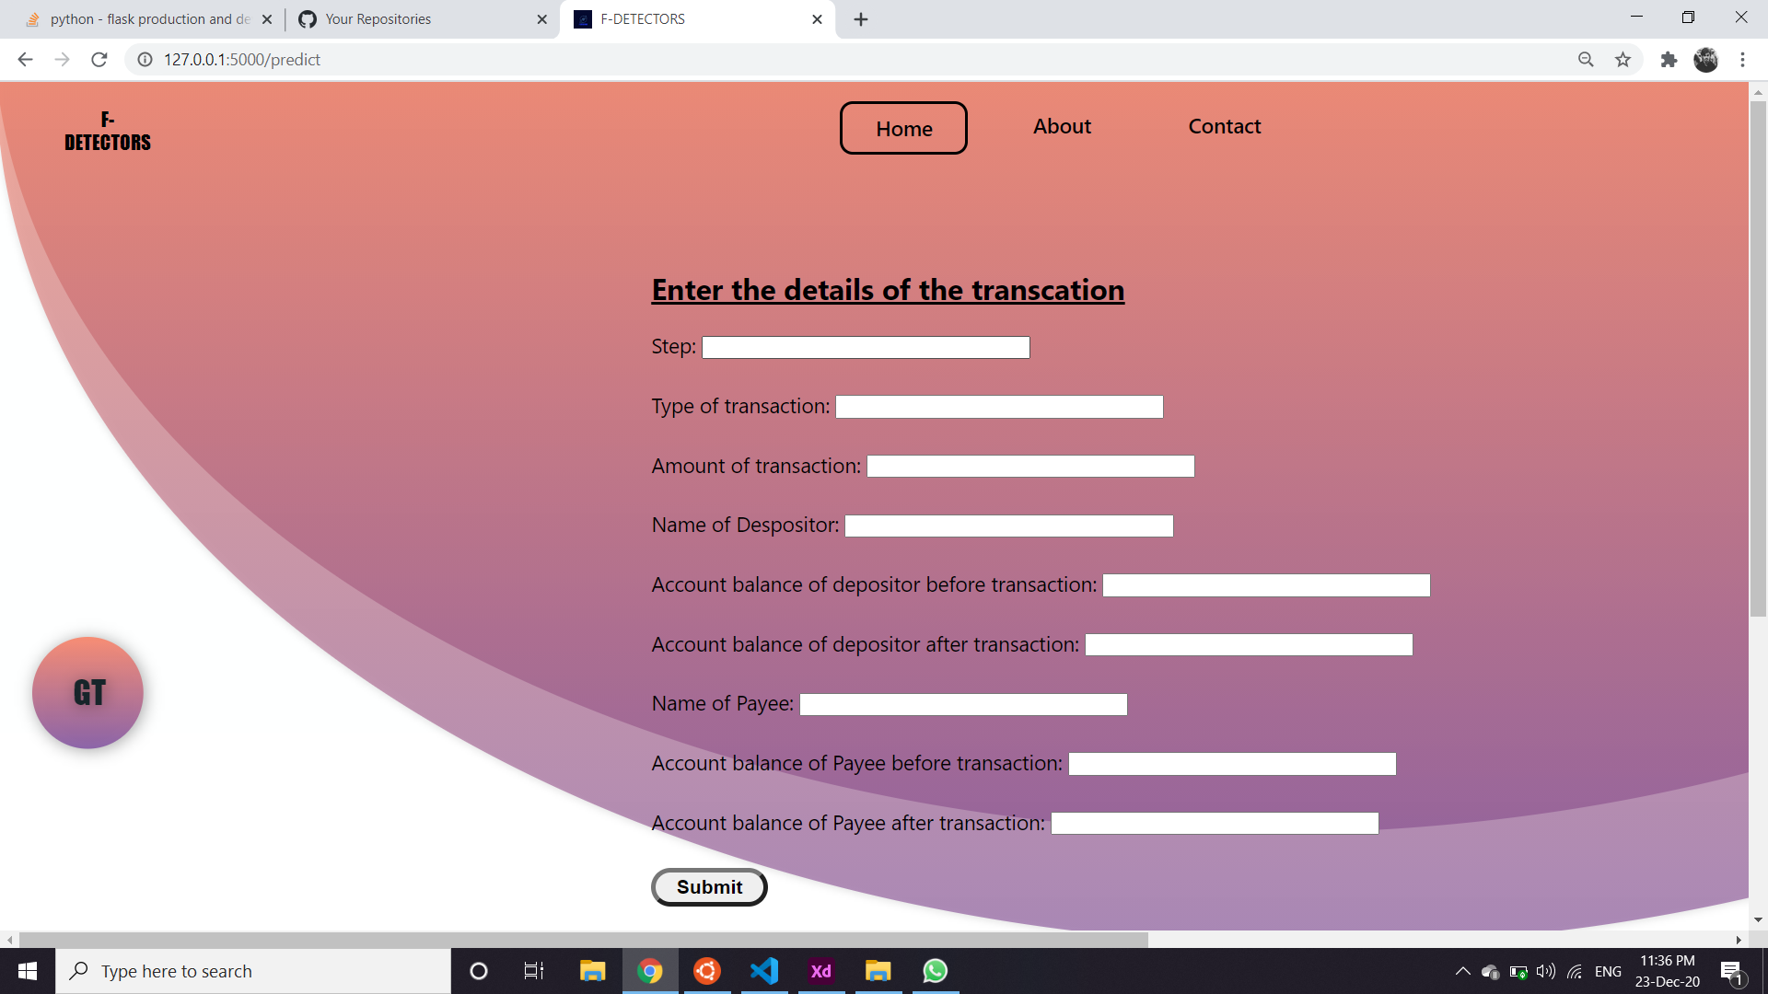

ENTERING THE CASE DETAILS(MORE INPUT FIELDS WILL BE ADDED IN THE COMING VERSIONS)

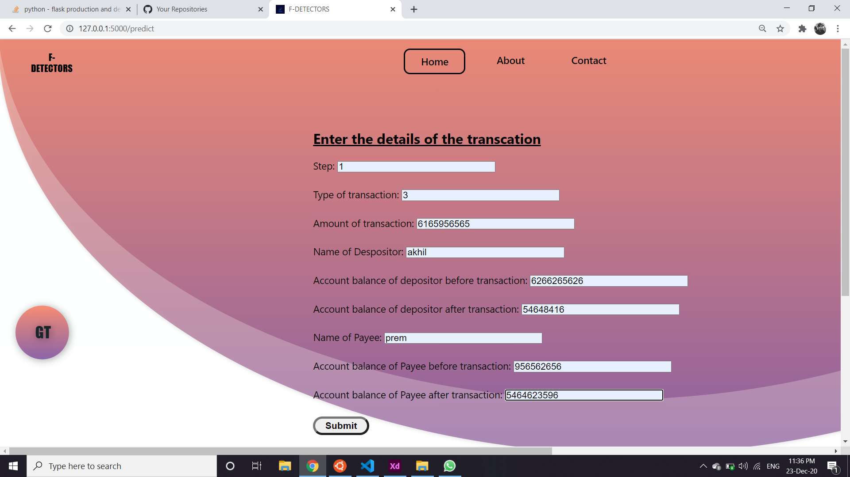

IF THE CASE IS PREDICTED AS FRAUDULENT,

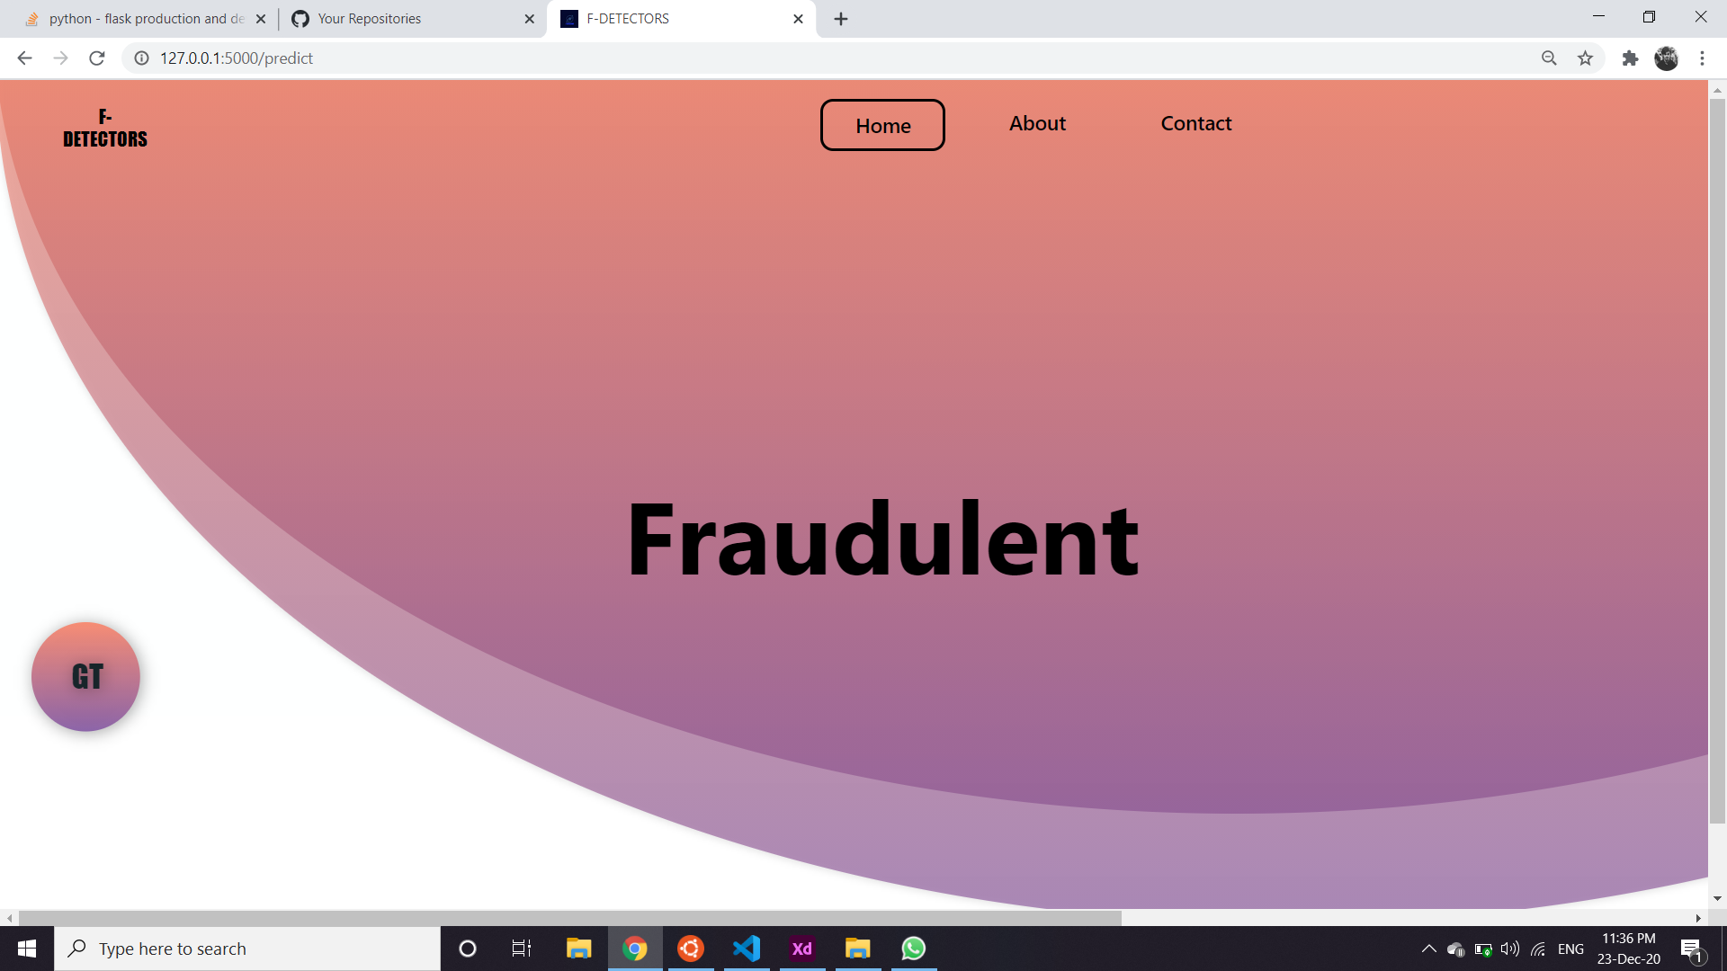

IF THE CASE IS PREDICTED AS NON-FRAUDULENT

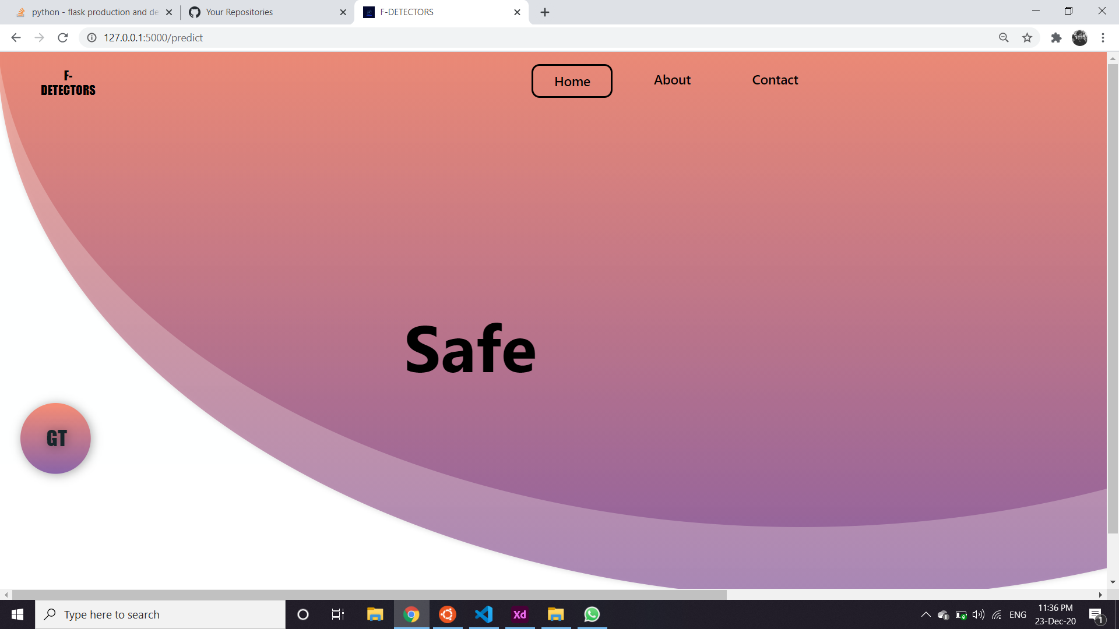

SCAN THIS QR CODE TO WATCH A VIDEO OF LIVE TESTING



GITHUB REPO LINK

https://github.com/Pranoypauljr/F-DetectoR

THE TEAM -GT HACKERS

->V S SREERAM

->AKHIL PREM

->ARJUN SARMA

->PRANOY SANTHOSH M