Token Distribution Proposal

The GBA would like to become a member-driven organization. Where tokens are distributed should reflect what members feel to be important (and thus, where members should be most rewarded for contributing). Thus, rather than just voting directly for individual members, all voters are distributing reward tokens across goals and activities according to their level of importance (to that voter). Voters can then only vote for the sub-distributions to individuals for those specific activities and groups that they personally are actively involved in and, therefore, have reasonably direct knowledge of.

In order to facilitate this, voting will be performed against a four level hierarchical collection of buckets such as the example just below (divided into two halves for legibility):  
  
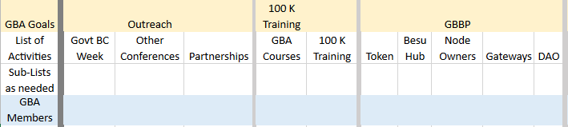  
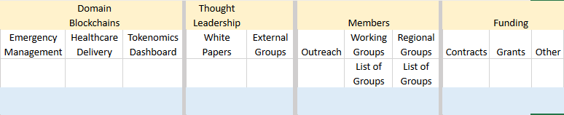

Ideally, all GBA members would vote to distribute tokens across the top (GBA Goals) level and within each goal at the second (List of Activities) level. Any member can distribute tokens across the groups in sub-list level (the third row in the example) provided that they feel that they have a good knowledge of the relative activity of each group. Only members that are active participants in a given activity or group may distribute votes across the members of that group (the GBA Members level/level 4).

Note that the instructions for voting for specific members is specifically designed/intended not to give any advantage for merely holding a position – as activity/group members will be asked to evaluate the contributions of their peers, not their titles (although good and active leadership is certainly a solid contribution that will undoubtedly be recognized). This is necessary, in particular, to ensure that reward tokens are not regarded as a payment for holding a position, an occurrence which would then cause problems with the SEC.

Voting in a given month should reflect contributions in the previous ***completed*** month (so the token distribution at the end of February, for example, reflects contributions made in January).

Individual GBA members will need to maintain a profile that contains monthly information about activities/groups that they actively participated in. This profile will consist of a list of records composed of the activity/group name/id; a number denoting the hours contributed during the month; and a free-text form for substantial achievements where necessary. This will provide the lists for the fourth (GBA Member) level (both for voting and receiving votes) and assist their peers in remembering their contributions. Individuals not completing their profile for a given month may still vote and be voted for -- but an empty month is likely to garner fewer votes from their peers.

Voting can be performed and altered by a given GBA member at any time. The current distribution will always be displayed, and a snapshot taken at the end of each month for GBA Reward token distribution. Note that the votes of a given individual are also public knowledge. At the end of the month, votes will be frozen for the month, and new buckets opened for the following month.

The first month (I.e. the initial token distribution) is a special case. In that month, ***all*** previous contributions from the past several years should be considered. The membership will vote first – but the final actual voting for the initial distribution will be performed by the 22 electors who will take the results of the member voting into account. There will also be a one-time top-level category for exceptional service where members (and electors) can vote to give specific individuals a higher percentage of the tokens awarded in the first distribution.

Each GBA member’s votes will be weighted by an as-yet-to-be-determined formula based upon their number of GBA Reward tokens (which is why the electors are necessary for the first month where votes cannot be properly weighted). The votes of those with more tokens, presumably because they have contributed more time, effort and value to the GBA, will be weighted more heavily than those who have less tokens. This may also be incentive for members to not trade tokens for discounts (on classes, conferences, etc.) and should also give the tokens a greater value.

{ Frederick asked “What happens if someone felt he did a lot of work but somehow that didn’t show and people didn’t vote for his token reward request? Can he appeal?” This is something that we should discuss but my immediate reaction is that this person should have a form to fill out that will go to the management team who will keep an eye out for any sustained abuse but is unlikely to step in on individual cases. For someone to be cheated, it really takes most of his peers – or, at least, the heavily weighted ones – to go against what is fair. Also note that, since votes are visible to all, that person can privately appeal to voters that the appealing person feels were unfair – particularly if their votes were made early in the month (which we should encourage and which works since the votes are for the previous completed months and should be made before people forget, anyways) and can still be changed.}