Token Distribution Proposal

The GBA would like to become a member-driven organization. Where tokens are distributed should reflect what members feel to be important (and thus, where other members should be best rewarded for work). Thus, rather than just voting directly for individual members, voters should be able to divide tokens among higher-level priorities and only vote for distributions to individuals for the specific activites and groups that they are actively involved in and thus have relatively direct knowledge of.

In order to facilitate this, the voting will be performed against a hierarchical collection of buckets such as the example just below (divided into two halves for legibility):  
  
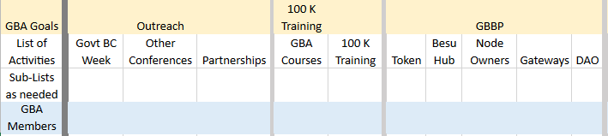  
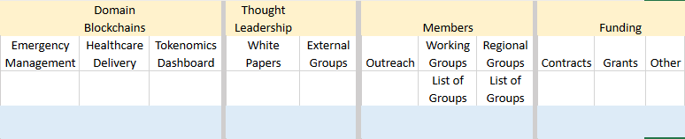

Ideally, all GBA members would vote to distribute funds across the top (GBA Goals) level and within each goal at the second level. Any member can distribute funds across the groups in level 3 if they feel that they have a good knowledge of the relative activity of each group. Only members that are active participants in a given activity or group may distribute votes across the members of that group (level 4). Note that this does not give any advantage to those who merely hold positions – as activity/group members will be asked to evaluate the contributions of their peers (although good and active leadership is certainly a solid contribution that will undoubtedly be recognized). Voting in a given month should reflect contributions in the previous ***completed*** month (so the token distribution at the end of February, for example, reflects contributions made in January).

Individual GBA members will need to maintain a profile that contains monthly information about activities/groups that they actively participated in. This profile will consist of a list of records composed of the activity/group name/id; a number denoting the hours contributed during the month; and a free-text form for substantial achievements where necessary. This will provide the lists for the fourth (GBA Member) level (both for voting and receiving votes) and assist their peers in remembering their contributions. Individuals not completing their profile for a given month may still vote and be voted for -- but an empty month is likely to garner fewer votes from their peers.

Voting can be performed and altered by a given GBA member at any time. The current distribution will always be displayed, and a snapshot taken at the end of each month for GBA Reward token distribution. At the end of the month, votes will be frozen for the month, and new buckets opened for the following month.

The first month (I.e. the initial token distribution) is a special case. In that month, ***all*** previous contributions from the past several years should be considered. The membership will vote first – but the final actual voting for the initial distribution will be performed by the 22 electors who will take the results of the member voting into account. There will also be a one-time top-level category for exceptional service where members (and electors) can vote to give specific individuals a higher percentage of the tokens awarded in the first distribution.

Each GBA member’s votes will be weighted by an as-yet-to-be-determined formula based upon their number of GBA Reward tokens (which is why the electors are necessary for the first month where votes cannot be properly weighted).