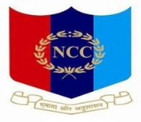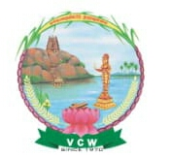

**VELLALAR COLLEGE FOR WOMEN (AUTONOMOUS), ERODE - 12.**

**College with Potential for Excellence**

**(Reaccredited with ‘A’ Grade by NAAC & Affiliated to Bharathiar University, Coimbatore)**

**National Cadet Corps**

**15(Tamil Nadu) Battalion NCC**

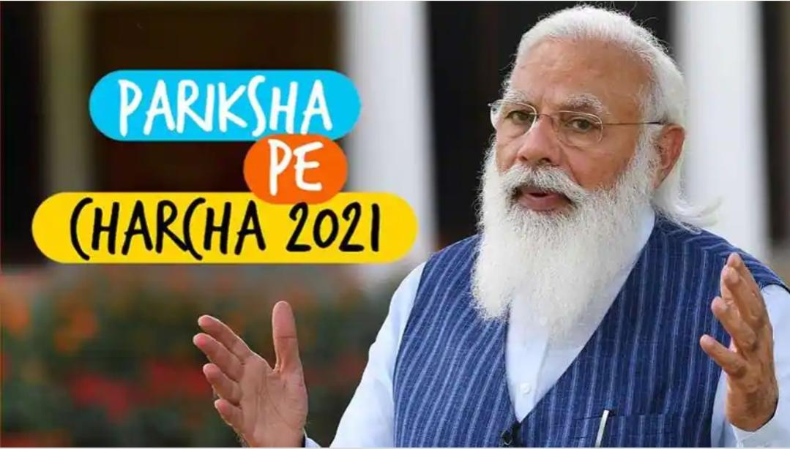 **PARIKSHA PE CHARCHA 2021**

**Venue:** Online

**Date :** 08.04.2021

**Programme Objectives:**

To create an awareness among the interaction with Prime Minister.

**VELLALAR COLLEGE FOR WOMEN (AUTONOMOUS), ERODE - 12.**

**PARIKSHA PE CHARCHA 2021**

**REPORT**

80 Cadets from Vellalar College for Women took part in the Pariksha Pe Charcha Webcast. This activity was guided by Captain Dr.N.Kavitha, Associate NCC Officer. The objective of this programme was to make an interaction between the Prime Minister, teacher, parents and students about the education level of the future leaders. PARIKSHA PE CHARCHA (Exam Warriors) is the part of larger movement led by Prime Minister Narendra Modi to create stress free atmosphere for youngsters. It is the movement driven by his efforts to bring students, parents, teachers and the society to foster an environment together where the unique individuality of each child is celebrated, encouraged and allowed to express itself fully. Notable event in this movement is Prime Minister Narendra Modi published his book 'Exam Warriors'. Through this book, the Prime Minister outlined a refreshing approach to education. He urges everyone to put exams in the right perspective, rather than making it a life-and-death situation punctuated by undue stress and pressure. Through this webcast our cadets gained awareness about the exams and came to know that an examination should be seen as opportunity not as life changing event. This programme gave the positive hope about the exam to the present generation. The youngsters may not be fear while facing the examination by utilizing this webcast. It vanish the panic and built the trust on education among the youths.

**YOU LEARN MORE FROM FAILURE THAN FROM SUCCESS**

**Cadets watching the webcast:**

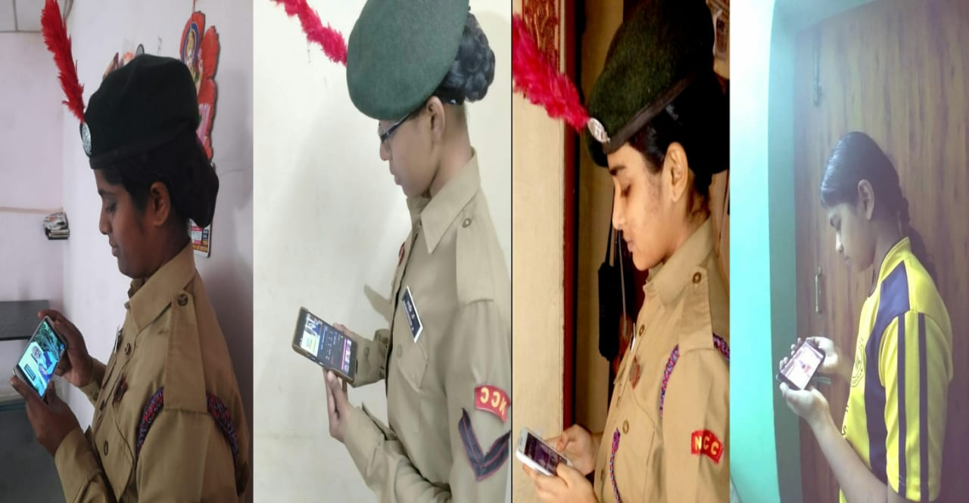

**NATURE WILL SALUTE YOU**